ROSENIVITHA J - 192424009

**EXP 21: Write a Prolog Program to implement Towers of Hanoi.**

**AIM:**

To Write a Prolog Program to implement Towers of Hanoi.

**PROGRAM:**

% 21. Prolog Program to implement Towers of Hanoi

hanoi(1,Source,Target,_) :-

write('Move disk from '), write(Source), write(' to '), write(Target), nl.

hanoi(N,Source,Target,Aux) :-

N > 1,

M is N - 1,

hanoi(M,Source,Aux,Target),

hanoi(1,Source,Target,_),

hanoi(M,Aux,Target,Source).

**Query:**

?- hanoi(3,left,right,center).

OUTPUT:

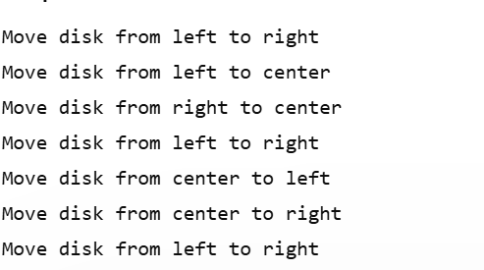

**RESULT:**

Thus, the output is verified Prolog Program to implement Towers of Hanoi.