ROSENIVITHA J - 192424009

**EXP 22: Write a Prolog Program to print particular bird can fly or not. Incorporate required queries.**

**AIM:**

To Write a Prolog Program to print particular bird can fly or not. Incorporate required queries.

**PROGRAM:**

% 22. Prolog Program to check if a bird can fly

can_fly(sparrow).

can_fly(pigeon).

can_fly(parrot).

can_fly(eagle).

cannot_fly(penguin).

cannot_fly(ostrich).

% Rules

bird_can_fly(Bird) :- can_fly(Bird).

bird_can_fly(Bird) :- cannot_fly(Bird), write(Bird), write(' cannot fly'), nl, fail.

**Query:**

?- bird_can_fly(sparrow).

?- bird_can_fly(penguin).

OUTPUT:

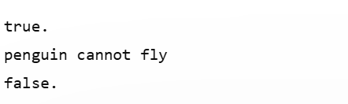

**RESULT:**

Thus, the output is verified Prolog Program to print particularbird can fly or not. Incorporate required queries.