ROSENIVITHA J - 192424009

**EXP 23: Write the prolog program to implement family tree.**

**AIM:**

To Write the prolog program to implement family tree.

**PROGRAM:**

% 23. Prolog Program for Family Tree

% Facts

male(ram).

male(rahul).

female(sita).

female(meera).

parent(ram, rahul).

parent(sita, rahul).

parent(ram, meera).

parent(sita, meera).

% Rules

father(X,Y) :- male(X), parent(X,Y).

mother(X,Y) :- female(X), parent(X,Y).

sibling(X,Y) :- parent(P,X), parent(P,Y), X \= Y.

**Queries:**

?- father(ram,rahul).

?- sibling(rahul,meera).

OUTPUT:

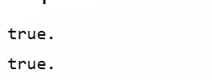

**RESULT:**

Thus, the output is verified Prolog Program to implement family tree.