ROSENIVITHA J - 192424009

**EXP 26: Write a Prolog Program for fruit and its color using Back Tracking.**

**AIM:**

To Write a Prolog Program for fruit and its color using Back Tracking.

**PROGRAM:**

% 26. Prolog Program for Fruit and Its Color using Backtracking

fruit(apple, red).

fruit(banana, yellow).

fruit(grapes, green).

fruit(orange, orange).

fruit(blueberry, blue).

% Query: ?- fruit(Fruit, red).

% Query: ?- fruit(Fruit, Color).

**Sample Query:**

?- fruit(Fruit, red).

**Output (with backtracking):**

Fruit = apple ;

false.

**Another Query:**

?- fruit(Fruit, Color)

OUTPUT:

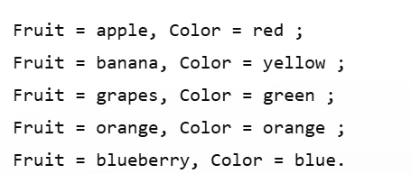

**RESULT:**

Thus, the output is verified Prolog Program for fruit and its color using Back Tracking.