ROSENIVITHA J - 192424009

**EXP 3: Write the python program for Water Jug Problem**

**AIM:**

3 Write the python program for Water Jug Problem

**PROGRAM:**

from collections import deque

def water_jug(jug1, jug2, target):

visited = set()

q = deque()

q.append((0, 0, [])) # state x, y, steps

while q:

x, y, path = q.popleft()

if (x, y) in visited:

continue

visited.add((x, y))

if x == target or y == target:

print("Solution steps:")

for step in path:

print(step)

return True

# Possible operations

states = [

(jug1, y, path+["Fill Jug1"]),

(x, jug2, path+["Fill Jug2"]),

(0, y, path+["Empty Jug1"]),

(x, 0, path+["Empty Jug2"]),

(x - min(x, jug2-y), y + min(x, jug2-y), path+[f"Pour Jug1 to Jug2"]),

(x + min(y, jug1-x), y - min(y, jug1-x), path+[f"Pour Jug2 to Jug1"])

]

for state in states:

q.append(state)

print("No solution found")

return False

# Example: Jug1=4, Jug2=3, Target=2

water_jug(4, 3, 2)

OUTPUT:

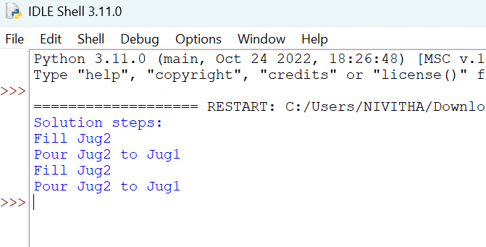

**RESULT:**

Thus, the output is verified for Water Jug Problem.