ROSENIVITHA J - 192424009

**EXP 4: Write the python program for Cript-Arithmetic problem**

**AIM:**

To Write the python program for Cript-Arithmetic problem

**PROGRAM:**

from itertools import permutations

def solve_cryptarithmetic():

letters = 'SENDMORY'

digits = range(10)

for perm in permutations(digits, len(letters)):

s, e, n, d, m, o, r, y = perm

if s == 0 or m == 0:

continue

send = s*1000 + e*100 + n*10 + d

more = m*1000 + o*100 + r*10 + e

money = m*10000 + o*1000 + n*100 + e*10 + y

if send + more == money:

print(f"SEND: {send}, MORE: {more}, MONEY: {money}")

return True

print("No solution found")

return False

solve_cryptarithmetic()

OUTPUT:

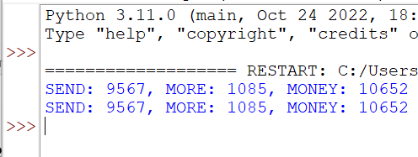

**RESULT:**

Thus, the output is verified for Cript-Arithmetic problem