ROSENIVITHA J - 192424009

**EXP 5: Write the python program for Missionaries Cannibal problem**

**AIM:**

To Write the python program for Missionaries Cannibal problem

**PROGRAM:**

from collections import deque

def missionaries_cannibals():

start = (3,3,0)

goal = (0,0,1)

visited = set()

q = deque([(start, [])])

moves = [(1,0),(2,0),(0,1),(0,2),(1,1)]

while q:

(m,c,b), path = q.popleft()

if (m,c,b) in visited: continue

visited.add((m,c,b))

if (m,c,b) == goal:

print("Solution moves (M,C in boat):", path)

return

for dm, dc in moves:

if b == 0:

nm, nc = m-dm, c-dc

nb = 1

else:

nm, nc = m+dm, c+dc

nb = 0

if 0<=nm<=3 and 0<=nc<=3:

if (nm==0 or nm>=nc) and (3-nm==0 or 3-nm>=3-nc):

q.append(((nm,nc,nb), path+[(dm,dc)]))

missionaries_cannibals()

OUTPUT:

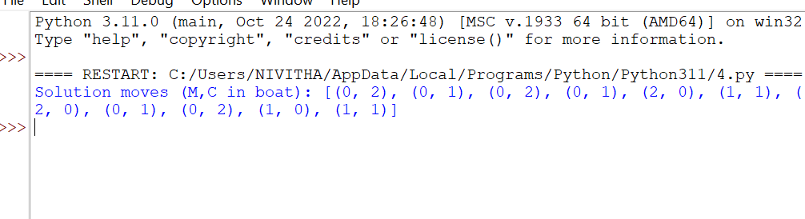

**RESULT:**

Thus, the output is verified for Missionaries Cannibal problem.