ROSENIVITHA J - 192424009

**EXP 6: Write the python program for Vacuum Cleaner problem**

**AIM:**

To Write the python program for Vacuum Cleaner problem.

**PROGRAM:**

environment = [0,1] # 0 = dirty, 1 = clean

position = 0

def vacuum_cleaner():

global environment, position

while 0 in environment:

if environment[position]==0:

environment[position]=1

print(f"Cleaned room {position}")

else:

position = 1-position # move to other room

print(f"Move to room {position}")

vacuum_cleaner()

OUTPUT:

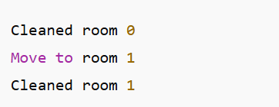

**RESULT:**

Thus, the output is verified for Vacuum Cleaner problem.