ROSENIVITHA J - 192424009

**EXP 7: Write the python program to implement BFS.**

**AIM:**

To Write the python program to implement BFS.

**PROGRAM:**

from collections import deque

graph = {

'A':['B','C'],

'B':['D','E'],

'C':['F'],

'D':[], 'E':[], 'F':[]

}

def bfs(start):

visited = set()

q = deque([start])

while q:

node = q.popleft()

if node not in visited:

print(node, end=' ')

visited.add(node)

q.extend(graph[node])

bfs('A')

7

OUTPUT:

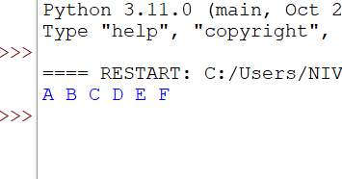

**RESULT:**

Thus, the output is verified for to implement BFS.