ROSENIVITHA J - 192424009

**EXP 8: Write the python program to implement DFS.**

**AIM:**

To Write the python program to implement DFS.

**PROGRAM:**

graph = {

'A':['B','C'],

'B':['D','E'],

'C':['F'],

'D':[], 'E':[], 'F':[]

}

def dfs(start, visited=set()):

if start not in visited:

print(start, end=' ')

visited.add(start)

for node in graph[start]:

dfs(node, visited)

dfs('A')

OUTPUT:

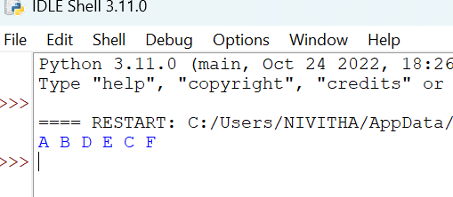

**RESULT:**

Thus, the output is verified for to implement DFS.