ROSENIVITHA J - 192424009

**EXP 9: Write the python to implement Travelling Salesman Problem**

**AIM:**

To Write the python to implement Travelling Salesman Problem.

**PROGRAM:**

from itertools import permutations

def tsp(graph):

n = len(graph)

vertices = list(range(n))

min_path = None

min_cost = float('inf')

for perm in permutations(vertices[1:]):

path = [0] + list(perm) + [0]

cost = sum(graph[path[i]][path[i+1]] for i in range(n))

if cost < min_cost:

min_cost = cost

min_path = path

print("Minimum path:", min_path)

print("Minimum cost:", min_cost)

# Example distance matrix

graph = [

[0, 10, 15, 20],

[10, 0, 35, 25],

[15, 35, 0, 30],

[20, 25, 30, 0]

]

tsp(graph)

OUTPUT:

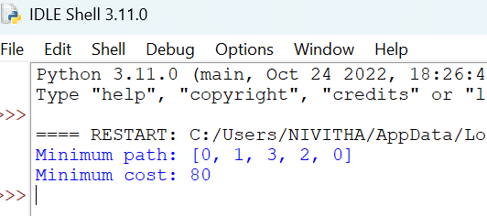

**RESULT:**

Thus, the output is verified for to implement Travelling Salesman Problem.