**Frequency response testing**

1012 booth

12/2015-01/2016

First free-field experiments in Sanes lab in which frequency is a crucial parameter.

Thus, we attempted to characterize the frequency response curve (level as a function of frequency) within the booth, and determine how to flatten it.

Particularly, we wish to ensure that the stimulus level is flat even at different positions within the cage.

All of the following graphs were created from data files that can be found in ­­­__folder__ on the 1012 rig computer, using the following equipment.

*Speaker A: Vifa DX25TG09-04, 4Ω, DP___*

*Mic: B&K 4189 (1/2”), serial # 2710813 (from B&K handheld device)*

*\*\*note: subsequently learned that this mic is pre-polarized, meaning that some sensitivity is lost because of its use with the amp/preamp*

*Sensitivity reference:* ***94 dB == 1357.2 mV*** *(RZ6 amp set to 45 dB)*

*\*\*this reference was re-measured at the start of each session, but was always in this range*

Additional details and results can be found in the following word documents:

*CalibrationNotes-rig1012_SpeakerA_Dec22*

*CalibrationQuestions-rig1012_SpeakerA_Dec22*

*CalibrationNotes-rig1012_SpeakerA_Jan05*

*CalibrationNotes-rig1012_SpeakerA_Jan06*

**Calibration procedure** ≪ ep_CalibrationUtil ≫

Pure tones are produced by the TDT, here ranging from 200 Hz to 30 kHz in steps of 50 Hz with no inter-stimulus interval. The output is a *constant voltage value* (which is meant to approximate 94 dB SPL, or any calibration level specified) according to the single reference point entered for mic sensitivity.

The signal from the mic is acquired through IN-A of the TDT, the SPL is calculated, as well as the correction that should be applied to the voltage in order to achieve the desired calibration level. The frequency, recorded level, and voltage correction values are saved in a -cal file (essentially a -mat file).

**Test procedure** ≪ ep_PostCalibrationUtil ≫

The program will first ask you to select a calibration file to reference. Then pure tones will be produced (for now, the same stimuli as the calibration file), but now at a *constant SPL*. A constant level is achieved by implementing the same Matlab and RPVdS code that is used when running a behavior experiment.

The signal from the mic is acquired as above, and the SPL is calculated and stored in a -cal file. A voltage correction value is also saved, but is irrelevant here.

**Analysis** can be performed using a function found in the SanesLab epsych folder:

≪ /DataAnalysis/Calibration/fq_resp_select≫

**Q: How stable is the spectrum (Hz vs. SPL) for a standard microphone position in the testing cage, when simulating experimental conditions and disturbances?**

**A: Fairly stable. Changes in response function resulting from moving around equipment are <5 dB SPL.**

Calibration and tests run with all equipment present.

Mic pointing vertical, in center of cage.

**rig1012-CeilingA-Test_i_Cal_a_Jan052016.cal (using cal file c)**

tested soon after calibration; minimal disturbance between

**rig1012-CeilingA-Test_vi_Cal_a_Jan052016.cal (using cal file c)**

test after moderate disturbance to mic position and cage equipment

**rig1012-CeilingA-Test_ix_Cal_a_Jan052016.cal (using cal file a)**

test after maximal disturbance to mic position and cage equipment, using oldest calibration file of the day

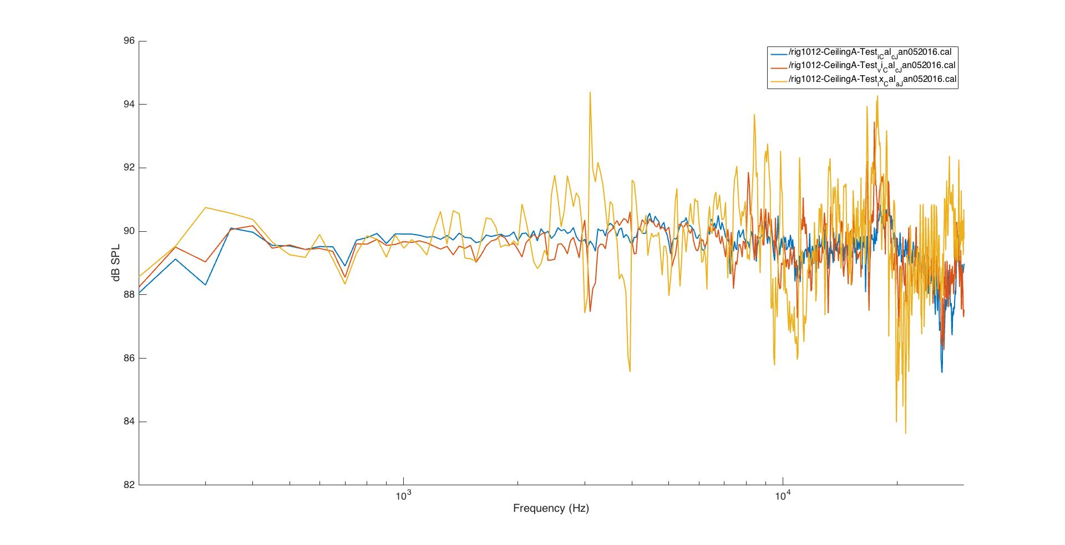 rig1012-CeilingA_test_center-consistency.jpg

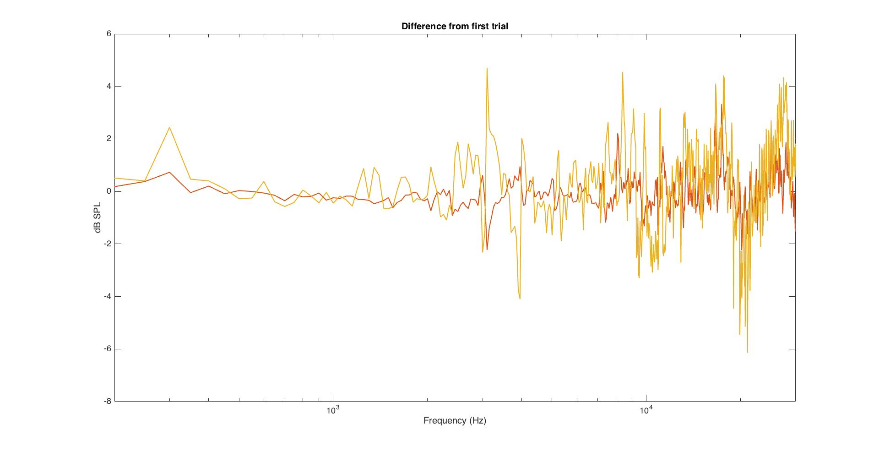

rig1012-CeilingA_test_center-consistency_Diff.jpg

**Q: How variable is the spectrum for a variety of positions in the cage?**

**A: There is significant distortion based on the proximity of the microphone to the sides of the cage, as much as +/- 10 dB. Some of the distortion is similar for all positions away from the center – particularly the large fluctuations observed between 2-8 kHz. The deviations in level become less regular at higher frequencies.**

Used a calibration file created with mic vertical in center of cage.

(rig1012-CeilingA-Cal_c_Jan052016.cal)

Ran test procedure to inspect the flatness of the response curve at various positions in the cage, all with mic still vertical and equipment present.

**rig1012-CeilingA-Test_i_Cal_c_Jan052016.cal – center**

**rig1012-CeilingA-Test_ii_Cal_c_Jan052016.cal – nose poke**

**rig1012-CeilingA-Test_iii_Cal_a_Jan052016.cal – spout**

**rig1012-CeilingA-Test_iv_Cal_c_Jan052016.cal – near side**

**rig1012-CeilingA-Test_v_Cal_c_Jan052016.cal – far side**

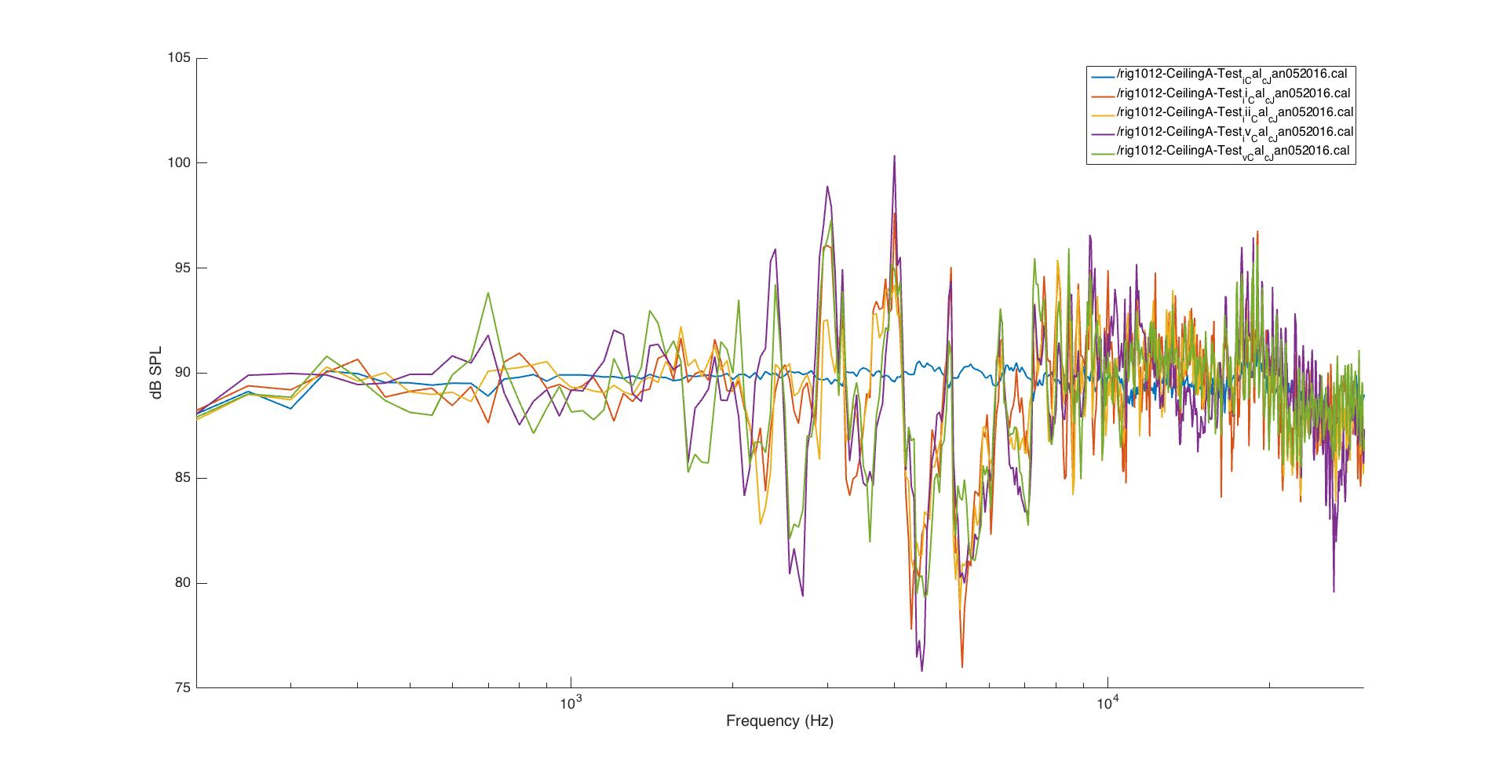

rig1012-CeilingA_test_5positions.jpg

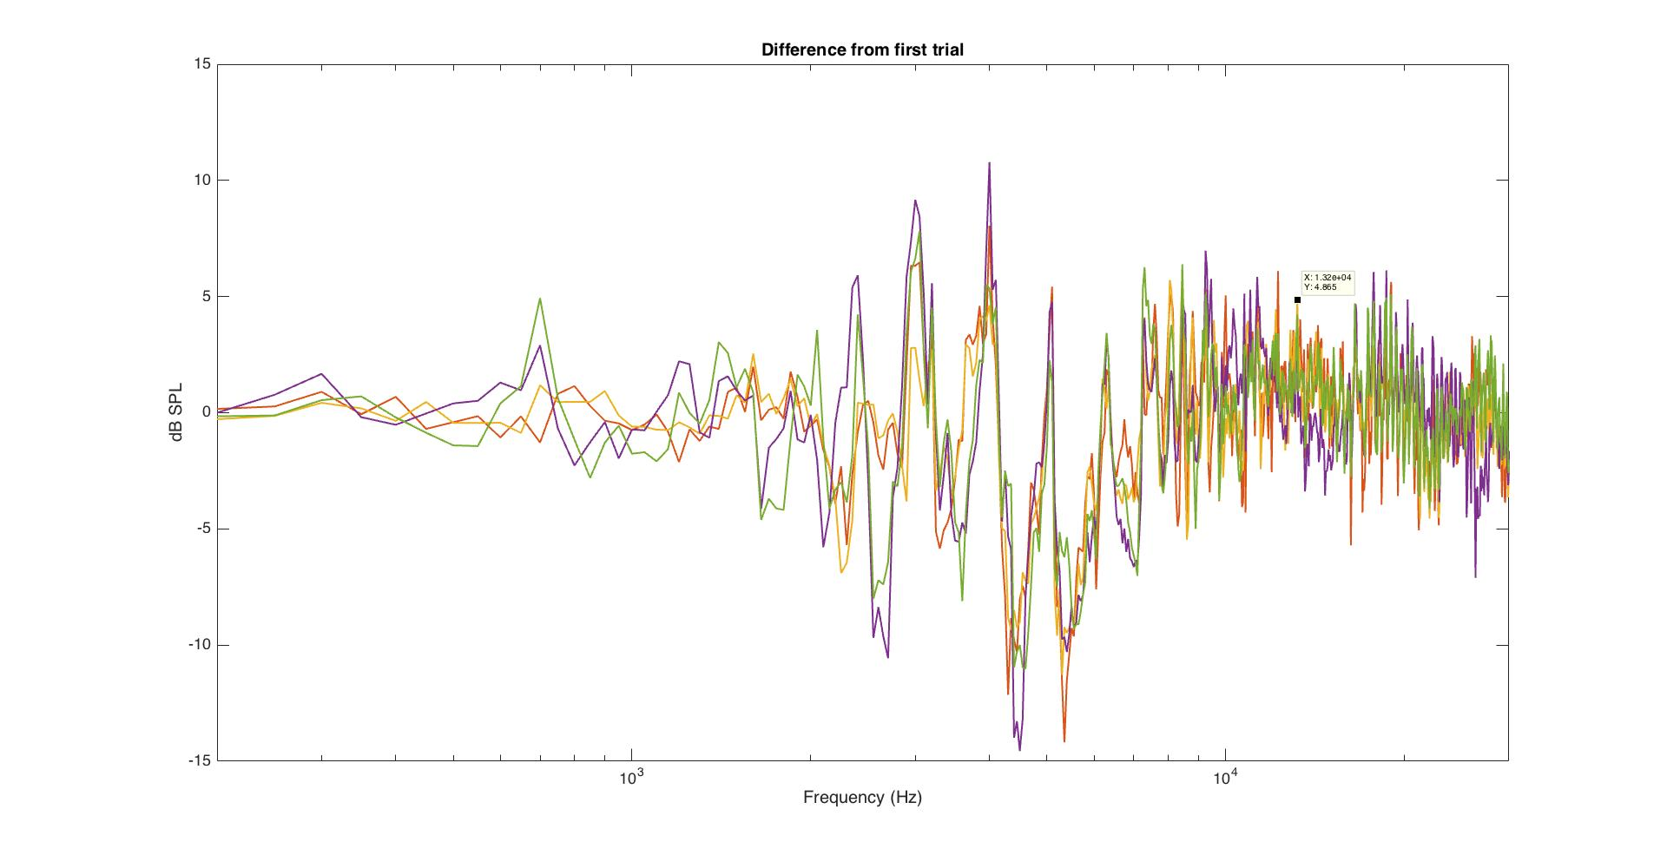

rig1012-CeilingA_test_5positions_Diff.jpg

**Evidence to implicate the cage itself as the source of this distortion:**

**Replace plastic tray with acoustic foam.**

**Wrap the cage in acoustic shielding foam.**