1. **How variable is the spectrum (Hz vs SPL, for a single RMS voltage) for a standard microphone position in the testing cage, when *all equipment is present* in the booth?**

*Don’t have replicated trials* with equipment in room*, at single voltage.*

*Do have replicated, single voltage trials in* empty *room:*

**rig1012_Ceiling_A_PureToneCal_a_Dec222015.cal**

vs.

**rig1012_ Ceiling_A_PureToneCal_x_Dec222015.cal**

🡪 equipment carried in then moved out; caveat is that many calibration runs were presented in between.

Compare to b, c, d for consecutive trials, i.e. best case scenario.

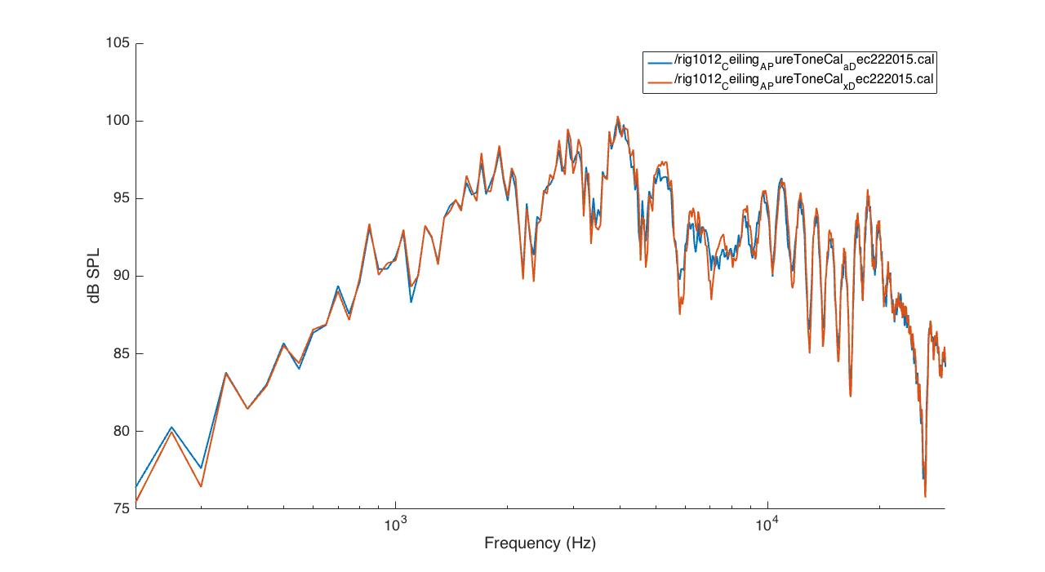

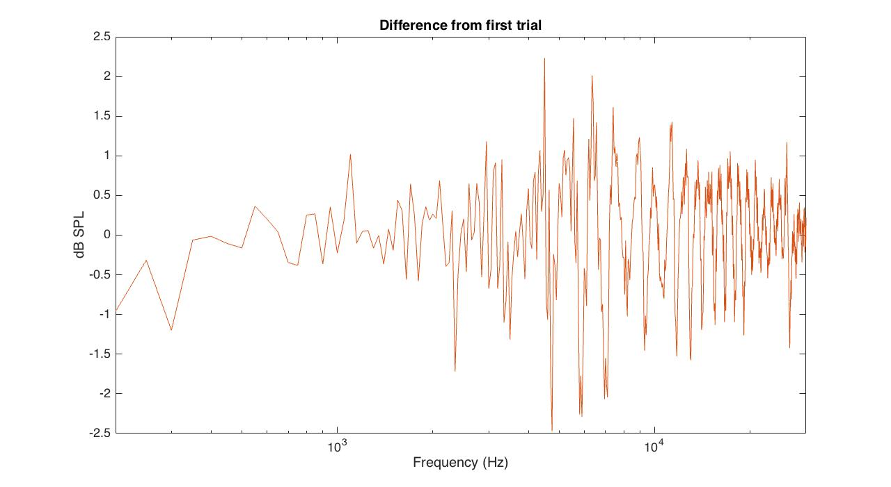

*Do have replicated, single voltage trials with equipment in room*; *consecutive, disturbed things a bit but did not fully remove and replace equipment (i.e. best case scenario; error mainly from calibration measurement procedure):*

**rig1012_ Ceiling_A_PureToneCal_l_Dec222015.cal**

**rig1012_ Ceiling_A_PureToneCal_m_Dec222015.cal**

**rig1012_ Ceiling_A_PureToneCal_n_Dec222015.cal**

**rig1012_ Ceiling_A_PureToneCal_o_Dec222015.cal**

and

**rig1012_Ceiling_A_Test_l_Cal_l_Dec222015.cal**

equipment was removed and replaced, setup replicated; but used corrected voltage.

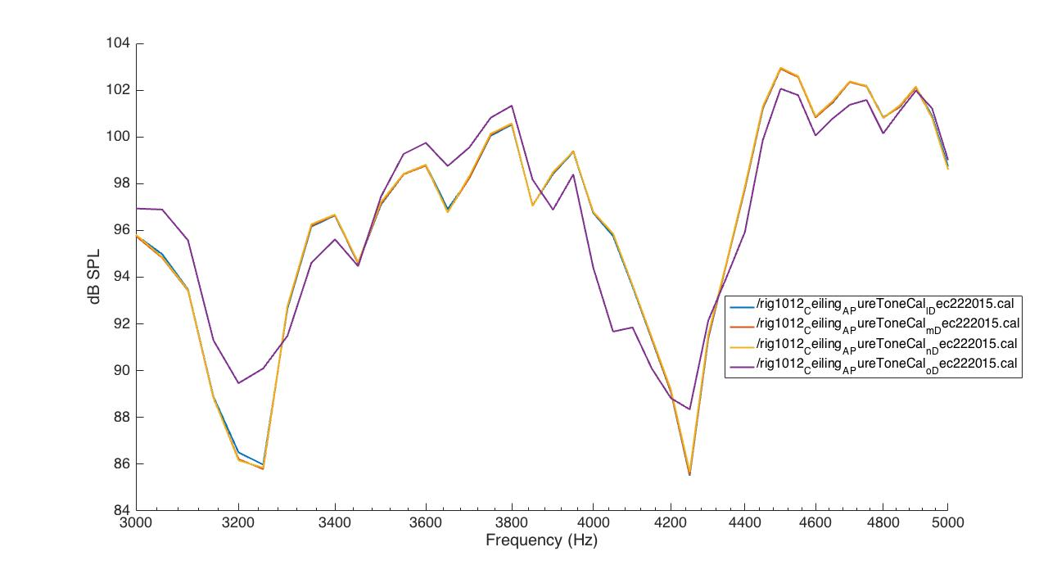

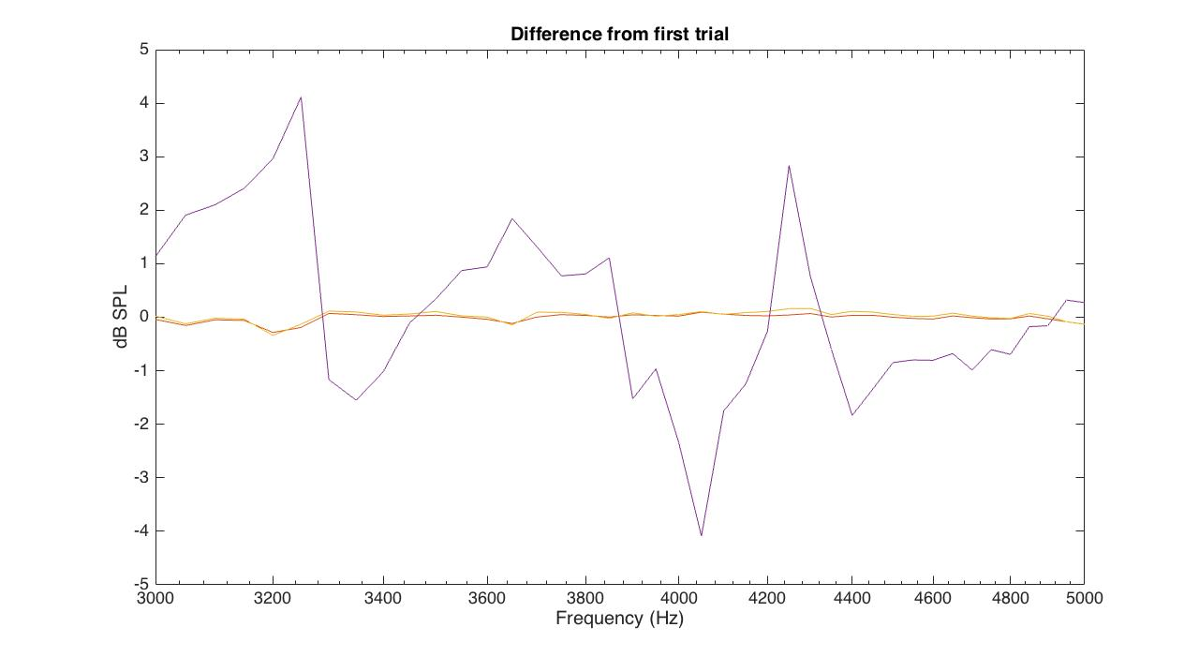

1. **How variable is the spectrum for a range of positions in the testing cage?**

**rig1012_ Ceiling_A_PureToneCal_o_Dec222015.cal**

**rig1012_ Ceiling_A_PureToneCal_p_Dec222015.cal**

**rig1012_ Ceiling_A_PureToneCal_q_Dec222015.cal**

**rig1012_ Ceiling_A_PureToneCal_r_Dec222015.cal**

**rig1012_ Ceiling_A_PureToneCal_s_Dec222015.cal**

**rig1012_ Ceiling_A_PureToneCal_t_Dec222015.cal**

**rig1012_ Ceiling_A_PureToneCal_u_Dec222015.cal**

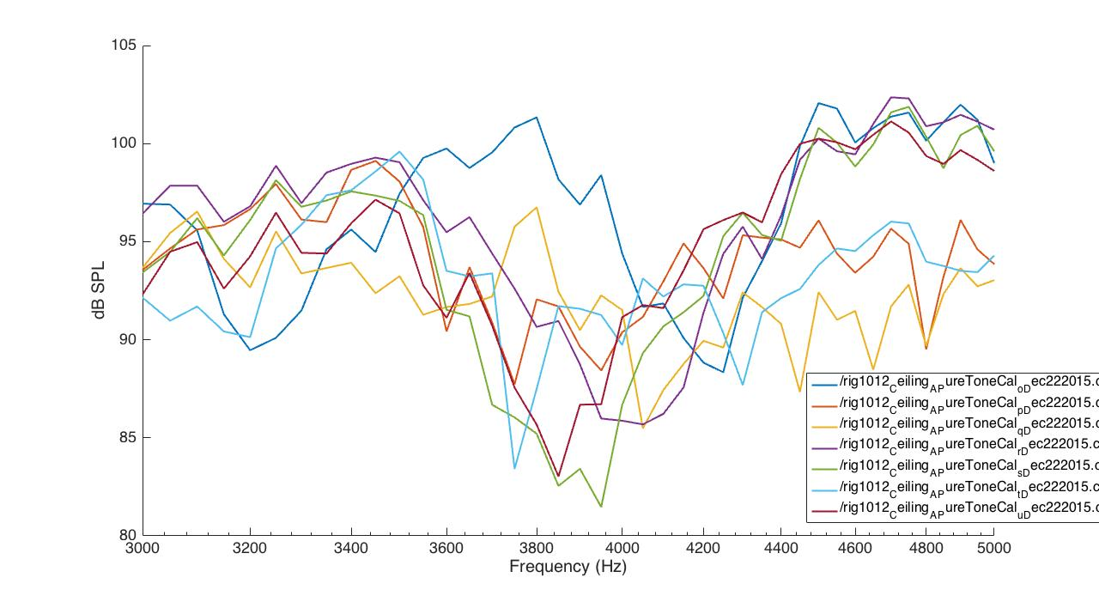

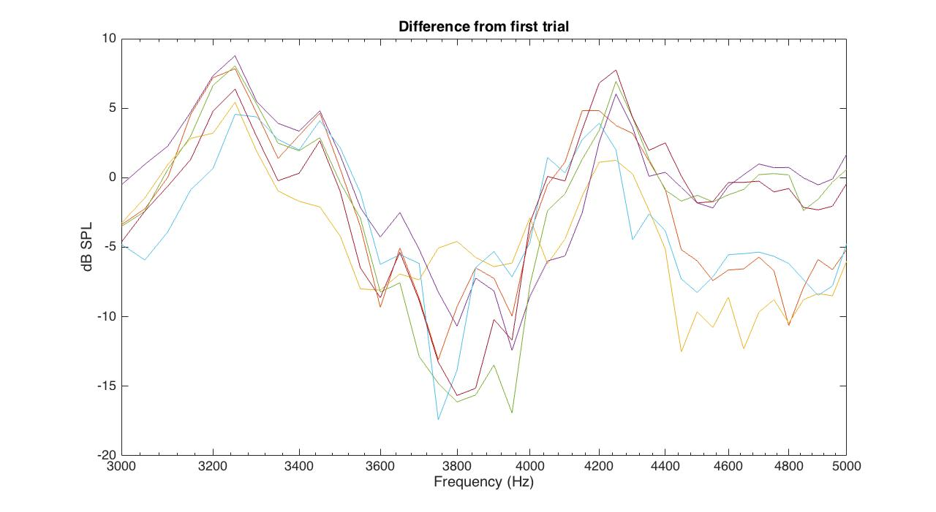

**full range:**

**rig1012_ Ceiling_A_PureToneCal_v_Dec222015.cal**

**rig1012_ Ceiling_A_PureToneCal_w_Dec222015.cal**

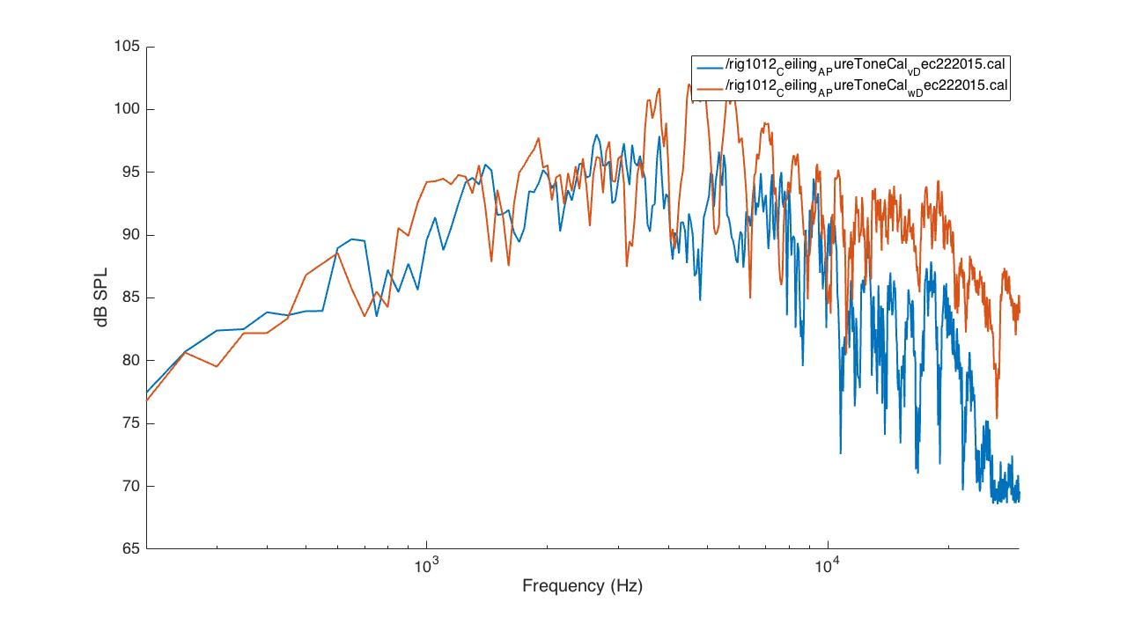

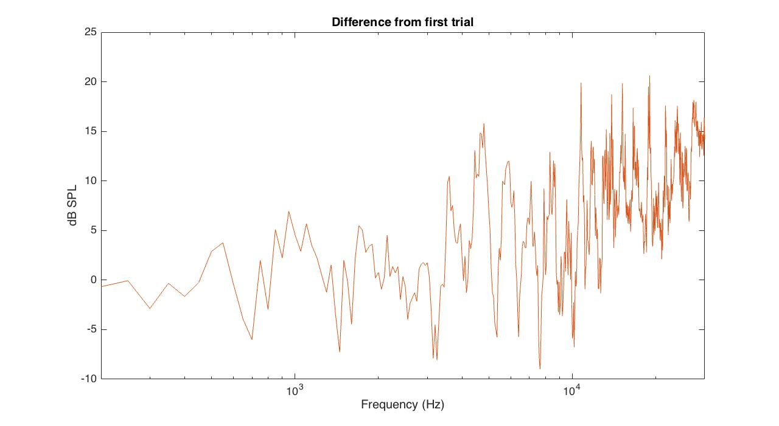

1. **How does our equipment influence this spectrum?**

**rig1012_ Ceiling_A_PureToneCal_w_Dec222015.cal** (without equipment)

vs

**rig1012_ Ceiling_A_PureToneCal_x_Dec222015.cal** (with equipment)

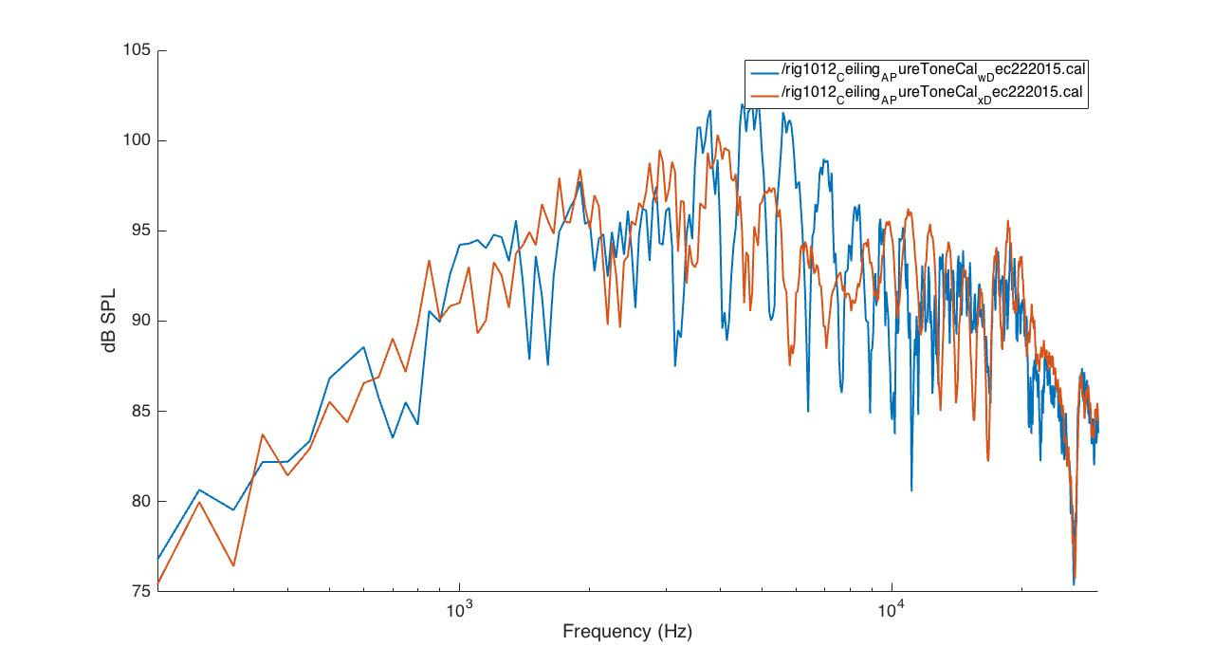

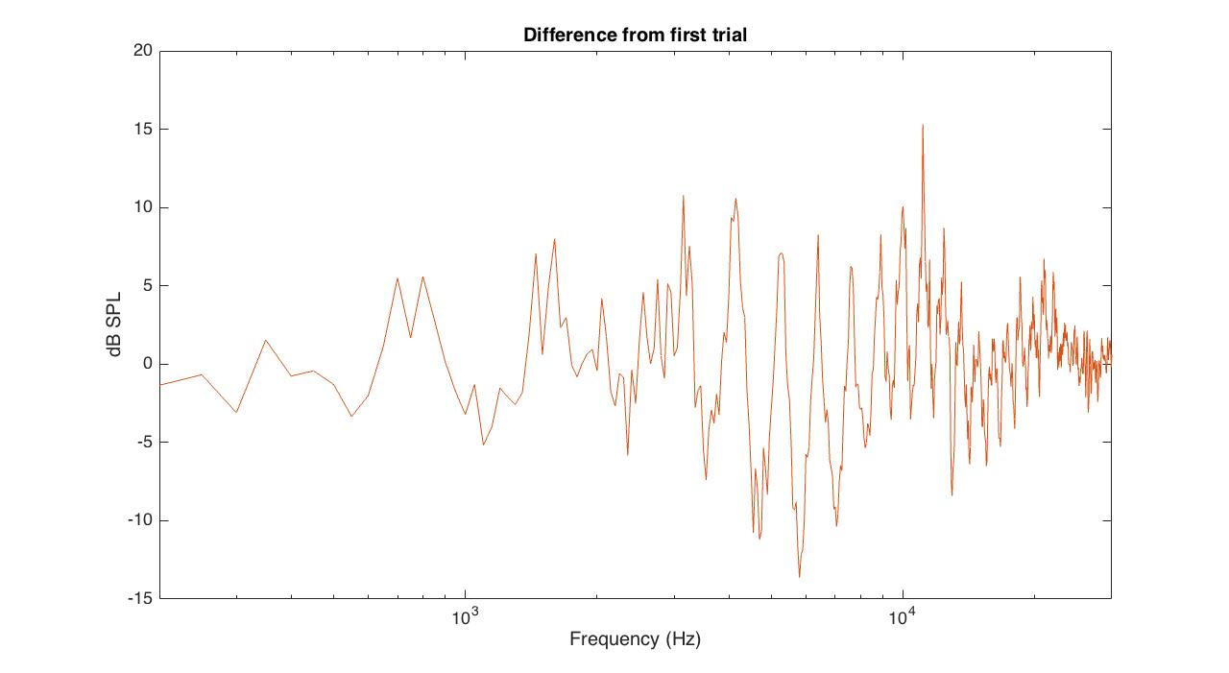

1. **What is the SPL range across which the system is linear?**

Set test level to 0 dB SPL. None saved.

***For each calibration file, which calibration configuration produces the most similar frequency response curves (with correction applied) across many test configurations?***

Cal a: bare room, vertical mic

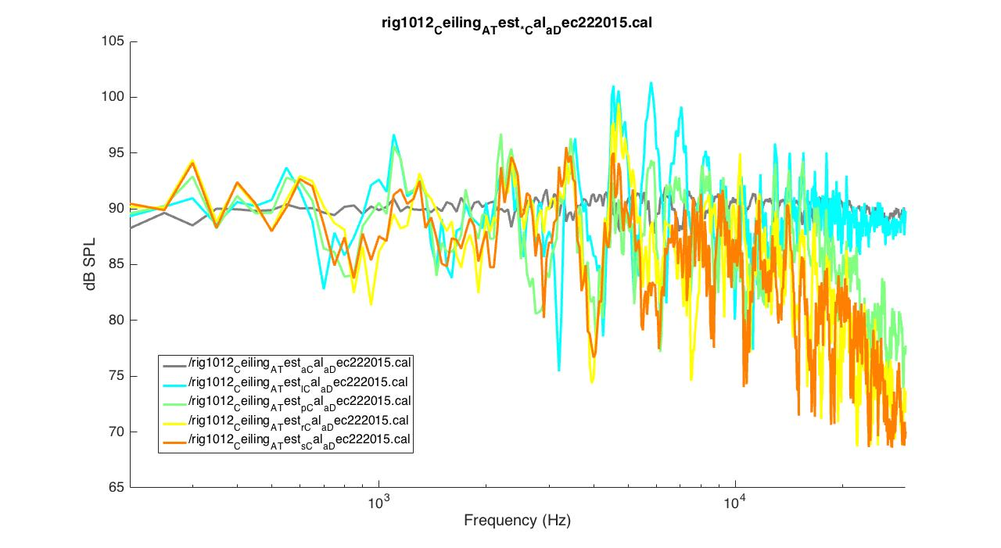

Cal l: all equipment, vertical mic orientation

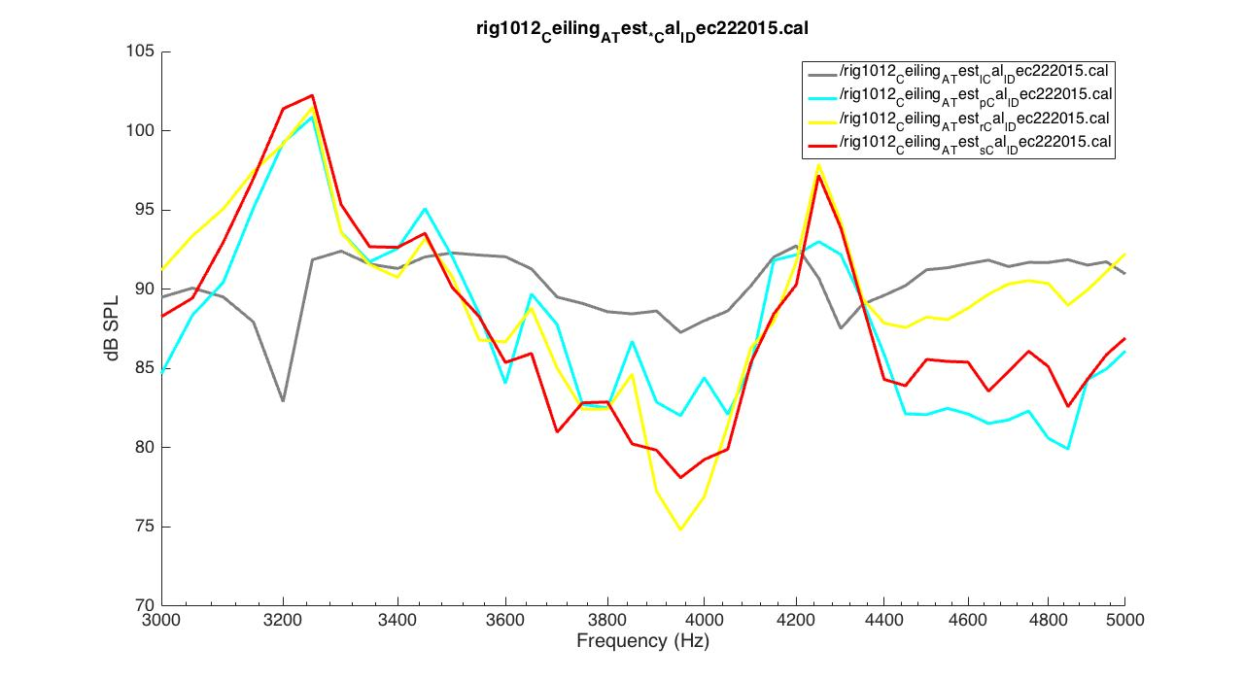

Cal p: mic angle -45° from vertical, 330° NW

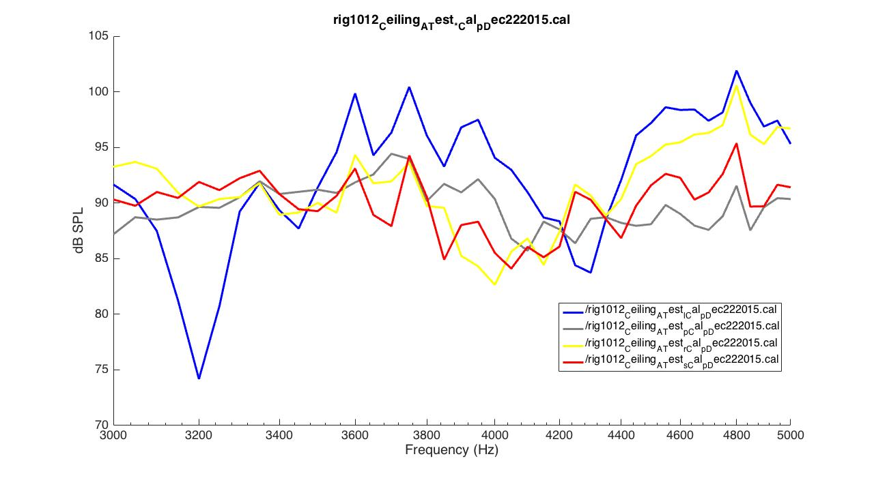

cal r: mic angle -90° from vertical, 285° NW

