Date: **01/05/2016**

**Further calibration tests of speaker A in 1012 booth**

*Speaker A: Vifa DX25TG09-04, 4Ω, DP___*

*Mic: B&K 4189 (1/2”), serial # 2710813; from B&K handheld device*

*Piston phone reference:* ***94 dB == 1357.2 mV*** *(RZ6 amp set to 45 dB)*

Test level: 90 dB

CALIBRATION RUNS

**rig1012-CeilingA-Cal_a_Jan052016.cal**

all equipment in room, mic pointing straight up, in center

full range [200:50:30000]

**rig1012-CeilingA-Cal_b_Jan052016.cal**

repeat, after picking up and replacing mic

full range [200:50:30000]

**rig1012-CeilingA-Cal_c_Jan052016.cal**

repeat, after picking up and replacing mic

full range [200:50:30000]

TEST RUNS

**rig1012-CeilingA-Test_i_Cal_c_Jan052016.cal**

using corrections from Cal file c

mic vertical, in center of cage

full range [200:50:30000]

**rig1012-CeilingA-Test_ii_Cal_c_Jan052016.cal**

using corrections from Cal file c

mic vertical, next to nose poke

full range [200:50:30000]

**rig1012-CeilingA-Test_iii_Cal_c_Jan052016.cal**

using corrections from Cal file c

mic vertical, next to lick spout

full range [200:50:30000]

**rig1012-CeilingA-Test_iv_Cal_c_Jan052016.cal**

using corrections from Cal file c

mic vertical, on near side of cage

full range [200:50:30000]

**rig1012-CeilingA-Test_v_Cal_c_Jan052016.cal**

using corrections from Cal file c

mic vertical, on far side of cage

full range [200:50:30000]

**rig1012-CeilingA-Test_vi_Cal_c_Jan052016.cal**

using corrections from Cal file c

mic vertical, in center of cage

full range [200:50:30000]

**rig1012-CeilingA-Test_vii_Cal_c_Jan052016.cal**

using corrections from Cal file c

mic vertical, next to nose poke

removed mic cord that had been draped around cage, and taped adjacent side bars

full range [200:50:30000]

**rig1012-CeilingA-Test_viii_Cal_c_Jan052016.cal**

using corrections from Cal file c

mic vertical, next to nose poke

taped all side bars

full range [200:50:30000]

**rig1012-CeilingA-Test_ix_Cal_a_Jan052016.cal**

using corrections from Cal file a

mic vertical, in center

removed tape from side bars; maximal disruption of cage, NP, spout, webcam – anything that would be rustled between experiments; used earliest cal file

full range [200:50:30000]

**ANALYSIS**

*All of the following calibrations and tests were performed with all equipment in the booth, with the mic in a vertical orientation.*

**1. Using a corrections calculated from a calibration with the mic in the center of the cage, how flat are the corrected test runs performed at different locations in the cage? (center, NP, spout, near side, far side)**

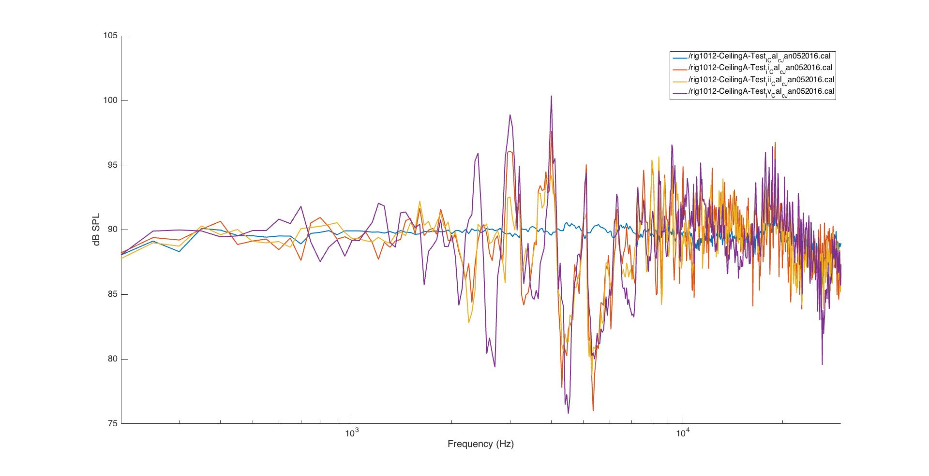

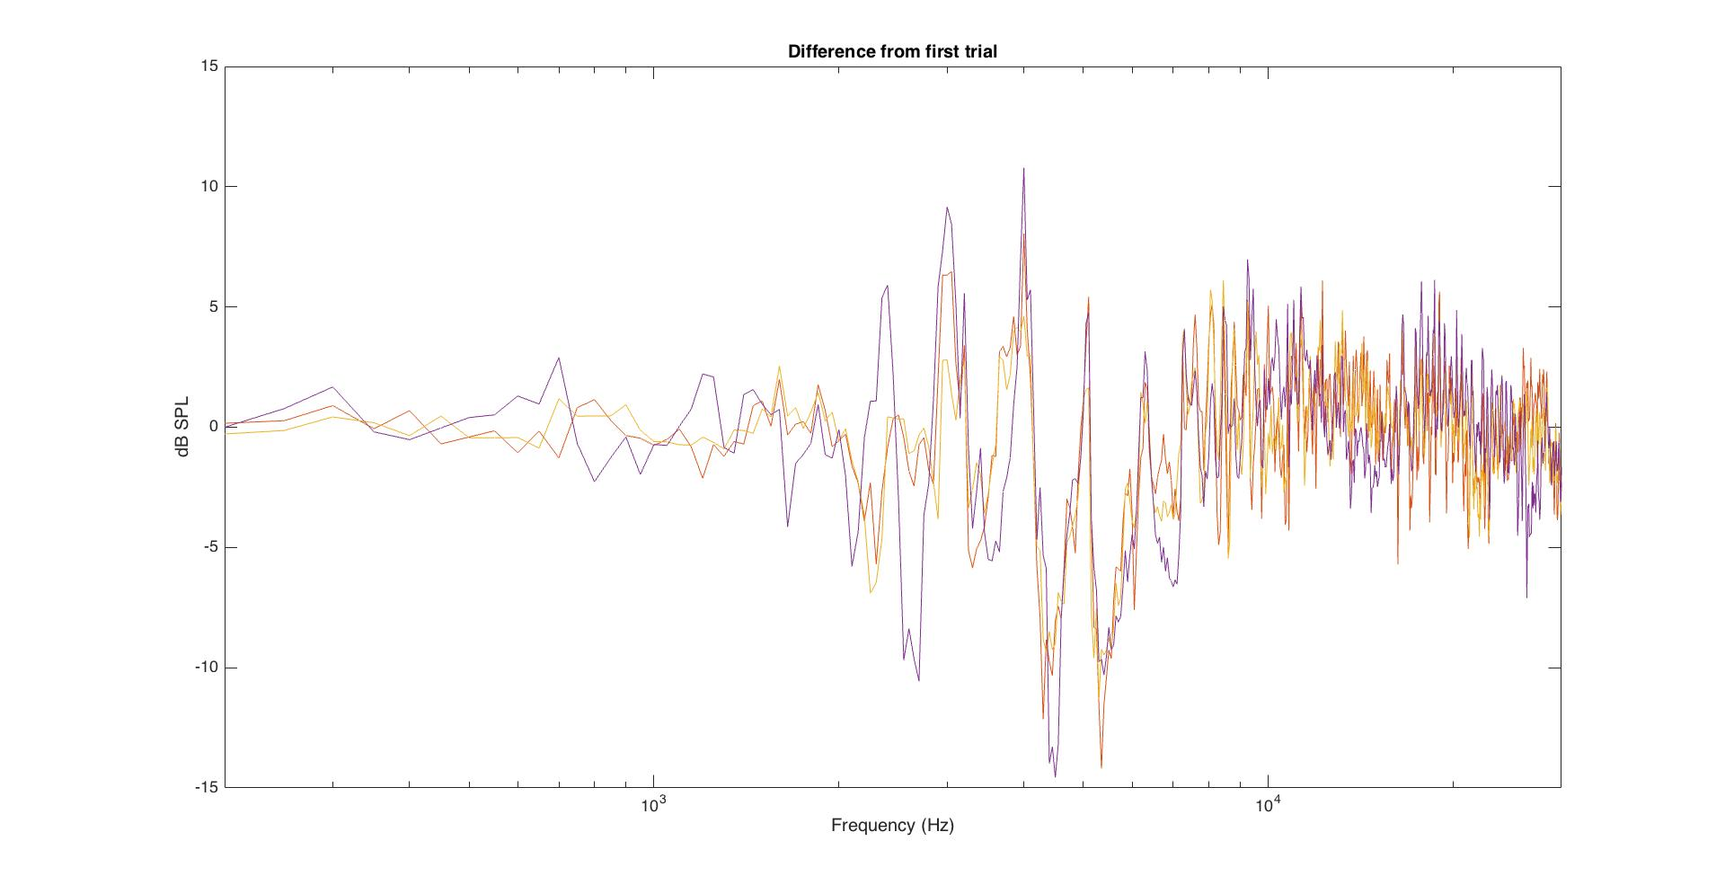

**2. Does taping the cage bars help remove some of the level fluctuations observed above, when the mic is close to the sides? (No.)**

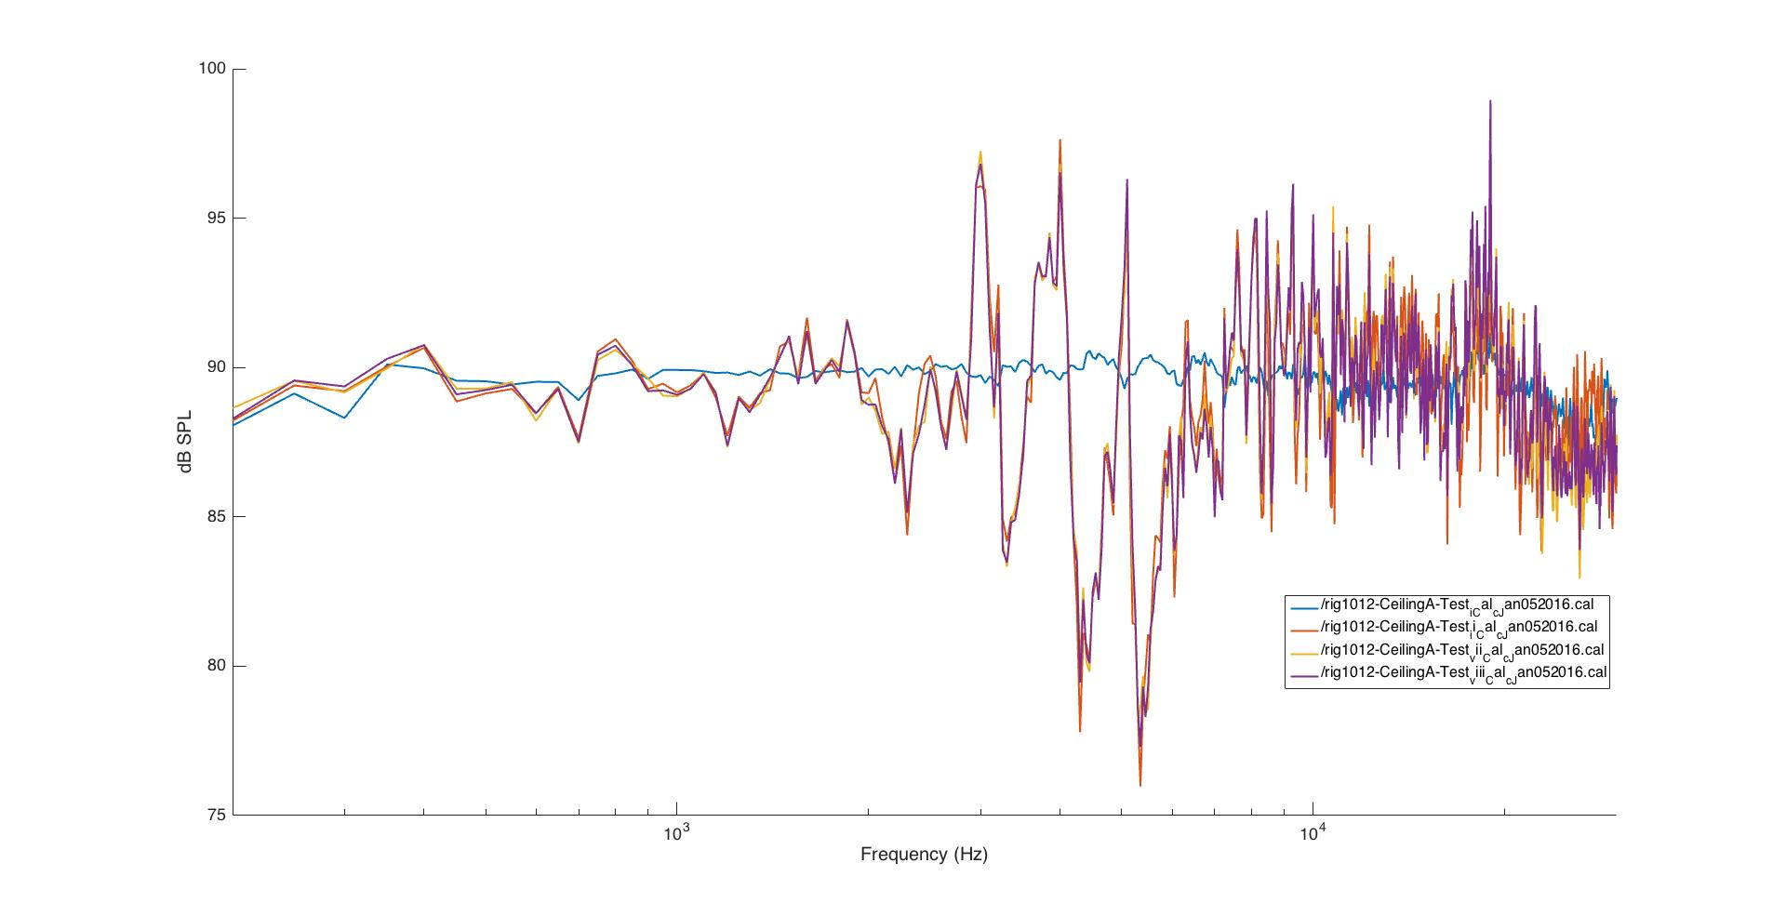

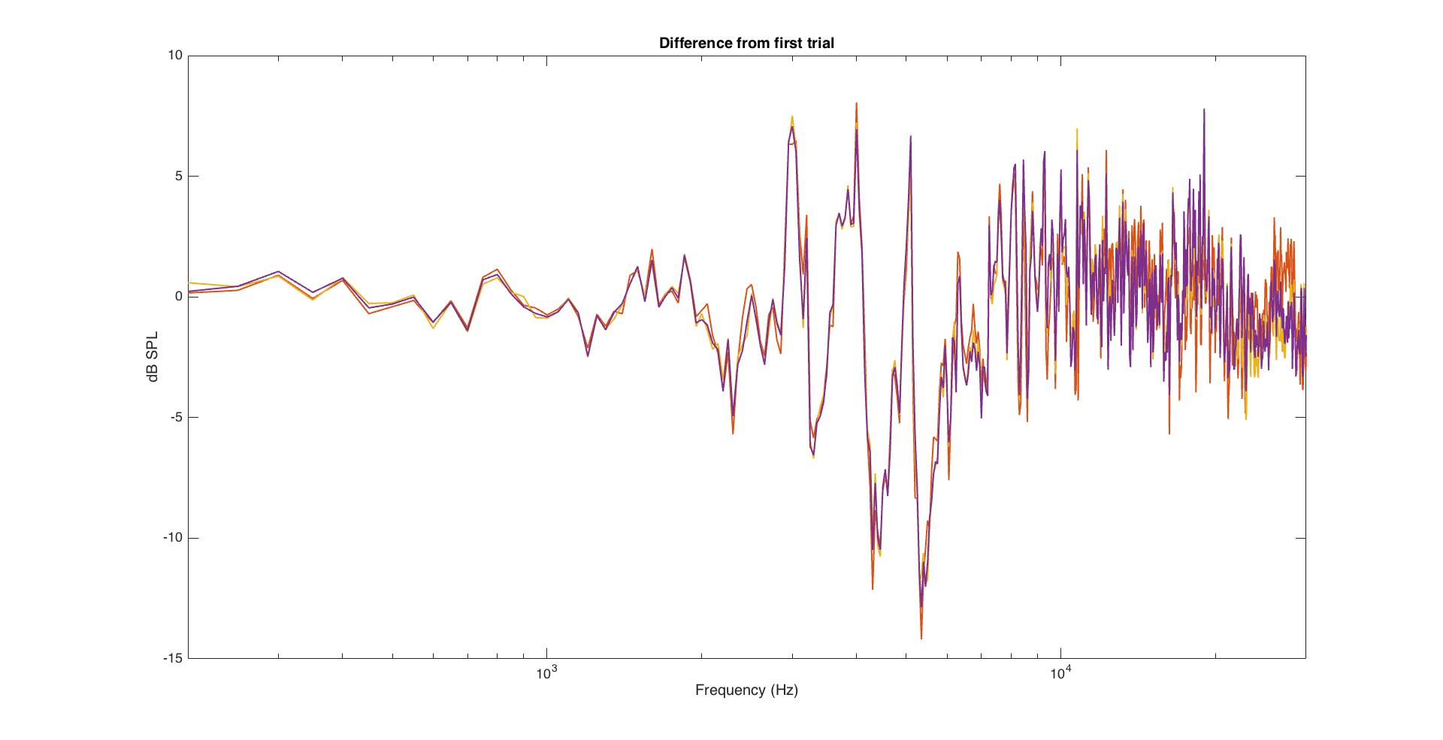

**3. How well do the corrections calculated from a calibration file flatten the output even after the mic is re-placed and experimentally-relevant equipment is disturbed?**

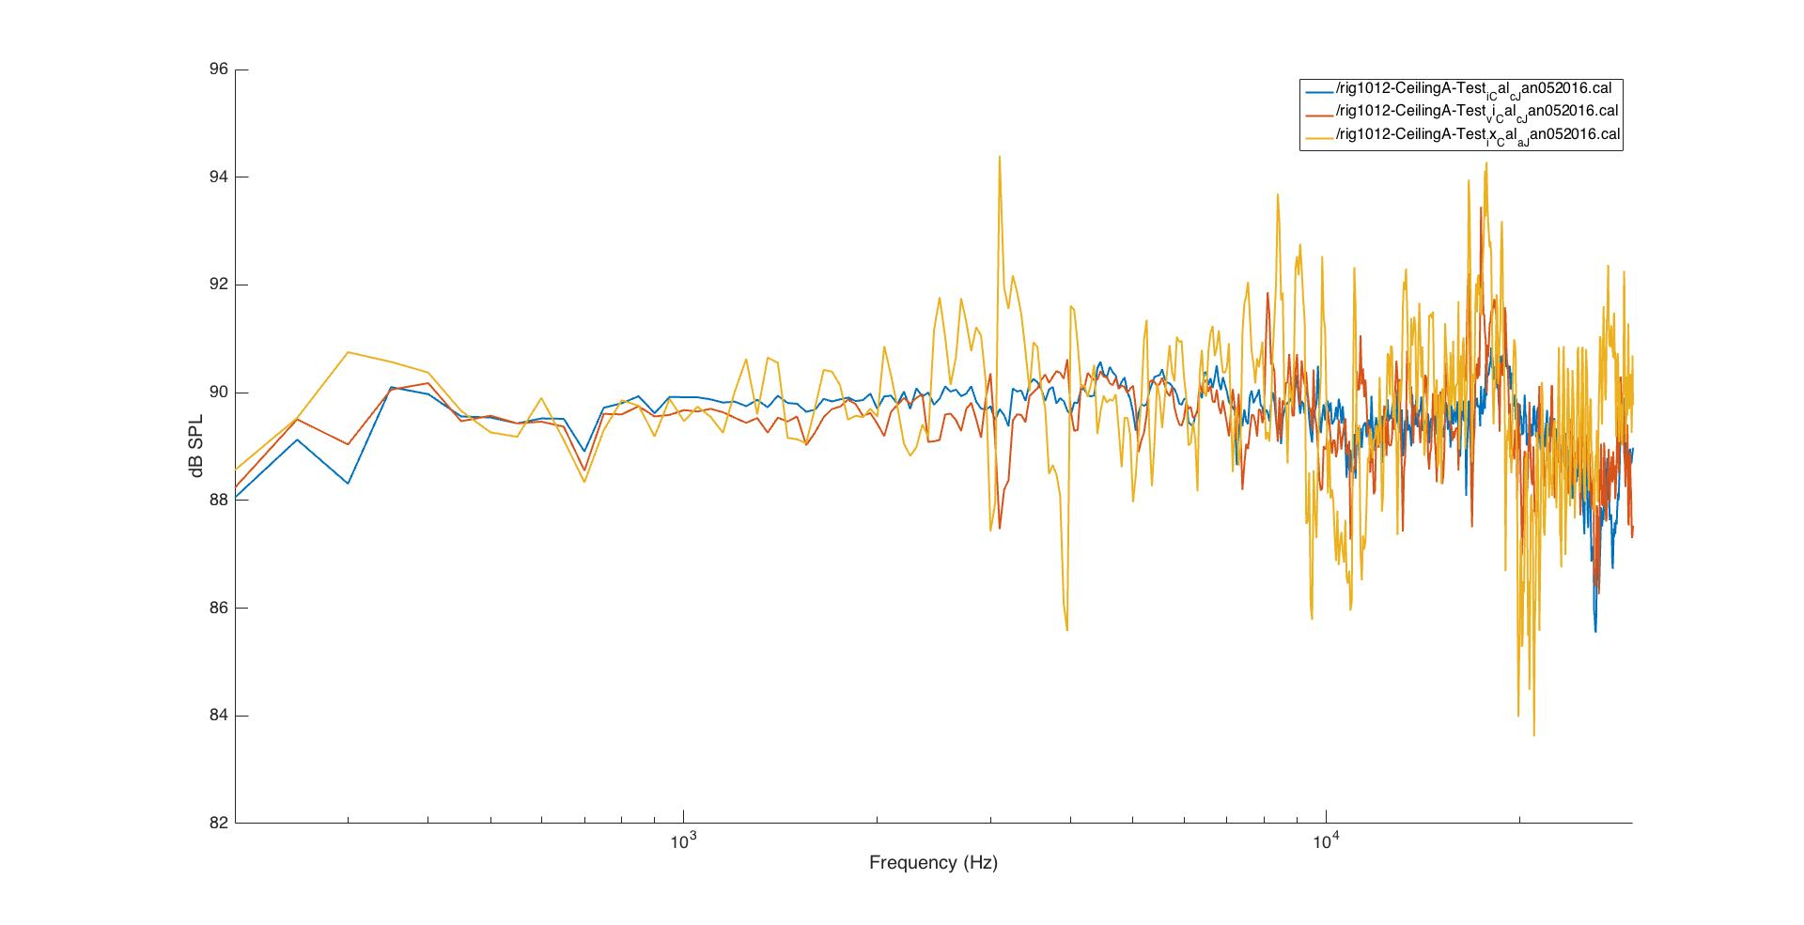

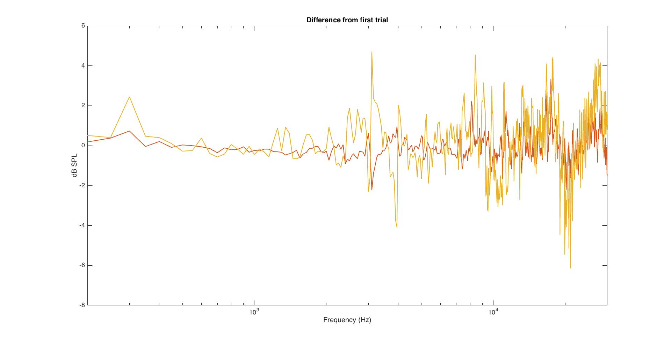

**≫ Can we narrow down what is causing the distortion when the position of the mic is changed within the cage?**

**What is the contribution of the pvc table alone, independent from the cage?**

*\*\* range [3000:50:5000]*

**rig1012_ Ceiling_A_PureToneCal_e_Dec222015.cal**

bare room, moved foam away that had been covering the cords and small equipment on the floor

**rig1012_ Ceiling_A_PureToneCal_g_Dec222015.cal**

replaced pvc table

**rig1012_ Ceiling_A_PureToneCal_h_Dec222015.cal**

again with pvc table

**rig1012_ Ceiling_A_PureToneCal_i_Dec222015.cal**

added poop tray

**rig1012_ Ceiling_A_PureToneCal_j_Dec222015.cal**

again with poop tray

**rig1012_ Ceiling_A_PureToneCal_k_Dec222015.cal**

again with poop tray

**rig1012_ Ceiling_A_PureToneCal_l_Dec222015.cal**

added cage

