Date: **01/06/2016**

**Further calibration tests of speaker A in 1012 booth**

*Speaker A: Vifa DX25TG09-04, 4Ω, DP___*

*Mic: B&K 4189 (1/2”), serial # 2710813; from B&K handheld device*

*Piston phone reference:* ***94 dB == 1357.2 mV*** *(RZ6 amp set to 45 dB)*

* *using values calculated yesterday*

Test level: 90 dB

CALIBRATION RUNS

**rig1012-CeilingA-Cal_a_Jan062016.cal**

all equipment in room, mic vertical in center

no acoustic foam

full range [200:50:30000]

**rig1012-CeilingA-Cal_b_Jan062016.cal**

all equipment in room, mic vertical in center

acoustic foam placed face down, over top of cage

full range [200:50:30000]

*\*\*\*significantly blocks sound – everything above ~1000 Hz is at noise floor; unable to take calibration*

**rig1012-CeilingA-Cal_c_Jan062016.cal**

all equipment in room, mic vertical in center

replaced the plastic poop tray with a piece of acoustic foam

full range [200:50:30000]

TEST RUNS

**rig1012-CeilingA-Test_i_Cal_c_Jan062016.cal**

using corrections from Cal file c (acoustic foam on floor instead of poop tray)

mic vertical, in center of cage

full range [200:50:30000]

**rig1012-CeilingA-Test_ii_Cal_c_Jan062016.cal**

using corrections from Cal file c (acoustic foam on floor instead of poop tray)

mic vertical, near nose poke

full range [200:50:30000]

*\*\*does not appear to fix the problem*

**rig1012-CeilingA-Test_iii_Cal_c_Jan062016.cal**

using corrections from Cal file c (acoustic foam on floor instead of poop tray)

wrapped cage in acoustic foam

mic vertical, near nose poke

full range [200:50:30000]

**rig1012-CeilingA-Test_iv_Cal_c_Jan062016.cal**

using corrections from Cal file c (acoustic foam on floor instead of poop tray)

cage wrapped in acoustic foam; added panels on top

mic vertical, near nose poke

full range [200:50:30000]

*\*\*still lots of distortion*

**rig1012-CeilingA-Test_v_Cal_c_Jan062016.cal**

using corrections from Cal file c (acoustic foam on floor instead of poop tray)

same configuration with foam – added 1000 ms to duration of each stimulus

mic vertical, near nose poke

full range [200:50:30000]

**rig1012-CeilingA-Test_vi_Cal_c_Jan062016.cal**

using corrections from Cal file c (acoustic foam on floor instead of poop tray)

removed all foam (repeat of test ii) – added 1000 ms to duration of each stimulus

mic vertical, near nose poke

full range [200:50:30000]

**rig1012-CeilingA-Test_vii_Cal_c_Jan062016.cal**

using corrections from Cal file c (acoustic foam on floor instead of poop tray)

no foam (repeat of test ii) – 1000 ms inter-stimulus interval set to more or less silence

mic vertical, near nose poke

full range [200:50:30000]

**rig1012-CeilingA-Test_viii_Cal_c_Jan062016.cal**

using corrections from Cal file c (acoustic foam on floor instead of poop tray)

no foam, interval removed; exact repeat of test ii

mic vertical, near nose poke

full range [200:50:30000]

**1. Does replacing the plastic poop tray with acoustic foam flatten the side positions? (No.)**

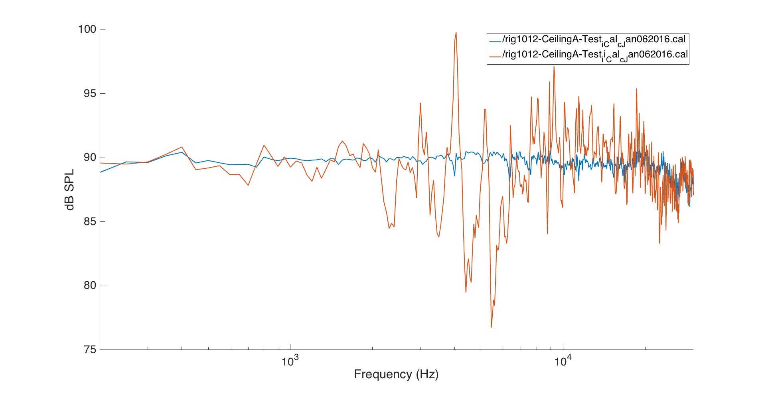

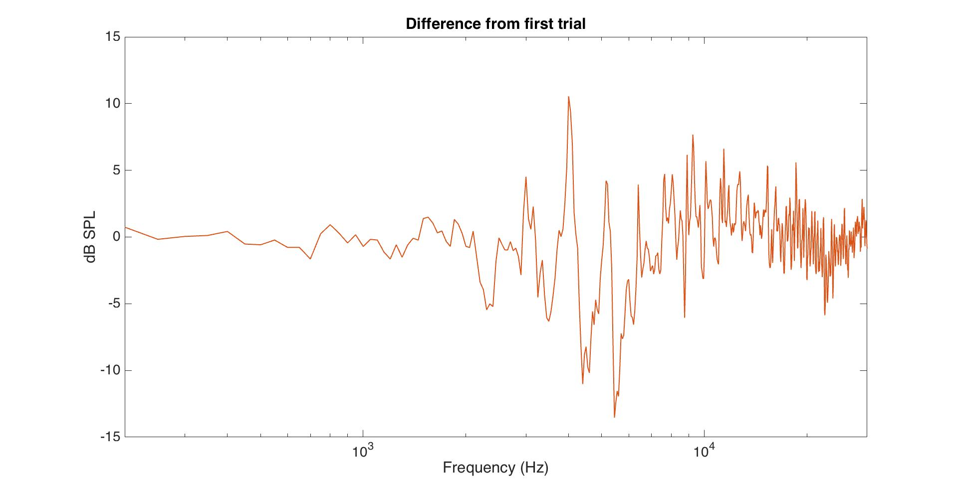

**2. What does isolating the cage (wrapping foam around it) do to the fq resp function?**

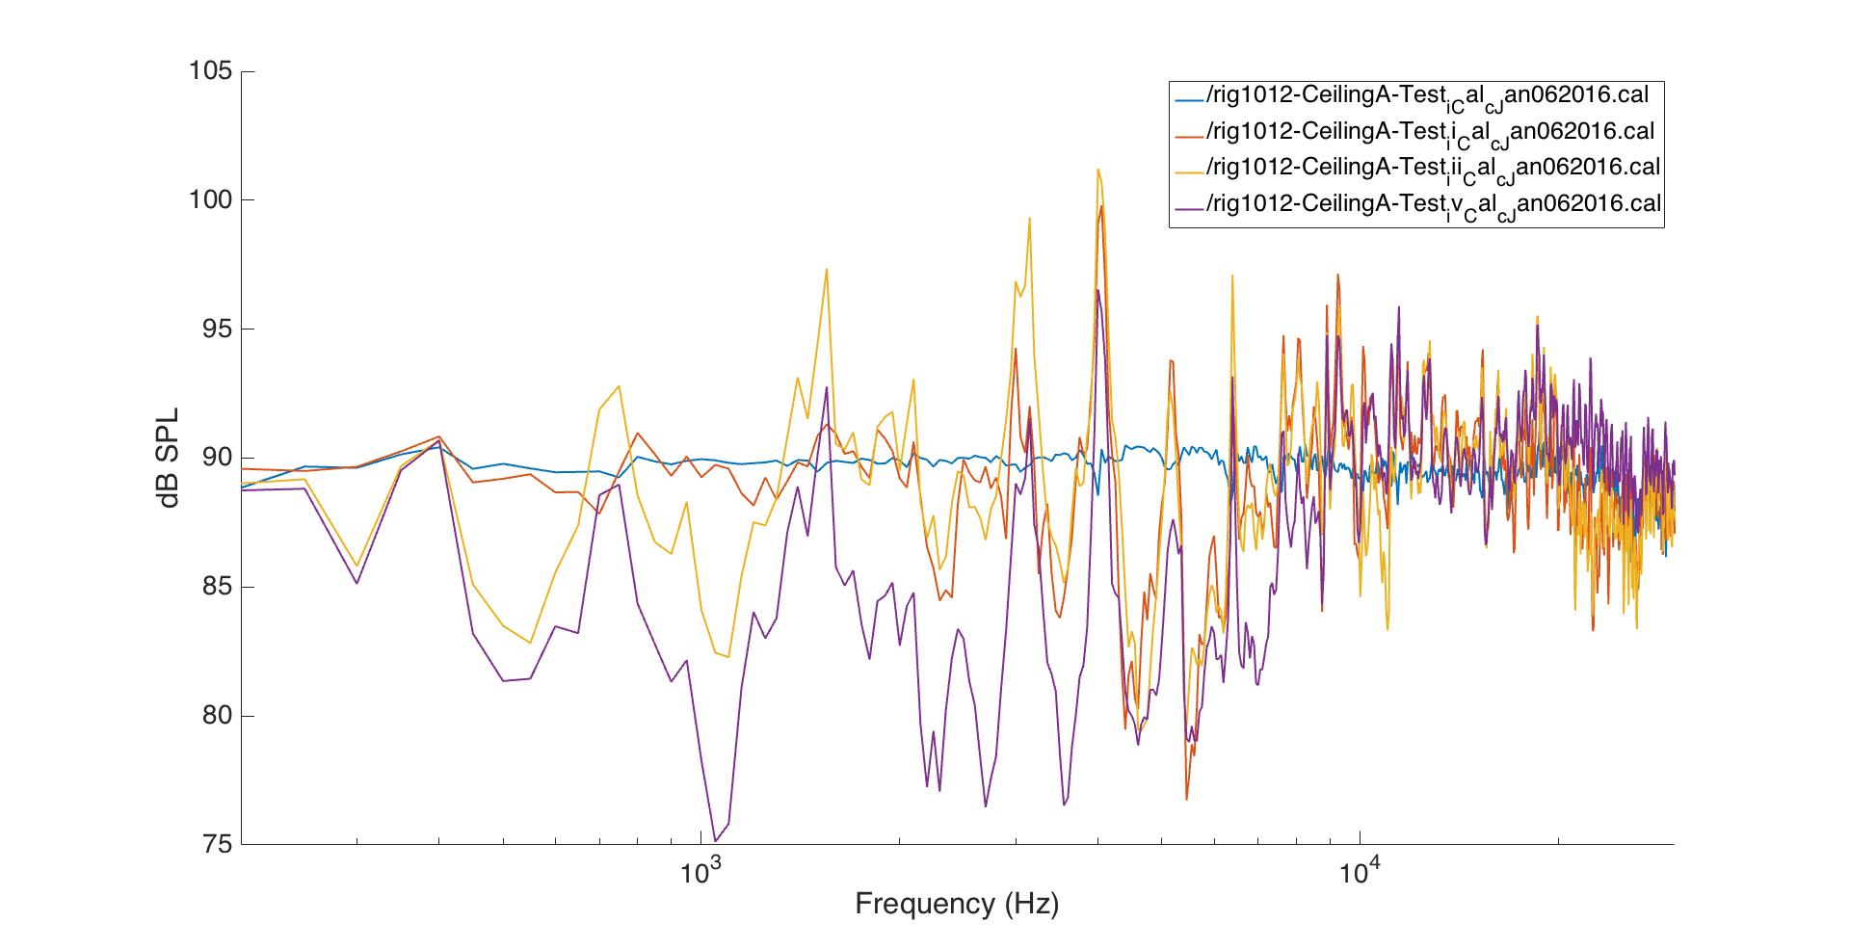

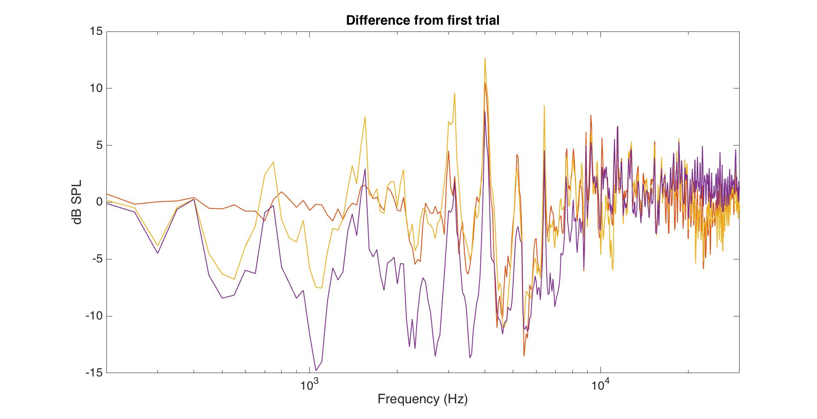

**3. What does changing the stimulus duration, or adding a silent ITI, do to the fq resp function? (Nothing.)**

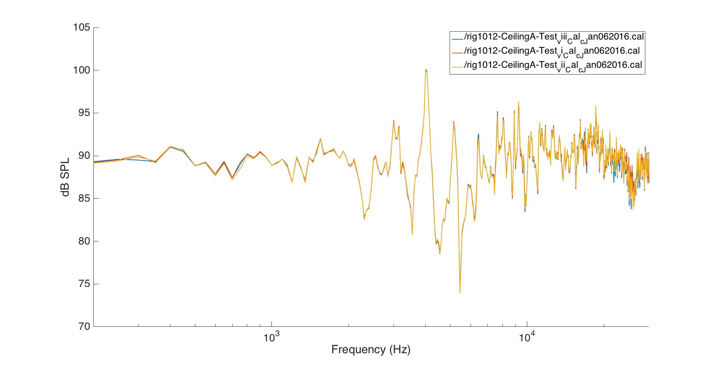

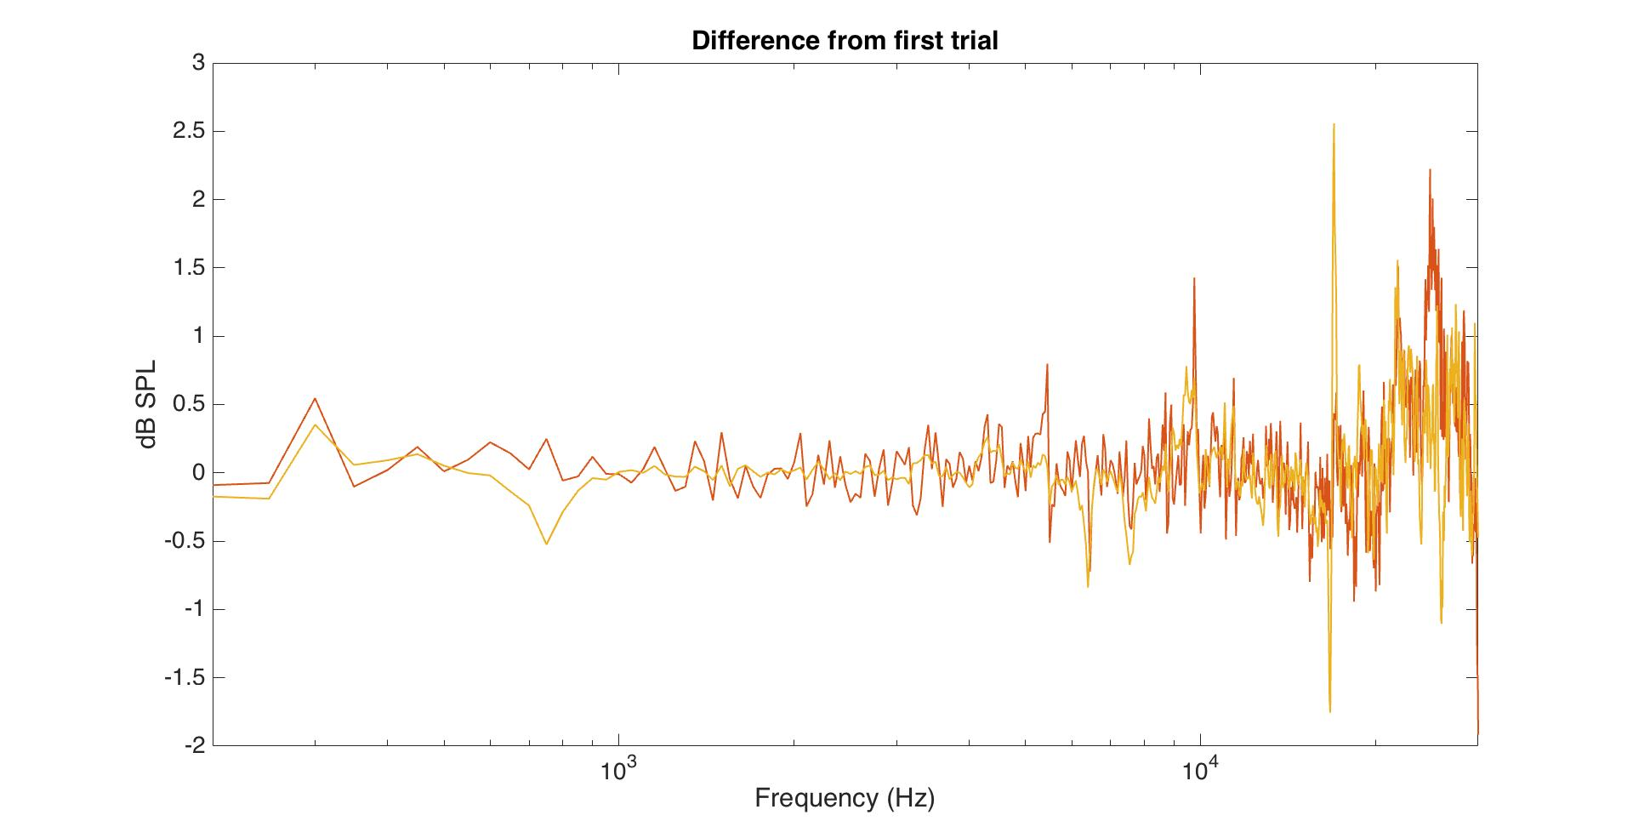

**4. Would it help to put acoustic foam over the top of the cage? (Nope. Dampens sound too much.)**

