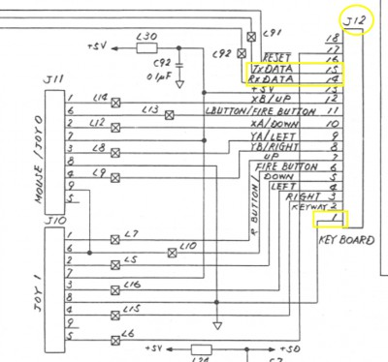
Atari 520 ST |  | Arduino
Pin | Assignment | Assignment | Pin
1 | GND | GND | GND
2 | – | – | –
3 | JOY 1 RIGHT | – | –
4 | JOY 1 LEFT | – | –
5 | JOY 1 DOWN | – | –
6 | JOY 1 FIRE | – | –
7 | JOY 1 UP | – | –
8 | JOY 0 RIGHT / MOUSE YB | – | –
9 | JOY 0 LEFT / MOUSE YA | – | –
10 | JOY 0 DOWN / MOUSE XA | – | –
11 | JOY 0 FIRE / MOUSE LBUTTON | – | –
12 | JOY 0 UP / MOUSE XB | – | –
13 | +5V | +5V | 5V
14 | Rx | RX1 | RX1
15 | Tx | TX1 | TX1
16 | RESET | configurable | 4
17 | – | – | –
18 | – | – | –

