CYBERSECURITY RECONNAISSANCE & NETWORK DISCOVERY PROJECT
theHarvester OSINT + Zenmap/Nmap Network Discovery
GitHub Portfolio Report | Assessment Evidence: September 21, 2026

1. Project Overview
This project combines two cybersecurity reconnaissance activities: passive open-source intelligence (OSINT) collection with theHarvester and local network host discovery with Zenmap/Nmap. The purpose is to demonstrate basic information-gathering, network-enumeration, evidence-review, and security-reporting skills in an authorized lab/home-network context.

2. Tools and Environment
Tool / Environment | Use in Project
Kali Linux 2026.2 | Security testing environment used for theHarvester.
theHarvester 4.10.x | Passive OSINT collection against the public domain microsoft.com.
Zenmap / Nmap 7.991 | Local host discovery on 192.168.1.0/24.
Windows Command Prompt | Verified the local IPv4 address, subnet mask, and default gateway.
Oracle VirtualBox | Virtualized Kali Linux environment.
GitHub | Intended portfolio/repository format for documenting the project, evidence, methodology, and findings.

3. Part One - Passive OSINT with theHarvester

Objective
Use theHarvester to demonstrate passive reconnaissance against microsoft.com and review publicly available information returned by the configured sources.

Observed Results
The captured output reported no IP addresses, email addresses, people, or hosts. LinkedIn-related collection also returned no users and zero links. SecurityScorecard and BuiltWith enrichment did not complete because their API keys were missing. Windvane continued with limited unauthenticated access because its API key was not configured.

Interpretation
These results show what the specific captured run returned; they do not prove that the target has no public infrastructure or contact information. Source availability, rate limits, network conditions, and API configuration can affect passive OSINT results.

4. Part Two - Network Discovery with Zenmap/Nmap

Objective
Identify active systems on the local 192.168.1.0/24 subnet using the Nmap ping-scan command “nmap -sn 192.168.1.0/24”. This command performs host discovery without a port scan.

Network Configuration
The Windows system showed IPv4 address 192.168.1.137, subnet mask 255.255.255.0, and default gateway 192.168.1.1, confirming that the local system was on the scanned /24 network.

Discovered Hosts
Host / IP | Vendor / Identity | Status
192.168.1.1 | Sagemcom Broadband SAS | Up
iPhone.lan (192.168.1.26) | Vendor shown as Unknown | Up
amazon-112a41053.lan (192.168.1.95) | Amazon Technologies | Up
192.168.1.111 | Vizio | Up
192.168.1.219 | Vendor shown as Unknown | Up
omos.lan (192.168.1.137) | Local Windows host | Up
Nmap reported 256 IP addresses scanned, 6 hosts up, and a total scan time of 28.06 seconds. Because the -sn option was used, the evidence does not establish open ports, running services, vulnerabilities, or compromise.

5. Combined Security Findings
Together, the exercises demonstrate two different reconnaissance perspectives. The OSINT portion focuses on information that may be discoverable from public sources, while the Nmap portion identifies devices visible on an authorized local network. The project also demonstrates the importance of validating tool limitations: missing API credentials reduced OSINT coverage, while a ping scan alone cannot provide service or vulnerability findings.

6. Recommendations
For future authorized exercises, preserve raw command output, document exact commands and data sources, use legitimate API credentials where permitted, and validate discovered information before reporting it as confirmed. For local-network security, maintain an inventory of known devices, investigate unrecognized systems, use strong Wi-Fi and router credentials, keep firmware updated, and separate guest or IoT devices when appropriate.

7. GitHub Repository Structure
A clean GitHub portfolio version of this project can be organized with a README at the repository root, a reports folder for the final report, an evidence folder for screenshots, and a notes folder for sanitized command output. Do not publish passwords, API keys, tokens, private identifiers, or sensitive network information.
cybersecurity-recon-project/
├── README.md
├── reports/
│ └── combined-cybersecurity-report.docx
├── evidence/
│ ├── theharvester/
│ └── nmap-zenmap/
└── notes/
└── methodology.md

8. Suggested GitHub README Content
Title: Cybersecurity Reconnaissance and Network Discovery Project
Summary: A hands-on cybersecurity project demonstrating passive OSINT with theHarvester and authorized local network host discovery with Zenmap/Nmap. The project documents methodology, observed results, limitations, security observations, and evidence.
Skills demonstrated: OSINT, reconnaissance, Nmap/Zenmap, network discovery, IP addressing, host identification, security documentation, evidence analysis, and responsible testing.
Ethics statement: Testing should only be performed on systems and networks that you own or have explicit permission to assess.

9. Conclusion
This combined project demonstrates foundational reconnaissance and network-discovery skills. The theHarvester exercise showed a passive OSINT workflow and the impact of missing API credentials. The Zenmap/Nmap exercise successfully identified six active hosts on the local subnet and confirmed the local system's network configuration. The evidence supports host-discovery and OSINT workflow conclusions only; it does not demonstrate exploitation or compromise.

10. Evidence
Figure 1. theHarvester OSINT evidence
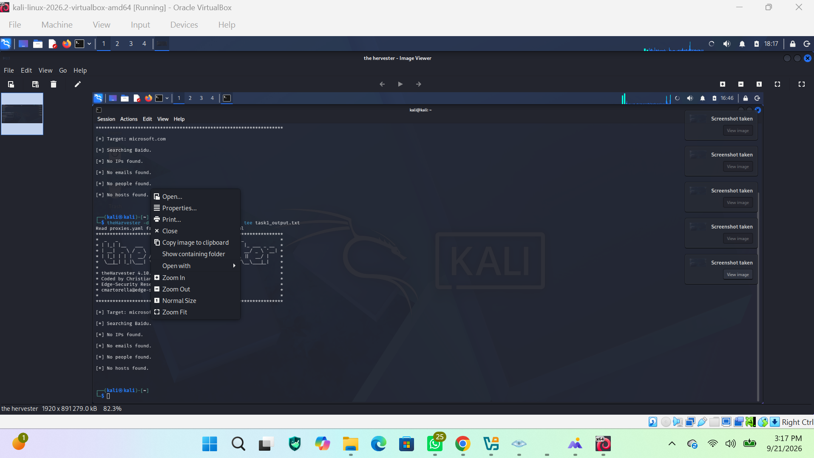
Figure 2. theHarvester output and API-key limitations
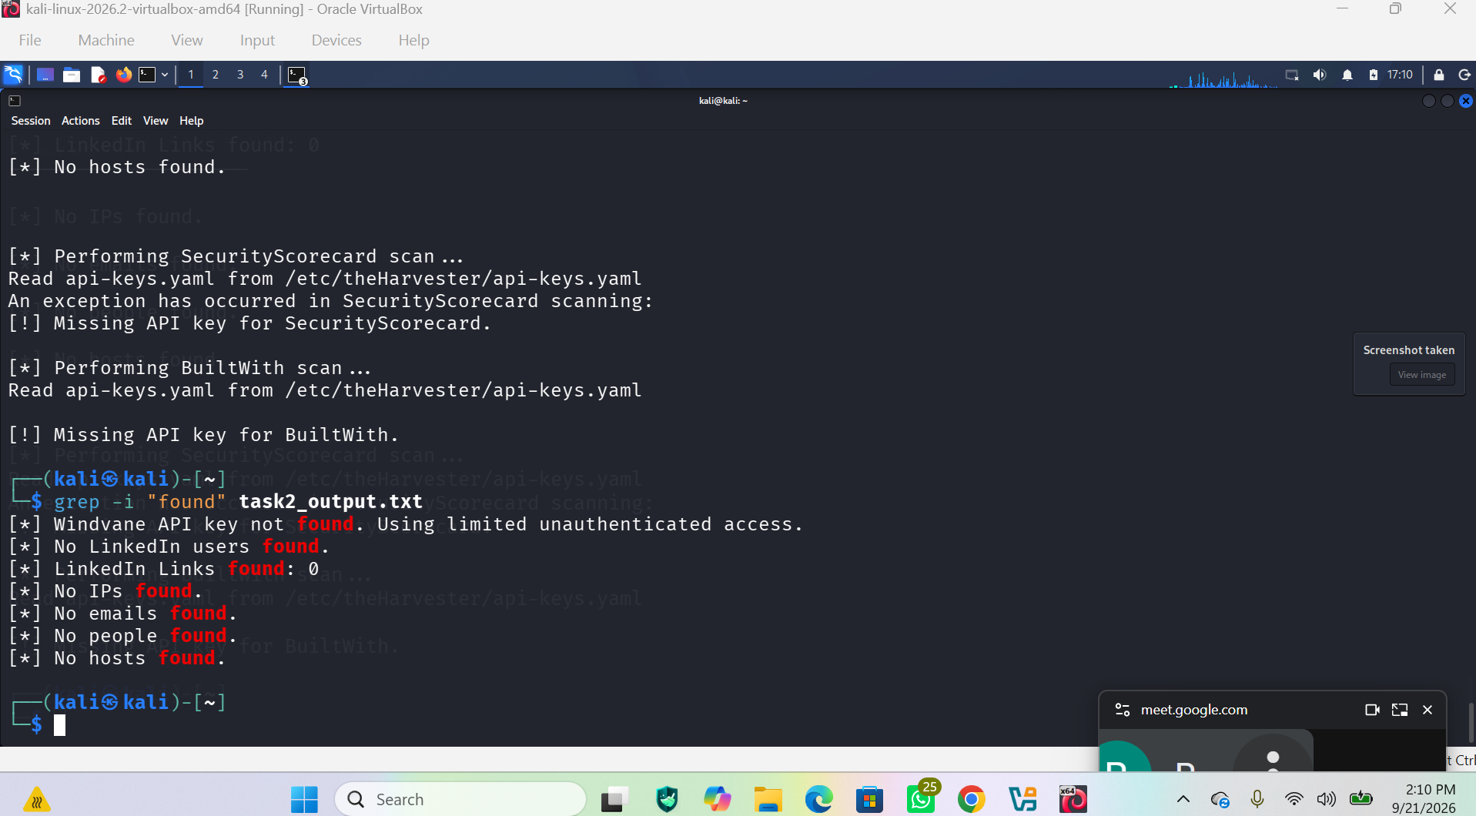
Figure 3. theHarvester result review
Figure 4. Zenmap/Nmap ping-scan results
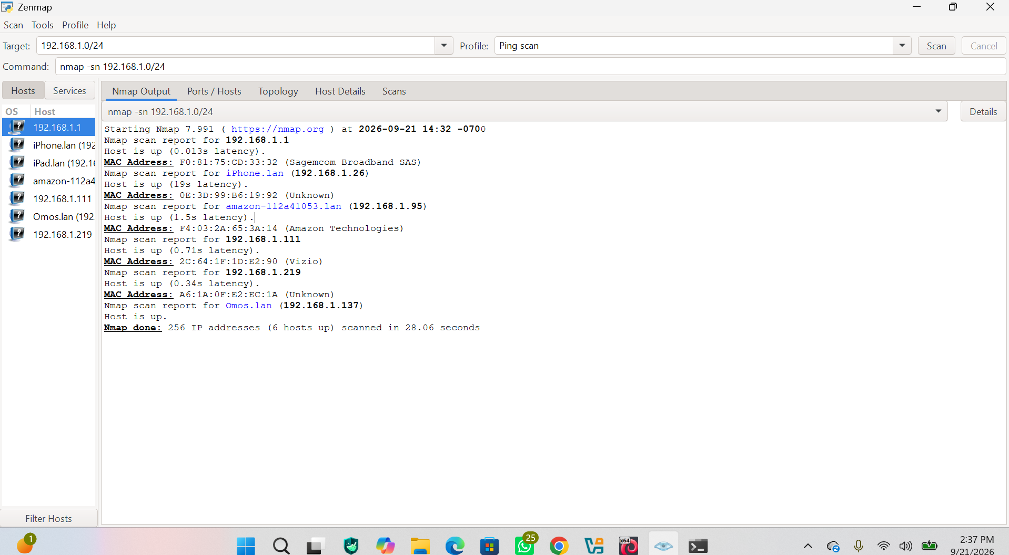
Figure 5. Windows IP configuration
