Physics I: Work

Basics of Work

- Work is the amount of force per unit of displacement:
$$W=Fd$$
  - 1 joule (J) = 1 newton-meter (N•m)
- Intuitively, you could think of work as “how hard it was to move something from one place to another.”
- Since we’re only concerned with the force doing the moving, we only care about the component of the force that matches the direction of the motion – i.e. the force parallel to the displacement.
  - Therefore, if the force is at an angle, we must use trig to determine how much force actually did the moving:
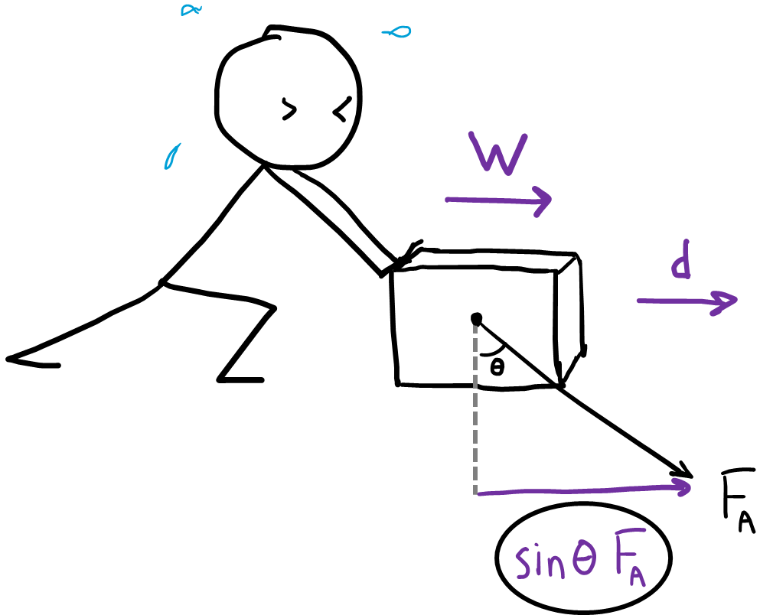

  - The person above is pushing down at an angle, but the displacement of the box is only in the x-direction. So we would calculate work using only the x-component of the force.
  - In this case, the formula for work would be: $W=Fd\sin{θ}$

- If there are multiple forces doing work on an object, the work done by each force is added together to find the net work.

$$W_{net}=W_{1}+W_{2}+W_{3}$$

