**Physics I: Newton’s Laws**

**First Law: “An object at rest will stay at rest. An object in motion will stay in motion.”**

* Also known as **Law of Inertia**
* The only way to overcome inertia is to apply a (net) force on the object.
* Translation: An object will never naturally accelerate unless you “force” it.

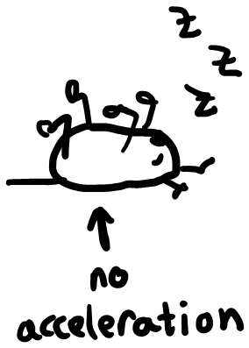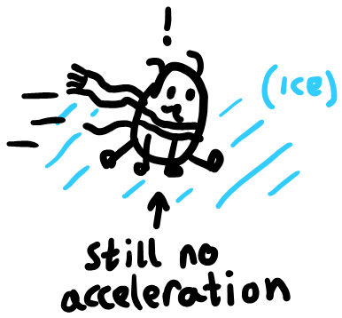

* …But how do we define a force?

$$F=ma$$

**Second Law:**

* Translation: a force causes an object to accelerate.
  + *Reminder: changing direction also counts as acceleration, even if the speed is constant. This is called rotational acceleration or* ***α*** *(alpha).*

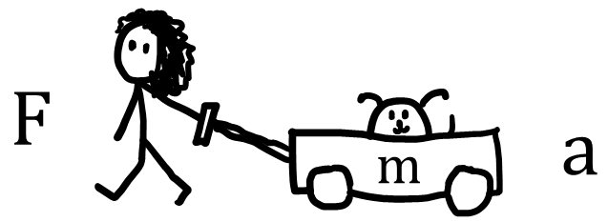

* You must exert a force (f) to accelerate (a) an object (m).

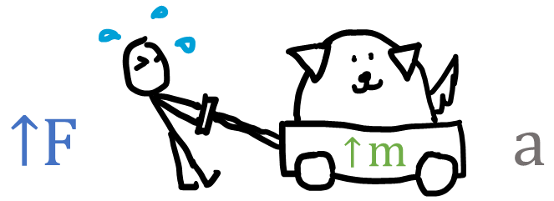

* If the mass increases, it takes more force to maintain the same acceleration.

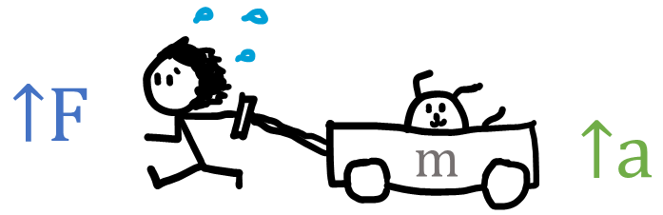

* Alternately, if you want the acceleration to increase, it will take more force to move the same mass.
* …But what if two forces meet?

**Third Law: “Every action has an equal and opposite reaction.”**

* If you exert a force on an object, the object must exert the same force on you.

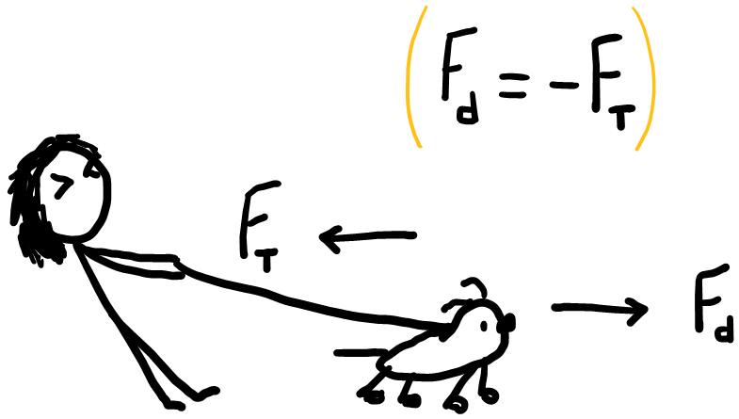

* Above, the leash exerts an equal and opposite force on the dog as the dog pulls on it. The leash does not break because the force exerted by the dog creates an equal and opposite force of tension. The two forces cancel one another. *(assume the person is stationary.)*
* *Normal force* is just the “equal and opposite” force that keeps the object from falling through the floor.

