**Physics I: Vectors**

**Vectors vs. Scalars**

* Scalars are just values. They can tell you one “aspect” of a vector.
* A vector has a **magnitude** and a **direction**.

**Vector Components**

* In order to work with vectors (adding, subtracting, etc.), you need to break them into components.
* 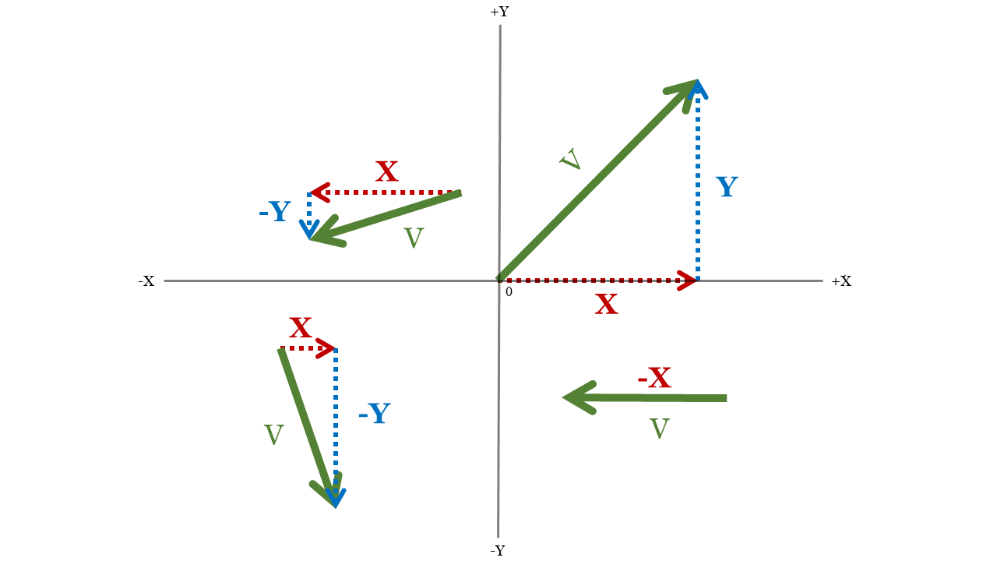Every vector has an X and a Y component.

*You could think of components like the vector’s “shadow” if you shine a flashlight at each axis:*

*Although this vector is in the +Y quadrant, the* ***magnitude*** *of the Y component is still negative.*

*This vector has no Y component!*

*(Vy = 0 m/s)*

**Vector Addition & Subtraction**

**=**

**+**

**+**

* Graphically:
  + Place vectors “tip-to-tail.”
  + Draw a vector from the tail of the first vector to the tip of the final vector.
* Algebraically:
  + Split them into components.
  + Perform the operation (addition, subtraction, etc.) on each component.
  + Use the resulting X- and Y- components to find the final vector.

**Example**

Harry’s anger management class was cancelled. He throws his stress ball at the wall in rage. It leaves his hand 2m from the floor, travels 1.5m, strikes the wall at a 40° angle, bounces off at a 50° angle relative to the horizontal, travels 5.5m, bounces off the ceiling at a 7° angle relative to horizontal, hits the other side of the ceiling 4m away, and bounces straight down.

1. If Harry is standing 9m from the left wall, how far from the wall should his roommate place his coffee mug so the ball lands in it?
2. If the ball falls 6m straight down from the ceiling to the table, how high is the table?

*Final Position of Stress Ball:*

( X , Y )

dmug

htable

**Solution**

First we need to break each vector into components (figure above).

The distance between the mug and the wall is expressed in the X direction, while the height of the table is in the Y direction. We can find the final position of the ball by adding up all the X and Y components separately:

Part A asks for the horizontal distance from the wall to the coffee mug. This is the X coordinate of the ball’s final position. To find it we’ll add all the X components (including the ball’s starting distance, dHarry).

Similarly, Part B asks for the height of the table, which will be the y-coordinate of the final position. So we will sum the Y components (including the starting height of the ball, hthrow).