**Physics I: Work**

**Basics of Work**

* Work is the amount of force per unit of displacement:
 $$W=Fd$$

 + 1 joule (J) = 1 newton-meter (N•m)
* Intuitively, you could think of work as “how hard it was to move something from one place to another.”
* Since we’re only concerned with the force doing the moving, we only care about the component of the force that matches the direction of the motion – i.e. *the force parallel to the displacement.*
  + Therefore, if the force is at an angle, we must use trig to determine how much force actually did the moving:

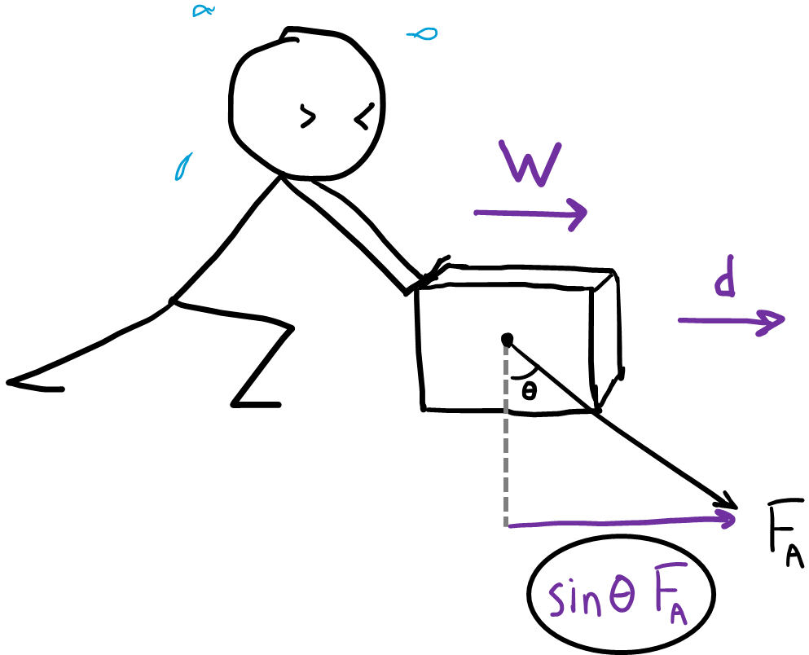

* + The person above is pushing down at an angle, but the displacement of the box is only in the x-direction. So we would calculate work using only the x-component of the force.
  + In this case, the formula for work would be: $W=Fd\sin{θ}$
* If there are multiple forces doing work on an object, the work done by each force is added together to find the net work.

$$W_{net}=W_{1}+W_{2}+W_{3}$$