[Insert VIT logo here]
ALLERGYGUARD
An Evidence-Based Allergen Information System for Packaged and Restaurant Food
A Project Report
submitted in partial fulfilment of the requirements for the award of the degree of
Bachelor of Technology
in [Programme / Specialisation]
by
[Student Name 1] ([Register No.])
[Student Name 2] ([Register No.])
[Student Name 3] ([Register No.])

Under the guidance of
[Guide Name]
[Designation, Department]
[School of Computer Science and Engineering]
VELLORE INSTITUTE OF TECHNOLOGY
[Campus]
[Month Year]

Abstract
People with food allergies must decide, many times a day, whether a food is likely to contain something that could harm them. Packaged-food labels are dense and inconsistent, precautionary statements such as "may contain" are voluntary, and restaurant dishes usually come with no written ingredient information at all. Existing consumer tools tend to reduce this to a single "safe" or "unsafe" verdict, which hides how reliable the underlying information actually is.
This project presents AllergyGuard, an allergen-information system with two customer pathways (packaged food and restaurant food) and a private dashboard for restaurant teams. A customer records their allergies once, at sign-up. For packaged food, the system reads the ingredient label from a photograph using optical character recognition (OCR), reads the barcode, and looks the product up in Open Food Facts. For restaurant food, it matches the dish to the selected branch's menu and retrieves the restaurant's own versioned recipe, allergen and cross-contact records. Where a restaurant is not registered, public recipes are used only as unverified candidates, together with a checklist of questions for restaurant staff.
Both pathways feed one shared, deterministic allergen analysis engine. It normalizes ingredient text, maps it to 14 regulated allergen categories using a knowledge base of 350 synonyms and 79 look-alike exclusions, weighs each source by how trustworthy and complete it is, detects conflicts between sources, and assigns every allergen one of four evidence-status outcomes: Present, Possible cross-contact, Unknown or Not listed in verified records. Missing evidence never produces a "safe" result. A large language model is used only, and optionally, to rephrase the engine's findings, and its output is rejected if it omits an allergen or makes a safety claim. Customer corrections remain unverified until authorized restaurant staff confirm them, which creates a new audited recipe version.
The system was implemented with FastAPI, PostgreSQL and React with TypeScript. All 108 automated backend tests pass, and browser-based end-to-end runs confirmed the main customer and restaurant workflows, including the full suggestion-to-verified-record loop. The engine evaluates a typical case in a median of 2.6 ms, and a label photograph is processed in a median of 0.44 s on a 4-core development machine. OCR remained accurate under moderate blur, rotation, compression and low light, and when heavy blur reduced OCR confidence the system correctly stopped using that label to rule allergens out. The report also discusses the system's limitations, safety and ethical considerations, cost, and alignment with the UN Sustainable Development Goals.
Keywords: food allergy, allergen detection, OCR, explainable decision support, evidence provenance, restaurant allergen management, FastAPI, React.

Table of Contents

[Right-click the table above and choose Update Field to refresh page numbers after editing.]

1. Introduction

1.1 Background
Food allergy is a common and potentially life-threatening condition. In a nationally representative survey of more than 40,000 adults in the United States, Gupta et al. estimated that about 10.8% of adults had a convincing food allergy, and that roughly half of them had experienced at least one severe reaction [1]. Reviews of global epidemiology report rising prevalence in many countries and wide regional variation [2], [3]. For most people with food allergy there is no cure, and day-to-day safety depends on avoiding the allergen [3].
Avoidance depends in turn on information. Regulators have responded by requiring the main allergens to be declared on pre-packed food: the European Union lists 14 allergens that must be emphasised in the ingredient list [4], the United States requires the declaration of nine major food allergens (sesame was added from 2023) [5], [6], and India's Food Safety and Standards (Labelling and Display) Regulations, 2020 require allergen declarations on packaged food [7]. Precautionary statements such as "may contain traces of nuts" are, by contrast, largely voluntary and are used inconsistently [8].
Restaurant food is harder still. A dish rarely comes with a written ingredient list, recipes change with suppliers and chefs, and cross-contact (for example, a shared fryer) is invisible to the customer. Customers rely on asking staff, who may not know every ingredient in a sauce or garnish.

1.2 Motivation
Many consumer tools try to simplify this by returning a single verdict such as "safe" or "contains allergen". For a person with a severe allergy, that simplification is itself a risk: a product that is merely missing from a database, or a label that was read badly, can look the same as a product that has been checked and found to be free of the allergen. The motivation for AllergyGuard is to present what the evidence actually shows, where it came from, and what remains unknown, so that the user can make an informed decision and know when to ask a person.

1.3 The AllergyGuard System
AllergyGuard is an allergen-information system with two customer-facing pathways and one private restaurant-facing dashboard:
- Packaged food: the customer photographs the product and its ingredient label (or enters the barcode or product name). The system reads the label with OCR, identifies the product, retrieves database information and compares the two.
- Restaurant food: the customer selects a restaurant and branch and photographs or names the dish. The system matches it to the branch's menu and uses the restaurant's own versioned records. For unregistered restaurants, public recipes are used only as unverified candidates.
- Restaurant dashboard: authorized restaurant teams maintain menus, ingredients, allergen and cross-contact records, recipe versions, branches and team members, and review customer suggestions.

Both customer pathways pass their evidence to a single shared allergen analysis engine, so that results are consistent and explainable regardless of where the information came from. The customer's allergies are captured once, at sign-up, and applied automatically to every check.

1.4 Scope
The project covers the complete software system: database, backend API, both analysis pipelines, the shared engine, the restaurant verification workflow and the web frontend for customers and restaurants. It does not cover clinical diagnosis, medical advice or certification of food safety. AllergyGuard is an information tool; the final decision always rests with the user, the manufacturer and the restaurant.

1.5 Organization of the Report
Chapter 2 states the problem and objectives. Chapter 3 reviews related work. Chapter 4 describes the system architecture and Chapter 5 the methodology, including the decision rules. Chapter 6 describes the development and deployment environment and its environmental impact. Chapters 7 to 10 discuss sustainability, safety, ethics and cost. Chapter 11 relates the project to the UN Sustainable Development Goals. Chapter 12 presents and discusses the results, Chapter 13 concludes, and Chapters 14 to 16 contain the references, the SDG mapping and the CO-PO-PSO mapping.

2. Problem Statement and Objectives

2.1 Problem Statement
People with food allergies lack a reliable, explainable way to check both packaged food and restaurant dishes against their own allergies. Label text must be read in full and interpreted (for example, knowing that casein and ghee indicate milk while cocoa butter does not); product databases may be incomplete or out of date; and restaurant information, where it exists at all, is held informally by staff. Existing tools typically collapse these uncertain inputs into a single verdict and treat the absence of information as the absence of risk.
The problem addressed by this project is therefore: to design and build a system that gathers the allergen evidence available for a packaged product or restaurant dish, evaluates it consistently against the user's own allergies, and communicates both the findings and their uncertainty, without ever presenting missing information as safety.

2.2 Objectives
- Provide a packaged-food pathway that identifies a likely product and extracts ingredient evidence from the label photograph and from external product data.
- Provide a restaurant-food pathway that matches a dish to the selected restaurant branch and retrieves its structured, versioned ingredient, allergen and cross-contact records.
- Build one shared allergen analysis engine for both pathways, covering ingredient normalization, allergen mapping, evidence fusion, conflict detection, uncertainty handling, personalization and result generation.
- Report results using four standardized evidence-status categories (Present, Possible cross-contact, Unknown, Not listed in verified records), each with its supporting evidence and limitations.
- Provide a fallback for unregistered restaurants that uses public recipes only as clearly labelled, unverified candidates and gives the customer questions to ask staff.
- Give restaurant teams a private, role-controlled dashboard to maintain their records, and a workflow in which customer suggestions change trusted records only after authorized confirmation, with every decision audited.
- Ensure that a large language model, where used, only explains structured findings and cannot invent ingredient facts or turn insufficient evidence into a safety claim.
- Verify the system with automated tests, end-to-end browser runs and measured performance.

2.3 Assumptions and Constraints
- The customer's allergies are known to the system: they are entered at sign-up and can be edited later. Analysis requests never carry allergies; the server reads them from the logged-in account.
- The 14 allergen categories of EU Regulation 1169/2011 Annex II are used as the standard set; they also cover the nine US major allergens [4], [5]. Customers can add other allergies as free text.
- AI services (image recognition, web search, natural-language explanation) are optional. The system must remain fully functional, and safe, without them.
- External product data is community-maintained and may be incomplete; restaurant data is private to each restaurant.
- The system is an information aid, not a medical device, and does not certify any food as safe.

3. Literature Review

3.1 Food Allergy and Allergen Labelling
Sicherer and Sampson review the epidemiology, mechanisms, diagnosis and management of food allergy and emphasise that strict avoidance remains the primary management strategy [3]. Population studies show substantial prevalence among adults as well as children [1], with considerable variation between regions [2]. Because avoidance depends on accurate information, allergen labelling is regulated in many jurisdictions. EU Regulation (EU) No 1169/2011 requires 14 allergens (Annex II) to be emphasised in ingredient lists and requires allergen information for non-prepacked food, including food served in restaurants [4]. In the United States, FALCPA (2004) established mandatory declaration of major food allergens [5] and the FASTER Act (2021) added sesame as the ninth [6]. In India, the FSSAI Labelling and Display Regulations, 2020 require declaration of specified allergens on packaged food [7]. The Codex Alimentarius general labelling standard provides the international reference for these rules [9].
Precautionary allergen labelling ("may contain") is not harmonized and is applied inconsistently; consumers find it hard to interpret, and its presence or absence does not reliably indicate risk [8]. A practical consequence for software is that a precautionary statement must be treated as a distinct kind of evidence (possible cross-contact), not as an ingredient, and that the absence of such a statement is not evidence of absence.

3.2 Optical Character Recognition of Labels
Tesseract is a widely used open-source OCR engine originally developed at HP and later maintained by Google [10]. Smith describes its architecture, including line finding, word recognition and adaptive classification [10]; later versions added an LSTM-based recognizer. OCR accuracy on product packaging is affected by curved surfaces, glare, small fonts, blur and low resolution. Label OCR is therefore best treated as evidence with a confidence level rather than as ground truth, and image quality should be assessed and reported to the user.

3.3 Product Identification and Food Databases
Packaged products carry GS1 Global Trade Item Numbers (EAN/UPC barcodes) with a check digit [11], which make identification by barcode precise when the barcode can be read. Open Food Facts is a collaborative, open database of food products, released under the Open Database Licence, that exposes ingredient lists and allergen and trace tags through a public API [12]. Because it is crowd-sourced, its data may lag behind recipe changes.
When no barcode is available, image-based recognition can propose candidates. Food image recognition has been studied extensively, for example with the Food-101 benchmark [13], and is surveyed in the context of food computing by Min et al. [14]. Vision-language models trained on large image-text corpora, such as CLIP, enable recognition without task-specific training [15]. Such models produce plausible but sometimes wrong candidates, so their output should be treated as a hypothesis that requires confirmation.

3.4 Large Language Models, Hallucination and Grounding
Large language models (LLMs) can produce fluent explanations, but they are known to generate content that is not supported by their input, a behaviour usually called hallucination [16]. Retrieval-augmented generation reduces this by conditioning generation on retrieved documents [17], but it does not eliminate it. In a safety-relevant setting such as allergy information, a reasonable design is to let deterministic rules make every decision and to restrict the LLM to rephrasing structured, already-decided findings, with automatic checks on its output. AllergyGuard follows this design.

3.5 Existing Approaches and Research Gap
Existing consumer approaches broadly fall into the categories in Table 3.1. Each addresses part of the problem; none combines packaged and restaurant food with explicit evidence status and a verified restaurant data workflow.
Table 3.1: Categories of existing approaches and their limitations
Approach | Strengths | Limitations
Barcode-scanning product apps | Fast identification; large product databases | Depend on database coverage and freshness; usually a single verdict; no restaurant food
Reading the label manually | Uses the current, legally required label | Time-consuming; requires knowledge of synonyms (e.g. casein, ghee); error-prone
Restaurant allergen menus / matrices | Authoritative when maintained | Often static documents; not versioned; not personalized; cross-contact rarely detailed
Restaurant review and community apps | Real customer experiences | Unverified; not specific to the current recipe; anecdotal
General image recognition / chatbots | Work without a barcode or menu | May guess wrong dishes or ingredients; hallucination risk [16]

The gap addressed by AllergyGuard is a system that (a) treats every input as evidence with an explicit trust level, (b) uses one consistent, deterministic engine for packaged and restaurant food, (c) distinguishes present, possible cross-contact, unknown and not listed in verified records, (d) gives restaurants a versioned, audited way to maintain trusted records and respond to customer feedback, and (e) restricts AI to roles where its mistakes cannot become safety claims.

4. System Architecture

4.1 Overview
Figure 4.1 shows the finalized architecture. Two client applications, the customer application and the private restaurant dashboard, communicate with a FastAPI backend over HTTPS using JSON and JSON Web Token (JWT) authentication. The backend validates input, enforces authentication and role- and tenant-based authorization, and routes each analysis request to the packaged-food or restaurant-food pipeline. Both pipelines convert what they find into a common evidence format and pass it to the shared allergen analysis engine, which produces the standardized result.
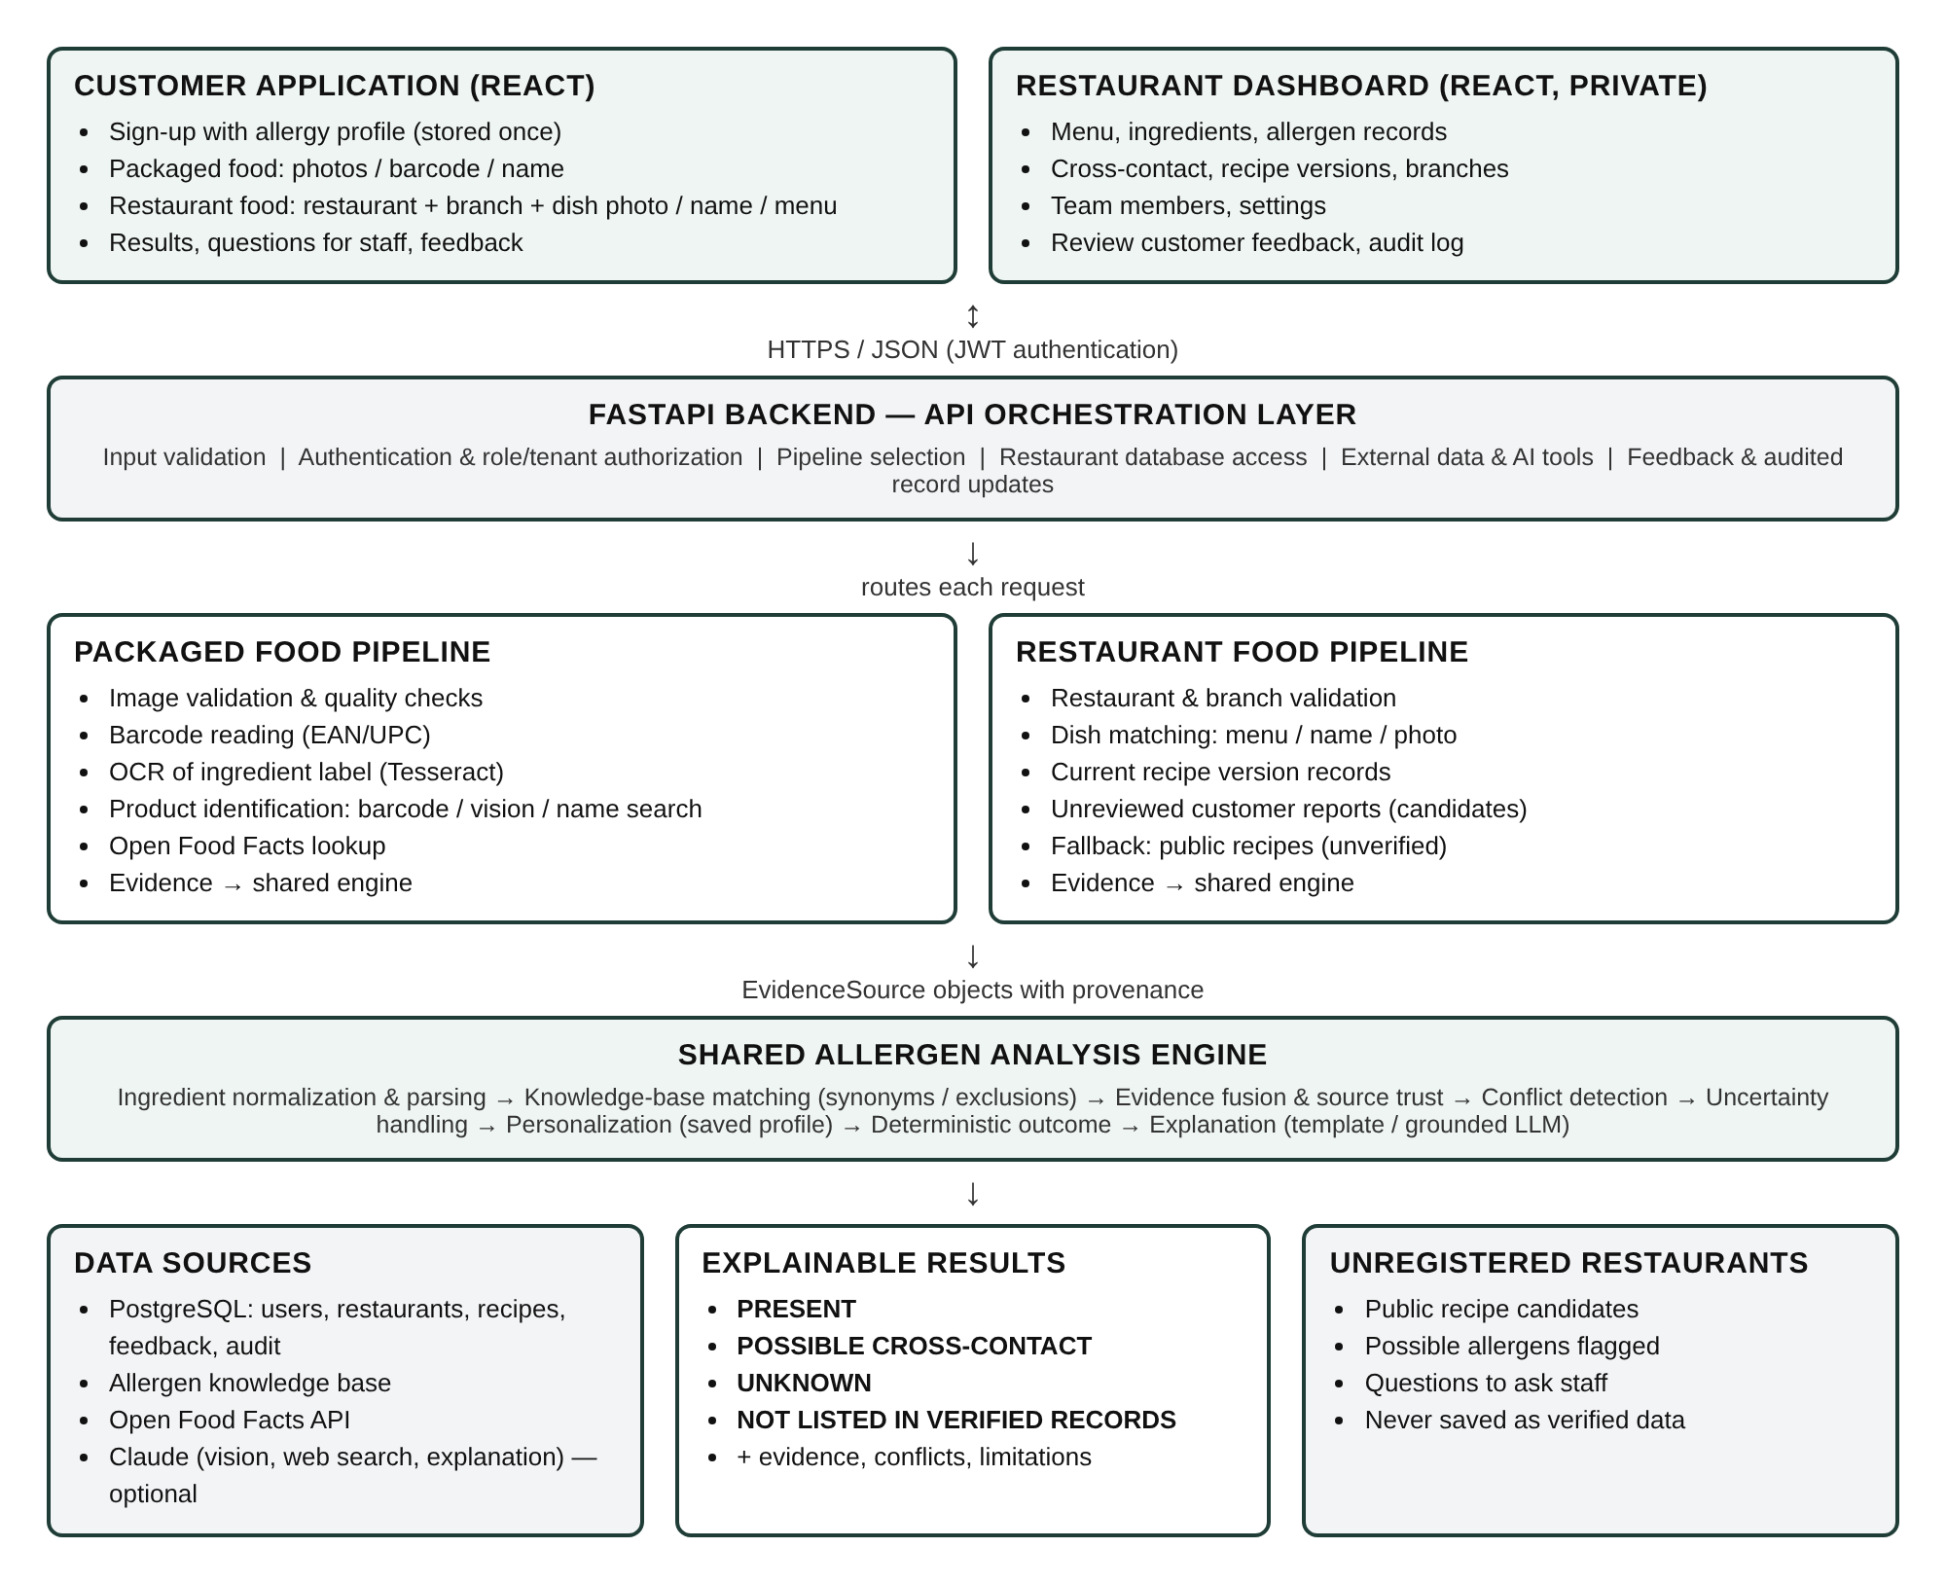
Figure 4.1: AllergyGuard system architecture

4.2 Components
Table 4.1: Main components and responsibilities
Component | Responsibility
Customer application | Sign-up with allergy profile; packaged-food, restaurant-food and typed-ingredient checks; results with evidence, limitations and questions for staff; correction suggestions and their status
Restaurant dashboard | Overview of items needing attention; menu and recipe management with versioning and verification; cross-contact records; feedback review; branches, team, settings, audit log
API orchestration layer (FastAPI) | Validation, authentication (JWT), authorization by role and restaurant membership, pipeline routing, access to the database and external services
Packaged-food pipeline | Image checks, barcode reading, label OCR and ingredient-section extraction, product identification and Open Food Facts lookup
Restaurant-food pipeline | Branch validation, dish matching, retrieval of the current recipe version, unreviewed customer reports as candidates, public-recipe fallback, questions for staff
Shared allergen analysis engine | Text normalization, knowledge-base matching, source trust, evidence fusion, conflict detection, uncertainty handling, personalization, outcome and explanation
PostgreSQL database | Users and allergy profiles; restaurants, branches, menu items and recipe versions; allergen knowledge base; feedback; audit log
External services (optional) | Open Food Facts API; Claude for product/dish image recognition, public-recipe web search and explanation wording

4.3 Request Flow
Figure 4.2 summarizes the end-to-end flow of an analysis request. The customer's allergy profile is loaded on the server from the authenticated account; it is never sent with the request, so a result is always computed against the profile the customer saved.
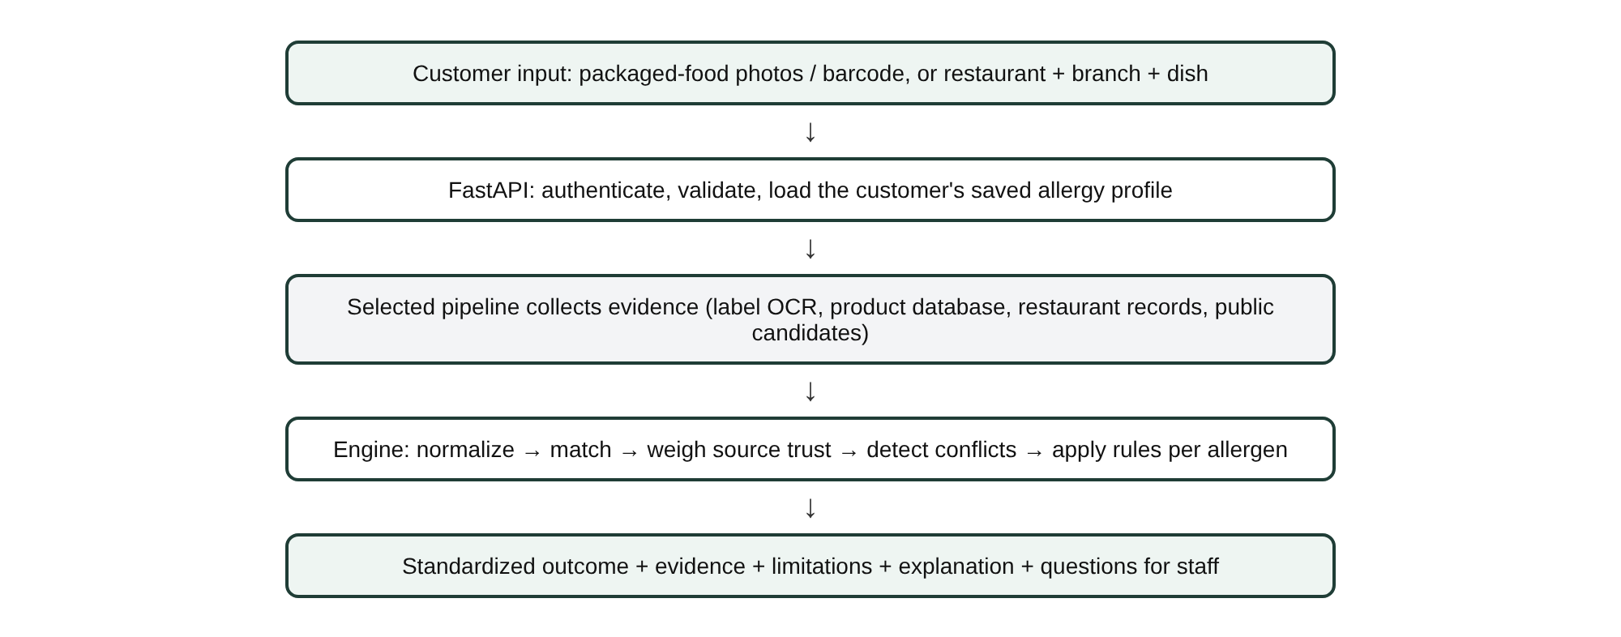
Figure 4.2: End-to-end analysis flow

4.4 Data Model
Figure 4.3 shows the logical data model. Each restaurant is a tenant with branches; each branch offers menu items; each menu item has an ordered series of recipe versions. A recipe version is an immutable snapshot that owns its ingredient records, allergen records and cross-contact records. Changes always create a new version, so the history of trusted records can be traced. Feedback suggestions reference the menu item and the recipe version they were made against, and confirmed suggestions link to the version they produced. Every decision and change is written to an append-only audit table.
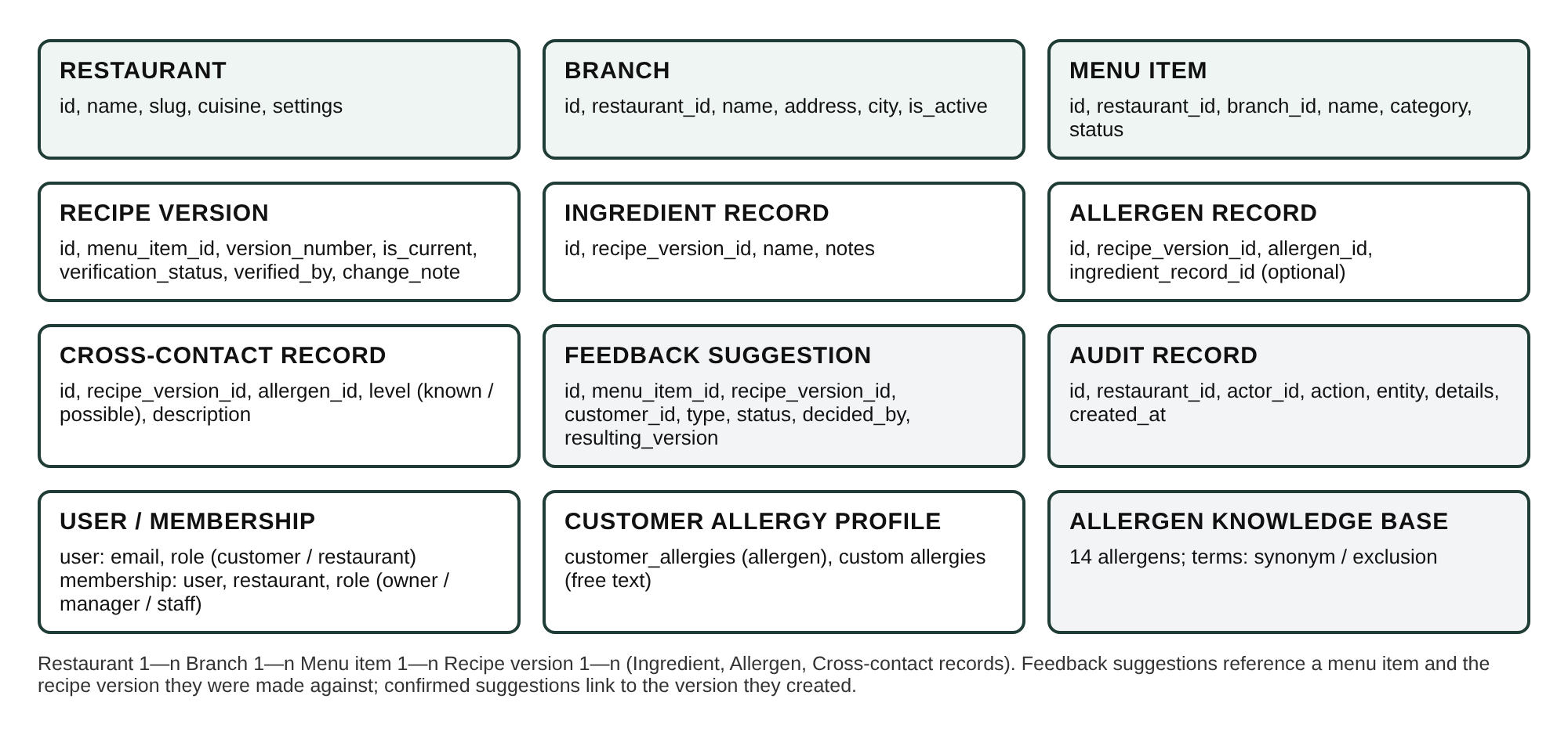
Figure 4.3: Logical data model

4.5 Feedback and Verification Workflow
Figure 4.4 shows how a customer suggestion moves through the system. A suggestion is stored as unverified and never changes the trusted record by itself. Only an owner or manager of that restaurant can confirm it. Confirmation creates a new verified recipe version with the change applied; rejection leaves the record unchanged. Both are logged.
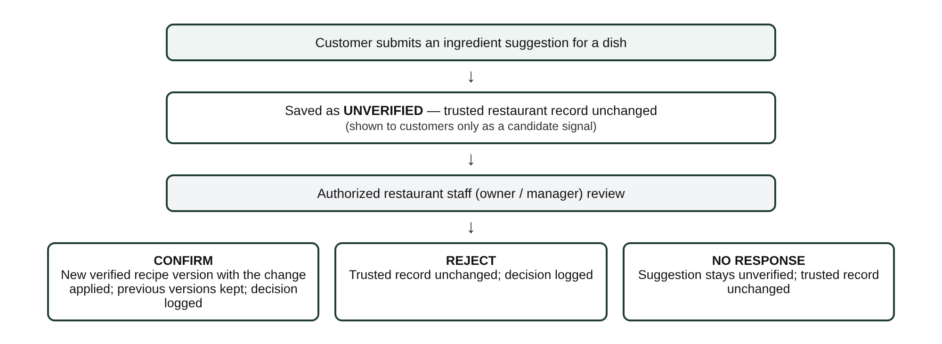
Figure 4.4: Customer feedback and restaurant verification workflow

4.6 Security Architecture
- Authentication: passwords are hashed with bcrypt; sessions use signed JWTs with an expiry. The server refuses to start in production mode with the default signing secret.
- Roles: user accounts are either customer or restaurant accounts. Within a restaurant, members are owners (full control), managers (edit records, review feedback) or staff (read-only).
- Tenant isolation: every dashboard route depends on a single access check that verifies the caller's membership of the restaurant in the URL, and every query filters by that restaurant. Identifiers belonging to another restaurant return "not found" rather than "forbidden", so restaurants cannot probe each other's data.
- Data exposure: customers can see restaurant names, branches and menu item names, but recipe and allergen records are used only inside an analysis.

4.7 API Summary
Table 4.2: Principal API endpoints (27 paths in total)
Endpoint | Access | Purpose
POST /api/auth/register/customer | Public | Sign-up with required allergy profile
POST /api/auth/register/restaurant | Public | Creates owner, restaurant and first branch
POST /api/auth/login, GET /api/auth/me | Public / user | Login and current user
GET, PUT /api/me/allergy-profile | Customer | View and edit allergies
POST /api/analyze/packaged | Customer | Photos, barcode or product name
POST /api/analyze/restaurant | Customer | Registered or unregistered restaurant dish
POST /api/analyze/text | Customer | Typed ingredient list
GET /api/public/restaurants[...]/menu | Logged in | Restaurant directory and menu names
POST /api/feedback, GET /api/me/feedback | Customer | Suggest corrections; view outcomes
/api/restaurants/{id}/menu[...] | Members | Menu items, recipe versions, verification
/api/restaurants/{id}/feedback[...] | Members | Review queue and decisions
/api/restaurants/{id}/branches, team, audit | Members | Branches, team roles, audit log

5. Methodology

5.1 Development Approach
The system was built incrementally in five parts, each completed, verified and committed to version control before the next began. This ordering allowed the shared engine to be developed and tested independently of images and external services, and then reused unchanged by both pipelines.
Table 5.1: Development phases
Part | Scope | Key deliverables
1 | Foundation | FastAPI application, PostgreSQL schema for all entities, authentication and roles, tenant isolation, allergen knowledge base, demo data
2 | Shared allergen engine | Evidence model, text processing, knowledge-base matching, decision rules, conflict detection, personalization, explanation with output checks
3 | Packaged-food pipeline | Image checks, barcode reading, OCR and ingredient extraction, Open Food Facts client, optional vision identification
4 | Restaurant pipeline and dashboard API | Dish matching, recipe versioning, feedback workflow, public-recipe fallback, questions for staff, dashboard endpoints, audit log
5 | Frontend | React and TypeScript customer application and restaurant dashboard; end-to-end browser verification

5.2 Allergen Knowledge Base
The knowledge base contains the 14 allergen categories of EU Regulation 1169/2011 Annex II [4]: cereals containing gluten, crustaceans, eggs, fish, peanuts, soybeans, milk, tree nuts, celery, mustard, sesame, sulphur dioxide and sulphites, lupin and molluscs. Each category has two kinds of terms:
- Synonyms (350 in total), which indicate the allergen: for example whey, casein, ghee, paneer (milk); semolina, maida, malt (gluten); tahini (sesame); E220 (sulphites). Common Indian ingredient names are included alongside European and American ones.
- Exclusions (79 in total), which look related but do not indicate the allergen: for example cocoa butter, coconut milk and peanut butter are not milk; nutmeg and water chestnut are not tree nuts; buckwheat and rice flour are not gluten; eggplant is not egg; oyster mushroom is not a mollusc.

Matching is whole-word and plural-tolerant, and treats spaces and hyphens as equivalent. An exclusion suppresses only matches of its own allergen that it fully covers. Thus peanut butter suppresses the milk match on butter but keeps the peanut match on peanut butter. When several synonyms of the same allergen overlap, the longest match is kept so that evidence shows the most specific term.

5.3 Ingredient Text Processing
- Normalization: Unicode normalization, lower-casing, standard quotes and dashes, collapsed whitespace, and removal of a leading "Ingredients:" heading, percentages and asterisks.
- Precautionary statements: phrases such as "may contain", "traces of" and "made in a factory that also handles" are separated from the ingredient text and treated as cross-contact evidence, never as ingredients.
- Compound ingredients: the list is split on commas, semicolons and brackets so that both a compound name and its components are checked; chocolate (sugar, milk powder) yields chocolate, sugar and milk powder.
- Free-from claims: phrases such as "gluten-free" or "free from milk" are recognized. The claim suppresses the matching allergen inside that ingredient but produces an Unknown outcome, because the claim cannot be verified.
- Non-specific ingredients: general terms such as spices, natural flavourings or sauce are listed as a limitation because their components are not stated.

5.4 Evidence Model and Source Trust
Each pipeline describes what it found as a set of evidence sources. A source has a type, a name, ingredient text or items, optionally its own allergen declarations and cross-contact declarations, a completeness flag and a confidence value. Table 5.2 shows how source types are treated.
Table 5.2: Treatment of evidence sources
Source type | Presence counts as PRESENT | Can support NOT LISTED
Label photo (OCR) | Yes | Yes, if complete and OCR confidence >= 0.6
Label typed by the customer | Yes | Yes (limitation shown)
Product database / manufacturer | Yes, if identification confidence >= 0.7 | Same condition, and complete
Restaurant records, verified | Yes, if dish match confidence >= 0.7 | Same condition
Restaurant records, not verified | Yes, if dish match confidence >= 0.7 | No
Public recipe (unregistered restaurant) | No: candidate only (Unknown) | No
Unreviewed customer suggestion | No: candidate only (Unknown) | No

5.5 Decision Rules
For each allergen in the knowledge base, and for each custom allergy, the engine applies the following rules in order; the first that applies determines the outcome:
- Any presence evidence (ingredient match or explicit declaration) from a trusted source: PRESENT.
- Any cross-contact evidence (declared cross-contact or a precautionary statement): POSSIBLE CROSS-CONTACT.
- Presence evidence only from candidate or untrusted sources: UNKNOWN, with the possible presence explained.
- Only a free-from claim mentions the allergen: UNKNOWN.
- At least one complete, reliable, verified ingredient source exists, and the ingredient lists of such sources do not disagree substantially: NOT LISTED IN VERIFIED RECORDS, always with the statement that this is not proof of absence.
- Otherwise: UNKNOWN, with the reason absence could not be established.

The overall result is the most severe outcome among the customer's own allergies, in the order Present, Possible cross-contact, Unknown, Not listed. Allergens outside the customer's profile are reported separately when they are present or possible. The thresholds used are listed in Table 5.3.
Table 5.3: Thresholds used by the engine and pipelines
Parameter | Value | Effect
Minimum identification / dish-match confidence | 0.70 | Below this, identity-dependent sources become candidates
Minimum source (OCR) confidence | 0.60 | Below this, a source cannot support NOT LISTED
Ingredient-list overlap threshold | 0.50 | Lower overlap between complete sources blocks NOT LISTED
Photo-only dish match cap | 0.60 | A photo alone never reaches the trust threshold
Minimum menu match | 0.50 | Below this, no menu item is treated as the dish
Barcode identification confidence | 0.95 | Exact product match from a valid barcode

5.6 Conflict Detection
- Allergen disagreement: one reliable source indicates an allergen that another reliable source does not mention (for example, the label photo and the product database). Presence still wins, and the conflict is reported.
- Ingredient-list mismatch: the word overlap between two complete ingredient lists is below 0.5, suggesting different products, variants or recipe versions; NOT LISTED is then not used.
- Declaration mismatch: a restaurant's ingredients indicate an allergen that its own allergen declaration omits (for example, ghee without milk). The ingredient wins, and the conflict is reported to the customer and shown as a warning on the dashboard.

5.7 Packaged-Food Pipeline
- Image checks: JPEG, PNG and WebP up to 10 MB; orientation corrected from EXIF data; low resolution, blur (variance of an edge-filtered image), darkness and low contrast detected and reported.
- Barcode: EAN/UPC barcodes are read from the photos with zxing-cpp, or typed by the customer, and validated by their check digit [11].
- OCR: each photo is converted to grayscale, upscaled if small and contrast-stretched before Tesseract recognition [10]; the mean word confidence is recorded. The ingredient statement is extracted between the "Ingredients" heading and the next section (nutrition information, storage, best before and so on), keeping any allergy advice.
- Identification: a valid barcode is looked up in Open Food Facts [12]. Otherwise, the brand and product name are read from the photo by a vision model (when configured) or taken from the typed name, and the closest Open Food Facts search result is chosen; confidence is the recognition confidence multiplied by name similarity.
- Evidence: the label text and the database entry (ingredients, allergen tags, and trace tags as cross-contact) are passed to the engine. If the database is unreachable, the label is still analysed and the limitation is shown.

5.8 Restaurant-Food Pipeline
- Branch validation: the restaurant and branch must exist and be active.
- Dish matching: a dish picked from the menu has confidence 1.0; a typed name is matched by fuzzy similarity; a photo is matched by a vision model choosing from the branch's menu, capped at 0.6 because a photograph is not proof of the recipe; agreement between name and photo raises confidence. The top candidates are returned so that the customer can confirm the dish.
- Records: the current recipe version's ingredients, allergen records and cross-contact records become a verified or unverified restaurant source.
- Customer reports: unreviewed suggestions for the dish are added as candidate evidence; they can make a result more cautious but never produce PRESENT.
- Fallback: for an unregistered restaurant or an unmatched dish, public recipes found by web search (when configured) provide candidate ingredients with links to their sources. They are never stored and never produce PRESENT or NOT LISTED.
- Questions for staff: a deterministic checklist is generated from the result, naming common hidden sources of each allergen (for example, milk in butter, ghee, cream or yogurt).

5.9 Explanation Generation
A template explanation is always generated from the structured result. If an API key is configured, the result is also sent to a large language model (Claude, low reasoning effort) with instructions to use only the given facts, keep every outcome unchanged, mention each of the customer's allergens, state that "not listed" is not proof of absence, and recommend confirmation with the manufacturer or staff. The output is then checked automatically: it is discarded, and the template used instead, if it omits any of the customer's allergens or contains a safety claim such as "safe to eat", "allergen-free" or "no risk". The model can therefore improve readability but cannot change a decision.

5.10 Verification Methodology
- Automated tests (pytest): 108 tests covering knowledge-base matching, each decision rule, conflict detection, the packaged and restaurant pipelines through the API, the dashboard, tenant isolation and the feedback workflow. The tests run against a separate PostgreSQL database and use real Tesseract OCR and real barcode decoding on generated images. External services are replaced by fixed responses in tests.
- End-to-end browser runs (Playwright with Chromium): the main customer and restaurant journeys were executed in a real browser against the running system, on desktop and phone-sized viewports.
- Performance measurement: response times were measured over repeated requests.
- OCR robustness experiment: a label image was degraded in controlled ways and recognition quality measured.

6. Environment

6.1 Development Environment
Table 6.1: Development and test environment
Item | Specification
Hardware | 4 vCPU Intel Xeon @ 2.10 GHz, 15 GB RAM (cloud development container)
Operating system | Linux (Ubuntu-based container)
Backend runtime | Python 3.13
Frontend runtime | Node.js 22, npm 10
Database | PostgreSQL 16
OCR engine | Tesseract 5.3.4 (English language data)
Browser testing | Playwright with Chromium
Version control | Git, hosted on GitHub

6.2 Software Stack
The backend is built with FastAPI [22] on PostgreSQL [23]; the frontend uses React [24]; label OCR uses the Tesseract engine [25]. Table 6.2 lists the main libraries and the versions used.
Table 6.2: Main libraries and frameworks
Library | Version | Use
FastAPI | 0.162 | REST API, validation, dependency injection
SQLAlchemy | 2.1 | Object-relational mapping
psycopg | 3.3 | PostgreSQL driver
Pydantic | 2.13 | Request and response models
PyJWT, bcrypt | 2.15, 5.0 | Tokens and password hashing
Pillow | 12.3 | Image loading, quality metrics, preprocessing
pytesseract | 0.3.13 | Interface to Tesseract OCR
zxing-cpp | 3.1 | Barcode reading
httpx | 0.28 | Open Food Facts client
anthropic (Claude SDK) | 2.3 | Optional vision, web search and explanation
React, React Router | 19.3, 7.18 | User interface and routing
TypeScript, Vite | 5.9, 7.3 | Type checking and build
pytest, Playwright | 9.2, - | Automated and browser testing

6.3 Deployment Environment
The repository includes a Docker Compose configuration with three services: PostgreSQL, the backend (a Python image with Tesseract installed) and the frontend (a static build served by nginx, which also forwards /api requests to the backend). Configuration is supplied through environment variables, including the database connection, the JWT secret, allowed origins, the optional AI key and upload limits. The application can also be run directly, with the Vite development server forwarding API requests to the backend. A modest virtual machine (for example, 2 vCPU and 4 GB RAM) is sufficient for a pilot deployment, because OCR is the only computationally significant step and the engine itself runs in milliseconds.

6.4 Environmental Impact
The environmental footprint of the system is small. The core engine is rule-based and needs no model training or GPU; it evaluates a case in a few milliseconds on a general-purpose CPU. OCR runs locally on the CPU in under half a second per photo. Images are downscaled before being sent to an AI service, and AI calls are optional and made only where they add value (image recognition without a barcode, public-recipe search, explanation wording). A deployment can therefore run on a single small server, and can run entirely without AI services where energy use or cost must be minimized.

7. Sustainability

7.1 Technical Sustainability
- Modularity: the engine is independent of the pipelines, so new evidence sources (for example, a manufacturer feed or a new country's database) can be added without changing the decision rules.
- Testability: 108 automated tests document and protect the behaviour of the rules, pipelines and workflows, so that changes can be made with confidence.
- Data traceability: recipe versions are immutable snapshots, and every change is audited, so records remain explainable over time.
- Open standards and data: the system relies on open-source software, GS1 barcodes and openly licensed product data [11], [12].
- Maintainability work remaining: database migrations are currently created from the models at start-up; a migration tool such as Alembic should be added before production use, so that schema changes preserve live data.

7.2 Economic Sustainability
All core components are open source and there are no licence fees. Running costs are dominated by hosting and, optionally, AI usage (Chapter 10). Because the AI features are optional and degrade to deterministic fallbacks, the service can operate at very low cost, and AI usage can be enabled selectively as funding allows. For restaurants, maintaining structured records in the dashboard replaces ad hoc allergen matrices and can reduce the time staff spend answering allergen questions.

7.3 Social Sustainability
The system supports people with food allergies in participating more fully in everyday food choices, including eating out. Its value grows as more restaurants maintain verified records, and the feedback workflow lets customers contribute to data quality without being able to change trusted records directly. Plain-language results, questions for staff and a phone-friendly interface lower the barrier to use.

7.4 Environmental Sustainability
As described in Section 6.4, the system is designed for low computational cost. Indirectly, clearer information may help consumers avoid buying products they cannot eat; this effect has not been measured and is not claimed as a result.

8. Safety

8.1 Safety Principles
- AllergyGuard communicates available evidence and uncertainty. It never certifies food as safe and is not medical advice; every result carries this statement.
- Missing information is never treated as absence: the most favourable outcome is "Not listed in verified records", which is always accompanied by "this is not proof that it is absent".
- When sources conflict, the more cautious finding prevails (presence over absence).
- Uncertain inputs (poor images, uncertain identification, unverified records, public recipes, customer reports) can make a result more cautious but never less cautious.
- Every decision is made by deterministic, tested rules; AI cannot change an outcome.

8.2 Hazard Analysis
Table 8.1: Hazards, mitigations and residual risk
Hazard | Mitigation in AllergyGuard | Residual risk
OCR misreads or misses an ingredient | Confidence threshold; image quality checks; missing heading means presence-only; extracted text shown to the user | A confidently misread word could still be missed; user is advised to check the label
Wrong product identified | Identification confidence; data from uncertain matches is candidate-only; label and database compared | A wrong product with a high-confidence match is unlikely with barcodes, possible with name search
Wrong dish matched | Menu selection preferred; photo-only matches capped below trust threshold; customer asked to confirm | Customer may confirm the wrong dish
Outdated or incorrect restaurant record | Recipe versions with verification status; unverified versions cannot support NOT LISTED; customer feedback | Kitchen practice may differ from records
Missing synonym in knowledge base | 350 synonyms, regulated allergen names, staff declarations, conflict detection | Unusual names may be missed
Allergen hidden in a non-specific ingredient | Listed as a limitation; questions for staff | Outcome itself is not downgraded
LLM invents or softens facts | LLM only rephrases; output rejected on omission or safety wording; template fallback | Subtle misphrasing not caught by checks
Malicious or mistaken customer suggestion | Stored unverified; only owners or managers can confirm; audit log | Unverified reports can make results more cautious
Cross-tenant data leak | Membership check on every route; restaurant filter on every query; tests | Implementation defects

8.3 Residual Risk Communication
Residual risk is communicated in three ways: the four-level outcome vocabulary, the reasons and limitations listed for each result, and the standing disclaimer that users should always confirm with the manufacturer or restaurant staff. For restaurants, the dashboard explains that only verified recipe versions can tell a customer that an allergen is not listed.

9. Ethics

9.1 Privacy of Health Information
A customer's allergy profile is health information. Under the EU General Data Protection Regulation, data concerning health is a special category of personal data [18], and India's Digital Personal Data Protection Act, 2023 governs the processing of digital personal data, including consent, purpose limitation and the rights of data principals [19]. AllergyGuard applies data minimisation: the profile contains only the allergies needed for analysis, analysis requests do not carry the profile, and the profile is used only to compute the customer's own results. Restaurant staff never see customers' allergy profiles; a customer suggestion records the customer's account but does not expose their allergies. A production deployment would additionally need an explicit consent notice, a privacy policy, account deletion and data export, and encryption of data at rest.

9.2 Honesty and Transparency
The central ethical choice in the design is to avoid overstating certainty. The system shows where every finding came from, distinguishes verified restaurant records from unverified ones and from public recipes, and lists the limitations of every result. Where an AI model has written the explanation, the interface says so. This transparency allows users to calibrate their trust instead of relying on an opaque verdict.

9.3 Responsible Use of AI
- AI is assistive and optional: it proposes product or dish candidates, finds public recipes and rephrases findings, but never decides an outcome.
- AI suggestions are treated as hypotheses: a photo-only dish match cannot reach the trust threshold, and public-recipe ingredients are candidates only.
- AI output is checked automatically and replaced by a template when it omits information or makes a safety claim.
- Images sent to an AI service are reduced in size and contain only the product or dish photographed by the user.

9.4 Fairness to Restaurants and Accountability
Restaurant data is private to each restaurant, and public recipes are never presented as a restaurant's own data. A customer cannot change a restaurant's records; only authorized staff can, and every decision is attributed and time-stamped in the audit log. Customer reports appear to other customers only as unverified, cautionary evidence. This protects restaurants from unverified claims while still allowing customers to raise concerns.

9.5 Accessibility and Inclusion
The interface uses text labels in addition to colour for every outcome, keyboard-focusable controls, labelled form fields and a layout that works on phone-sized screens without horizontal scrolling. Custom allergies allow users whose allergies fall outside the 14 regulated categories to use the system. A formal accessibility audit against WCAG 2.1 remains future work.

9.6 Professional Responsibility
The evaluation reported in Chapter 12 is presented with its limitations: tests used generated images rather than photographs of real packaging, and some external services could not be exercised in the development environment. No accuracy figure is claimed that was not measured.

10. Cost

10.1 Development Cost
The system was developed entirely with free and open-source software (Table 6.2), so there were no licence costs. Development used existing personal computers and a cloud development environment.
Table 10.1: Development cost summary
Item | Cost | Remarks
Software licences | Nil | All open source
Development hardware | Nil | Existing laptops
Cloud development environment | [Amount, if any] | [Provider / credits]
AI API usage during development | [Amount, if any] | Optional features
Team effort | [Person-hours] | [Number of members x hours]
Total | [Total]

10.2 Operating Cost
Table 10.2 gives indicative monthly running costs for a pilot deployment. Hosting prices vary by provider and region and are given as typical ranges. AI usage prices are those published for the Claude API at the time of writing (Claude Opus 5.5: US$4 per million input tokens and US$20 per million output tokens; Claude Haiku 5.5: US$0.10 and US$0.50; web search billed per search) and should be re-checked before deployment [20]. Token counts are engineering estimates, not measurements.
Table 10.2: Indicative monthly operating cost for 10,000 analyses (US$)
Item | Without AI | With AI (Opus 5.5) | With AI (Haiku 5.5)
Application server (2 vCPU, 4 GB) | 20-40 | 20-40 | 20-40
Managed PostgreSQL (optional) | 0-30 | 0-30 | 0-30
Domain and TLS certificate | ~1 | ~1 | ~1
Explanations (10,000 x ~1.5k in / ~0.4k out tokens) | - | ~140 | ~4
Product/dish image recognition (~1,500 requests) | - | ~40 | ~1
Public-recipe search (~1,000 requests, 3 searches each) | - | ~110 | ~32
Open Food Facts API | Free | Free | Free
Approximate total | ~21-71 | ~311-361 | ~58-108

The figures show that the deterministic system is inexpensive to run, and that the cost of the optional AI features depends strongly on the chosen model. Because AI only improves convenience and wording and never decides outcomes, a cheaper model or no model can be used without affecting the safety logic. [Convert to INR at the current exchange rate if required by your department.]

11. SDG Goal
The 2030 Agenda for Sustainable Development defines 17 Sustainable Development Goals (SDGs) [21]. AllergyGuard contributes most directly to SDG 3, and also to SDGs 2, 12, 9 and 10.

11.1 SDG 3: Good Health and Well-being (primary goal)
Food-induced allergic reactions range from mild symptoms to anaphylaxis [3]. By helping people with food allergies identify allergens, cross-contact risks and gaps in information before eating, and by prompting them to ask the right questions, AllergyGuard supports the prevention of avoidable reactions. This relates to target 3.d (strengthening capacity for risk reduction and management of health risks) and, more broadly, to the goal of ensuring healthy lives and promoting well-being for all.

11.2 SDG 2: Zero Hunger
Target 2.1 calls for access to safe, nutritious and sufficient food for all. For people with food allergies, "safe" food depends on accurate information about what the food contains. Better information widens the range of foods they can choose with confidence.

11.3 SDG 12: Responsible Consumption and Production
Target 12.8 aims to ensure that people everywhere have relevant information for informed choices. AllergyGuard turns dense label text and informal restaurant knowledge into structured, explained information, and gives restaurants a disciplined way to maintain and publish accurate allergen records.

11.4 SDG 9: Industry, Innovation and Infrastructure
The project applies digital technology (OCR, open data, cloud services and optional AI) to a public-health information problem, and offers small restaurants a low-cost digital tool for allergen management (targets 9.5 and 9.c).

11.5 SDG 10: Reduced Inequalities
People with food allergies are often excluded from ordinary social eating. Making allergen information more accessible, including through restaurant feedback and staff-question checklists, supports their social inclusion (target 10.2).

12. Results and Discussion

12.1 Implementation Outcome
All parts of the finalized design were implemented. The backend consists of about 4,900 lines of Python application code and 1,200 lines of tests, and the frontend of about 2,800 lines of TypeScript and CSS. The API exposes 27 paths. Table 12.1 relates the delivered system to the objectives in Section 2.2.
Table 12.1: Objectives and their realization
No. | Objective | Realization
1 | Packaged-food pathway | Photo checks, barcode, OCR, Open Food Facts, optional vision identification
2 | Restaurant-food pathway | Menu/name/photo dish matching; versioned branch records
3 | Shared allergen engine | One engine used by all three analysis endpoints
4 | Four outcome categories with evidence | Implemented with reasons, sources, conflicts, limitations
5 | Unregistered-restaurant fallback | Public-recipe candidates (optional AI) and staff questions
6 | Restaurant dashboard and verification workflow | Role-controlled dashboard; audited confirm/reject creating versions
7 | Grounded, optional LLM explanation | Template always; LLM output checked and replaceable
8 | Verification | 108 tests, browser end-to-end runs, measurements (this chapter)

12.2 Automated Test Results
All 108 automated tests pass. Table 12.2 summarizes what they cover.
Table 12.2: Automated test suite (108 tests, all passing)
Test module | Tests | Coverage
test_engine | 57 | Knowledge-base matching including look-alikes (27 cases); every decision rule; source trust; conflicts; free-from claims; custom allergies; explanation safety checks
test_packaged | 15 | Barcode validation; ingredient extraction; image quality checks; full pipeline with real OCR on generated labels; database found / missing / unreachable; name search
test_restaurant_pipeline | 12 | Public directory; menu, name and photo matching; weak matches; unverified recipes; branch selection; unregistered restaurants; public-recipe candidates
test_foundation | 11 | Sign-up with required allergies; login; profile editing; roles; tenant isolation
test_dashboard | 7 | Menu and recipe versions; warnings; validation; branches; team roles; last-owner guard; tenant isolation
test_feedback | 4 | Suggestions stay unverified; confirm creates verified version; reject changes nothing; permissions; audit
test_analyze_api | 2 | Typed ingredient analysis uses the saved profile; customer-only access

12.3 End-to-End Scenario Results
The scenarios in Table 12.3 were executed in a real browser against the running system using the demonstration data. The demonstration customer is allergic to milk and peanuts. No browser errors occurred.
Table 12.3: End-to-end scenarios (observed results)
Scenario | Observed result
Typed list: rice, sugar, oil, salt; "may contain peanuts" | Peanuts: Possible cross-contact; Milk: Not listed in verified records
Label photo with butter (milk) and "may contain hazelnuts" | Milk: Present (from butter); Peanuts: Not listed; gluten and tree nuts reported as other allergens; database outage shown as a limitation
Restaurant, Butter Chicken chosen from menu | Milk: Present (butter, cream, declared); Peanuts: Possible cross-contact (shared kitchen); four staff questions
Restaurant, typed "chana masla" (misspelt) | Matched to Chana Masala with high confidence; both allergens Not listed
Customer suggests ghee in Chana Masala | Saved as unverified; milk becomes Unknown for that dish; recipe unchanged
Owner confirms the suggestion | Recipe v2 created and verified; audit entry recorded; customer sees "confirmed" with the note
Customer re-checks Chana Masala | Milk: Present (ghee, verified records)
Unregistered restaurant, pad thai (no AI key) | All allergens Unknown; questions for staff with common hidden sources
Owner adds a dish with the recipe editor | Allergens suggested from names (paneer, yogurt: milk; mustard oil: mustard); saved as unverified, then verified
Sign-up without allergies | Rejected with an explanatory message
Phone-sized screen (390 px) | Custom allergy (kiwi) detected; no horizontal scrolling
Customer opens the restaurant dashboard URL | Redirected to the customer home page

12.4 User Interface
Figures 12.1 to 12.10 show the implemented interface, captured from the running system.
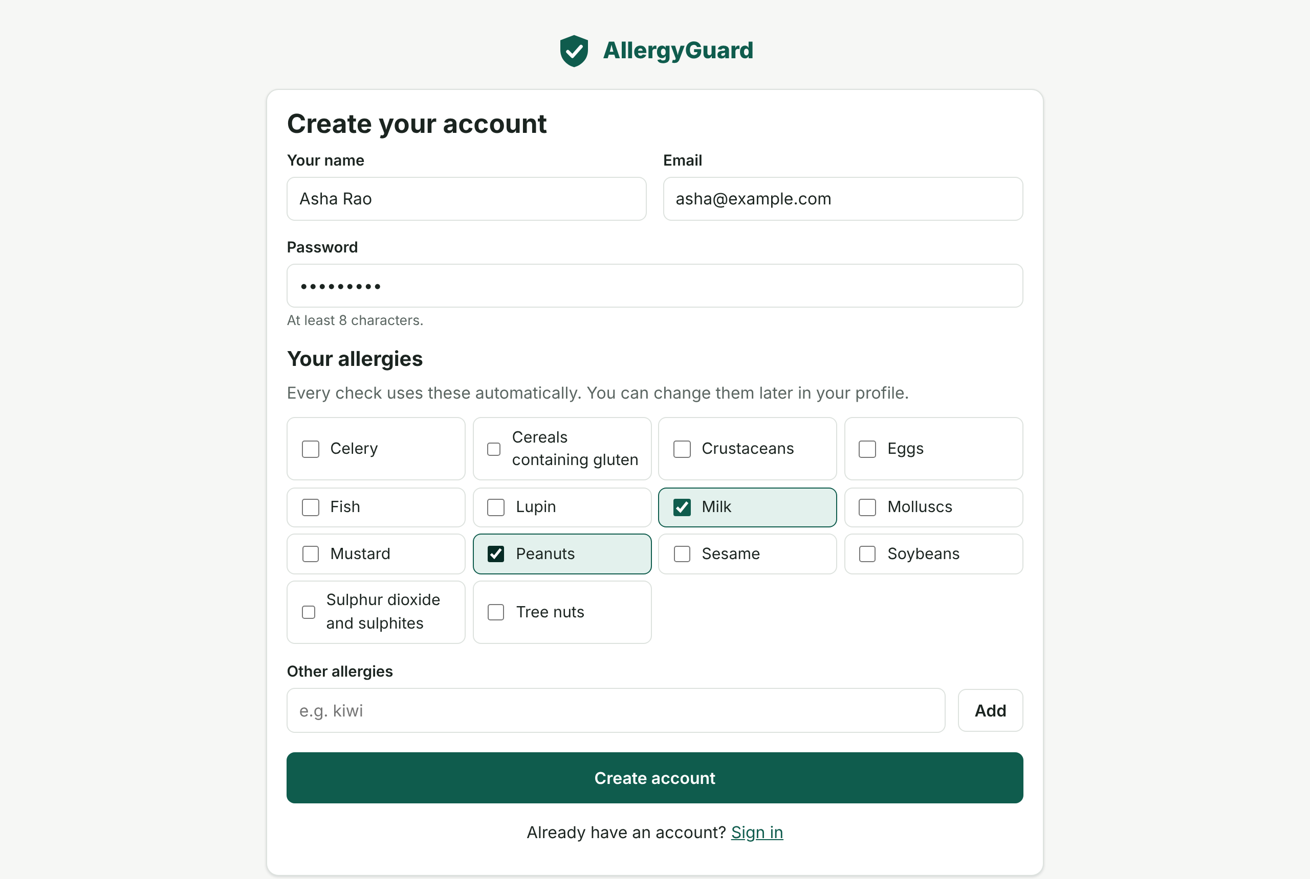
Figure 12.1: Customer sign-up with required allergy selection
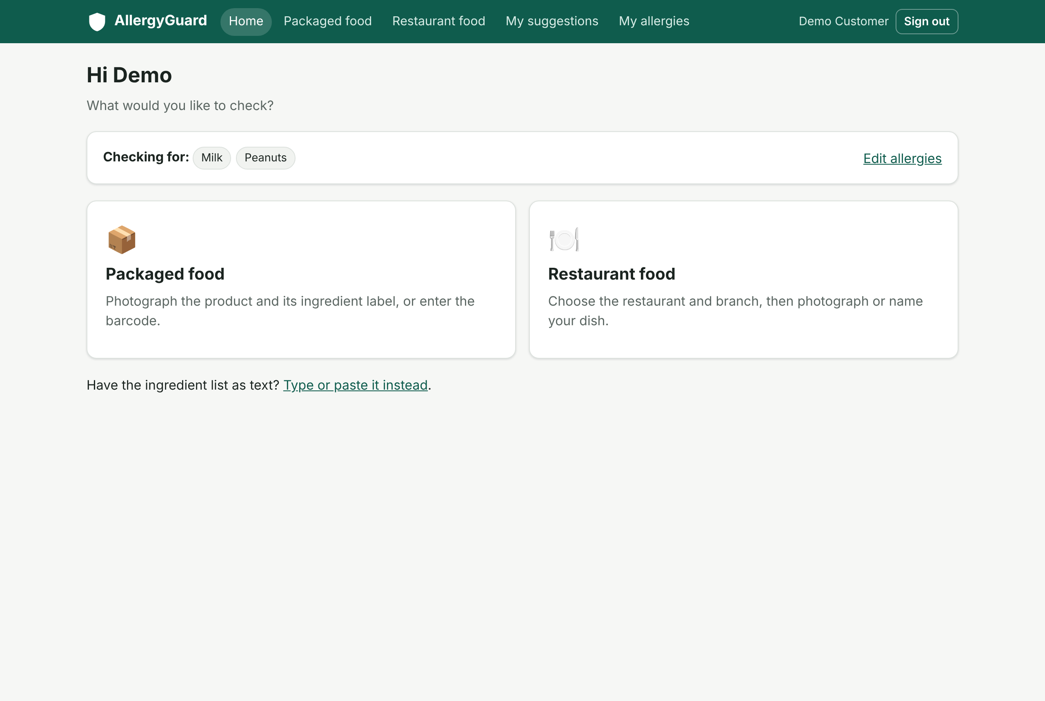
Figure 12.2: Customer home with the two checking pathways
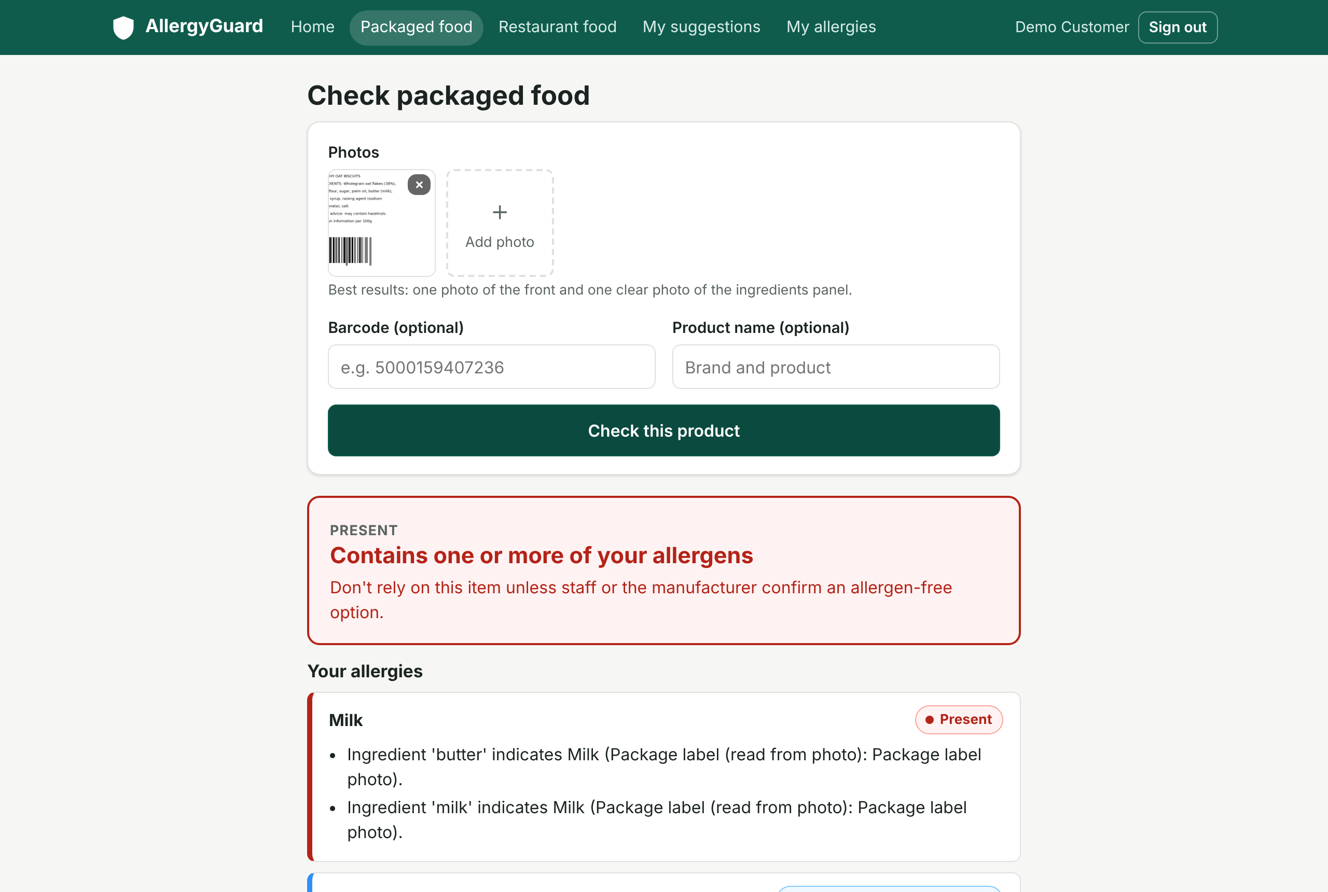
Figure 12.3: Packaged-food result from a label photograph
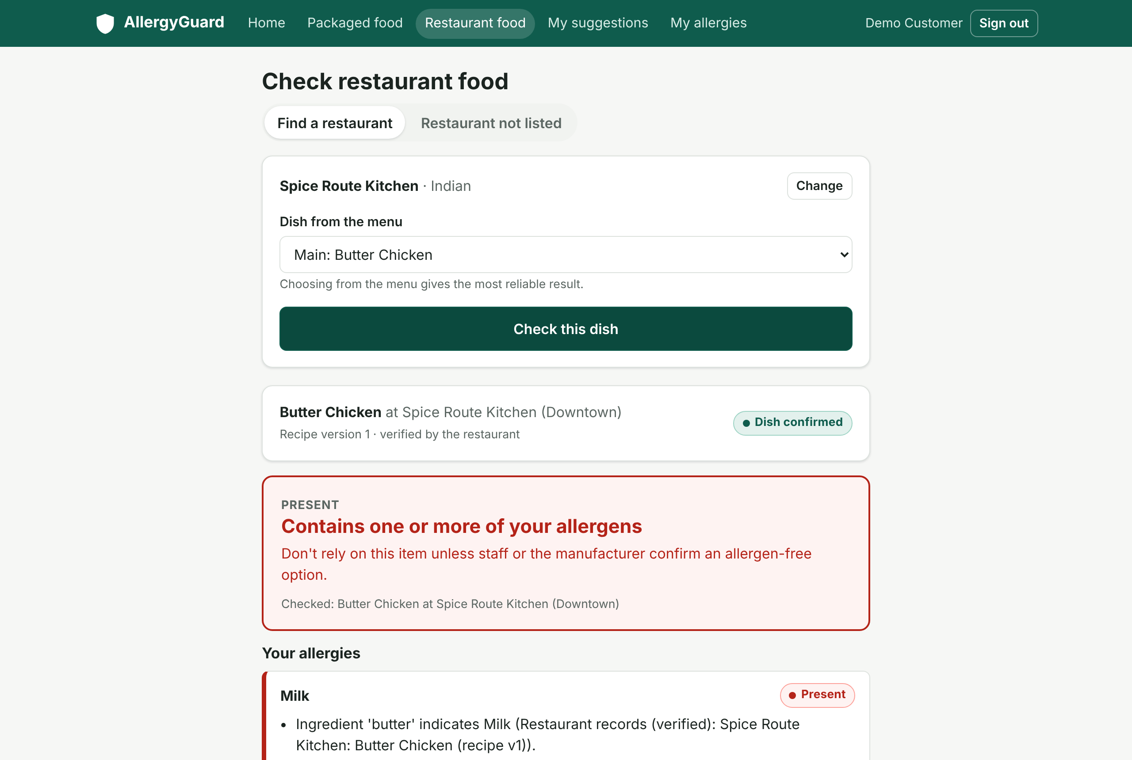
Figure 12.4: Restaurant dish result based on verified records
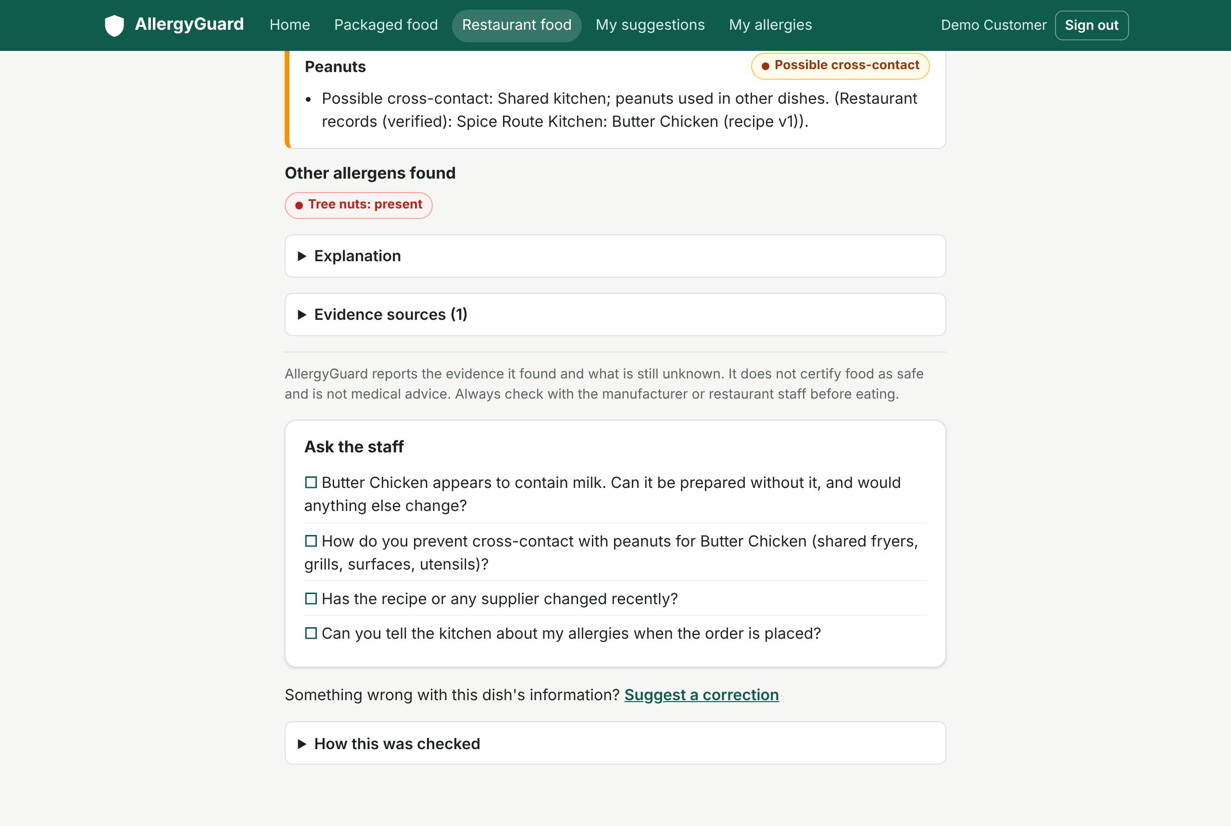
Figure 12.5: Evidence, disclaimer and questions for restaurant staff
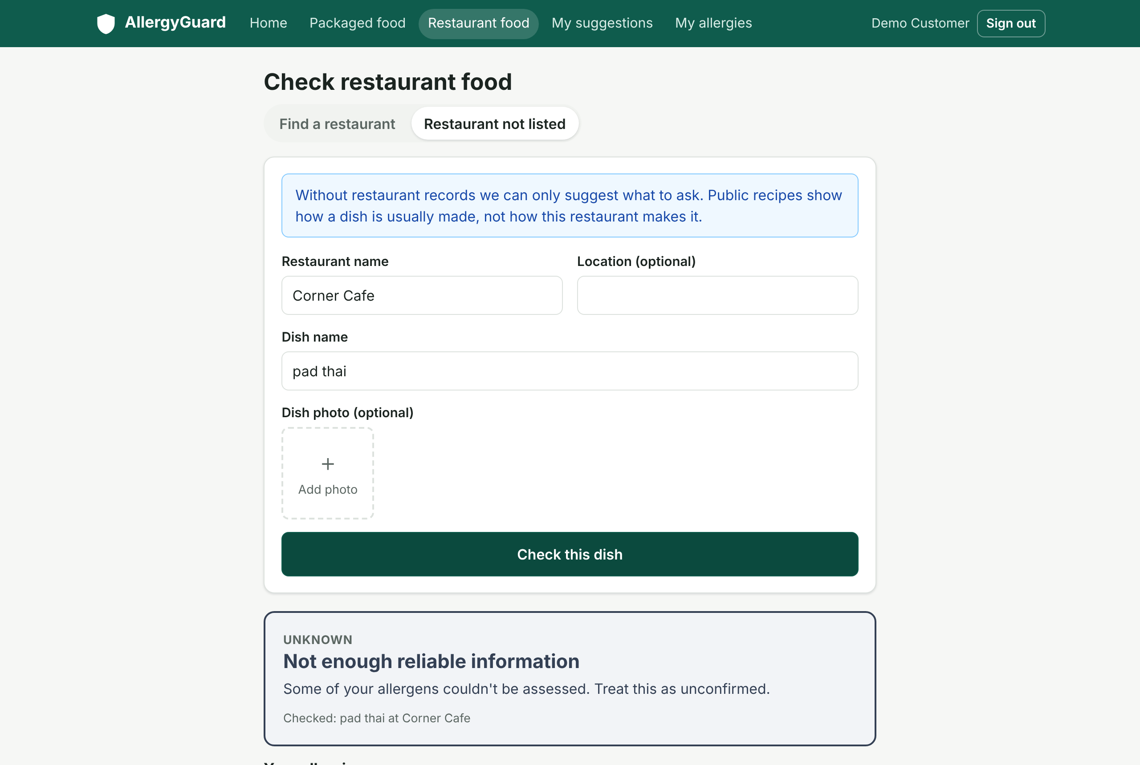
Figure 12.6: Unregistered restaurant: unknown outcomes with limitations
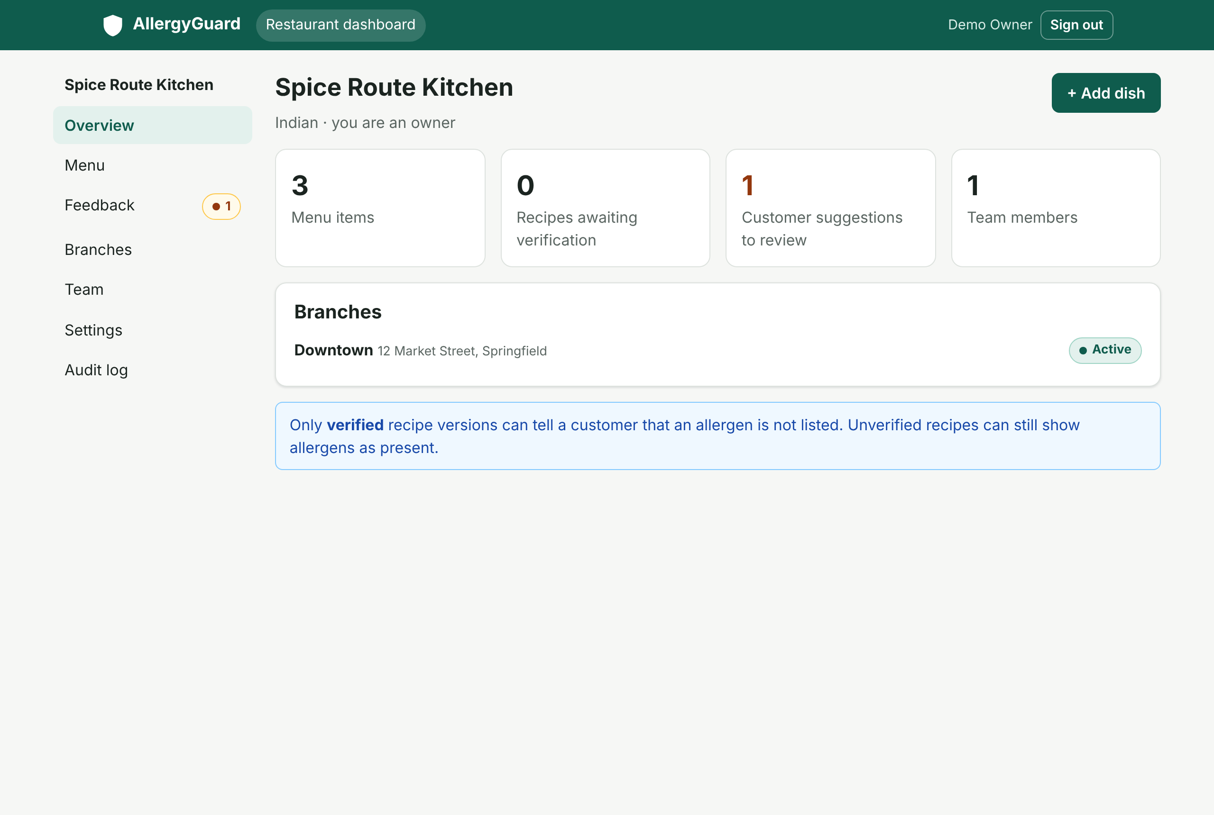
Figure 12.7: Restaurant dashboard overview
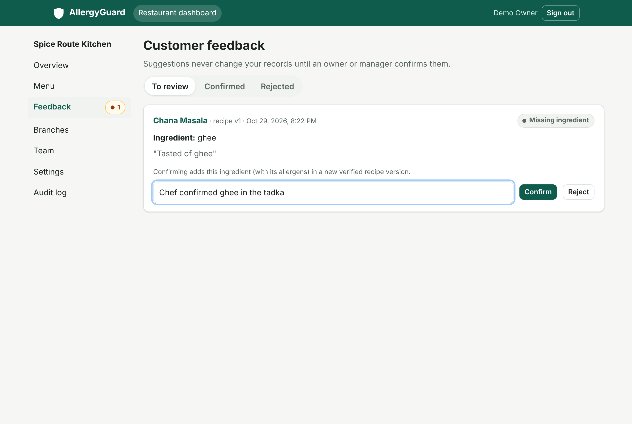
Figure 12.8: Review of a customer suggestion
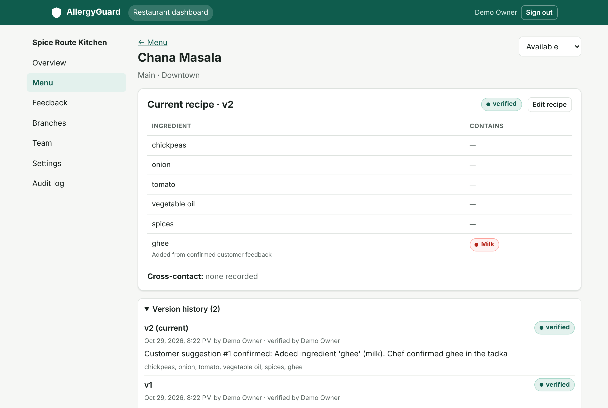
Figure 12.9: Dish page after confirmation: verified version 2 and history
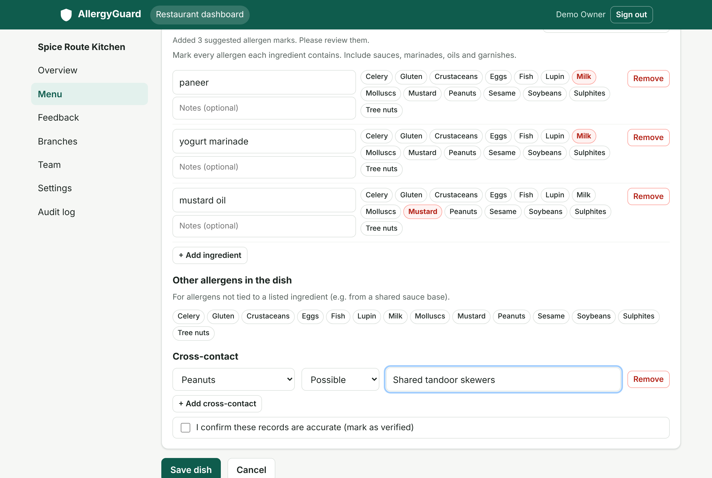
Figure 12.10: Recipe editor with allergen suggestions and cross-contact
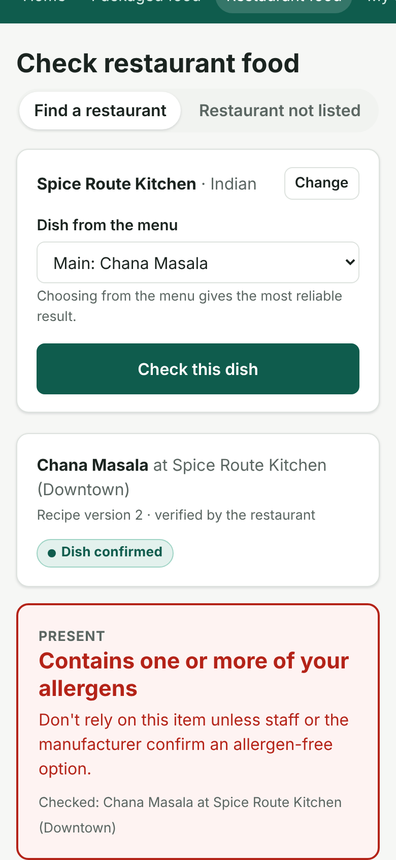
Figure 12.11: Restaurant result on a phone-sized screen

12.5 OCR Robustness
A generated ingredient label (16 ingredient words, with a barcode) was degraded in controlled ways and processed by the packaged-food pipeline's image checks, OCR, ingredient extraction and barcode reader. Ingredient word recall is the share of the 16 expected words found in the extracted ingredient text. Table 12.4 shows the results.
Table 12.4: OCR robustness on a degraded label image
Condition | Quality flag raised | OCR conf. | Heading found | Word recall | Milk found | Barcode read
Clean | None | 0.95 | Yes | 100% | Yes | Yes
Gaussian blur, r = 1 | None | 0.96 | Yes | 100% | Yes | Yes
Gaussian blur, r = 2 | None | 0.91 | Yes | 100% | Yes | No
Gaussian blur, r = 3 | Blurry | 0.54 | Yes | 24% | Yes | No
Downscaled to 50% | None | 0.95 | Yes | 100% | Yes | Yes
Downscaled to 30% | Low resolution | 0.92 | Yes | 100% | Yes | No
Rotated 3 degrees | None | 0.91 | Yes | 100% | Yes | Yes
JPEG quality 20 | None | 0.95 | Yes | 100% | Yes | Yes
Contrast reduced to 30% | None | 0.95 | Yes | 100% | Yes | Yes
Brightness reduced to 25% | Very dark | 0.95 | Yes | 100% | Yes | Yes

Recognition remained complete under moderate blur, downscaling, rotation, heavy compression, low contrast and low light. Under heavy blur (r = 3) recall fell to 24%; the image was flagged as blurry, and because OCR confidence (0.54) fell below the 0.6 threshold, the label was automatically excluded from establishing absence. The milk finding was still reported, because presence evidence is kept even from weak sources. This is the intended safety behaviour. Barcode reading was more sensitive to blur and low resolution than text recognition, which is why the system falls back to OCR and name search. The low-contrast image was read correctly but was not flagged by the contrast check; the threshold could be tuned with real photographs.

12.6 Performance
Table 12.5: Measured response times (4 vCPU Xeon @ 2.1 GHz, local PostgreSQL)
Operation | Median | 95th pct. | Runs
Engine assessment of one label (in-process) | 2.6 ms | 4.9 ms | 200
POST /analyze/text (typed ingredient list) | 11.5 ms | 14.5 ms | 50
POST /analyze/restaurant (dish name, verified records) | 22.5 ms | 30.7 ms | 50
POST /analyze/packaged (one label photo: checks, barcode, OCR) | 436 ms | 515 ms | 15

The deterministic parts of the system respond well within interactive limits; OCR dominates the packaged-food time. Network calls to Open Food Facts and optional AI services add their own latency (typically from a fraction of a second to a few seconds), which was not included because those services were not reachable from the test environment.

12.7 Discussion

Strengths
- Consistent results: the same engine and rules apply to labels, product databases, restaurant records and public recipes.
- Safety by construction: no path in the rules converts missing or weak evidence into a favourable result, and this is enforced by tests.
- Explainability: every outcome lists its reasons and sources, and conflicts and limitations are explicit.
- Data quality loop: customer feedback improves restaurant records only through authorized, audited, versioned changes.
- Graceful degradation: without AI or external services, the system still works and states what it could not do.

Limitations
- Evaluation used generated label images, not photographs of real packaging; accuracy on real-world photos (curved packs, glare, small print, non-English labels) has not been measured.
- Open Food Facts lookups and the AI features (vision identification, public-recipe search, AI explanations) could not be exercised against the live services in the development environment; their integration logic was tested with fixed responses.
- The formal evaluation planned in the design (top-k product identification, per-allergen precision and recall, dish-match accuracy on a labelled dataset) remains to be carried out.
- Custom allergies are matched by name only; allergens hidden in non-specific ingredients are reported as limitations but do not change the outcome.
- Database schema migrations are not yet managed by a migration tool.

13. Conclusion
This project designed and implemented AllergyGuard, an allergen-information system that helps people with food allergies check packaged food and restaurant dishes against their own allergies. Its distinguishing feature is a shared, deterministic engine that treats every input as evidence with an explicit level of trust, reports four evidence-status outcomes, and never presents missing information as safety. Restaurants maintain versioned, audited records through a private dashboard, and customer feedback improves those records only through authorized confirmation. AI is used only where its mistakes cannot become decisions.
The complete system, comprising the database, API, both pipelines, the engine, the verification workflow and the web application, was implemented and verified with 108 passing automated tests and end-to-end browser runs. Measured response times are interactive, and the OCR experiment showed both robustness to common image degradations and the intended conservative behaviour when image quality is poor.

13.1 Future Work
- Evaluate on a labelled dataset of real product photographs and restaurant dishes, reporting identification accuracy and per-allergen precision, recall and false-negative rate.
- Add multilingual OCR and knowledge-base terms for Indian and other languages.
- Add a migration tool, account deletion and data export, and a formal privacy notice before public deployment.
- Notify restaurant staff of new suggestions (email or push) and remind them to re-verify ageing recipes.
- Support manufacturer data feeds and recipe-change alerts for saved products.
- Conduct a usability study with people with food allergies and with restaurant staff, and a WCAG 2.1 accessibility audit.

14. References
[1] R. S. Gupta, C. M. Warren, B. M. Smith et al., "Prevalence and severity of food allergies among US adults," JAMA Network Open, vol. 2, no. 1, e185630, 2019.
[2] W. Loh and M. L. K. Tang, "The epidemiology of food allergy in the global context," International Journal of Environmental Research and Public Health, vol. 15, no. 9, 2043, 2018.
[3] S. H. Sicherer and H. A. Sampson, "Food allergy: A review and update on epidemiology, pathogenesis, diagnosis, prevention, and management," Journal of Allergy and Clinical Immunology, vol. 141, no. 1, pp. 41-58, 2018.
[4] European Parliament and Council, "Regulation (EU) No 1169/2011 on the provision of food information to consumers," Official Journal of the European Union, L 304, 2011.
[5] U.S. Congress, "Food Allergen Labeling and Consumer Protection Act of 2004 (FALCPA)," Public Law 108-282, Title II, 2004.
[6] U.S. Congress, "Food Allergy Safety, Treatment, Education, and Research (FASTER) Act of 2021," Public Law 117-11, 2021.
[7] Food Safety and Standards Authority of India, "Food Safety and Standards (Labelling and Display) Regulations, 2020," Gazette of India, 2020.
[8] K. J. Allen, P. J. Turner, R. Pawankar et al., "Precautionary labelling of foods for allergen content: are we ready for a global framework?" World Allergy Organization Journal, vol. 7, no. 1, 10, 2014.
[9] Codex Alimentarius Commission, "General Standard for the Labelling of Prepackaged Foods," CXS 1-1985, FAO/WHO.
[10] R. Smith, "An overview of the Tesseract OCR engine," in Proc. 9th International Conference on Document Analysis and Recognition (ICDAR), 2007, pp. 629-633.
[11] GS1, "GS1 General Specifications," GS1 AISBL, Brussels. [Online]. Available: https://www.gs1.org/standards/barcodes-epcrfid-id-keys/gs1-general-specifications
[12] Open Food Facts, "Open Food Facts API documentation." [Online]. Available: https://openfoodfacts.github.io/openfoodfacts-server/api/
[13] L. Bossard, M. Guillaumin and L. Van Gool, "Food-101: Mining discriminative components with random forests," in Proc. European Conference on Computer Vision (ECCV), 2014, pp. 446-461.
[14] W. Min, S. Jiang, L. Liu, Y. Rui and R. Jain, "A survey on food computing," ACM Computing Surveys, vol. 52, no. 5, article 92, 2019.
[15] A. Radford, J. W. Kim, C. Hallacy et al., "Learning transferable visual models from natural language supervision," in Proc. 38th International Conference on Machine Learning (ICML), PMLR 139, 2021, pp. 8748-8763.
[16] Z. Ji, N. Lee, R. Frieske et al., "Survey of hallucination in natural language generation," ACM Computing Surveys, vol. 55, no. 12, article 248, 2023.
[17] P. Lewis, E. Perez, A. Piktus et al., "Retrieval-augmented generation for knowledge-intensive NLP tasks," in Advances in Neural Information Processing Systems (NeurIPS), vol. 33, 2020.
[18] European Parliament and Council, "Regulation (EU) 2016/679 (General Data Protection Regulation)," Official Journal of the European Union, L 119, 2016.
[19] Government of India, "The Digital Personal Data Protection Act, 2023," Act No. 22 of 2023.
[20] Anthropic, "Claude API documentation: models and pricing." [Online]. Available: https://docs.claude.com
[21] United Nations General Assembly, "Transforming our world: the 2030 Agenda for Sustainable Development," A/RES/70/1, 2015.
[22] FastAPI documentation. [Online]. Available: https://fastapi.tiangolo.com
[23] PostgreSQL Global Development Group, "PostgreSQL 16 documentation." [Online]. Available: https://www.postgresql.org/docs/16/
[24] React documentation. [Online]. Available: https://react.dev
[25] Tesseract OCR project. [Online]. Available: https://github.com/tesseract-ocr/tesseract
[26] National Board of Accreditation, India, "General Manual of Accreditation" (Graduate Attributes and Programme Outcomes). [Online]. Available: https://www.nbaind.org

15. SDG Mapping
Table 15.1 maps the project's features to the Sustainable Development Goals and targets discussed in Chapter 11 [21]. Contribution level: High (3), Medium (2), Low (1).
Table 15.1: SDG mapping
SDG | Target | Project contribution | Level
SDG 3: Good Health and Well-being | 3.d: risk reduction and management of health risks | Identifies allergens and cross-contact before eating; explicit uncertainty; questions for staff; avoids false reassurance | High (3)
SDG 2: Zero Hunger | 2.1: access to safe, nutritious and sufficient food | Widens the range of food that allergic consumers can choose with confidence | Medium (2)
SDG 12: Responsible Consumption and Production | 12.8: relevant information for informed choices | Structured, explained allergen information; restaurant records maintained and versioned | High (3)
SDG 9: Industry, Innovation and Infrastructure | 9.5 / 9.c: innovation; access to ICT | Low-cost digital allergen management for restaurants; open-data and AI-assisted tooling | Medium (2)
SDG 10: Reduced Inequalities | 10.2: social inclusion of all | Supports people with food allergies in eating out and everyday food choices | Medium (2)

16. CO-PO-PSO Mapping
[[Replace the course outcomes (COs) and programme-specific outcomes (PSOs) below with those in your course handout and programme documents. The programme outcomes (PO1-PO12) follow the NBA graduate attributes [26].]]

16.1 Course Outcomes
Table 16.1: Course outcomes
CO | Description
CO1 | Identify a real-world problem, review the literature and formulate the problem statement and objectives
CO2 | Design a system architecture and data model that meet functional, safety and security requirements
CO3 | Implement the solution using modern tools, frameworks and engineering practices
CO4 | Test, evaluate and analyse the solution and interpret the results
CO5 | Consider safety, ethical, environmental, sustainability and cost aspects of the solution
CO6 | Work effectively in a team, manage the project and communicate it through reports and presentations

16.2 Programme Outcomes and Programme-Specific Outcomes
Table 16.2: Programme outcomes (PO) and programme-specific outcomes (PSO)
Code | Outcome
PO1 | Engineering knowledge
PO2 | Problem analysis
PO3 | Design / development of solutions
PO4 | Conduct investigations of complex problems
PO5 | Modern tool usage
PO6 | The engineer and society
PO7 | Environment and sustainability
PO8 | Ethics
PO9 | Individual and team work
PO10 | Communication
PO11 | Project management and finance
PO12 | Life-long learning
PSO1 | [e.g. Apply software engineering, data and AI techniques to design and develop computing solutions]
PSO2 | [e.g. Develop secure, scalable web and data-driven applications using modern platforms]
PSO3 | [e.g. Apply computing to solve societal problems responsibly]

16.3 Mapping Matrix
Correlation levels: 3 = high, 2 = medium, 1 = low, - = none.
Table 16.3: CO-PO-PSO mapping
CO | PO1 | PO2 | PO3 | PO4 | PO5 | PO6 | PO7 | PO8 | PO9 | PO10 | PO11 | PO12 | PSO1 | PSO2 | PSO3
CO1 | 2 | 3 | 1 | 2 | 1 | 2 | 1 | 1 | - | 1 | - | 2 | 2 | 1 | 2
CO2 | 3 | 3 | 3 | 2 | 2 | 1 | 1 | 1 | 1 | 1 | 1 | 1 | 3 | 3 | 2
CO3 | 3 | 2 | 3 | 1 | 3 | 1 | - | 1 | 2 | - | 1 | 2 | 3 | 3 | 2
CO4 | 2 | 3 | 2 | 3 | 3 | 1 | - | 1 | 1 | 1 | - | 2 | 3 | 2 | 1
CO5 | 1 | 2 | 2 | 1 | 1 | 3 | 3 | 3 | - | 1 | 2 | 1 | 1 | 1 | 3
CO6 | - | - | 1 | - | 1 | 1 | - | 2 | 3 | 3 | 3 | 2 | 1 | 1 | 1
Avg. | 2.2 | 2.6 | 2.0 | 1.8 | 1.8 | 1.5 | 1.7 | 1.5 | 1.8 | 1.4 | 1.8 | 1.7 | 2.2 | 1.8 | 1.8

16.4 Justification
Table 16.4: How the project addresses the programme outcomes
Outcome | Evidence in this project
PO1, PO2 | Analysis of allergen labelling regulations, OCR, product identification and LLM behaviour (Chapters 1-3) to formulate a precise problem
PO3 | Architecture, data model, decision rules and workflows designed for safety and explainability (Chapters 4-5)
PO4 | OCR robustness experiment, performance measurements and analysis of results and limitations (Chapter 12)
PO5 | FastAPI, PostgreSQL, React, TypeScript, Tesseract, Docker, Playwright, pytest and an LLM API (Chapter 6)
PO6, PO8 | Safety principles, hazard analysis, health-data privacy, responsible AI and accountability (Chapters 8-9)
PO7 | Low-compute design and sustainability analysis (Sections 6.4 and Chapter 7)
PO9, PO10 | Team development in five phases with version control; this report and the demonstration
PO11 | Development and operating cost analysis (Chapter 10)
PO12 | Adoption of new tools and identification of future work (Section 13.1)
PSO1-PSO3 | A complete, secure, data-driven web application applied to a public-health problem

