National University of Computer & Emerging Sciences
Karachi Campus



Adaptive Warehouse Management System with AI-Based Thread Scheduling
Project Report
Operating System
Section: BCS-4A

Group Members:

23K-0724 Roshaan Haider
23k-0530 Arti Devi
23k-0576 Syed Abdullah Azzam

1. Objective
The objective of this project is to design and implement a synchronized warehouse management simulation using core Operating System concepts. The system models suppliers as producer threads and retailers as consumer threads that access a shared warehouse buffer. The project also integrates a lightweight Q-learning based AI scheduler that observes buffer pressure and dynamically adjusts supplier and retailer execution delays to reduce starvation and improve balance.
The completed system demonstrates thread synchronization, semaphore-based bounded-buffer control, shared-memory IPC, persistent user management, logging, and a live professional terminal dashboard for visual explanation during demonstration and VIVA.
Objective | How It Is Achieved
Producer-consumer synchronization | Supplier and retailer threads coordinate through POSIX semaphores and a mutex-protected circular buffer.
Starvation reduction | AI observes low/high buffer states and waiting counters, then boosts suppliers or retailers through adaptive delay changes.
Live visualization | A full Ubuntu terminal interface shows buffer state, thread activity, AI decisions, Q-table values, and system logs.
Persistent administration | Admin, supplier, and retailer records are stored in files and reused across executions.

2. Introduction
Modern inventory systems involve many producers and consumers interacting with shared stock. If these operations are not synchronized, race conditions, incorrect counts, deadlocks, and starvation can occur. This project uses the classical Producer-Consumer Problem as the foundation for a warehouse simulation in which suppliers deliver items to a bounded buffer and retailers remove items from it.
The project extends the basic synchronization model by adding an AI observer thread. The AI scheduler uses a Q-table to learn which action is most useful in each warehouse state. Instead of claiming to modify real Linux thread priorities, the implementation uses controlled sleep-delay adjustment as a realistic simulation of priority boosting within a student OS project.

3. Background
The Producer Consumer Problem is one of the most important synchronization problems in Operating Systems. It explains how multiple threads or processes can safely share a limited resource. In this project, the limited resource is the warehouse buffer. Suppliers must wait when the buffer is full, while retailers must wait when the buffer is empty.
Traditional static scheduling gives each thread a fixed behavior. However, warehouse demand is not always balanced. If retailers consume faster than suppliers produce, the buffer can stay empty and consumers wait. If suppliers produce faster than retailers consume, the buffer can stay full and producers wait. The adaptive AI component addresses this by monitoring the live state and changing scheduling behavior at runtime.

4. Platform and Languages

Category | Technology Used | Purpose
Operating System | Ubuntu 24.04 / WSL | Native Linux environment for POSIX threading, semaphores, and shared memory.
Programming Language | C | Low level implementation aligned with OS course requirements.
Threading | pthread.h | Supplier, retailer, and AI observer threads.
Synchronization | pthread_mutex_t and sem_t | Critical section protection and full/empty buffer counting.
IPC | shm_open and mmap | Shared warehouse state readable by dashboard/observer processes.
Interface | ncurses terminal UI | Professional Ubuntu window dashboard and admin control room.
Build Tool | GCC and Makefile | Compilation of main system and dashboard targets.

5. Methodology
The system follows a modular design. The warehouse module owns the shared buffer, counters, semaphores, mutex, AI state, and runtime flags. Supplier and retailer modules implement producer and consumer behavior. The user module handles persistent accounts and logging. The AI module observes the shared warehouse state and updates the Q-table. The UI module displays and controls the system through a professional terminal interface.
Module | Main Responsibility
warehouse.c / warehouse.h | Creates shared memory, initializes semaphores/mutex, stores buffer, counters, AI status, and runtime state.
supplier.c | Runs supplier producer threads that generate random item IDs and quantities, then insert items into the buffer.
retailer.c | Runs retailer consumer threads that remove items from the buffer and record consumption activity.
ai.c / ai.h | Implements Q-learning state detection, action selection, reward calculation, delay adjustment, and Q-table updates.
user.c / admin.c | Stores admin/user accounts, authenticates users, manages roles, and writes logs.
ui.c | Provides the main admin interface, dashboard tabs, log view, and live AI visualization.

5.1 Producer-Consumer Flow
Each supplier thread waits for an empty slot before producing. Each retailer thread waits for a full slot before consuming. A mutex protects the critical section so only one thread updates the buffer at a time. This prevents race conditions and keeps the in/out circular-buffer pointers consistent.
Step | Supplier / Producer | Retailer / Consumer
1 | Waits on empty semaphore | Waits on full semaphore
2 | Locks warehouse mutex | Locks warehouse mutex
3 | Adds item to buffer and updates counters | Removes item from buffer and updates counters
4 | Unlocks mutex and posts full semaphore | Unlocks mutex and posts empty semaphore

6. AI-Based Adaptive Scheduling
The AI scheduler is implemented as a separate observer thread. Every cycle, it checks the warehouse buffer level, waiting counters, and starvation indicators. It then selects one of three actions: boost suppliers, boost retailers, or balance both sides. The selected action directly changes the delay used by supplier and retailer threads.
AI State | Meaning | Preferred Action
LOW BUFFER | Consumers may starve because the warehouse has too few items. | Boost suppliers
HIGH BUFFER | Producers may block because the warehouse is almost full. | Boost retailers
BALANCED | Production and consumption are stable. | Balance both sides
LOW/HIGH + STARVATION | A side is repeatedly waiting or blocked. | Give priority to the side that relieves the pressure

Action | Technical Effect | Why It Helps
BOOST SUPPLIERS | producer_delay becomes shorter and retailer_delay becomes longer | Suppliers run more often, helping refill an empty buffer.
BOOST RETAILERS | retailer_delay becomes shorter and producer_delay becomes longer | Retailers run more often, helping free full buffer slots.
BALANCE BOTH SIDES | Both delays return to normal | Stable systems do not need forced priority changes.

Q-learning is used to update the value of each state/action pair. Correct actions receive positive reward, while unsuitable actions receive penalties. The dashboard displays the changing Q-table so the evaluator can see that the AI is not only printing messages but learning which decision is most useful for each state.

7. Interface and Functional Features
The final system uses a professional Ubuntu terminal interface. This avoids raw terminal menus and makes the project easier to explain during demonstration. The interface acts as a control room where the admin can login, add suppliers, add retailers, start threads, set operation limits, stop/reset the simulation, and switch between overview, AI learning, and log tabs.
Interface Feature | Functionality
Admin control room | Admin login, account creation, user selection, and simulation controls.
Overview tab | Live buffer visualization, producer/consumer totals, waiting counters, and AI decision.
AI Learning tab | Q-table values and highlighted current AI state.
Logs tab | Recent system events and item production/consumption logs.
Bulk controls | Start all suppliers or all retailers for stress scenarios.

8. Results and Comparison
The completed implementation satisfies the main project requirements: synchronized producer-consumer execution, shared memory setup, AI observer thread, Q-table learning, starvation awareness, persistent users, logging, and a live interface. The AI-based behavior improves demonstration quality because the system reacts visibly when the buffer becomes low, high, or balanced.
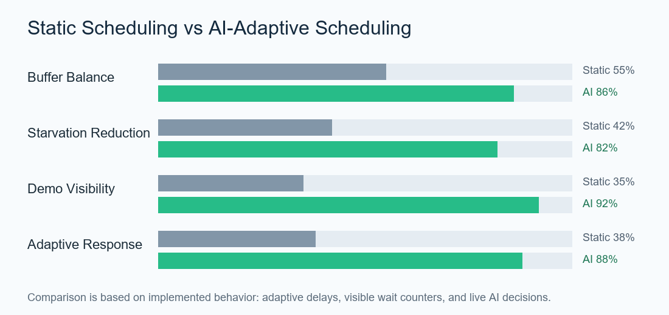
Figure 1. Qualitative comparison between static scheduling and adaptive AI scheduling in the implemented warehouse simulation.
Requirement | Final Status | Evidence in Project
Producer-consumer model | Completed | supplier.c and retailer.c use semaphores and mutex-protected buffer access.
POSIX threads | Completed | Suppliers, retailers, and AI scheduler run as pthread threads.
Shared memory IPC | Completed | Warehouse state is stored through shm_open and mmap.
AI scheduling | Completed with honest scope | Q-table updates and delay-based priority boosting are visible in UI.
Live dashboard | Completed | ncurses interface shows buffer, AI, waiting counters, Q-table, and logs.
Logging | Completed | system_log.txt records production/consumption with buffer statistics.

9. Conclusion
The Adaptive Warehouse Management System successfully demonstrates major Operating System concepts in a single integrated project. It uses POSIX threads to simulate multiple suppliers and retailers, semaphores to control buffer availability, a mutex to protect shared data, and shared memory to support dashboard-style monitoring. The user and admin system adds persistence and makes the simulation more realistic.
The AI scheduler improves the basic producer-consumer model by observing live warehouse pressure and adapting execution delays. This reduces starvation pressure and makes scheduling behavior easier to understand during the demo. The Q-learning table, reward values, and AI action display show how the system learns preferred actions for low, high, and balanced buffer states.
Overall, the final implementation is aligned with the original proposal while also adding a more complete interface and clearer demonstration features. The project is suitable for VIVA because each visible component maps directly to an OS concept: threads, synchronization, IPC, starvation, scheduling, logging, and real-time monitoring.

10. Future Scope
Improvement | Possible Extension
Real kernel priorities | Use pthread scheduling policies where permission and system configuration allow it.
More detailed analytics | Store historical buffer levels and generate measured graphs after each run.
Multi-process workers | Convert suppliers and retailers from threads into separate processes for deeper IPC demonstration.
Inventory categories | Support multiple product types and per-product buffer sections.

