BANK FRAUD MANAGEMENT SYSTEM

ROSHAAN REHMAN AND SARAH ARIF

Milestones
1.ERD diagram | V1.0
2.Database schema | V1.1

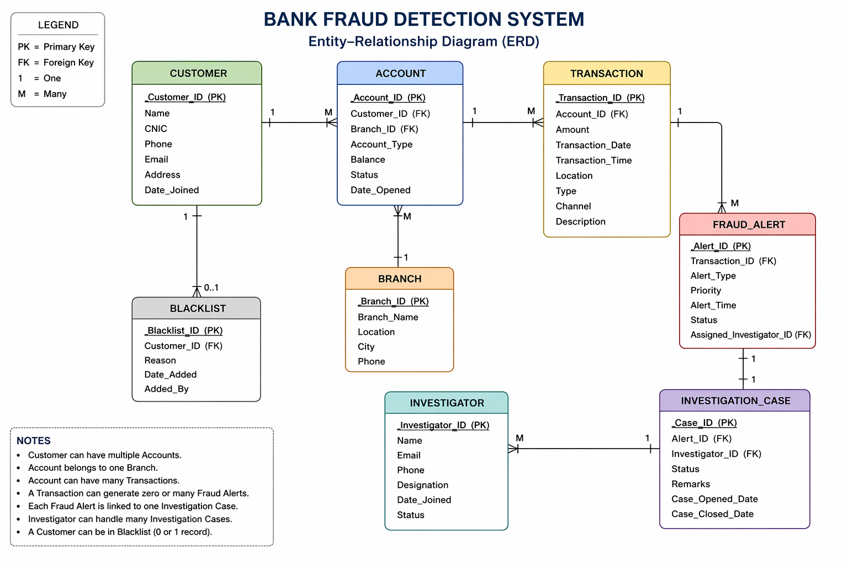

2. Relational Database Schema
2.1 BRANCH
Column Name | Data Type | Constraints | Description
Branch_ID | INT | PK, AUTO_INCREMENT | Unique branch identifier
Branch_Name | VARCHAR(100) | NOT NULL | Name of the branch
Location | VARCHAR(150) |  | Street / area address
City | VARCHAR(100) |  | City where branch is located
Phone | VARCHAR(20) |  | Branch contact number

2.2 CUSTOMER
Column Name | Data Type | Constraints | Description
Customer_ID | INT | PK, AUTO_INCREMENT | Unique customer identifier
Name | VARCHAR(100) | NOT NULL | Full legal name
CNIC | VARCHAR(15) | NOT NULL, UNIQUE | National identity number
Phone | VARCHAR(20) |  | Contact phone number
Email | VARCHAR(100) | UNIQUE | Email address
Address | VARCHAR(255) |  | Residential address
Date_Joined | DATE | NOT NULL | Date customer registered

2.3 ACCOUNT
Column Name | Data Type | Constraints | Description
Account_ID | INT | PK, AUTO_INCREMENT | Unique account identifier
Customer_ID | INT | FK → CUSTOMER, NOT NULL | Account owner
Branch_ID | INT | FK → BRANCH, NOT NULL | Branch managing account
Account_Type | VARCHAR(50) | NOT NULL | Savings / Current / etc.
Balance | DECIMAL(15,2) | NOT NULL, DEFAULT 0.00 | Current account balance
Status | VARCHAR(20) | NOT NULL, DEFAULT 'Active' | Active / Frozen / Closed
Date_Opened | DATE | NOT NULL | Account opening date

2.4 TRANSACTION
Column Name | Data Type | Constraints | Description
Transaction_ID | INT | PK, AUTO_INCREMENT | Unique transaction identifier
Account_ID | INT | FK → ACCOUNT, NOT NULL | Account that initiated transaction
Amount | DECIMAL(15,2) | NOT NULL | Transaction amount
Transaction_Date | DATE | NOT NULL | Date of transaction
Transaction_Time | TIME | NOT NULL | Time of transaction
Location | VARCHAR(150) |  | Physical / IP location
Type | VARCHAR(50) | NOT NULL | Debit / Credit / Transfer
Channel | VARCHAR(50) |  | ATM / Online / Branch
Description | VARCHAR(255) |  | Notes or reference

2.5 INVESTIGATOR
Column Name | Data Type | Constraints | Description
Investigator_ID | INT | PK, AUTO_INCREMENT | Unique investigator identifier
Name | VARCHAR(100) | NOT NULL | Full name
Email | VARCHAR(100) | UNIQUE | Work email
Phone | VARCHAR(20) |  | Contact number
Designation | VARCHAR(100) |  | Job title / rank
Date_Joined | DATE |  | Employment start date
Status | VARCHAR(20) | NOT NULL, DEFAULT 'Active' | Active / Inactive

2.6 FRAUD_ALERT
Column Name | Data Type | Constraints | Description
Alert_ID | INT | PK, AUTO_INCREMENT | Unique alert identifier
Transaction_ID | INT | FK → TRANSACTION, NOT NULL | Transaction that triggered alert
Alert_Type | VARCHAR(100) | NOT NULL | Unusual Location / Large Amount / etc.
Priority | VARCHAR(20) | NOT NULL | High / Medium / Low
Alert_Time | DATETIME | NOT NULL | When alert was generated
Status | VARCHAR(30) | NOT NULL, DEFAULT 'Open' | Open / Closed / Escalated
Assigned_Investigator_ID | INT | FK → INVESTIGATOR, NOT NULL | Investigator assigned to alert

2.7 INVESTIGATION_CASE
Column Name | Data Type | Constraints | Description
Case_ID | INT | PK, AUTO_INCREMENT | Unique case identifier
Alert_ID | INT | FK → FRAUD_ALERT, UNIQUE | One-to-one link to fraud alert
Investigator_ID | INT | FK → INVESTIGATOR, NOT NULL | Investigator handling case
Status | VARCHAR(30) | NOT NULL, DEFAULT 'Open' | Open / In Progress / Closed
Remarks | TEXT |  | Case notes and findings
Case_Opened_Date | DATE | NOT NULL | Date case was opened
Case_Closed_Date | DATE |  | Date case was resolved (nullable)

2.8 BLACKLIST
Column Name | Data Type | Constraints | Description
Blacklist_ID | INT | PK, AUTO_INCREMENT | Unique blacklist record identifier
Customer_ID | INT | FK → CUSTOMER, UNIQUE, NOT NULL | UNIQUE enforces 0-or-1 per customer
Reason | VARCHAR(255) | NOT NULL | Reason for blacklisting
Date_Added | DATE | NOT NULL | Date added to blacklist
Added_By | VARCHAR(100) |  | Name of officer who added entry

3. SQL DDL — CREATE TABLE Statements
The following SQL statements can be executed directly in MySQL / MariaDB to create the full schema.
-- ───────────────────────────────────────── -- BRANCH -- ───────────────────────────────────────── CREATE TABLE BRANCH ( Branch_ID INT PRIMARY KEY AUTO_INCREMENT, Branch_Name VARCHAR(100) NOT NULL, Location VARCHAR(150), City VARCHAR(100), Phone VARCHAR(20) );
-- ───────────────────────────────────────── -- CUSTOMER -- ───────────────────────────────────────── CREATE TABLE CUSTOMER ( Customer_ID INT PRIMARY KEY AUTO_INCREMENT, Name VARCHAR(100) NOT NULL, CNIC VARCHAR(15) NOT NULL UNIQUE, Phone VARCHAR(20), Email VARCHAR(100) UNIQUE, Address VARCHAR(255), Date_Joined DATE NOT NULL );
-- ───────────────────────────────────────── -- ACCOUNT -- ───────────────────────────────────────── CREATE TABLE ACCOUNT ( Account_ID INT PRIMARY KEY AUTO_INCREMENT, Customer_ID INT NOT NULL, Branch_ID INT NOT NULL, Account_Type VARCHAR(50) NOT NULL, Balance DECIMAL(15,2) NOT NULL DEFAULT 0.00, Status VARCHAR(20) NOT NULL DEFAULT 'Active', Date_Opened DATE NOT NULL, CONSTRAINT fk_acc_cust FOREIGN KEY (Customer_ID) REFERENCES CUSTOMER(Customer_ID) ON DELETE RESTRICT ON UPDATE CASCADE, CONSTRAINT fk_acc_branch FOREIGN KEY (Branch_ID) REFERENCES BRANCH(Branch_ID) ON DELETE RESTRICT ON UPDATE CASCADE );
-- ───────────────────────────────────────── -- TRANSACTION -- ───────────────────────────────────────── CREATE TABLE TRANSACTION ( Transaction_ID INT PRIMARY KEY AUTO_INCREMENT, Account_ID INT NOT NULL, Amount DECIMAL(15,2) NOT NULL, Transaction_Date DATE NOT NULL, Transaction_Time TIME NOT NULL, Location VARCHAR(150), Type VARCHAR(50) NOT NULL, Channel VARCHAR(50), Description VARCHAR(255), CONSTRAINT fk_txn_acc FOREIGN KEY (Account_ID) REFERENCES ACCOUNT(Account_ID) ON DELETE RESTRICT ON UPDATE CASCADE );
-- ───────────────────────────────────────── -- INVESTIGATOR -- ───────────────────────────────────────── CREATE TABLE INVESTIGATOR ( Investigator_ID INT PRIMARY KEY AUTO_INCREMENT, Name VARCHAR(100) NOT NULL, Email VARCHAR(100) UNIQUE, Phone VARCHAR(20), Designation VARCHAR(100), Date_Joined DATE, Status VARCHAR(20) NOT NULL DEFAULT 'Active' );
-- ───────────────────────────────────────── -- FRAUD_ALERT -- ───────────────────────────────────────── CREATE TABLE FRAUD_ALERT ( Alert_ID INT PRIMARY KEY AUTO_INCREMENT, Transaction_ID INT NOT NULL, Alert_Type VARCHAR(100) NOT NULL, Priority VARCHAR(20) NOT NULL, Alert_Time DATETIME NOT NULL, Status VARCHAR(30) NOT NULL DEFAULT 'Open', Assigned_Investigator_ID INT NOT NULL, CONSTRAINT fk_alert_txn FOREIGN KEY (Transaction_ID) REFERENCES TRANSACTION(Transaction_ID) ON DELETE RESTRICT ON UPDATE CASCADE, CONSTRAINT fk_alert_inv FOREIGN KEY (Assigned_Investigator_ID) REFERENCES INVESTIGATOR(Investigator_ID) ON DELETE RESTRICT ON UPDATE CASCADE );
-- ───────────────────────────────────────── -- INVESTIGATION_CASE -- ───────────────────────────────────────── CREATE TABLE INVESTIGATION_CASE ( Case_ID INT PRIMARY KEY AUTO_INCREMENT, Alert_ID INT NOT NULL UNIQUE, Investigator_ID INT NOT NULL, Status VARCHAR(30) NOT NULL DEFAULT 'Open', Remarks TEXT, Case_Opened_Date DATE NOT NULL, Case_Closed_Date DATE, CONSTRAINT fk_case_alert FOREIGN KEY (Alert_ID) REFERENCES FRAUD_ALERT(Alert_ID) ON DELETE RESTRICT ON UPDATE CASCADE, CONSTRAINT fk_case_inv FOREIGN KEY (Investigator_ID) REFERENCES INVESTIGATOR(Investigator_ID) ON DELETE RESTRICT ON UPDATE CASCADE );
-- ───────────────────────────────────────── -- BLACKLIST -- ───────────────────────────────────────── CREATE TABLE BLACKLIST ( Blacklist_ID INT PRIMARY KEY AUTO_INCREMENT, Customer_ID INT NOT NULL UNIQUE, Reason VARCHAR(255) NOT NULL, Date_Added DATE NOT NULL, Added_By VARCHAR(100), CONSTRAINT fk_bl_cust FOREIGN KEY (Customer_ID) REFERENCES CUSTOMER(Customer_ID) ON DELETE CASCADE ON UPDATE CASCADE );

