Apache Kafka with Java

1. Apache Kafka Overview

Theory
- Apache Kafka is an open-source distributed streaming platform used for handling real-time data streaming.
- Kafka is known for its scalability, fault-tolerance, and ability to handle high volumes of data.
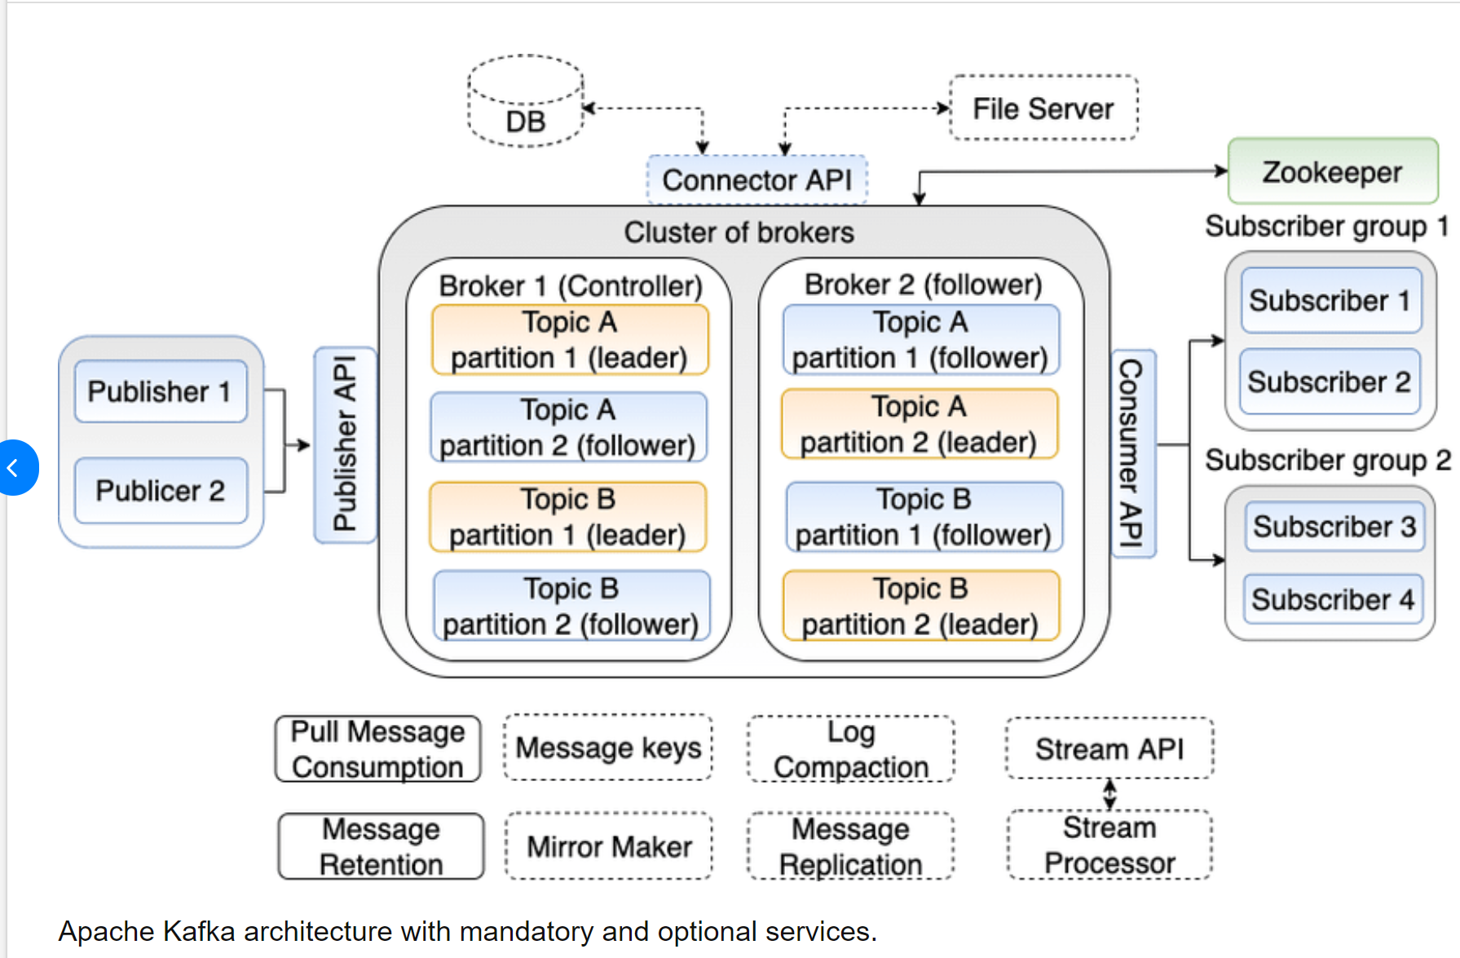
Key Concepts:
- Topics: Topics are categories or feeds to which messages are published in Kafka.
- Partitions: Topics are divided into partitions, which allow for parallel processing and scalability.
- Messages: Messages are units of data in Kafka, consisting of a key, a value, and additional metadata.
- Producers: Producers publish messages to Kafka topics.
- Consumers: Consumers subscribe to topics and consume messages from Kafka.
- Consumer Groups: Consumers can be organized into consumer groups, where each message is consumed by only one consumer within a group.
- Brokers: Brokers are the servers that handle storage and replication of Kafka topic partitions.
- ZooKeeper: ZooKeeper is used for managing and coordinating Kafka brokers and consumers.
Publish-Subscribe Model:
- Kafka follows a publish-subscribe model, where producers publish messages to topics, and consumers subscribe to topics to consume messages.
- Topics can have multiple producers and multiple consumers, forming a distributed and scalable architecture.
Key Features:
- Scalability: Kafka can scale horizontally across multiple machines to handle large volumes of data.
- Fault-tolerance: Kafka provides replication of data across multiple brokers, ensuring high availability and durability.
- High-throughput: Kafka is optimized for high write and read throughput, making it suitable for real-time streaming applications.
- Message Retention: Kafka retains messages for a configurable period, allowing consumers to replay messages and perform batch processing.
- Exactly-once Semantics: Kafka supports exactly-once message processing semantics, ensuring no data loss or duplication.
- Extensibility: Kafka integrates with other systems through Kafka Connect API and allows stream processing through Kafka Streams API.

Use Cases:
- Real-time Streaming: Kafka is widely used for real-time data ingestion, processing, and analytics in domains like finance, e-commerce, and social media.
- Log Aggregation: Kafka can collect logs from multiple sources and store them in a central location, facilitating analysis and monitoring.
- Event Sourcing: Kafka serves as an event sourcing platform, capturing and storing all events in a system for easy state reconstruction and auditing.
- Data Integration: Kafka acts as a data backbone for integrating and synchronizing data across different systems and applications.
Kafka Ecosystem:
- Kafka Connect: Kafka Connect is a framework for building connectors that import/export data between Kafka and external systems.
- Kafka Streams: Kafka Streams is a client library for building real-time stream processing applications.
- KSQL: KSQL is a streaming SQL engine for querying and transforming Kafka topics using SQL-like syntax.
- Schema Registry: The Schema Registry stores and manages Avro schemas for Kafka messages, ensuring compatibility and data consistency.

Apache Kafka is an open-source distributed event streaming platform used for real-time data streaming, messaging, log aggregation, event sourcing, and event-driven architectures.
Main capabilities:
- High throughput
- Fault tolerance
- Horizontal scalability
- Durability
- Low latency

2. Key Components
- Topics: Logical categories where records are published.
- Partitions: Divide topics for parallel processing.
- Records: Each record contains an optional key, value, timestamp, and metadata.
- Producers: Publish records.
- Consumers: Read records.
- Consumer Groups: One consumer per partition within the same group.
- Brokers: Store partitions and replicas.
- KRaft: Modern metadata management replacing ZooKeeper.

3. Important Correction: ZooKeeper vs KRaft
The original notes mention ZooKeeper as required. Modern Kafka (4.x) removes ZooKeeper completely and uses KRaft. Kafka 3.x introduced KRaft as the replacement.

4. Kafka Architecture
Flow: Producer → Topic → Partition Leader → Replica Followers → Consumer → Offset Commit.

5. Kafka Features
Feature | Purpose
Scalability | Add brokers horizontally
Fault Tolerance | Replicated partitions
High Throughput | Optimized reads and writes
Message Retention | Replay historical events
Exactly Once | Transactions + idempotence
Kafka Connect | External integrations
Kafka Streams | Java stream processing

6. Modern Installation (KRaft)
bin/kafka-storage.sh random-uuid
bin/kafka-storage.sh format -t <cluster-id> -c config/kraft/server.properties
bin/kafka-server-start.sh config/kraft/server.properties

7. Kafka CLI Commands
Create topic:
bin/kafka-topics.sh --create --topic my-topic --bootstrap-server localhost:9092 --partitions 3 --replication-factor 1
List topics:
bin/kafka-topics.sh --list --bootstrap-server localhost:9092
Describe topic:
bin/kafka-topics.sh --describe --topic my-topic --bootstrap-server localhost:9092
Console producer:
bin/kafka-console-producer.sh --topic my-topic --bootstrap-server localhost:9092
Console consumer:
bin/kafka-console-consumer.sh --topic my-topic --bootstrap-server localhost:9092 --from-beginning

8. Java Project Setup
<dependency>
<groupId>org.apache.kafka</groupId>
<artifactId>kafka-clients</artifactId>
<version>4.1.0</version>
</dependency>

9. Java Producer
Configuration:
Properties props = new Properties();
props.put("bootstrap.servers","localhost:9092");
props.put("key.serializer","org.apache.kafka.common.serialization.StringSerializer");
props.put("value.serializer","org.apache.kafka.common.serialization.StringSerializer");
KafkaProducer<String,String> producer = new KafkaProducer<>(props);
Send with callback:
ProducerRecord<String,String> record =
new ProducerRecord<>("my-topic","key1","Hello Kafka");
producer.send(record,(metadata,exception)->{
if(exception==null){
System.out.println(metadata.partition());
System.out.println(metadata.offset());
}else{
exception.printStackTrace();
}
});
producer.flush();
producer.close();

10. Java Consumer
Properties props = new Properties();
props.put("bootstrap.servers","localhost:9092");
props.put("group.id","my-group");
props.put("key.deserializer","org.apache.kafka.common.serialization.StringDeserializer");
props.put("value.deserializer","org.apache.kafka.common.serialization.StringDeserializer");
props.put("auto.offset.reset","earliest");
props.put("enable.auto.commit","false");
KafkaConsumer<String,String> consumer = new KafkaConsumer<>(props);
consumer.subscribe(List.of("my-topic"));
Polling loop:
while(true){
ConsumerRecords<String,String> records =
consumer.poll(Duration.ofSeconds(1));
for(ConsumerRecord<String,String> record: records){
System.out.println(record.value());
consumer.commitSync();
}
}

11. Serialization
Kafka stores bytes. Common Java serializers:
- StringSerializer
- IntegerSerializer
- LongSerializer
- Jackson JSON serializer
- Avro
- Protobuf

12. Consumer Groups and Offsets
If a topic has three partitions and three consumers in the same group, each consumer gets one partition. Extra consumers remain idle.
Strategy | Behavior
Auto Commit | Simple but may lose progress
Manual Commit | More reliable
Commit Before Processing | At-most-once
Commit After Processing | At-least-once

13. Producer Configurations
Property | Purpose
acks=all | Highest durability
enable.idempotence=true | Prevent duplicates
retries | Retry failures
linger.ms | Batch delay
batch.size | Larger batches
compression.type=zstd | Better compression
max.in.flight.requests.per.connection | Parallel requests

14. Consumer Configurations
Property | Purpose
group.id | Consumer group
auto.offset.reset | earliest/latest
enable.auto.commit | Automatic commits
max.poll.records | Batch size
session.timeout.ms | Failure detection
heartbeat.interval.ms | Heartbeats

15. Best Practices
Producer:
- acks=all
- enable.idempotence=true
- compression.type=zstd
- linger.ms=5
- batch.size=32768
Consumer:
- enable.auto.commit=false
- commitSync() after processing
- Tune max.poll.records
- Tune heartbeat settings

16. Kafka Connect and Kafka Streams
Kafka Connect integrates Kafka with external systems like MySQL, PostgreSQL, Elasticsearch, MongoDB, and S3.
Kafka Streams is a Java library for stream processing.
StreamsBuilder builder = new StreamsBuilder();
builder.stream("orders")
.filter((k,v)->v.contains("paid"))
.to("paid-orders");

17. Java Interview Questions
Q: What is Kafka?
A: Distributed event streaming platform.
Q: Topic vs Partition?
A: Topic is logical; partition is physical.
Q: What is a Consumer Group?
A: Consumers share partitions for load balancing.
Q: Why use a key?
A: Same key goes to the same partition.
Q: Ordering guarantee?
A: Only within one partition.
Q: commitSync vs commitAsync?
A: Sync is blocking; async is faster.
Q: What is idempotence?
A: Prevents duplicates during retries.
Q: How does Kafka provide fault tolerance?
A: Leader-follower replication.
Q: ZooKeeper vs KRaft?
A: KRaft is the modern replacement.

18. Corrections Applied to Original Notes
- ZooKeeper replaced with KRaft.
- Added enable.idempotence=true.
- Added zstd compression.
- Manual commitSync() shown.
- Modern installation commands.

