In this project, we build a logistic regression model to predict whether a student gets admitted into a university.

**Problem Statement:**

Suppose that you are the administrator of a university department and you want to determine each applicant’s chance of admission based on their results on two exams. You have historical data from previous applicants that you can use as a training set for logistic regression. For each training example, you have the applicant’s scores on two exams and the admissions decision.

**About Dataset:** The file ex2data1.txt contains student’s scores for two exams in two columns.

**Packages used:** pandas, matplotlib, numpy

**Note: This problem statement and dataset is from Coursera, Andrew Ng’s machine learning**[**Coursework**](https://www.coursera.org/learn/machine-learning)

**Important points to be noted:**

1. Visualize the data using scatter plot.

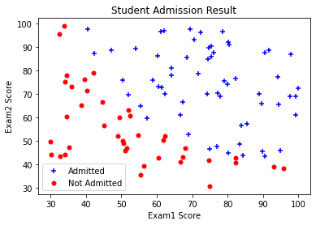

1. Implement sigmoid function used in Logistic Regression.
2. Implement the cost function and gradient for logistic regression.
3. After learning the parameters, you can use the model to predict whether a particular student will be admitted.
4. Plot the decision boundary

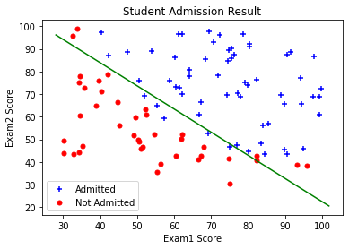

1. Calculate the training accuracy to evaluate how well the performance of our classifier. Achieved training accuracy of 89%.