**PHASE 4** (media streaming with ibm cloud video streaming)

STEP 1

CREATE A TOPIC AND RESOURCE EVENT TO STREAM

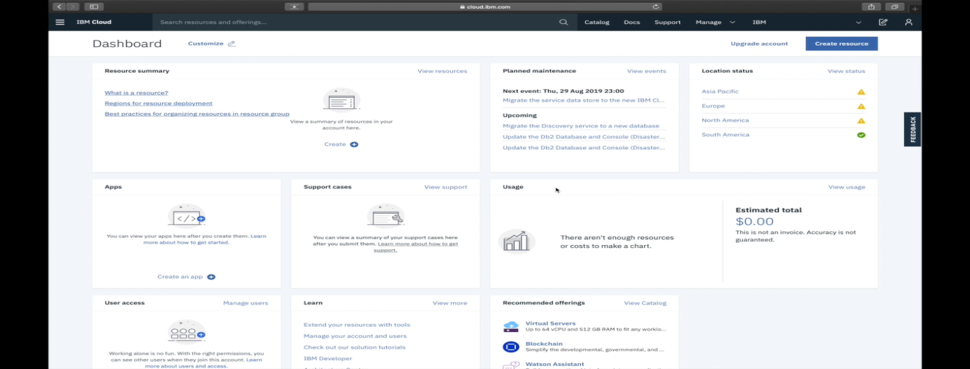

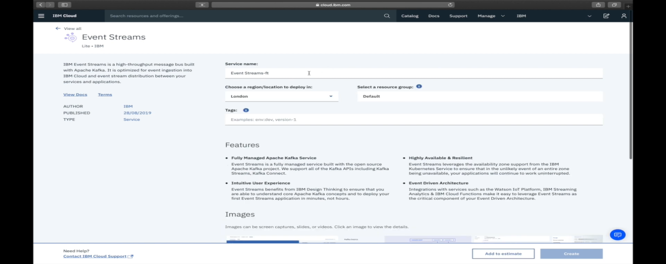

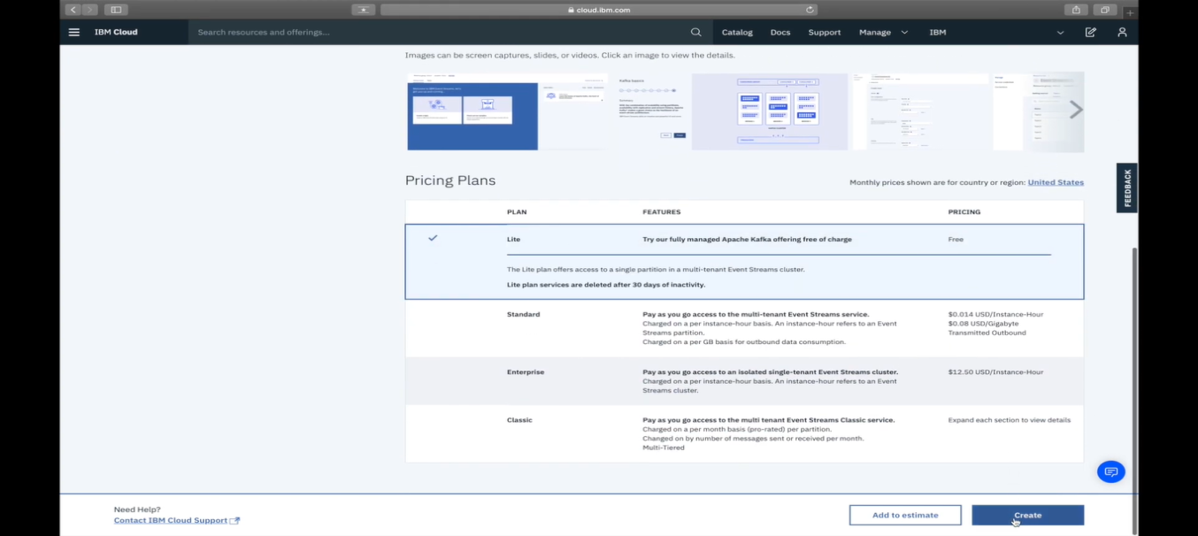

STEP 2

THEN CREATE A CREDENTIALS

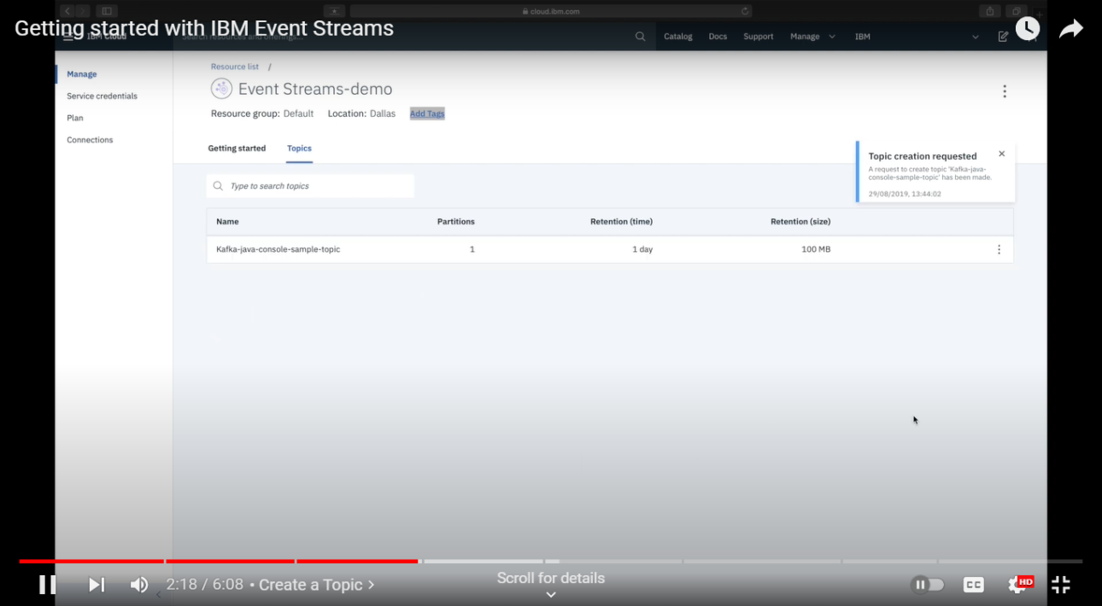

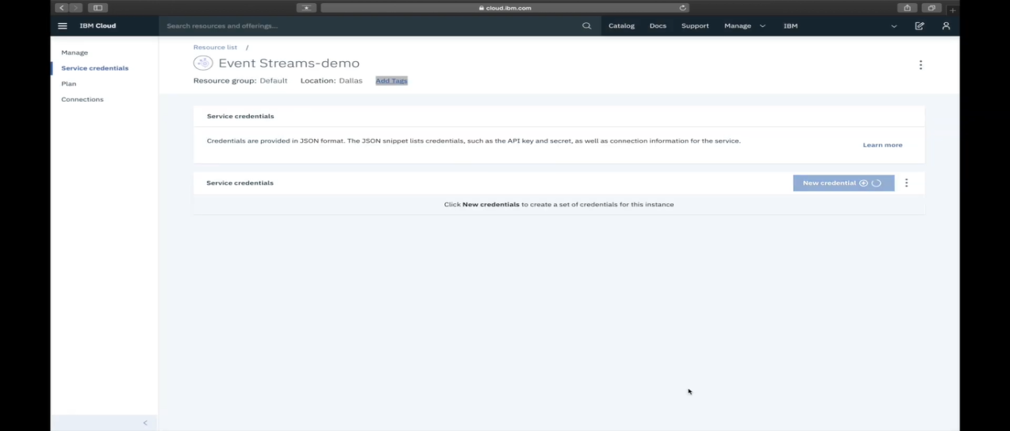

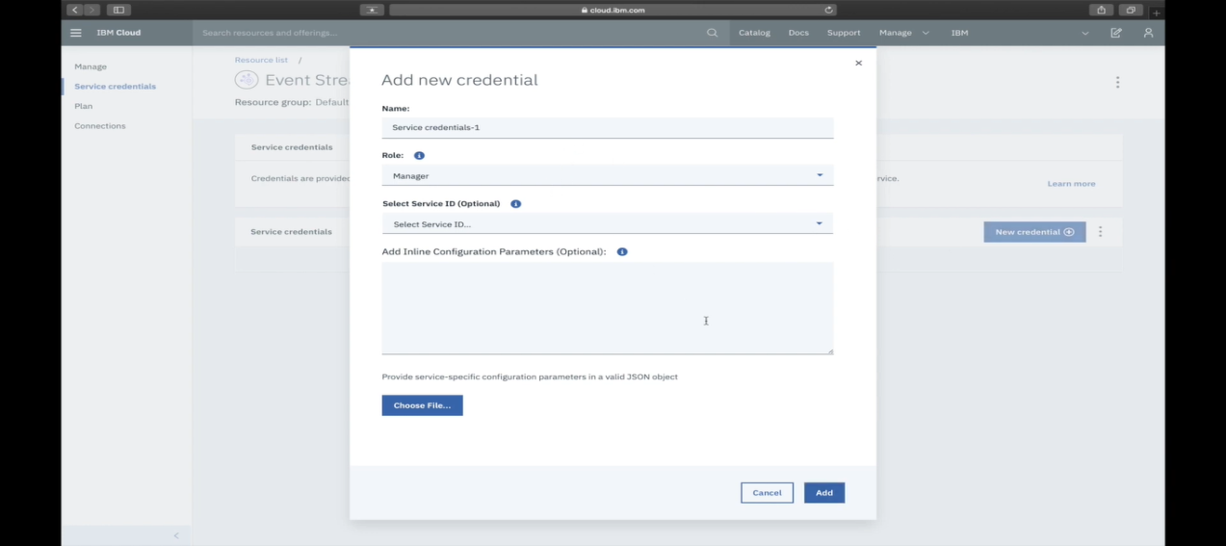

STEP 3

CLONE THE GITHUB REPOSITORY FOR SAMPLE APPLICATION

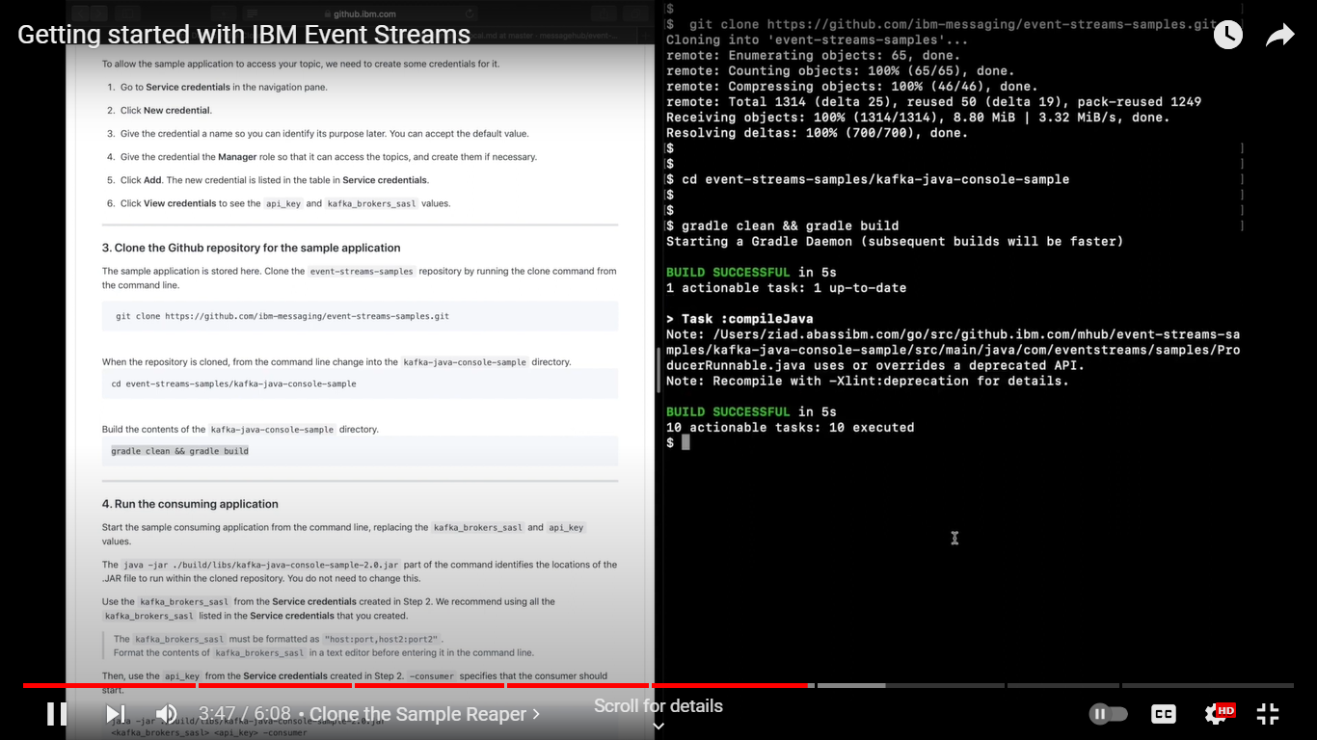

STEP 4

RUN THE CONSUMING APPLICATION.

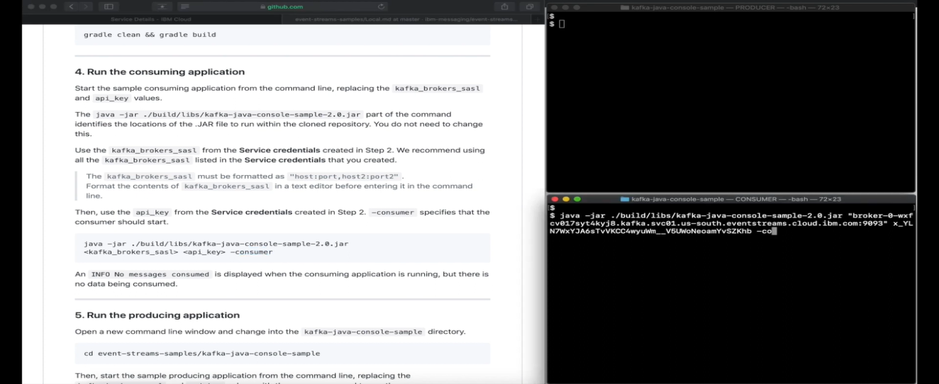

STEP 5

RUN THE PEOCEDURE .

