FINAL REPORT FOR DISCOVER
Spend Analyzer Bot

MIS - 4970
Spring 2024



Bot Developer and Report: Roshan Rai
Professor : Ye Hua, Jonathan
May 6th, 2024

Table of Contents

Executive Summary 3
Business Requirement 3
About Bot 4
Bot Explanation - 4
Bot Management and Maintaince – 5
Reflection on RPA 5
Link: 5
Bot Working 5
References 5

​
​
​
​
​
​

Executive Summary
Discover, the third largest credit card brand in the United States with 60.6 million cardholders, faces the challenge of meeting evolving customer needs. To address this, a Spend Analyzer bot is proposed to provide comprehensive insights into spending habits. Leveraging Microsoft Power Automate and UI Path, the bot automates expense analysis, streamlining workflow and empowering customers to manage finances effectively. It categorizes expenses, generates monthly reports with personalized insights, and offers budget tracking features. This initiative aligns with Discover's commitment to innovation, customer-centricity, and fostering financial literacy. To ensure the bot's long-term effectiveness, regular maintenance tasks such as performance monitoring, data quality assurance, software updates, and user testing are recommended. Despite the benefits of RPA, considerations regarding its impact on traditional job roles are acknowledged. Overall, the bot represents a significant step towards enhancing customer satisfaction, loyalty, and financial well-being while embracing the potential of automation in financial services.

Business Requirement
Discover is the third largest credit card brand in the United States by number of cards in circulation, with 60.6 million cardholders (Chargebacks, 2024). It is issued primarily in the United States. For the fifth time in six years, Discover ranked highest for credit card customer satisfaction among U.S. credit card companies by J.D. Power (Discovercard, 2019).
Discover, being one of the leading credit card companies in the United States, faces the challenge of continuously meeting the evolving needs and expectations of its vast customer base. Managing and understanding the spending habits of such a large and diverse clientele becomes increasingly complex. Additionally, in today's fast-paced and digitally-driven world, customers expect seamless and convenient tools to help them monitor and manage their finances effectively.
One of the primary challenges Discover encounters is the need to provide its customers with comprehensive insights into their spending patterns. Without clear visibility into where their money is going, customers may struggle to make informed financial decisions, set realistic budgets, or identify opportunities for savings. Moreover, as competition in the credit card market intensifies, Discover must find innovative ways to differentiate itself and enhance customer satisfaction and loyalty.
Furthermore, with the emergence of new technologies and digital solutions, customers increasingly expect personalized and user-friendly experiences from their financial service providers. Discover must adapt to these changing expectations by leveraging technology to offer value-added services that go beyond traditional credit card offerings. Providing customers with tools that simplify expense tracking, categorization, and analysis is crucial in meeting these expectations and maintaining a competitive edge in the market.
Moreover, Discover recognizes the importance of fostering financial literacy and well-being among its customers. By empowering individuals to gain a deeper understanding of their spending habits and financial behaviors, Discover not only strengthens its relationship with customers but also contributes to their long-term financial health and success. However, achieving this goal requires more than just providing transactional data—it requires actionable insights and tools that empower customers to take control of their finances proactively.
Discover, a prominent credit card company, is dedicated to empowering individuals to manage their finances effectively. Recognizing the importance of understanding spending habits, Discover has embarked on a mission to provide its customers with a robust expense analysis tool.
As a contractor hired by Discover, I am tasked with addressing the challenge of providing customers with comprehensive insights into their spending habits and empowering them to manage their finances effectively. Recognizing the importance of understanding spending patterns, Discover has identified the need for a robust expense analysis tool that can streamline the process of tracking, categorizing, and analyzing expenses for its vast customer base.
My role is to develop and implement a solution that meets these requirements, ultimately enhancing customer satisfaction, loyalty, and financial well-being. With features such as budget tracking, personalized recommendations, and interactive reports, the Spend Analyzer bot will enhance customer satisfaction, loyalty, and financial well-being, ultimately achieving Discover's mission of empowering individuals to manage their finances effectively.
I have been hired as a contractor to create a bot that helps customers track their spending habits and report monthly through invoices. This tool, aptly named the Spend Analyzer bot, aims to revolutionize the way customers track and manage their expenses, ultimately fostering greater financial literacy and well-being. The business requirements for the Spend Analyzer bot are driven by Discover's commitment to customer-centricity and innovation. By offering a comprehensive expense analysis solution, Discover seeks to differentiate itself in the competitive credit card market and enhance customer satisfaction and loyalty. Through the bot, Discover aims to address the evolving needs of its diverse customer base, catering to individuals seeking greater control over their financial lives and a deeper understanding of their spending patterns.
The decision to automate expense analysis processes through the Spend Analyzer bot is firmly justified by the tangible benefits it offers to Discover's customers and consistently being the best in customer service.. By providing monthly reports for insights into spending habits, the bot empowers customers to make informed financial decisions, set meaningful budgeting goals, and identify opportunities for savings. Moreover, the bot serves as a valuable tool in Discover's broader strategy to foster financial literacy and well-being, aligning with the company's mission to empower individuals on their financial journey.

About Bot
The bot will leverage a combination of Microsoft Power Automate and UI Path to retrieve invoices, extract data, categorize expenses, and generate monthly reports for customers. By automating these processes, the bot will streamline the expense analysis workflow, saving time and effort for both customers and Discover. The first step in developing the Spend Analyzer bot is to integrate Microsoft Power Automate by taking images of invoices. Power Automate will be used to retrieve information key metrics such as store name, invoice ID, invoice date, and total amount will be captured, along with the price of each item listed on the invoice from invoices. In cases where not all information is available, Power Automate will capture whatever data is accessible, ensuring that no information is lost in the process.
Once the data is extracted into the Excel sheet, UI Path will categorize each item into distinct expense categories. Given the potential diversity of categories, they will be streamlined into broader classifications such as food, clothing, technology, housing, recreation, or miscellaneous. UI Path will then sort the items into these categories, generating a corresponding graph to visualize the distribution of expenses across different categories. This graph will be included in the monthly reports sent to customers via email, providing them with a clear overview of their spending habits.

Bot Explanation -
Power Automate : How does bot extract key information and send email using power automate ?

- The flow is triggered by a button press.
- The flow extracts information from invoices using AI Builder Invoice Processing.
- The extracted information is used to create an HTML table with columns for description, quantity, and amount.
- The flow retrieves the user's profile information from Office 365. An email is sent to the user's email address with the subject "Invoice processed" and a body containing the extracted fields from the invoice.
- The email includes attachments of the processed invoice. For each line item in the extracted information, a row is added to an Excel table with the vendor name, invoice ID, invoice date, invoice total, line item description, and line item price. Below is the image of that power automate sends.
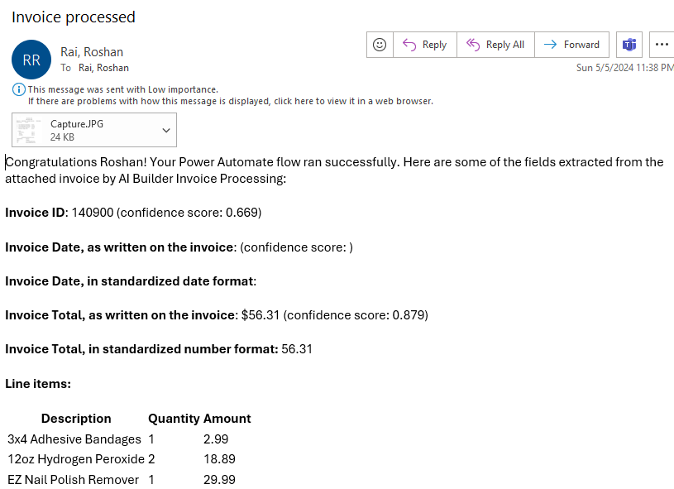
UI Path : How does bot categorize the expense, send email with the report of expenses ?

Once the data has been extracted from invoice into the excel spreadsheet. The next steps is to categorize, make chart and send it over to the email.

- Using a switch in the UI Path to categorize. For instance: we have defined there are only possible number of categories such as fooding, housing, sports, clothing, technology, medical and others. Here it seemed more practical to use switch instead of if else as there are more conditions. Using a for each loop, it will go through each row and check the line desciption to check what category it belongs to. And then assign its category to the its respesctive cell in spereadsheet. Here is an image of condition checking if its food.
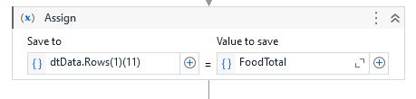
To know the category bot is using the OpenAI. Image below
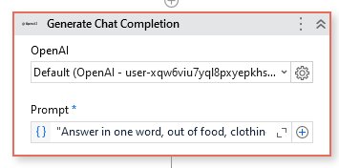
- After the category is defined and placed in its respective cell. The total is calculated. Bot uses excel to make chart with the calculation of total of expenses.
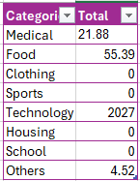
- Based on this calculation, a chart is preapred.
- By default, the heading of the chart is “total” and I want it to be “Monthly expenses”. The chart title is changed and copied to clipboard. It is then saved to image path graph. And the chart image is being saved to image_name as a variable name. This process of saving and copying is important to be able to send it to the email to the user. Here, email template.txt file is created so that the image path is replaced everytime.
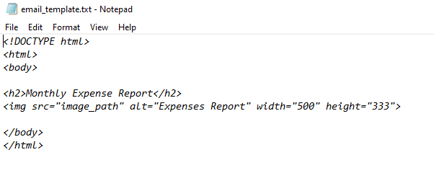
- After that, “str_template.Replace("image_path",image_name)” is saved to variable name email template.
- Here is an exmaple of Body of email, “"Hello," & Environment.NewLine & "Here is your monthly expense report." & Environment.NewLine & email_template & Environment.NewLine & "Regards," & Environment.NewLine & "Rai"”.
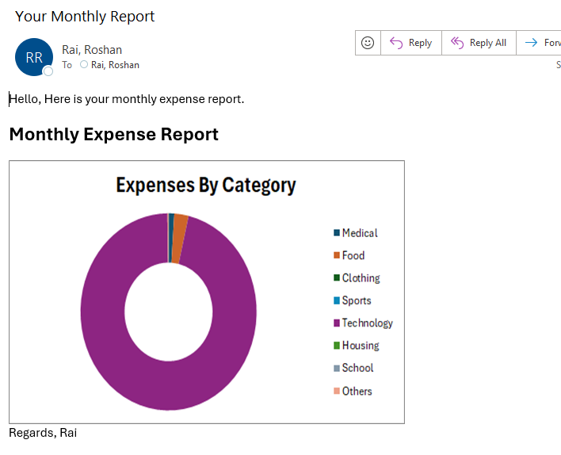

Bot Management and Maintaince
Technology are a great thing to implement in a company but the implementation is only the beginning because it needs to be maintenance and upgraded every once in a while with time nad necessities. Similarly, this bot also needs contant maintenance after this project. Few thing that can be done are:

- Running the bot once a month with all collected invoices, there are several other maintenance tasks that can be performed to ensure its smooth operation and effectiveness over time. As the bot can only take one invoice at a time, it is necessary to run all the invoices. Using UI Path would address this problem and be able to take all the invoices. However, UI Path’s inbuilt machine learning couldn’t identify the each line’s item category. So, having to choose invoice individually is a trade off we paid for this project.
- Regular Performance Monitoring: It's essential to monitor the performance of the bot regularly to identify any potential issues or bottlenecks. This can involve tracking metrics such as processing time, accuracy of categorization, and email delivery success rates. By keeping a close eye on performance metrics, any deviations or anomalies can be addressed promptly.
- Data Quality Assurance: As the bot relies on data extracted from invoices, ensuring data accuracy and consistency is crucial. Regular audits of the extracted data can help identify any discrepancies or errors that may arise. Implementing data validation checks and error handling mechanisms can help maintain data quality and reliability.
- Software Updates and Upgrades: Just like any other software, the tools and frameworks used to build the bot may receive updates and new features over time. It's important to stay up-to-date with these updates and incorporate them into the bot to leverage improvements in functionality, security, and performance.
- Feedback and User Testing: Soliciting feedback from users and conducting periodic user testing sessions can provide valuable insights into the usability and effectiveness of the bot. This feedback can be used to identify areas for improvement and prioritize enhancements or new features based on user needs and preferences.
- Adaptation to Regulatory Changes: The financial industry is subject to regulatory changes and compliance requirements that may impact the functionality of the bot. This may involve updating categorization rules, data handling processes. Scalability Planning As Discover's customer base grows and evolves, the demand for the bot's services may increase. It's important to plan for scalability and ensure that the bot can accommodate larger volumes of data and users without sacrificing performance or reliability. This may involve optimizing code, scaling infrastructure, or implementing load balancing mechanisms.

Reflection on RPA
Working with RPA has been an eye-opening experience for me. I've always been aware of the concept, but actually getting hands-on with it has been truly amazing. The power and efficiency of RPA are fantastic, and it's clear to see why it's become such a vital tool in today's business landscape. One of the most impressive aspects of RPA is its ability to save considerable time for businesses looking to automate their processes. By creating bots to handle repetitive tasks, organizations can redirect their resources towards more strategic initiatives, maximizing productivity and efficiency. Moreover, the capability of RPA to perform data scraping tasks is particularly noteworthy. In classes such as MIS and MIT, we often discuss the importance of big data in today's world. However, the process of collecting and organizing data can be tedious and time-consuming. RPA provides an excellent solution to this challenge by automating the data extraction process, allowing businesses to gather valuable insights from large volumes of data more efficiently than ever before. Furthermore, I strongly believe that RPA presents a significant opportunity for small businesses with limited resources and manpower. By leveraging RPA technologies, these businesses can streamline their operations and compete more effectively in the market. The efficiency and effectiveness of RPA make it an ideal solution for automating tasks in organizations with fewer employees and multiple responsibilities.
However, I do have some concerns about the potential impact of RPA on traditional job roles. While RPA offers undeniable benefits in terms of efficiency and cost-effectiveness, there is a concern that it may lead to the displacement of human workers. As bots become increasingly sophisticated and capable of performing tasks previously done by humans, there is a risk that certain job roles may become obsolete.
It's essential for businesses to approach RPA implementation with careful consideration and ensure that it complements, rather than replaces, human labor. Despite these concerns, my experience with RPA has been overwhelmingly positive. I've gained invaluable skills and insights through coursework and hands-on projects, and I'm excited to continue exploring the potential of this powerful tool. Beyond the classroom, RPA has practical applications in everyday life, as demonstrated by the invoice bot I created. By automating tasks like expense tracking, RPA can help individuals like myself better manage their finances and improve overall efficiency in various aspects of life. I have been so proud of the bots that I have made, I am showing this project to my friends around during social events.

Link:

Bot Working
https://mymedia.ou.edu/media/Final_Project+%28Bot+Running%29/1_h55on9q9

References
Chargebacks. (2024, January 17). Discover Card chargebacks: Everything to know in 2024. Chargebacks911. https://chargebacks911.com/discover-card-chargebacks/
Discover Card ranks highest in customer satisfaction by J.D. Power. (2019). https://investorrelations.discover.com/newsroom/press-releases/press-release-details/2019/Discover-Card-Ranks-Highest-in-Customer-Satisfaction-by-JD-Power/default.aspx
Bot developed will be send in the file.

​​
​​

