Assignment 1: Tableau
Roshan Rai
Question 1
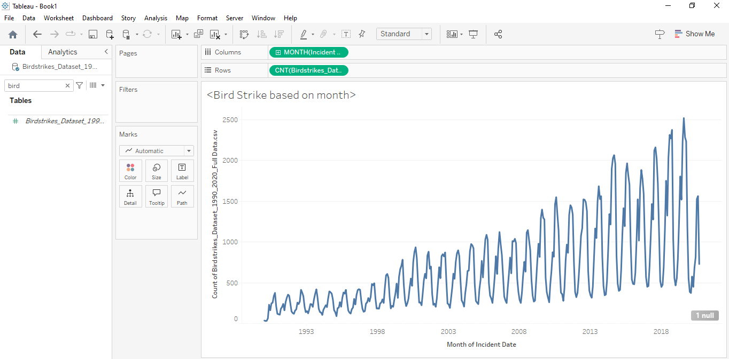
a) Yes, the data indicates that the highest number of bird strikes occurs in August, September, and October. This suggests that the beginning of the Fall season experiences a peak in bird strikes. In contrast, February, January or relatevily less but December and March shows the lowest number of bird strikes. This is in spring season.
Additionally, there appears to be a yearly increase in the frequency of bird strikes.
b) Possible explanations for this pattern might include:
i. Birds begin their migration in August as they prepare for the winter months, which could lead to a higher number of bird strikes during this time.
ii. February is one of the coldest months, and since bird migration is less active during this period, the number of bird strikes tends to be lower.

Question 2
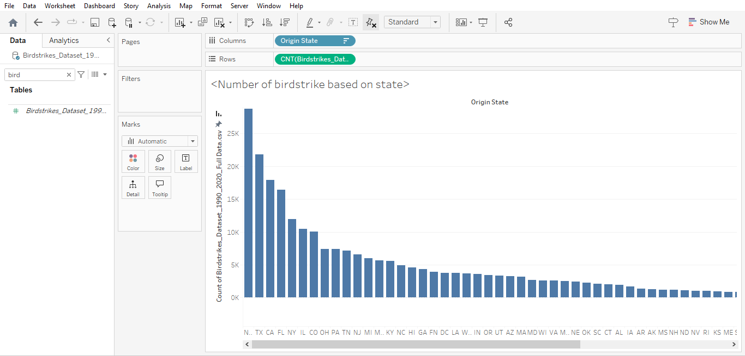
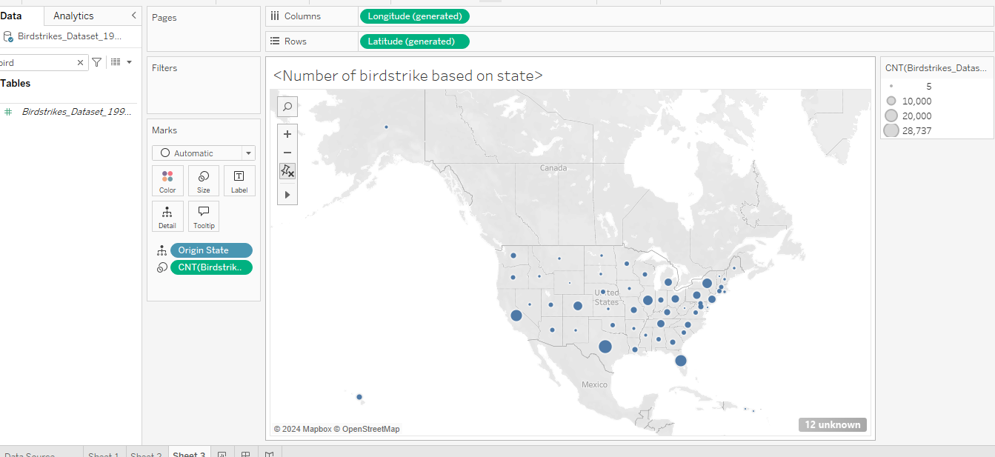
a) In the visualization, High Bird Strikes: A few states, such as Texas (TX), California (CA), Florida (FL), New York (NY) have significantly higher counts of bird strikes compared to other states. Some states like Illinois (IL), Ohio (OH), and Georgia (GA) show moderate counts of bird strikes. Several states, especially those with smaller populations or less air traffic (e.g., South Carolina (SK), Vermont (VT), Wyoming (WY)), exhibit low numbers of bird strikes.
Other than those, the circle shows more dense and bigger in east side than west side.
b) Possible Explanations:
1. Air Traffic Volume: - States with major airports or high volumes of air traffic, like California, Florida, New York, and Texas, are more likely to experience higher numbers of bird strikes. These states have some of the busiest airports in the country, which increases the likelihood of bird strikes.
2. Geography and Migration Patterns: - Some states lie along major bird migration routes (e.g., the Mississippi Flyway). States like Florida and Texas are along these routes, making them more susceptible to bird strikes during migration seasons. The east side of the Untied States has more population than west side, it is more likely that the population of birds are also more in the east. Therefore, more possibilities of birdstrikes with plane. Other than that, geographically California, NY and Texas are the state that touches the sea side, which could also be another reason for higher brid strike.

Question 3
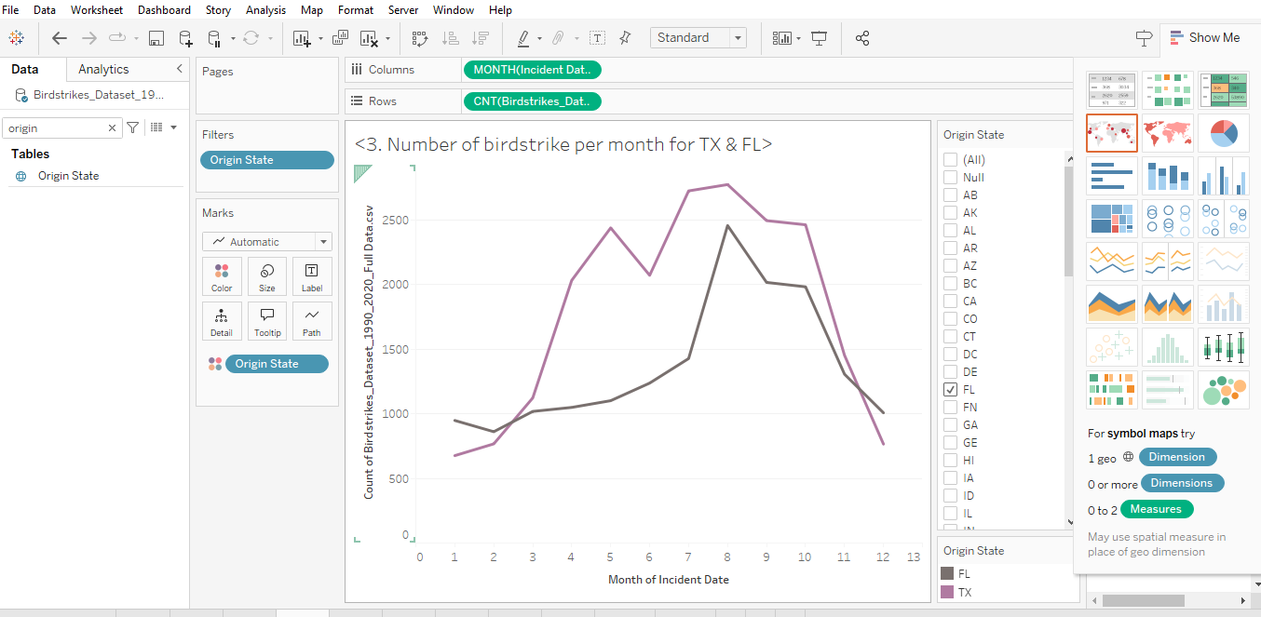
b. In both states, bird strikes are lowest in January and highest in August. This pattern is due to birds migrating for the winter, leading to more strikes in August and fewer in January when cold temperatures reduce bird activity. Additionally, there is a noticeable drop in strikes in September, likely because migration peaks in August and then suddenly decreases. October sees a slight rise in strikes. In Texas, May shows a small increase in bird strikes as birds prepare for summer migration, but Florida doesn’t experience this pattern, possibly due to its year-round tropical climate and minimal winter effects. Geographic differences between Florida and Texas may also influence these patterns.

Question 4
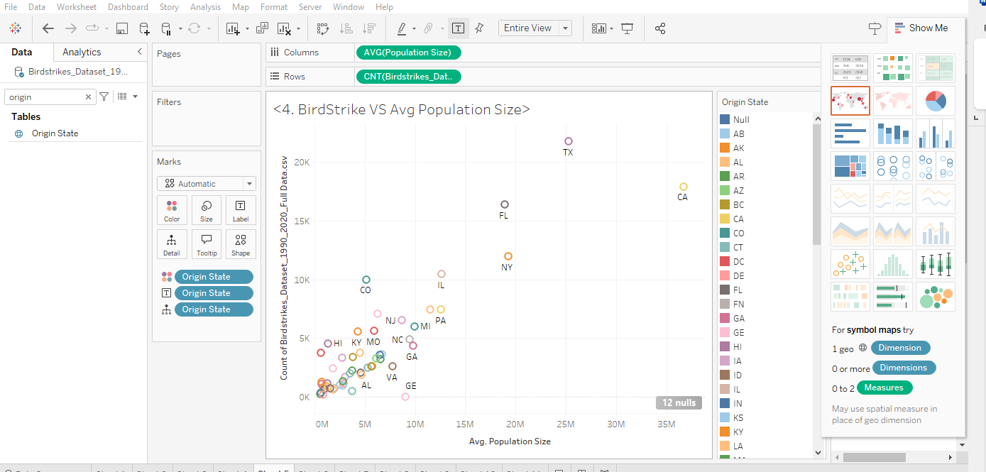
There is a positive correlation between the number of bird strikes and the average population size. Birds often reside closer to populated areas to fulfill basic needs like food, leading to a higher bird population in these regions, which in turn increases the likelihood of bird strikes. Additionally, more populated areas tend to have more planes, further raising the probability of bird strikes.
For example, California (CA) and Texas (TX) have large populations and also experience a higher number of bird strikes. However, Colorado (CO) and Illinois (IL) stand out as outliers; despite their average populations not being that high, they also report a high number of bird strikes. This could be attributed to their colder climates, which might influence bird migration patterns or behavior. It's expected that these states would have fewer bird strikes relative to their population size compared to others as similar populations have lower birdstrikes.
The general trend shows a positive relationship between population size and bird strikes, although it’s not a perfectly linear one, as various factors like airport presence, flight traffic density, and geography can also impact the number of bird strikes.

Question 5
a.
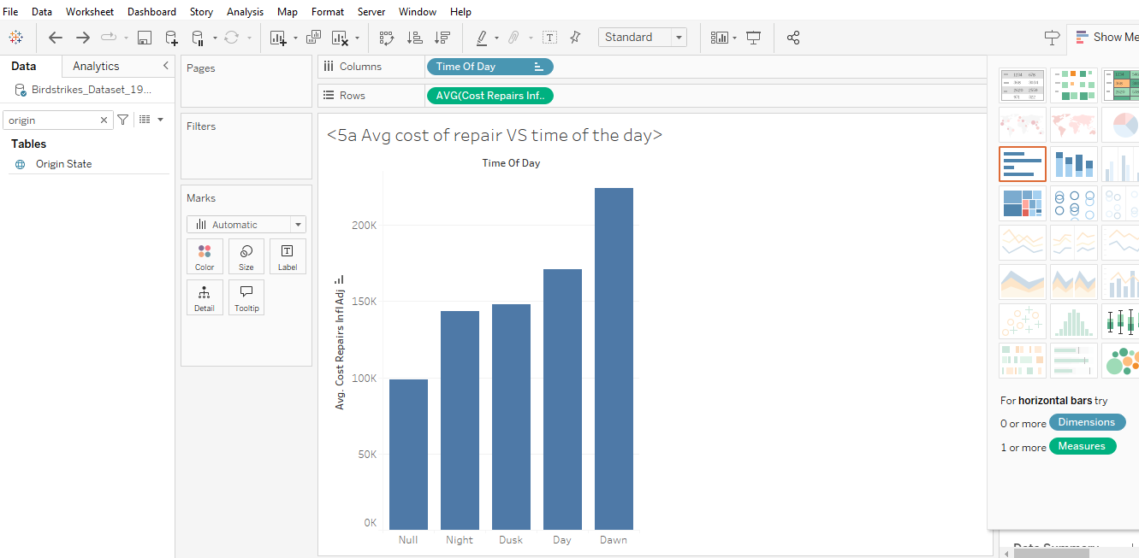
The visualization reveals that repairs are most costly during dawn. This is likely because birds are active in the morning while searching for food, leading to a higher frequency of bird strikes and thus more expensive repairs. In contrast, bird strikes are least common at night, as birds are generally back in their nests and less active due to reduced visibility and mobility.
b.
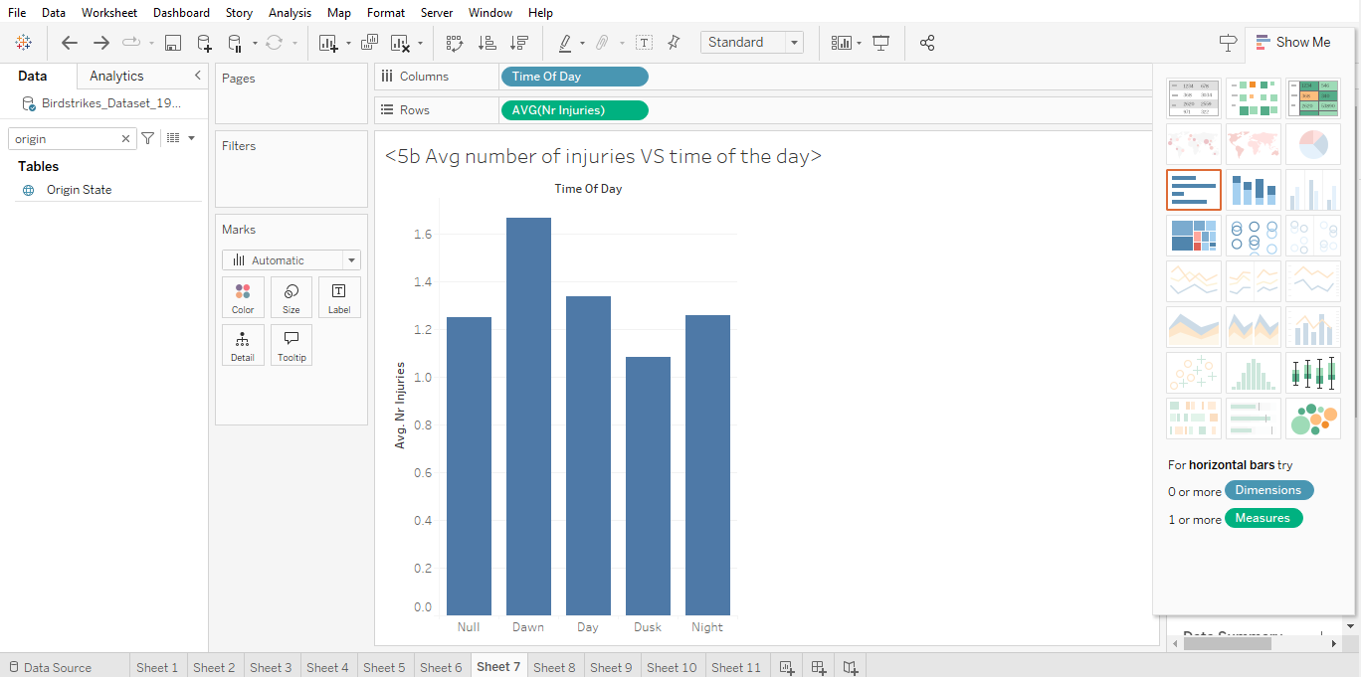
Dawn likely has the highest average number of injuries due to increased bird activity in the morning, as many birds are actively migrating or foraging for food at this time. In contrast, dusk tends to have the lowest number of injuries because bird activity decreases as they return to their nests for the night. This reduction in bird movement during dusk lowers the likelihood of bird strikes and, consequently, the number of injuries.
The night could have even more injuries because of the visibility of the aircraft also.

Question 6
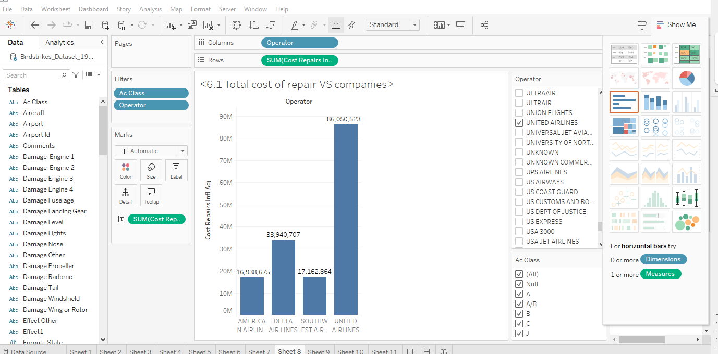
United has the highest repair costs among the top four airlines, likely due to several factors. They might operate more expensive aircraft, leading to higher repair expenses. United could also have a higher number of flights, increasing the risk of damage and overall repair costs. Additionally, United may invest more in safety and maintenance, reflecting their commitment to quality.
In contrast, American Airlines has the lowest repair costs, possibly for reasons opposite to those of United. Delta and Southwest fall in between, potentially reflecting different priorities or operational practices.
b.
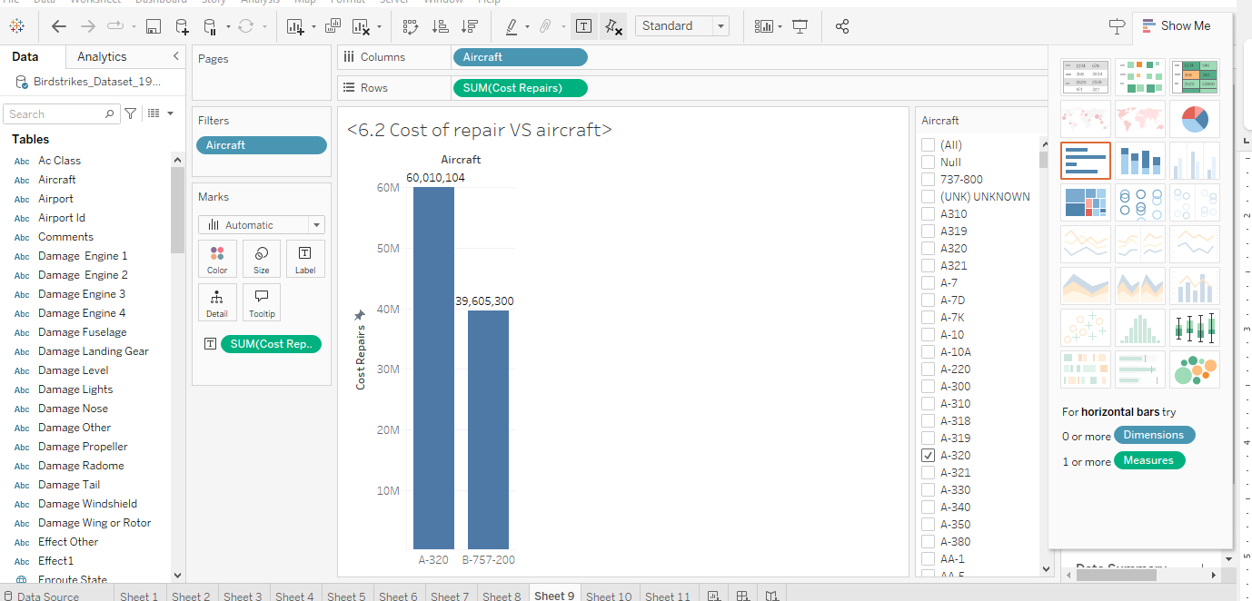
c. The A-320 and B-757-200 are among the most costly aircraft to repair. This suggests that the top four airlines (Delta, American, southwest, united) might be operating these models because of their high repair costs. These aircraft may be expensive to maintain due to their complex designs or age, which requires frequent upgrades and maintenance. Additionally, if these aircraft are newer, the high repair costs could be attributed to the novelty of their technology and the associated labor expenses.

Question 7
