1a.
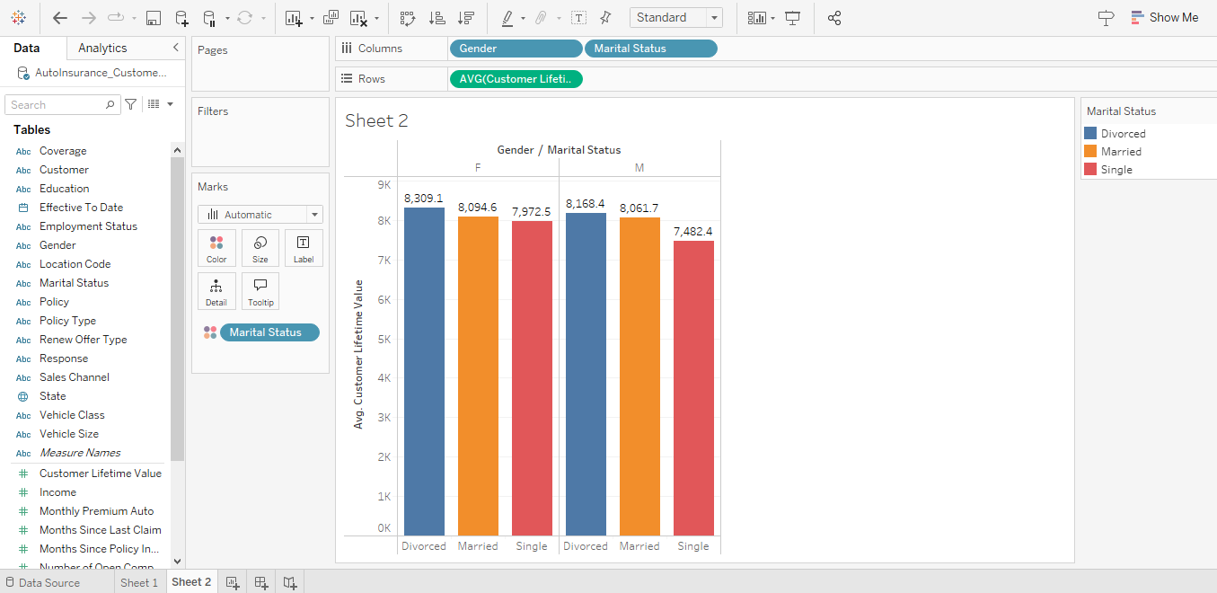
Divorced Female has the highest customer lfietime value. As customer lifetime value is predicted net profit that can be gained from the future relationship with a customer, the data shows that divorced female has 8309 which provides highest customer lifetime value in average with most profitable.
Secondly, divorced male also has second highest customer lifetime value after divroced female.
The data shows that the divorced are the most profitables.

1. Single male are the least profitable.
The data shows that singles are least profitable.
1b.

No, high education level has does not matter with customer lifetime value. This is because even though the highest number of customr elifetime value is by high school degree people. To support the hypothesis of high educatio level and customer lifetime value, people with highest education level i.e bachlors degree are suppose to have the highest customer lifetime value which is not the case in both male and female.
Question 2
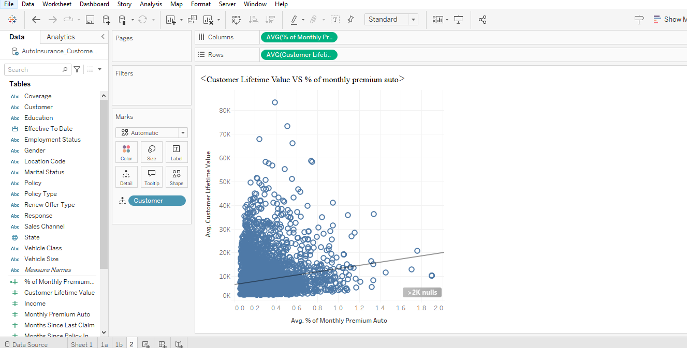
R-Squared: 0.0328392
p-value (significance): < 0.0001
The R Squared value if very less 3% which means it doesn’t have any correlation between the individual's income and their total Customer Lifetime Value. However, the p value is lesser than 0.05 which shows the values are statistically significant. However, the R value is so low, there is no corelation.
Question 3a.


3b.
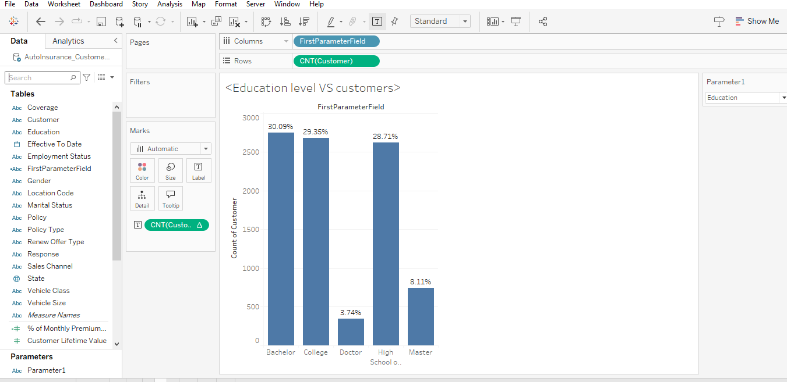
3c. For Education level, the largest segments is Bachlors.
For marital status, the largest segments is married.
Question 4: 5pts
Based on your findings in Question 1 (customer lifetime value) and Question 3 (market size), what demographics should the company target:
- the most?
By Gender, it shows that the male has the lowest customer lifetime value. In addition to this, single male has even lesser customer lifetime value from the graph 1a. And from question 3 Male customer is lesser than females. By educational profession, it shows that doctors has the lowest count of customer. Lastly, even though retired as lowest count of customer, as they don’t have sustainable income, I think the company should focus on employed demographics which is still 62% which is large segment.
In conclusion, single male who is employed most likely in medical field has potential market as they are not one of the customers yet. They have low number of customer lifetime value and lesser number in customer. Therefore, they should be more focused.

- The least?
By Gender and educational background from question 1a and 1b, we can conclude that divorced female are already a big part of our customer lifetime value. But from question 3 it shows that married have the highest number of customers. So, married women who already has high school or bachelors degree can be ignored as they are already a lot of our customers.

5a.
I believe, the store cashier and her husband dropping off their children to school will be the most profitable for the insurance company as it it more meaningful than the others. As the asumption is that “that individuals belonging to the target market segment will be more responsive if the commercial involves actors that share the demographic characteristics of these potential customers.” I think a family is potential customer to have insruance as it is more secured and futurustic. This adverstiment shows a relatable and broad middle-class family scenario, which is a large segment of potential customers who could be looking for family-oriented and affordable insurance. Also because more roles are involved I adverstisemnt for example, children, farmer so it has more audicne. This scenario has a higher chance of resonating with a diverse audience, leading to increased responsiveness and profitability. It is the most likely to be profitable for the insurance company.
6a.

Agent has the highest percentage of successful responses

6b.
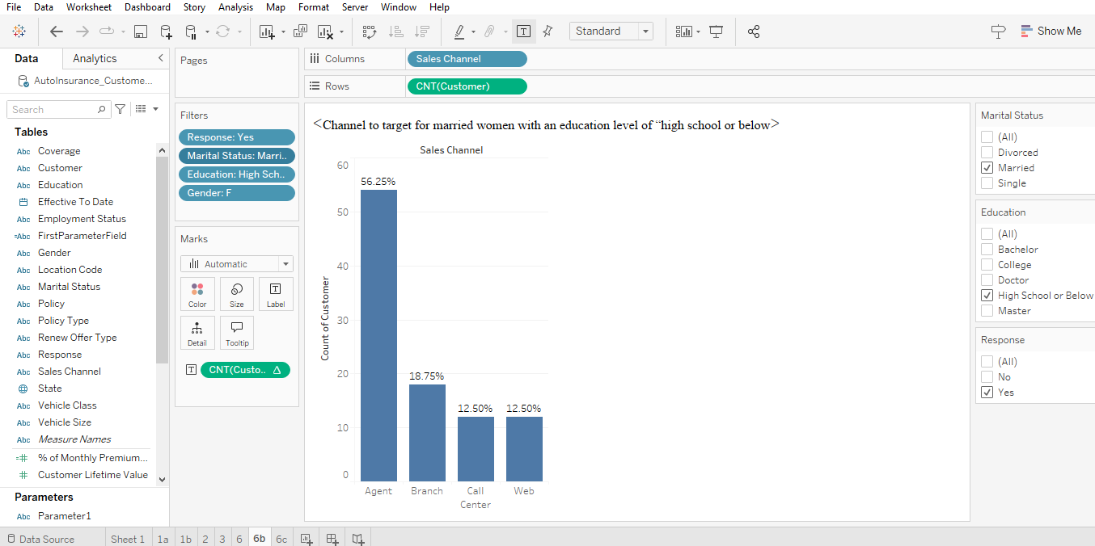
The best channel to target for “married women with an education level of “high school or below”, is Agent channel, as it has the highest number of succesful response.
6c. Yes, the agent channel still has the highest number of “Yes” (sucesful response) for single men an education level of “high school or below”.
