Assigment 2 Tableau
Roshan Rai
1.
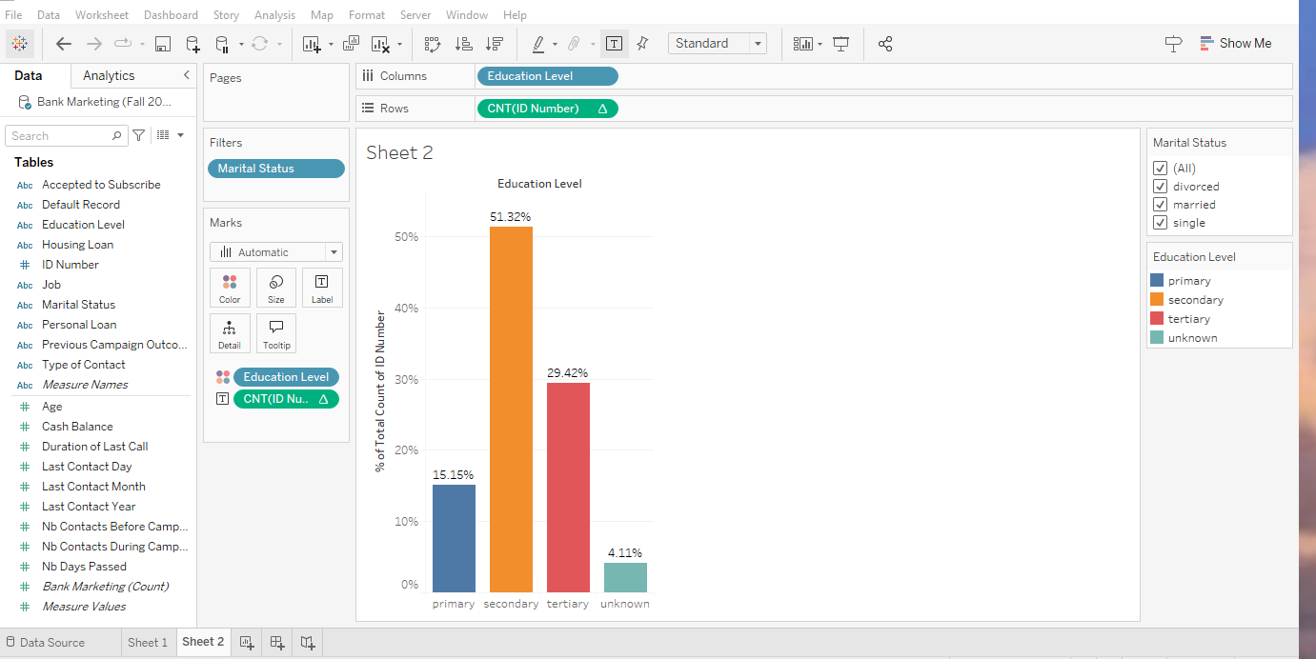
2 a.
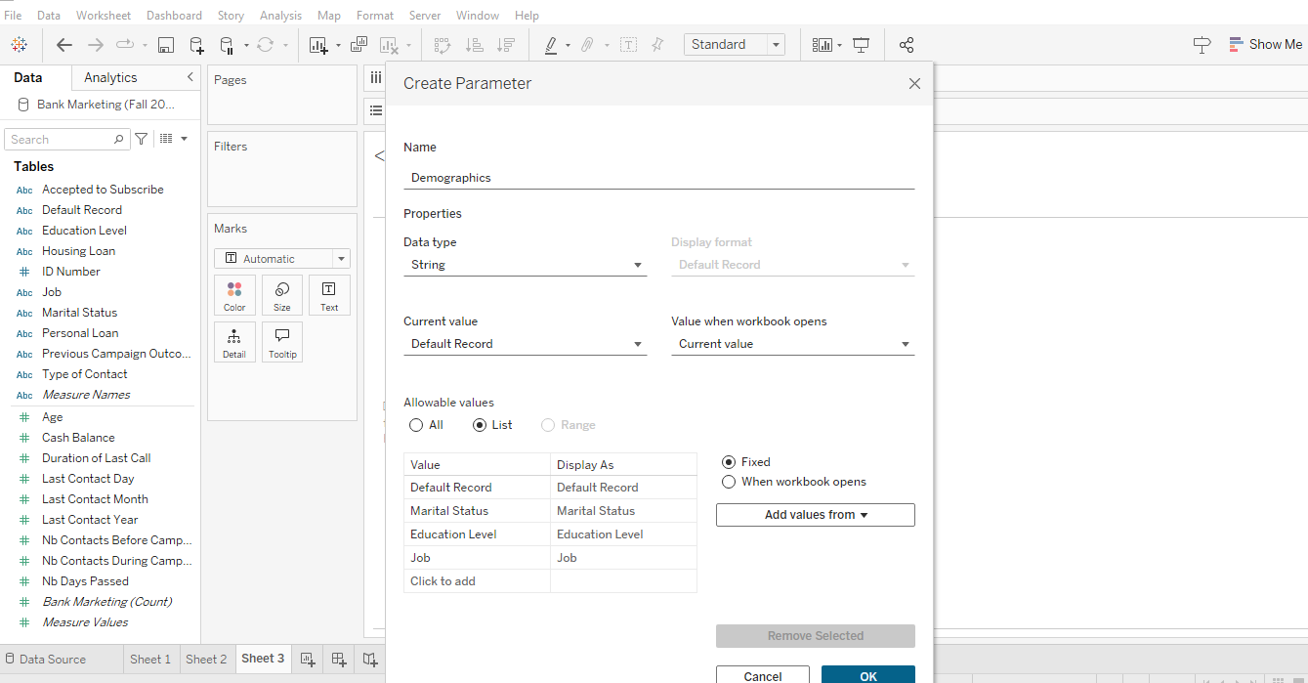
2 b.
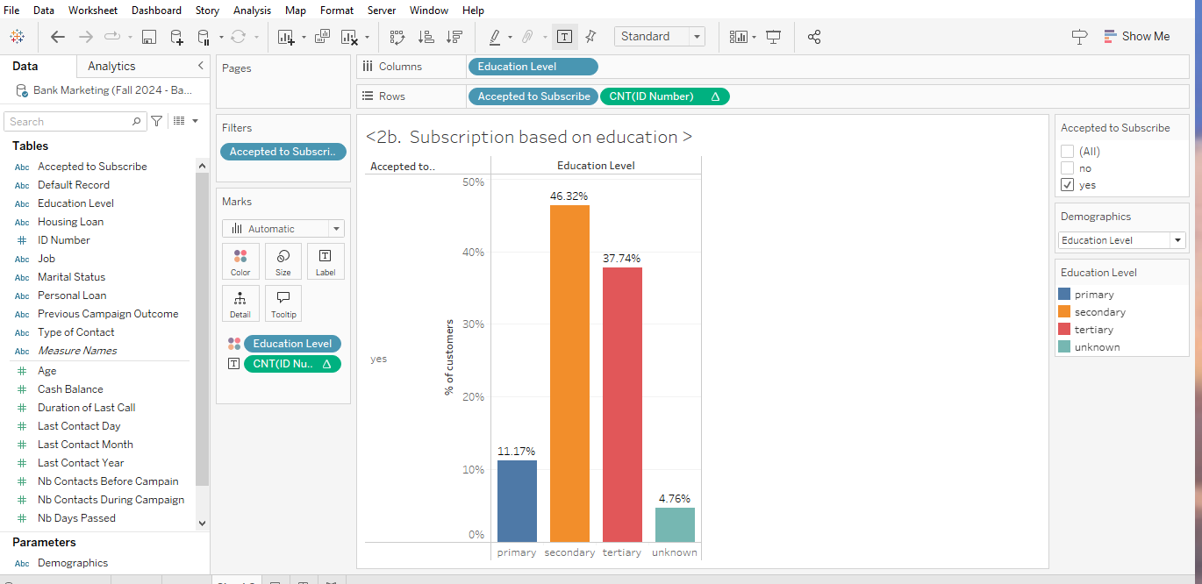
2c.
Secondary level education indicated highest level of subscription with 46.32%.
3.
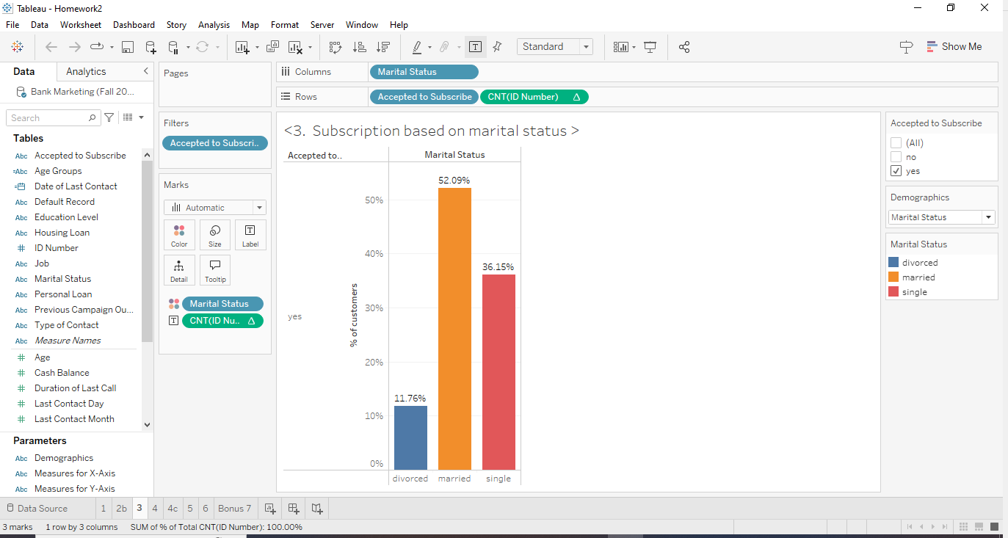
Based on the graph, the best demographic group to target for marketing the CD based on marital status would be the married individuals.
The data shows that 52.09% of the customers who subscribed to the CD are married, which is the highest percentage among the three groups (married, single, and divorced). This shows the higher subscription percentages, higher market potential. Since a larger proportion of married individuals have already shown interest in subscribing to the CD, they represent a demographic that is more likely to respond positively to future marketing efforts.
4a.
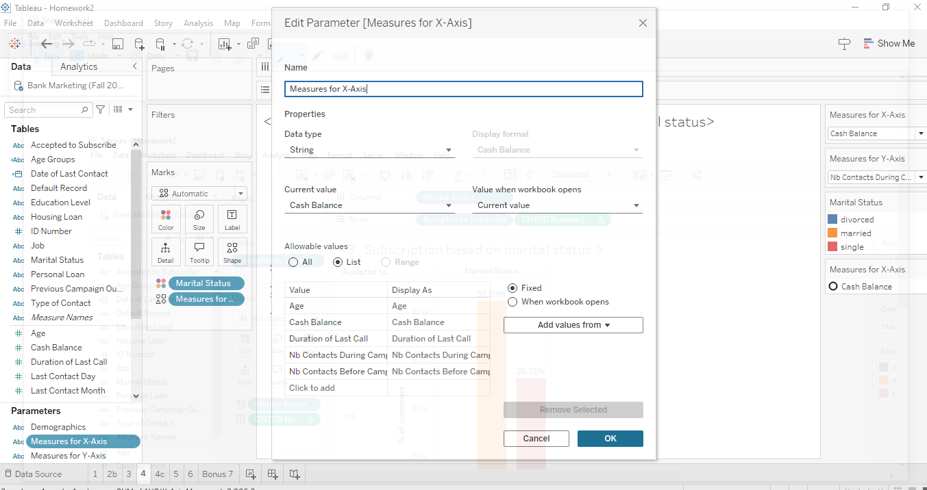
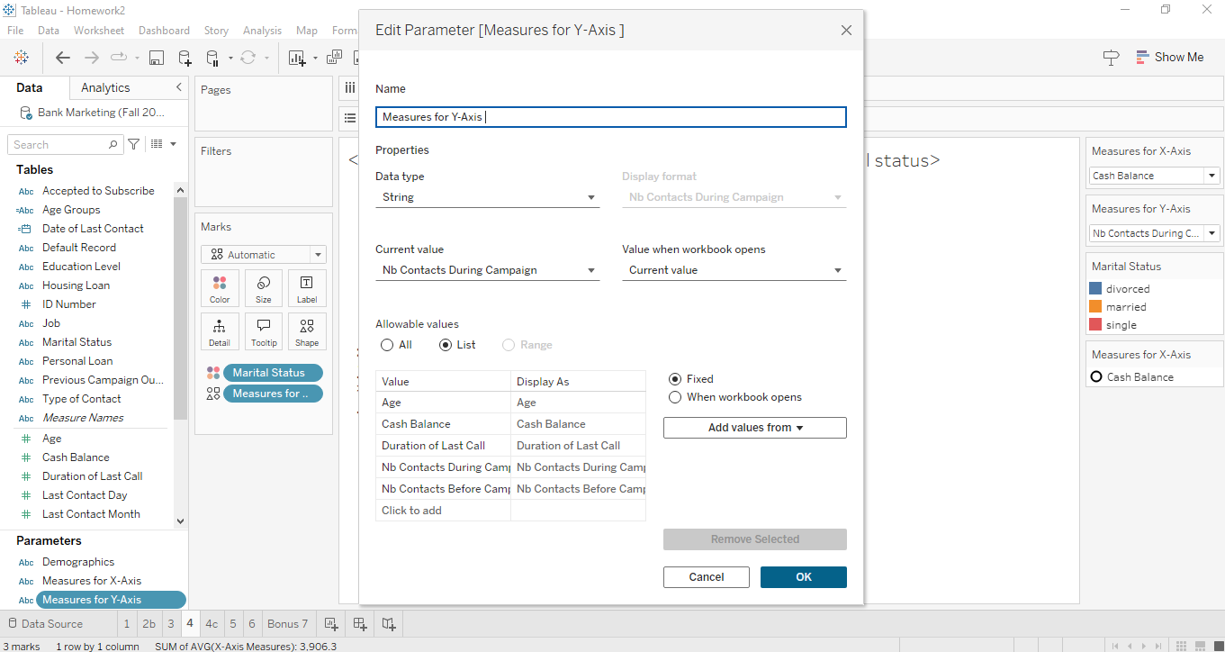

4b.
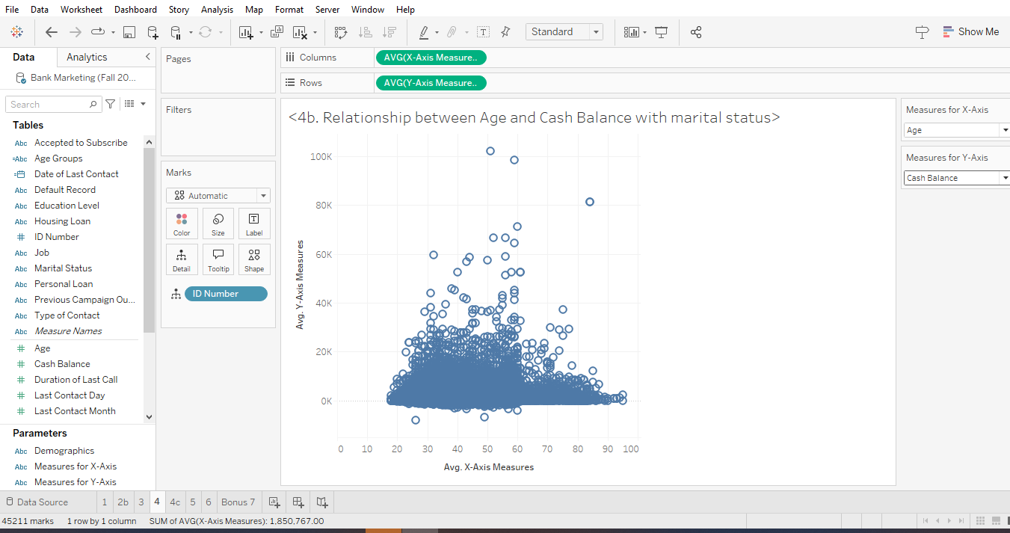
4c:
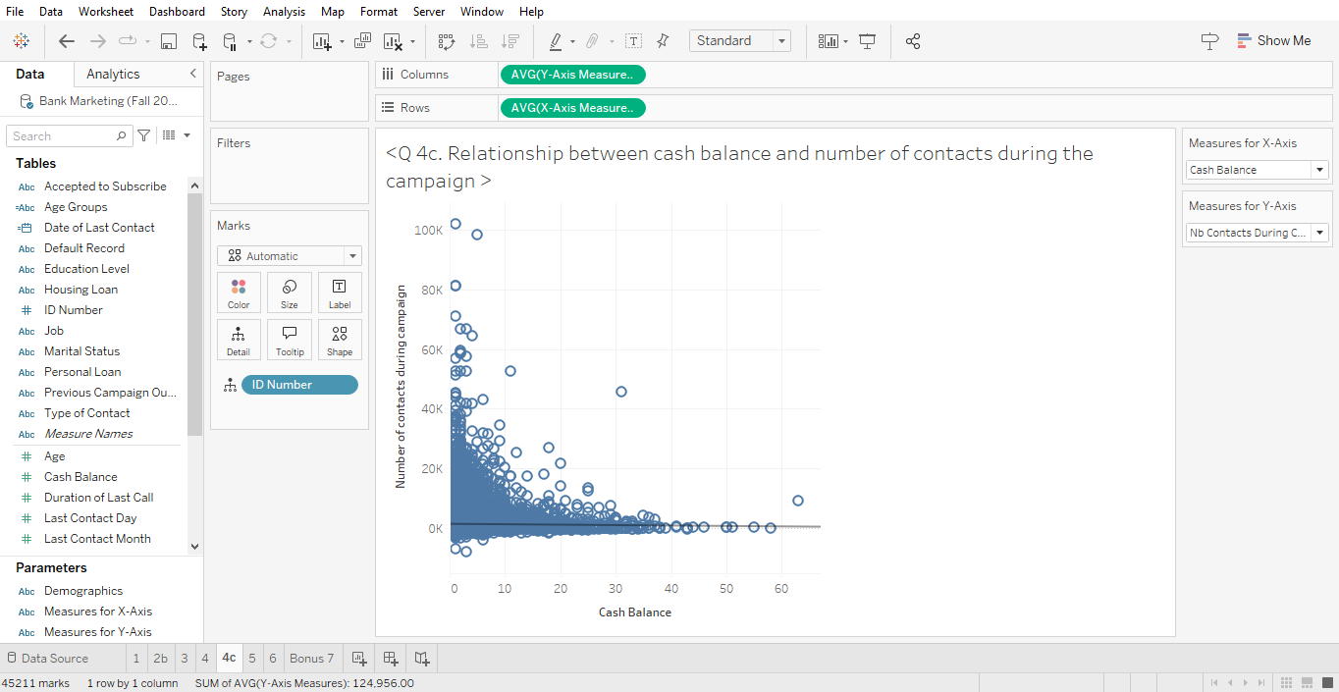
Trend Lines Model
A linear trend model is computed for average of X-Axis Measures given average of Y-Axis Measures. The model may be significant at p <= 0.05.
Model formula: ( Avg. Y-Axis Measures + intercept )
Number of modeled observations: 45211
Number of filtered observations: 0
Model degrees of freedom: 2
Residual degrees of freedom (DF): 45209
SSE (sum squared error): 4.19035e+11
MSE (mean squared error): 9.26883e+06
R-Squared: 0.0002125
Standard error: 3044.48
p-value (significance): 0.0019362
The R value of trend line is 0.0002125 and the P value of 0.0019362, the relationship between cash balance and the number of contacts during the campaign interpreting on basis of R value and p value are :
- R Value:
  - R value measures the correlation. The R value of 0.0002125 (0.02%) indicates an extremely weak correlation between cash balance and the number of contacts during the campaign. This value is very close to zero, which suggests that there is virtually no linear relationship between these two variables.
- P Value (Significance Level):
  - The P value of 0.0019362 is very low, indicating that the result is statistically significant. However, statistical significance does not imply a strong relationship; it simply means that the observed weak correlation is unlikely to be due to random chance.

5a.
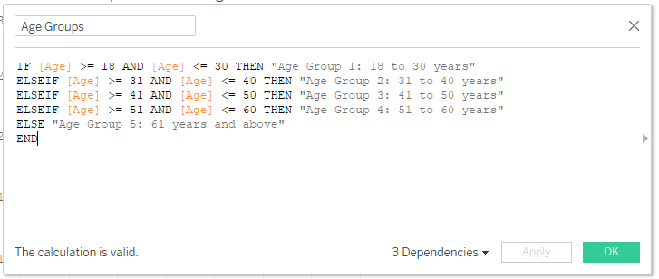
5b.
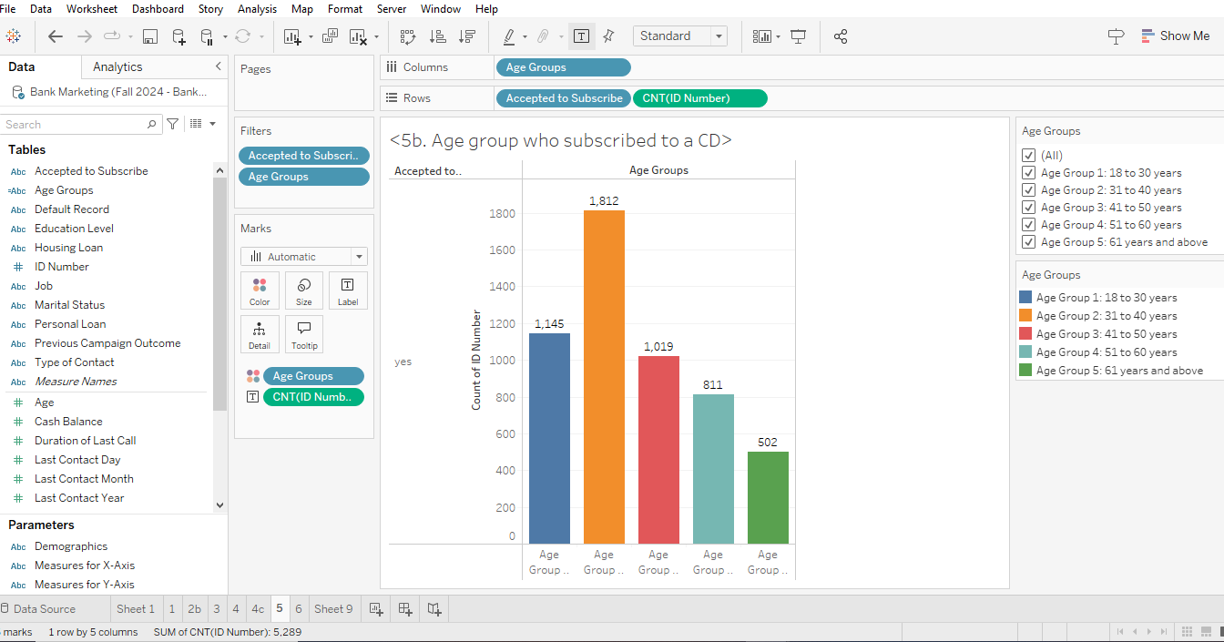
5c. The age group that are most represented are age group 2 of 31 to 40 years and Age group 1 of 18 to 30 years. These groups might have subscribed to a CD because they might have strong financial plans like starting a long term plans for future. They might also have steady earnings and more income than people above 41 years old. They could be planning to future retirement by saving at this age.

6.
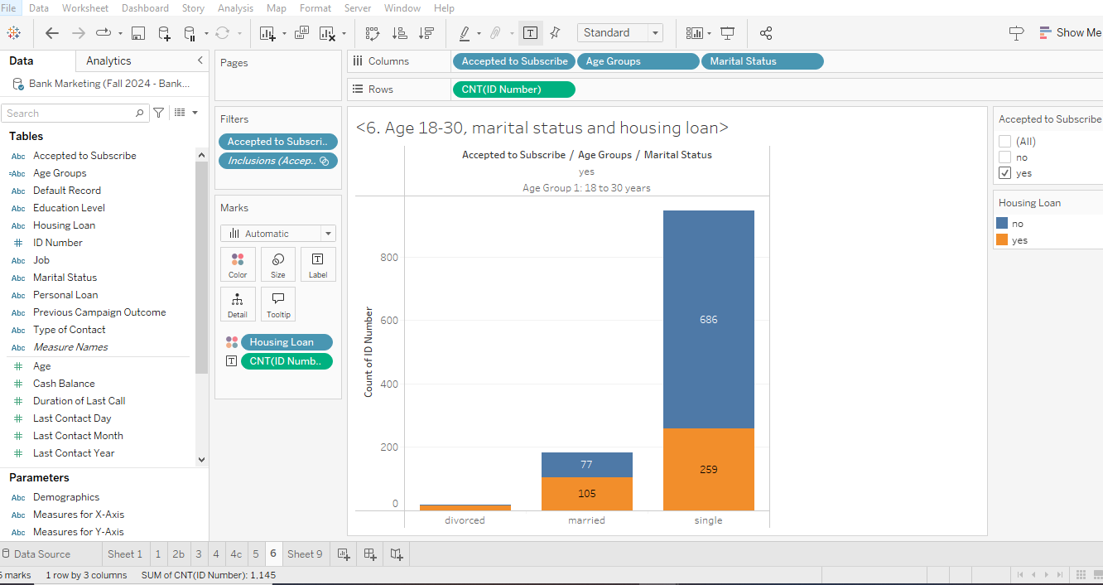
6a.
Yes, The strategy seems reasonable since there is a significant number of married individuals with housing loans (105 people), indicating that they could indeed be financially responsible and thus a suitable target for the bank's campaign.
No, the data suggests targeting married individuals with housing loans, which only includes 105 people in the 18-30 age group. However, there are 686 individuals in this age group who are single and do not have a housing loan, representing a larger population that could potentially have a higher likelihood of subscribing to the CD. Focusing solely on married individuals with housing loans might therefore restrict the campaign's overall reach. In addition to these, single people may not have children or other financial responsibility. So, it would be nice to target them for CD.
6b.
The group that might be ignored is the single individuals without a housing loan (686 people). This group might not fit the bank's mentioned criteria for financial responsibility and could potentially be less likely to subscribe to a certificate of deposit. The reasoning is that single individuals without housing loans may not have the financial stability or responsibility that the bank is targeting with this campaign.
If we look on the basis of numbers, we could ignore the people who doesn’t have housing loan and are divorced because it is very small number of pool, which is insignificant compared to others.
While the data does support targeting married individuals with housing loans, the bank might also consider targeting single individuals with housing loans (259 people) as they form a larger group than the married individuals with housing loans. As the bank is trying to find, who is financially responsible having housing loan as an indicator, the number of people who are single and have housing loan is more than twice the married people with housing loan. So, it would mean that single people with housing loan are bank’s targettted individual, with even higher probablity of getting CD.
7.
7a.
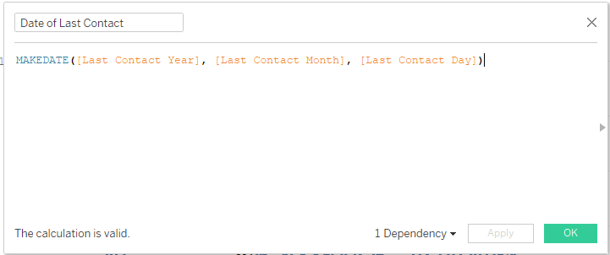
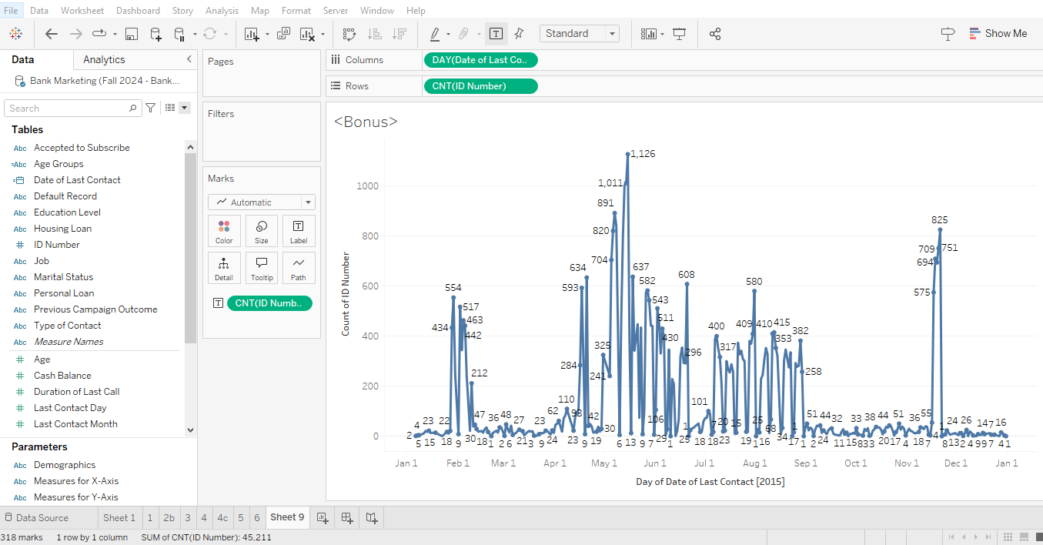
7b. The day with the highest number of contacts is clearly visible as May 15, 2015, with a peak showing 1,126 contacts made on that day.

