Roshan Rai
Tableau Assignment 3
1a.
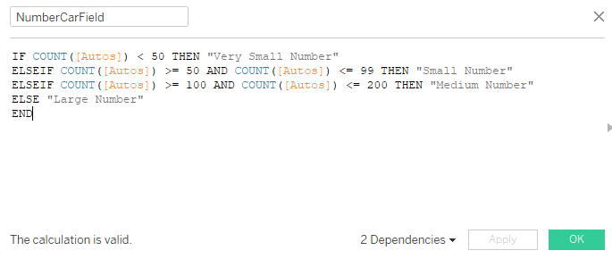
1b.
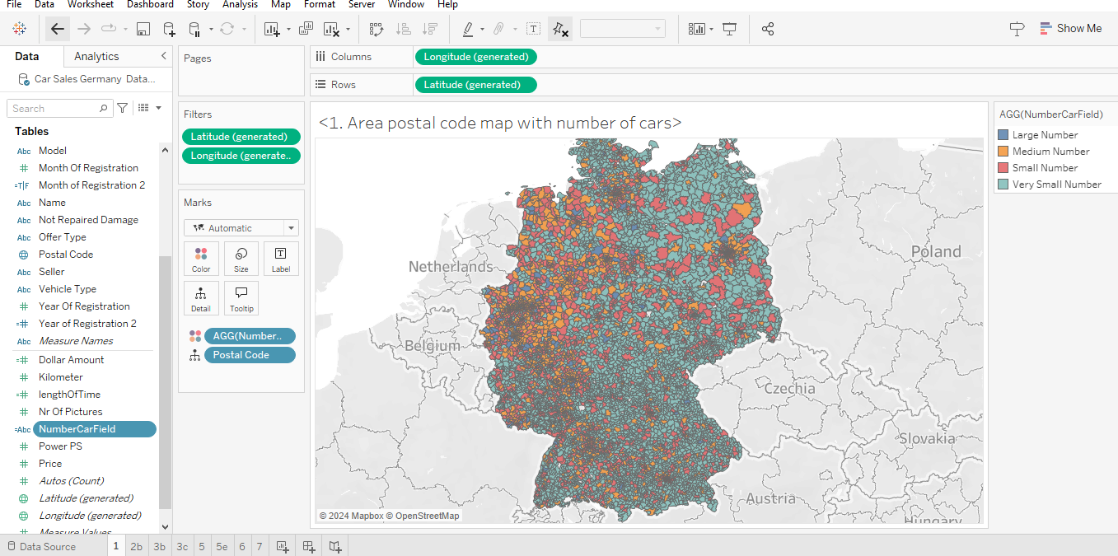

2a.
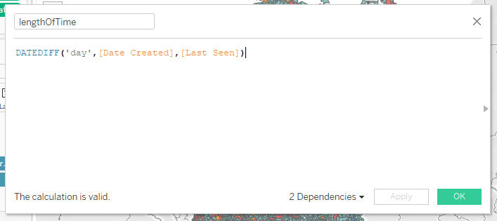
2b.
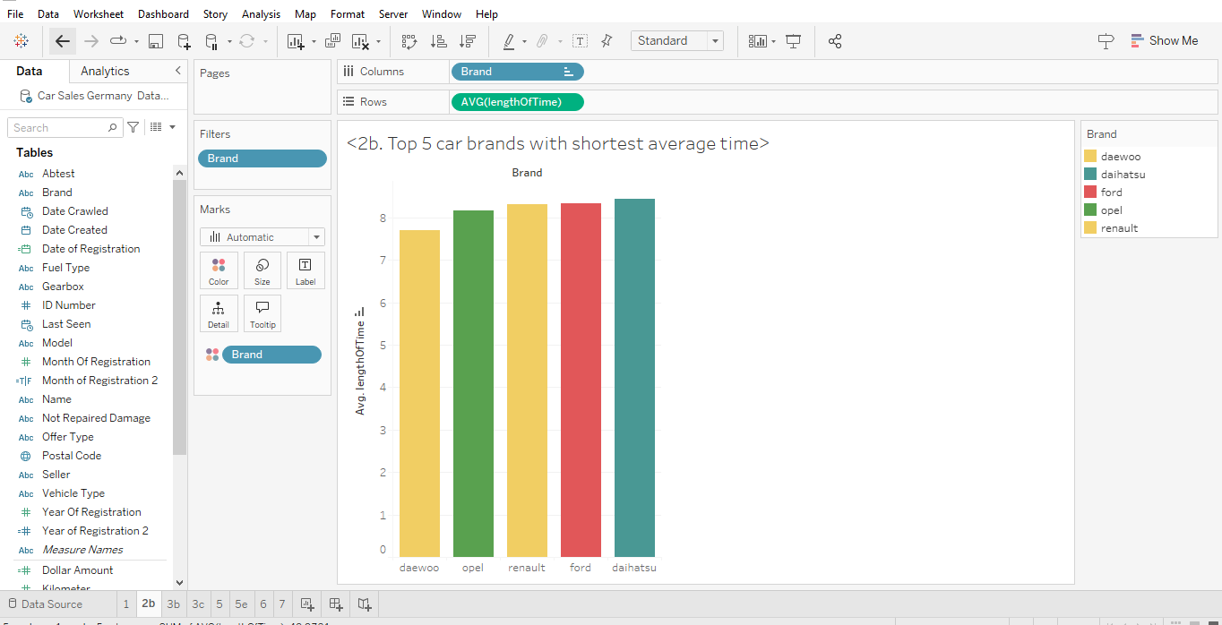
The top 5 car brands with the shortest average time before sale are : daewo, opel, renault, ford, daihatsu.

3a.
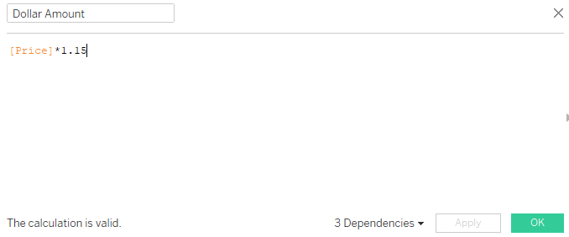
3b.
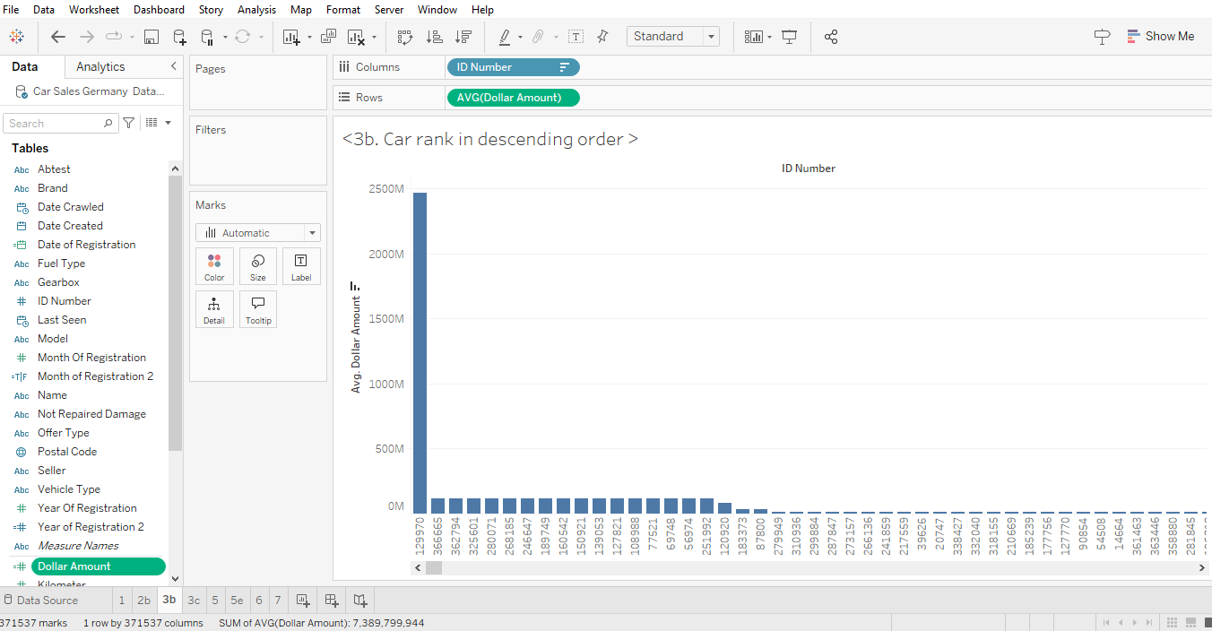

3c.
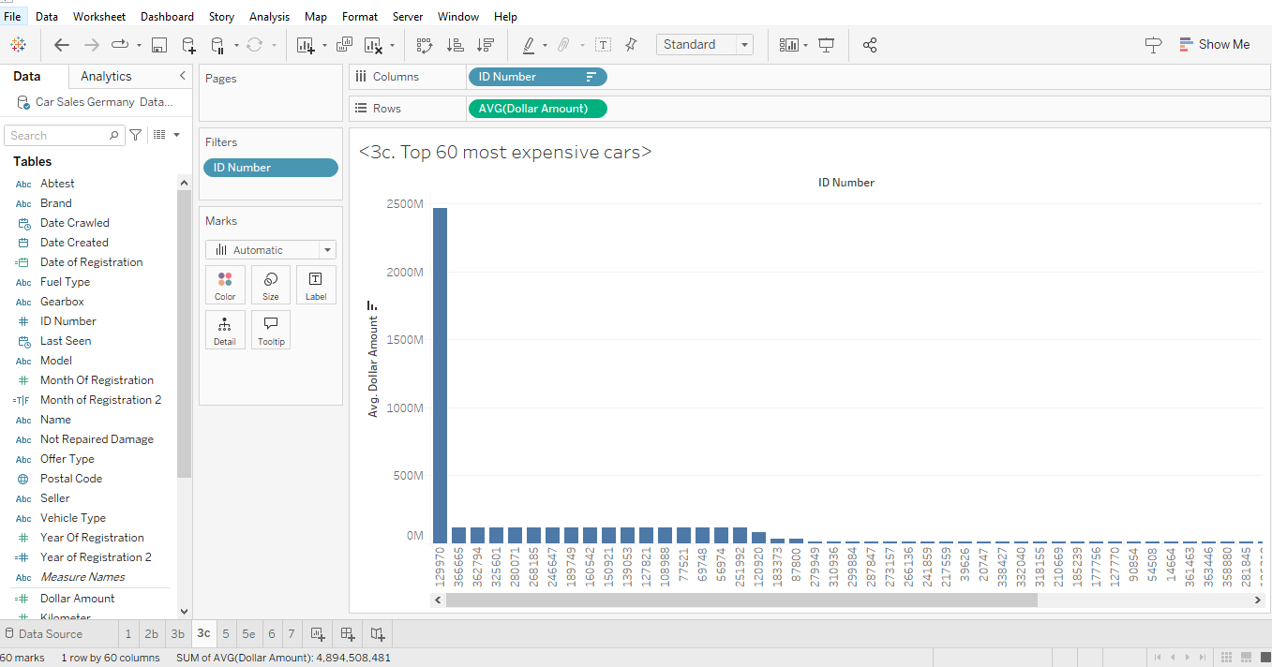
No, the prices do not look reasonable. I would review the data in the excel. Upon reviewing the data in Excel, I noticed that some values are listed as 0, 1, and 999. This suggests that missing values might have been substituted with placeholder numbers, which is likely contributing to the unrealistic price range. It also indicates that the data was not properly cleaned before preparing the visualizations, leading to inaccurate insights.
4a. Are there cars that cost less than $100?
Yes, there are cars listed with prices lower than $100.
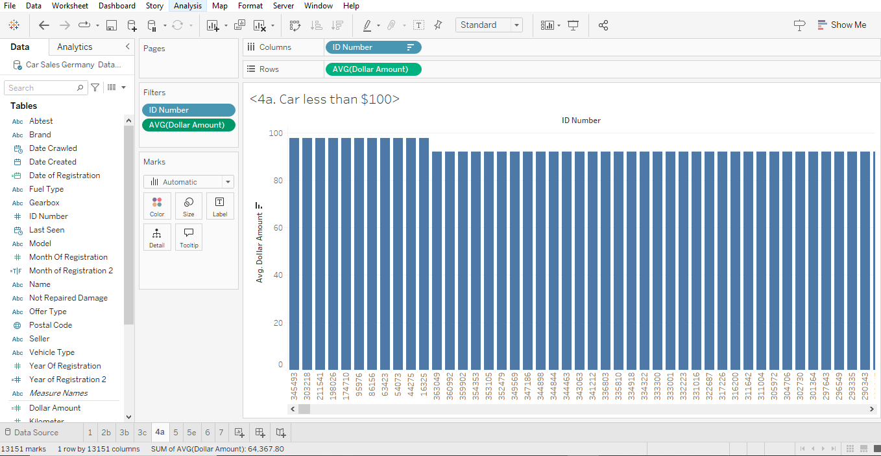
4b. Are these prices realistic?
No, these prices are not realistic. It’s highly unlikely that any car would be priced under $100, so these values seem erroneous.
4c. How would you handle these data points?
To address this issue, I would clean the data by removing or correcting entries with values like 0, 1, or 999. These are likely placeholder or incorrect values that should be either replaced with more accurate data or excluded from the analysis. Additionally, I would apply a threshold to filter out prices that fall outside of a realistic range (e.g., removing prices below $1,000 or above $1,000,000) to ensure the data reflects a more accurate picture of the market.

5a.
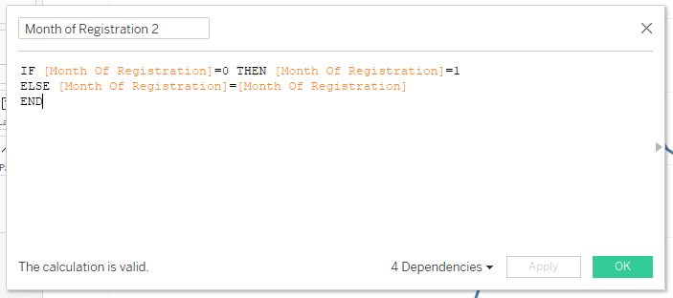
5b.
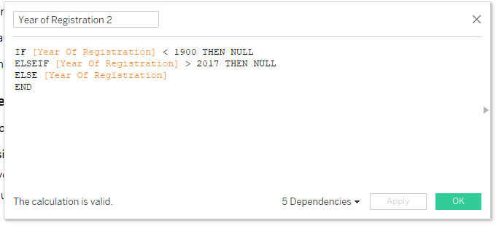

5c.
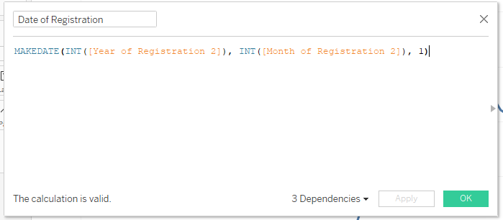
5d.
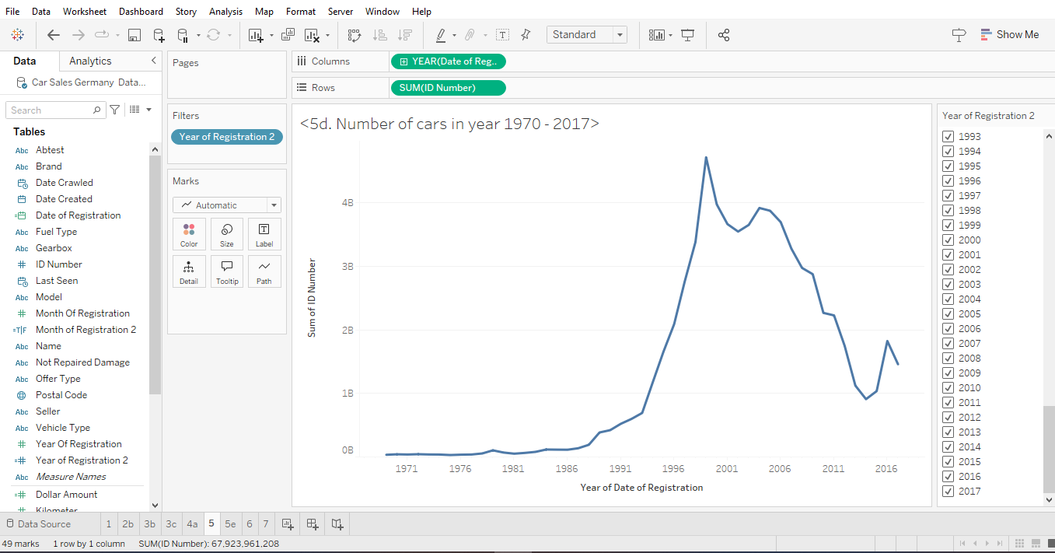

5e.
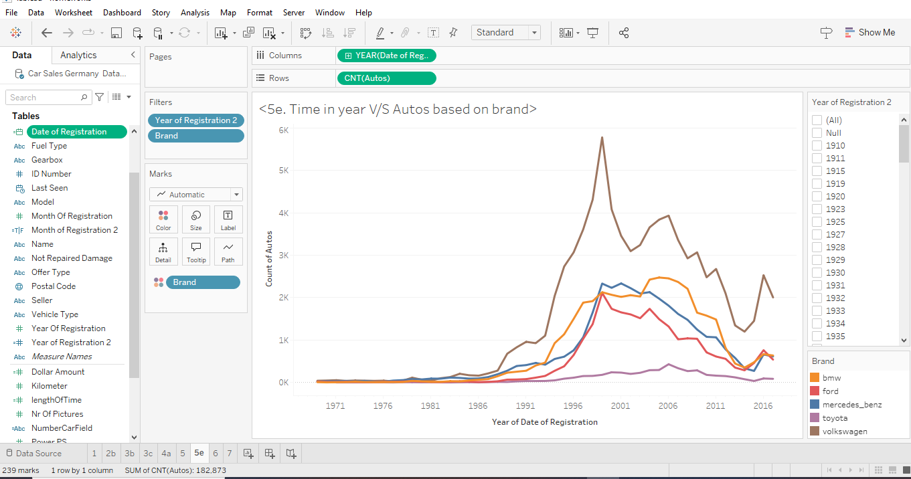
6.
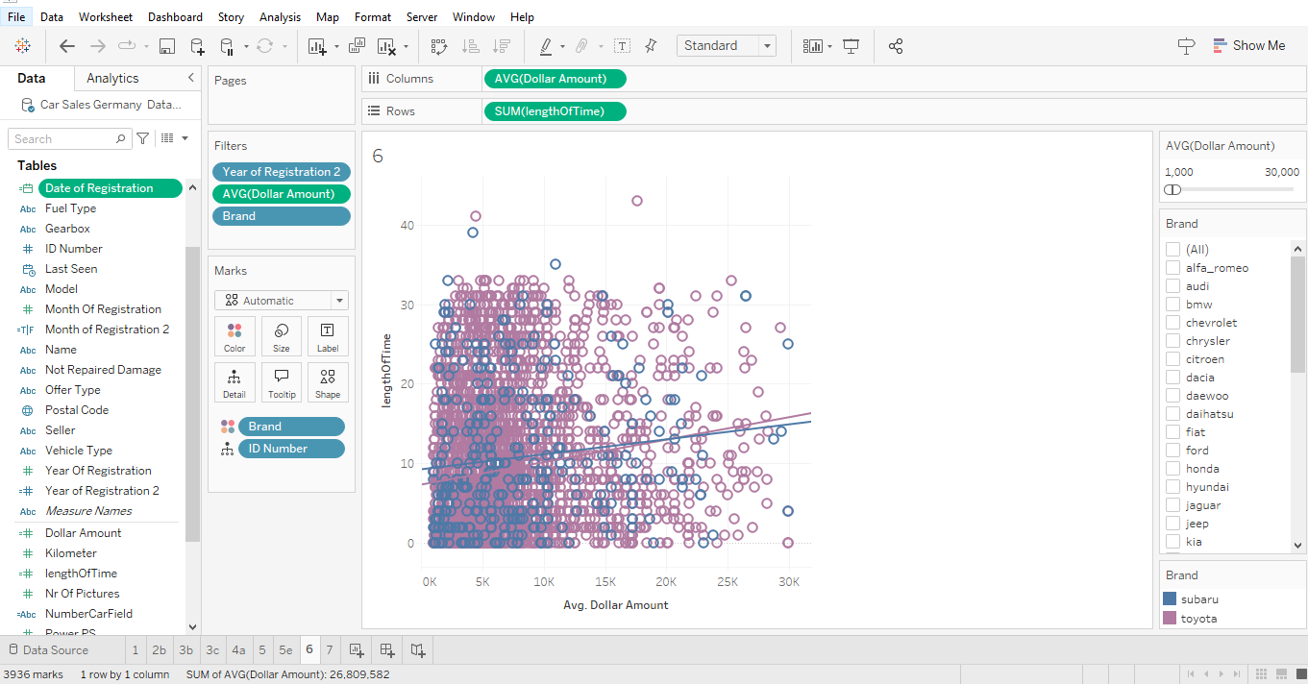
You work for a car sales company which sells Toyota and Subaru cars with dates of registration starting from the year 2000. The company targets customers who can afford cars in the price range of $1,000 to $30,000.
After restricting the dataset to the two brands (Toyota and Subaru), to the appropriate period of registration (year 2000 and beyond), and to cars within the price range of $1,000 to $30,000, do you find any relationship between the length of time it takes to sell a car and the price of that car?
Show and justify your answer.
For Toyota, the R value of 0.025 suggests a very weak positive correlation. This means that while there is a slight tendency for more expensive cars to take longer to sell, it’s so small (2.5%) that it’s nearly negligible.
For Subaru, the R value of 0.017 is even smaller, indicating an even weaker correlation (1.7%).However, R value alone doesn’t tell us whether the observed relationship is meaningful or could have occurred by random chance. That’s where the p-value comes in.
For Toyota, the p-squared value of 0.0001 shows that the relationship is statistically significant, meaning we can confidently say that the correlation, while weak, exists and is not due to random chance. For Subaru, the p-squared value of 0.01929 suggests that the relationship is statistically significant, though still very weak.

7.
