🔍 **Analyzing McMaster University Google Reviews: Insights from Data**

I recently undertook a sentiment analysis of McMaster University's Google reviews up until July 7, 2024, and the findings are fascinating! 📊 Here’s a glimpse into what the data revealed:

**Sentiment Analysis**

Using TextBlob, I computed sentiment polarity for each review to gauge overall sentiment. I categorized positive comments as those with a polarity score above 0.5, while negative ones were below -0.5.

**Top Positive Comments: Top Negative Comments:**

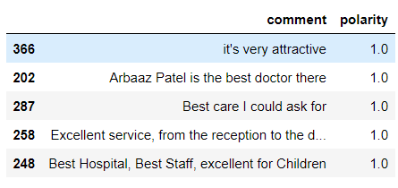

**Word Cloud Analysis**

Using WordCloud, I visualized the most frequently occurring words in both positive and negative reviews:

**Positive Sentiment Word Cloud:** **Negative Sentiment Word Cloud:**

**Emoji Analysis**

Analyzing emojis used in the reviews provided additional insights into sentiment:

**Top Emojis Used:**

Understanding sentiment from online reviews helps McMaster University enhance its offerings and better meet the needs of its community. What insights have you uncovered from analyzing reviews?

#DataAnalysis #SentimentAnalysis #McMasterUniversity