**PHASE 3**

**PUBLIC HEALTH AWARENESS**

1. **Dataset Acquisition:**

Download the dataset from the provided Kaggle link, which contains data related to mental health in the tech industry. Make sure you have it saved locally.

1. **Define Analysis Objectives:**

Clearly define the objectives of your public health awareness campaign analysis. What specific insights or goals are you trying to achieve with this data?

1. **Data Preprocessing:**

Begin with data preprocessing to ensure data quality and accuracy. This may involve tasks like handling missing values, removing duplicates, and dealing with outliers.

1. **Data Exploration:**

Explore the dataset to understand its structure and the variables it contains. You can use tools like Python or IBM Cognos for this step.

1. **Data Visualization:**

Use IBM Cognos for visualization as you mentioned. Create meaningful and informative visualizations to gain insights from the data.

1. **Analysis and Insights:**

Perform the analysis based on your defined objectives. This could involve statistical analysis, trend identification, or any other relevant methods.

1. **Campaign Strategy:**

Based on your analysis, develop a public health awareness campaign strategy. Consider what actions or initiatives can be taken to address the insights gained from the data.

1. **Report and Presentation:**

Present your findings and campaign strategy using IBM Cognos reports and visualizations. Ensure the information is clear and accessible.

**BAR CHART:**

A bar chart or bar graph is a chart or graph that presents categorical data with rectangular bars with heights or lengths proportional to the values that they represent. The bars can be plotted vertically or horizontally. A vertical bar chart is sometimes called a column chart.

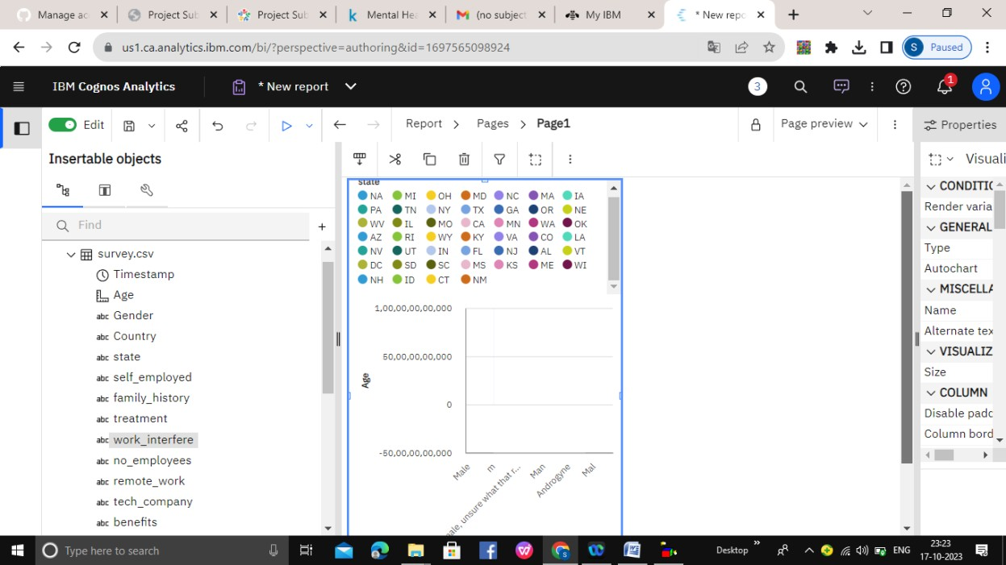

**SCATTER PLATS:**

A scatter plot is a type of plot or mathematical diagram using Cartesian coordinates to display values for typically two variables for a set of data. If the points are coded, one additional variable can be displayed.

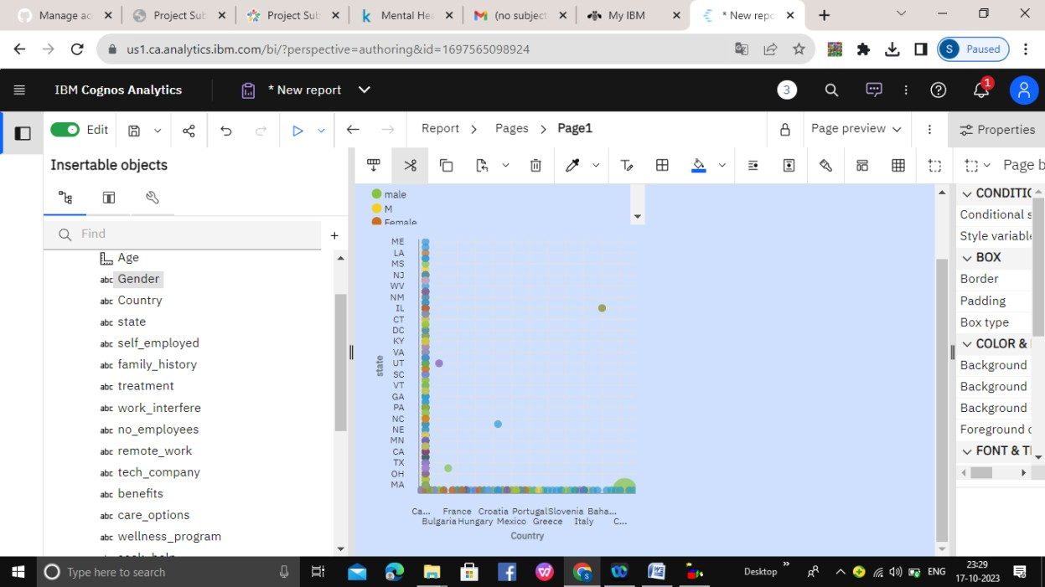

**FLOTING BAR CHART:**

Floating bar charts are charts with a single or multiple bars floating between a minimum and maximum value instead of being connected to the axis. It displays information as a range of data by plotting two Y-values(low and high) per data point.

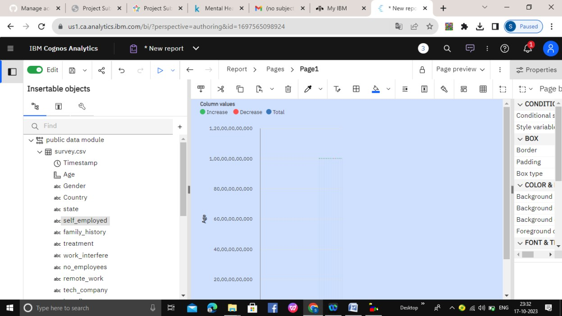

**Histogram:**

**Public health awareness is crucial for the well-being of communities. A histogram is a visual representation of data distribution. When applied to public health, it can illustrate various aspects of the field. These histograms may depict disease prevalence, vaccination rates, environmental factors, or healthcare access. They provide a snapshot of the population's health status and can be used to identify trends and disparities. By raising public health awareness through data visualization, individuals and policymakers can better understand the challenges and opportunities in healthcare. This promotes informed decision-making, resource allocation, and the development of targeted interventions to improve overall community health.**

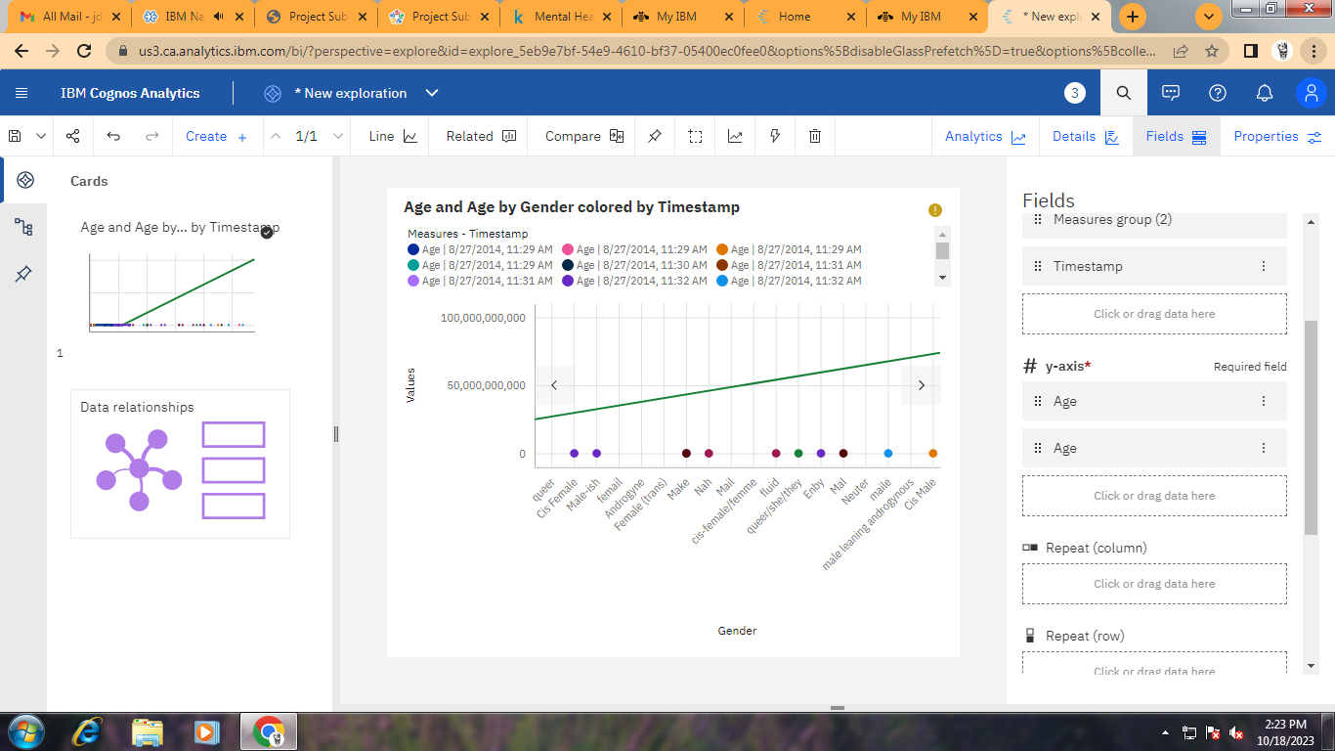

Pie Chart :

**A pie chart in public health awareness visually represents data distribution, emphasizing the proportion of different factors influencing community health. This intuitive visualization aids in understanding resource allocation and priorities, fostering informed decision-making for better public health outcomes.**

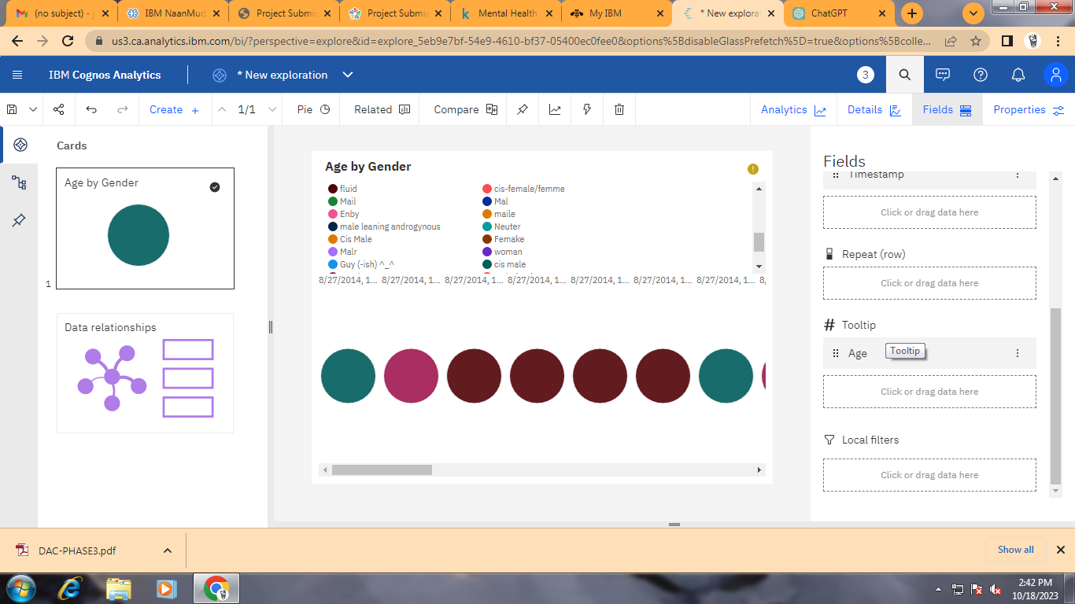

CONCLUSION:

Our code might conclude with a summary of the model performance, insights gained from the analysis, and recommendations

For public health awareness campaigns or further research.