Experiment-4
Name: Dod Roshan Manoj
Id no. 2400080292
1. Project Structure
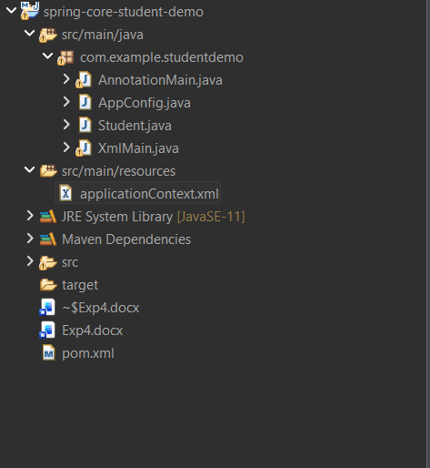

2. Files inside the Project Structure
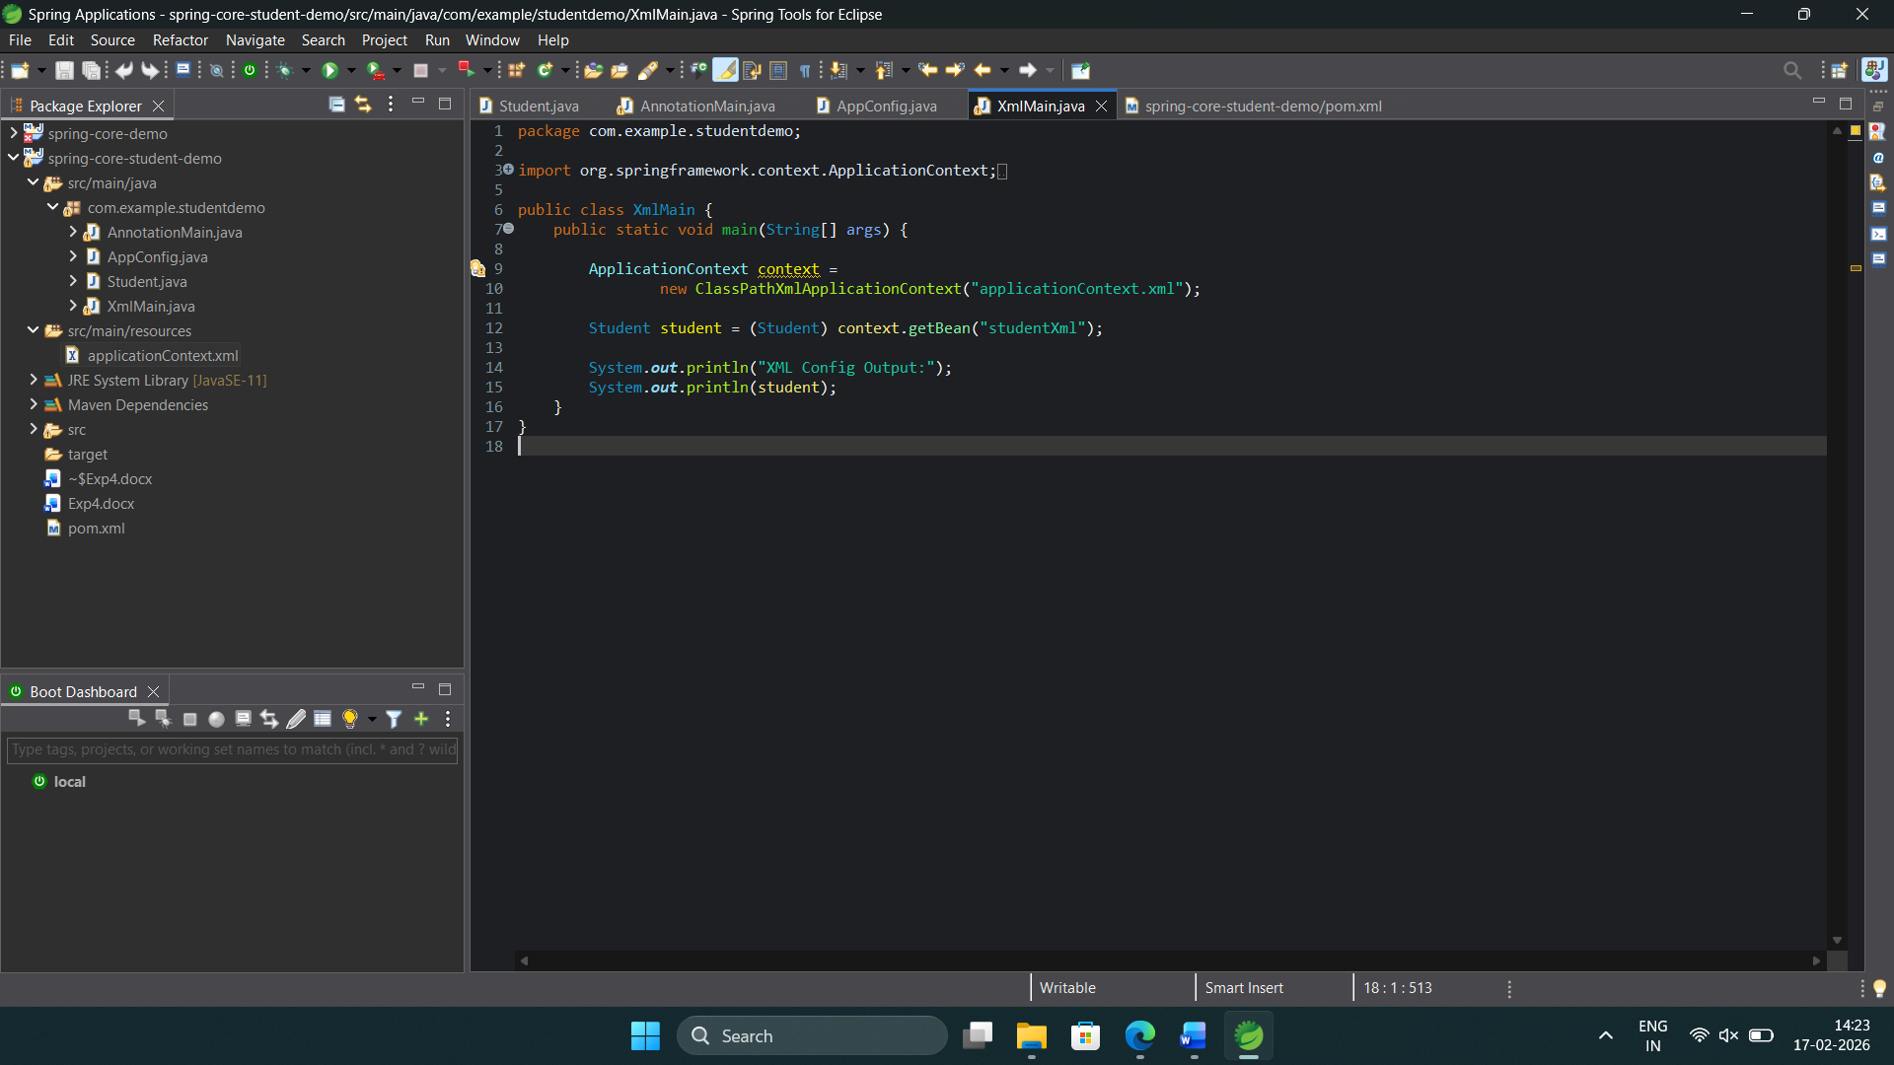
3. Running Status
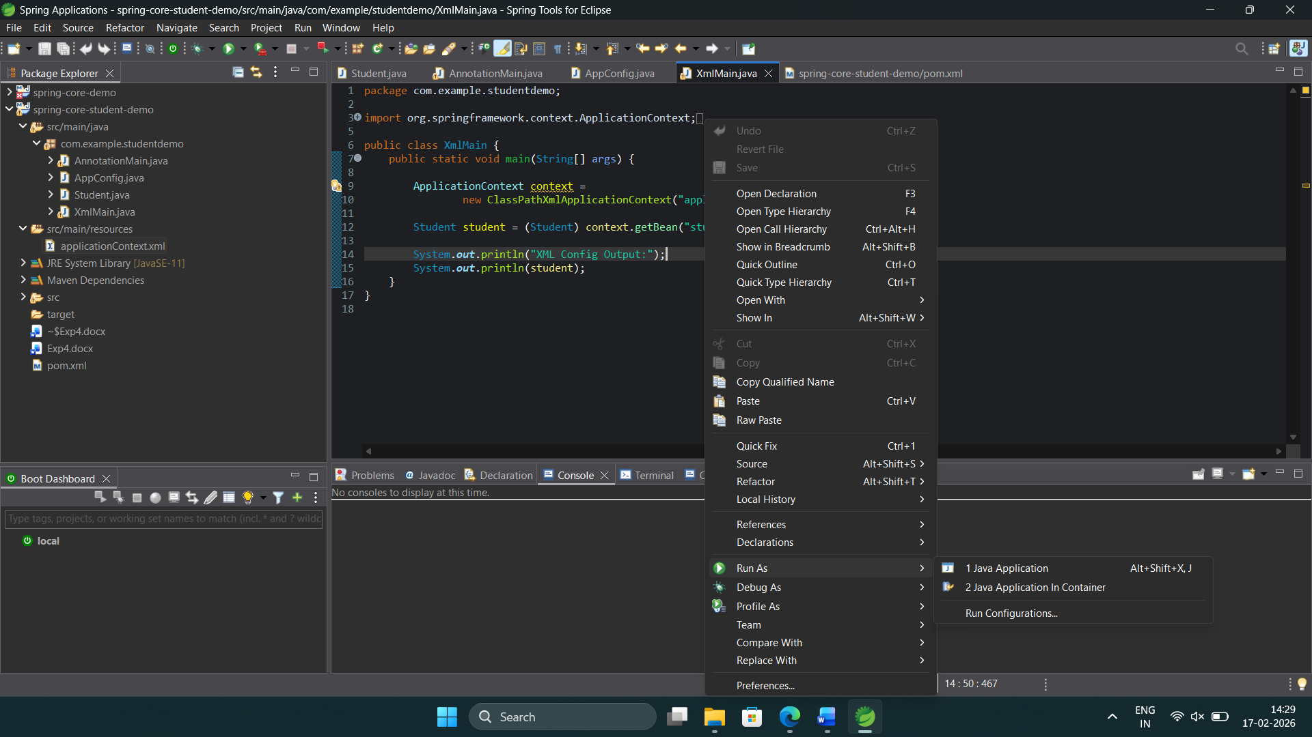

4. Console Outputs:

A. Using XML Configuration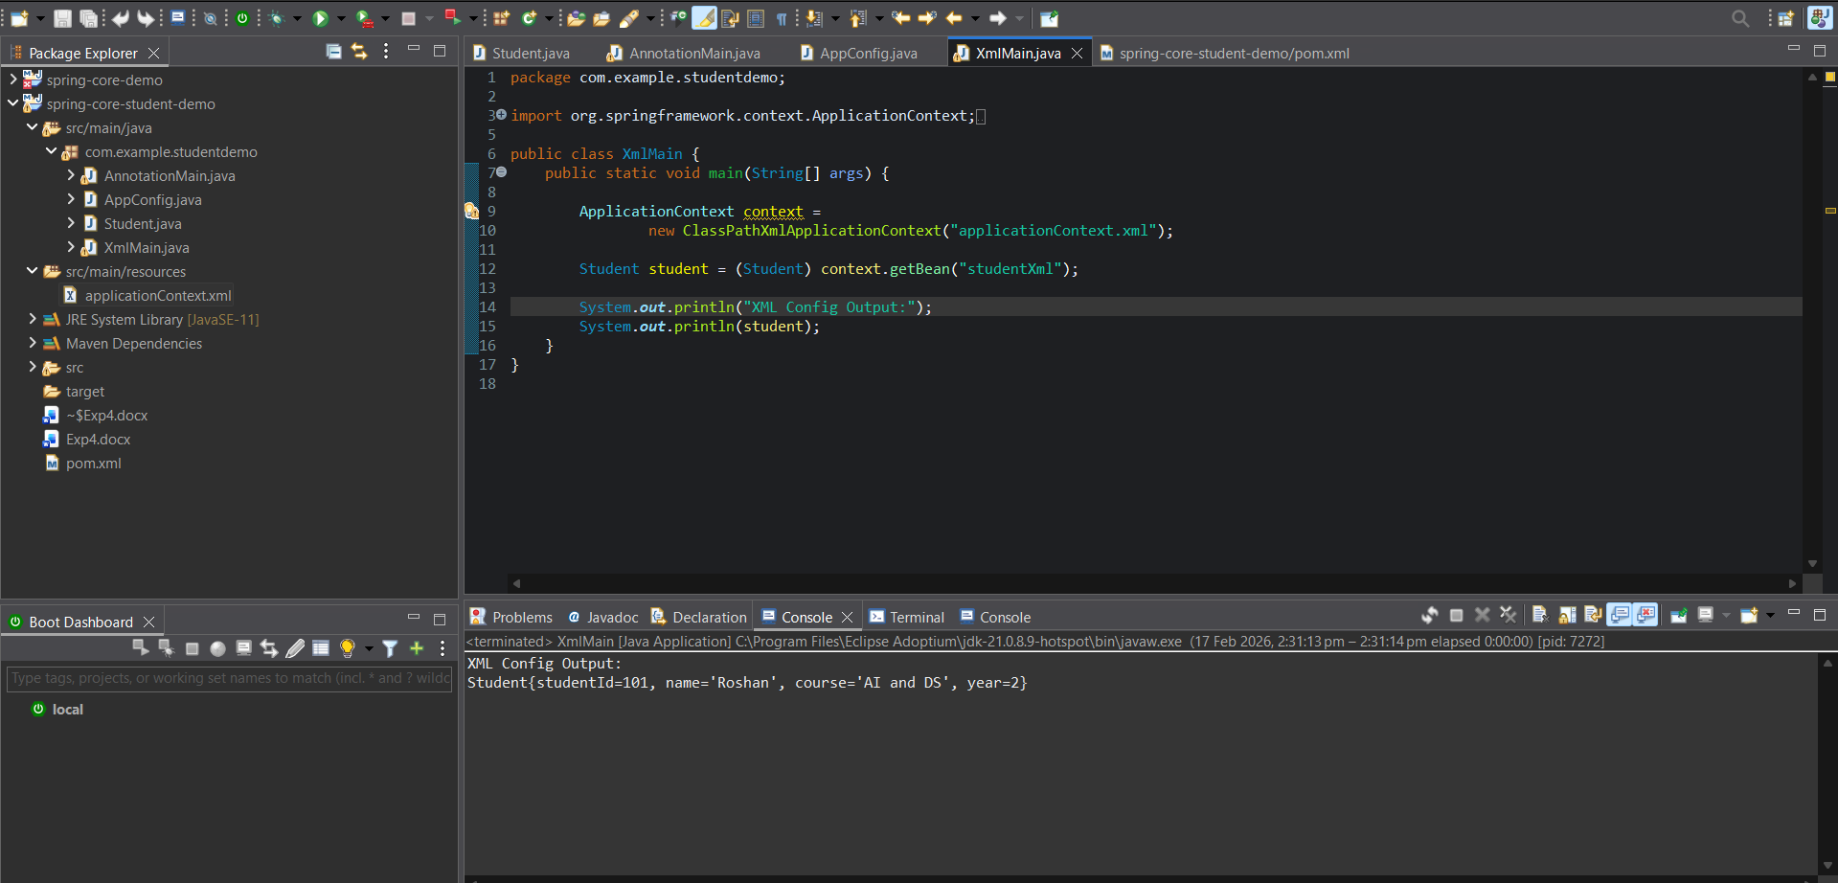
B. Using Annotation Configuration