# 1. Hosting Website using Xampp

**Install the required files from the internet and open up the setup**

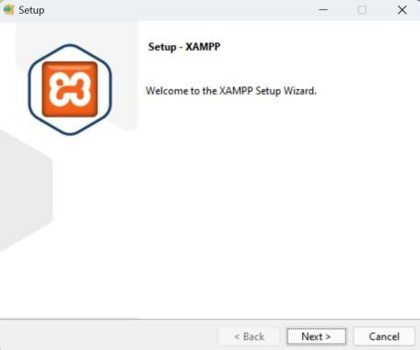

**Make the changes according to your requirements**

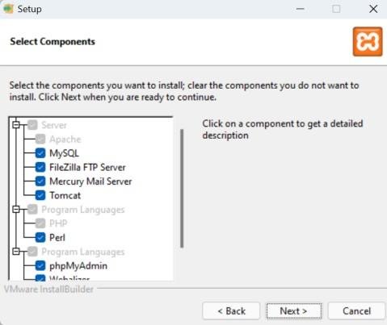

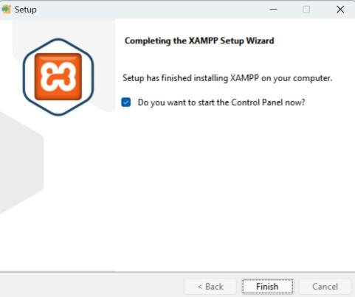

**Open the control panel and click start for Apache**

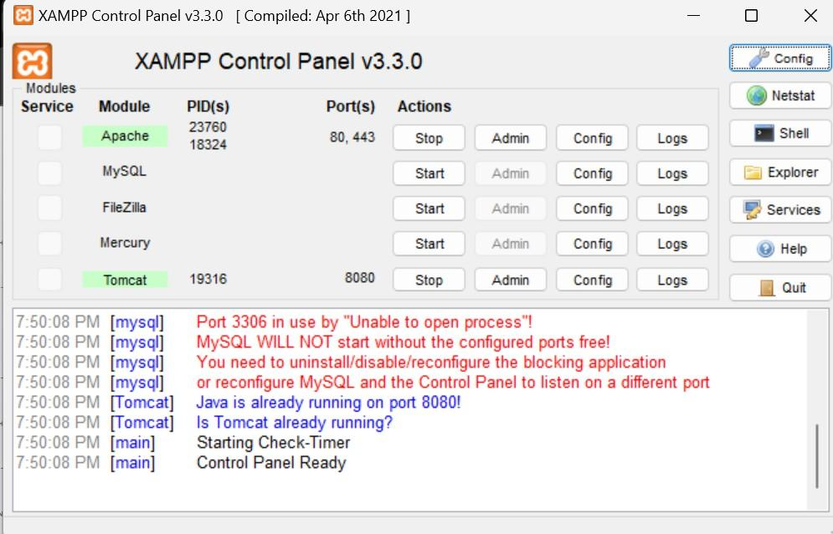

**Write down your code and save it inside the htdocs folder in xampp files**

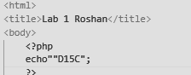

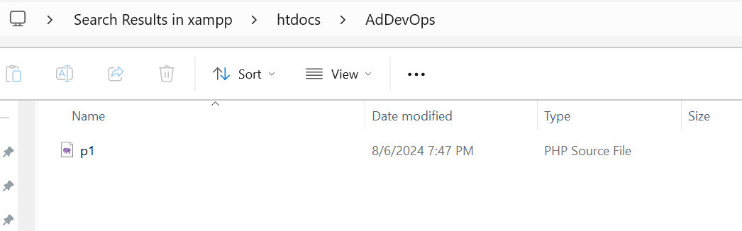

**Go to your browser and type <localhost/filename/>**

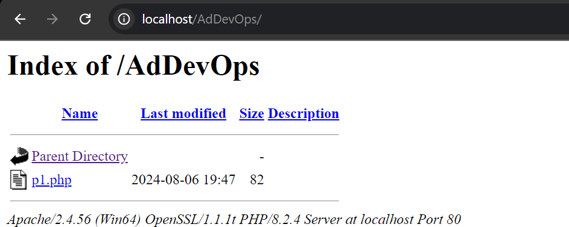

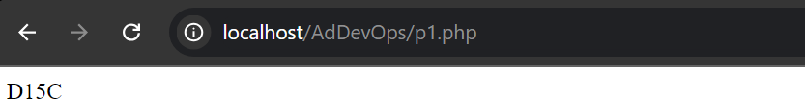

# Hosting website with Amazon S3

**Open your learner lab’s and Go to Amazon S3 in services**

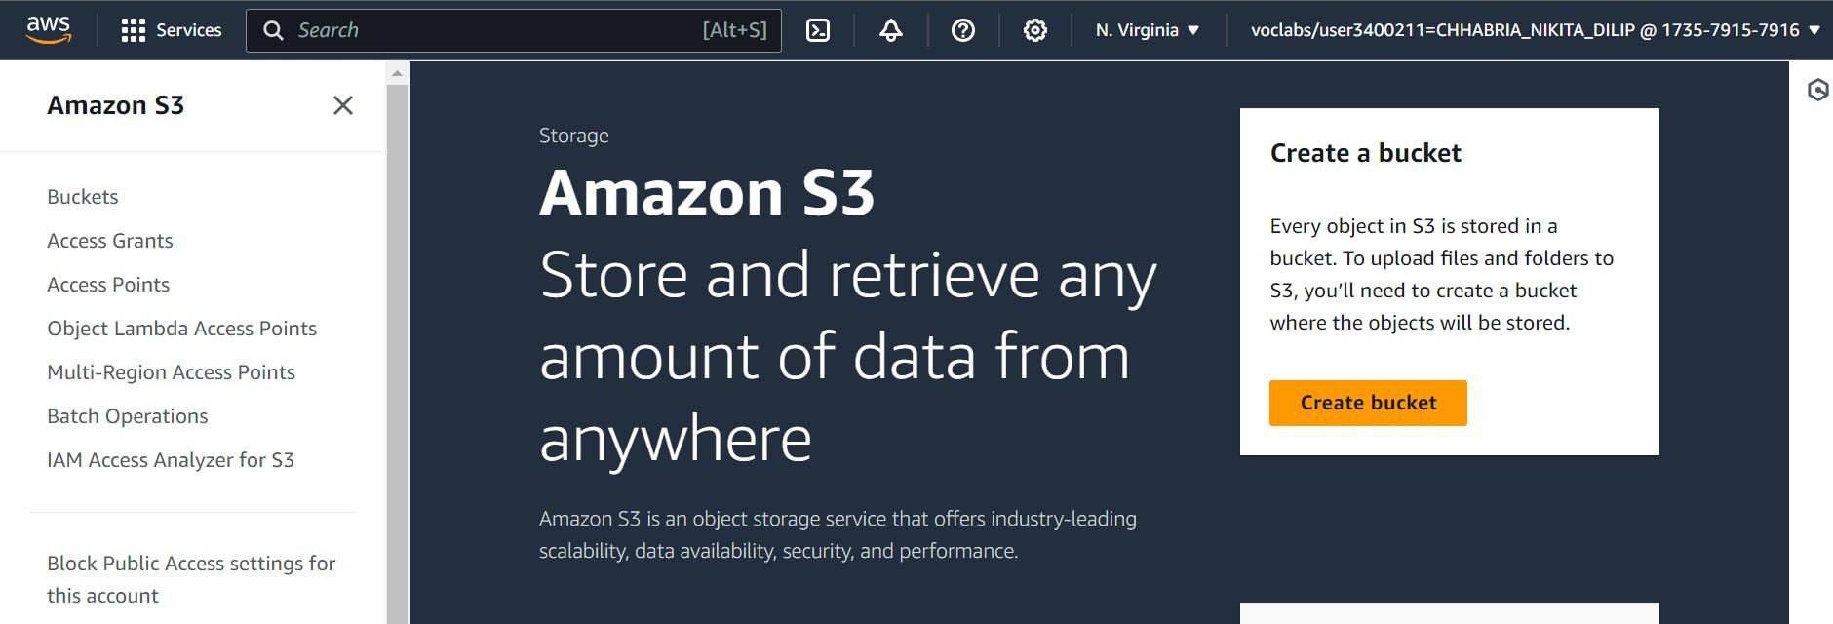

**Click on create bucket and make a bucket with any name**

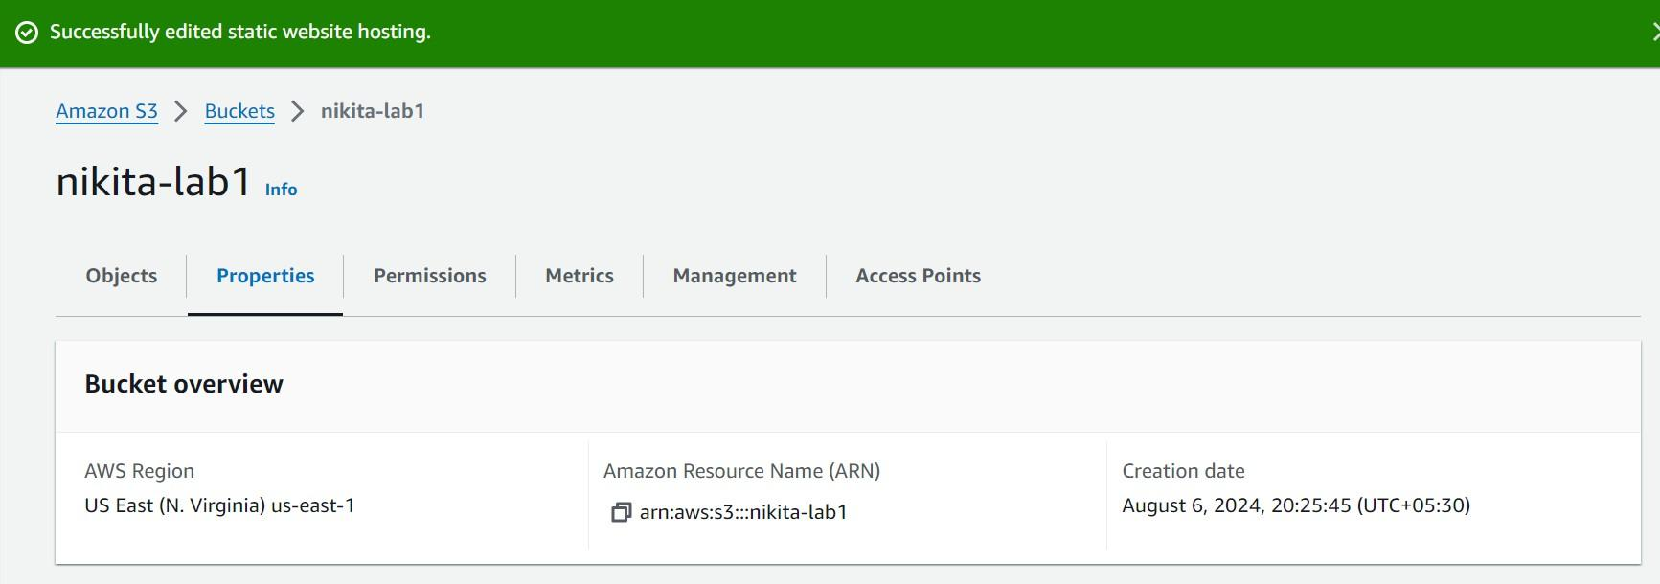

**In properties go to static website hosting and enable it**

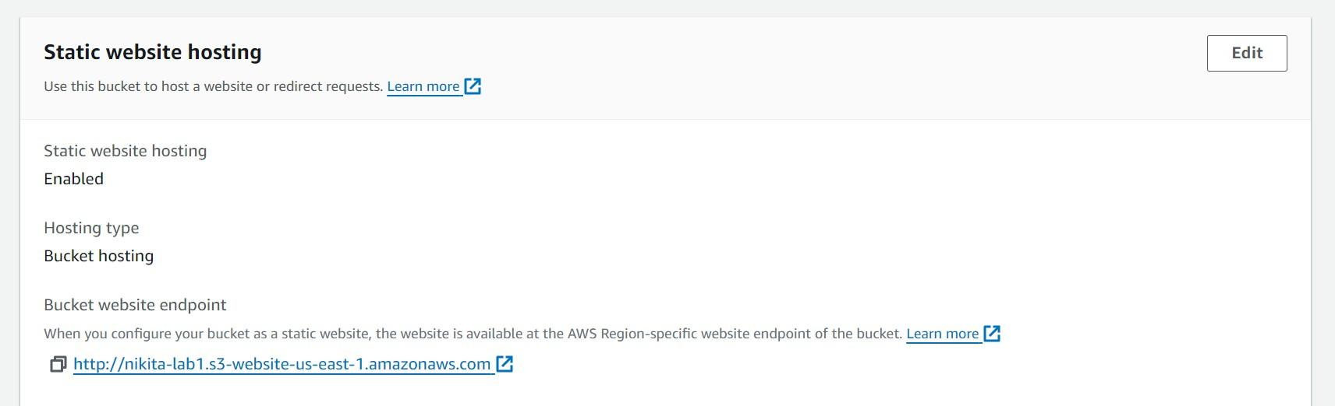

**Go to Uploads option and upload the code files in them**

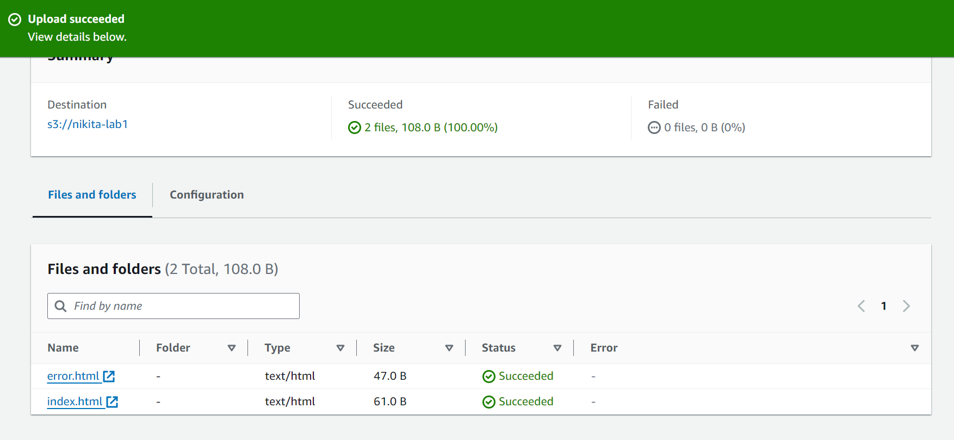

**To host the website we need some permissions which can be changed using the following code**

