Appendix B – Detailed Gantt Chart

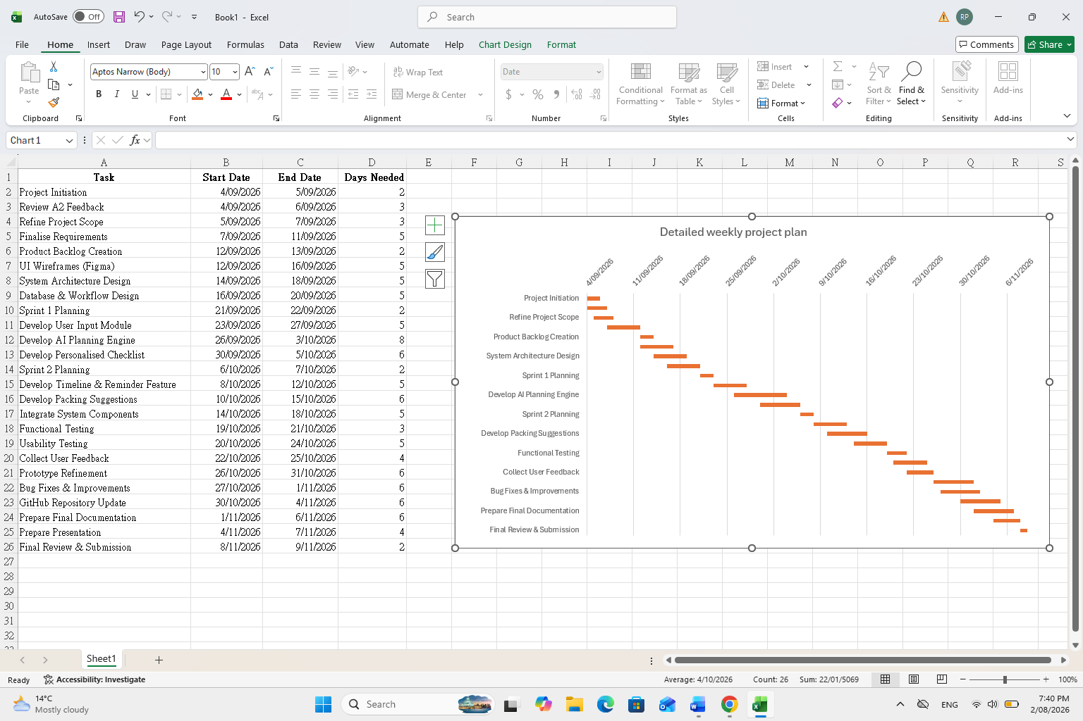
The Gantt Chart shows all of the steps in the process from start date (September 04, 2026) through final submission date (November 09, 2026). Each step will be completed sequentially as outlined below. The first sequence includes project initiation, refined requirements, and system design. Following this will be two Agile Development Sprints to create and test the minimum viable product (MVP). Next we will conduct systems integration, functionality and user experience testing, refine prototypes, prepare a formal document, finalize a presentation, and submit the final document. To assure timely completion of each task and maintain dependency order, the timeline was developed so each subsequent task is dependent upon the successful completion of the prior task(s). The purpose of developing such an extensive plan is to provide adequate opportunity to monitor and evaluate the project's status and allocate resources appropriately; also to provide ample time to identify and correct errors or omissions before submitting the final version.

