

**Submitted To: Submitted By:**

IBM Roshan Gulgulia

UID:15BCS7051

CSE(Hons) Cloud

**DEPARTMENT OF APPLIED SCIENCE & ENGINEERING**

**CHANDIGARH UNIVERSITY**

**GHARUAN, MOHALI, PUNJAB, INDIA-140413**

**2015**

TABLE OF CONTENT

Brief Discussion of Project: 3

Header Files Used 4

Function Used 5

Coding 6

Screen Shot 8

Conclusion 10

**ACKNOWLEDGEMENT**

I am using this opportunity to show my project to everyone. who supported me throughout the project. I am thankful for their aspiring guidance, invaluably constructive criticism and friendy advice during the project work. I am sincerely grateful to them for sharing their truthful and illuminating views on a number of issues related to the project.

I express my warm thanks to our IBM teachers and MY SF Teacher for their support and guidance in my Project

**Brief Discussion of project**

In this project i am going to separate the files, the different files like doc file pptx file txt file will be saved in different folder. like doc file will be saved in doc folder and text file in text folder same way other files.

In this program i am opening the directory and taking a file and checking the file is doc or txt or in which format and when the format is known by program it saves the file in that format file directory and if the file is not present then it will create a folder name with that format name and showing all files present in that directory.

So we can easily within a second we can seperate thousand of files and all the different format files will be saved in different folder.

I think this is the simplest way to seperate files and the same concept can be use to save similar files in any respect ( when created or who created) in different folders and this same concept can be use many other programs to develop any app like java or android or windows.

I have not learnt graphics otherwise i can make a file operating system that will saw us files folder in graphical view and this program will be much interesting.

**HEADER FILES**

**stdio.h:-** The **stdio.h** header defines three variable types, several macros, and various functions for performing input and output.Like:

Variable type: **size_t, fpos_t,FILE.**

Macros type: EOF,NULL, **stderr, stdin,** and **stdout etc.**

Functions type**: printf,scanf,gets,puts etc.**

**strings.h**:The string.h header file contanins one variable type,one macro type and several functions for manipulating the char array.

variable type: **size_t.**

**Macro type: NULL.**

**function type: strncpy,strlen,strcat etc.**

**dirent.h:** In dirent.h there is a structure name dirent is available which returns the file information about file name, file length etc.

**Functions Used**

**opendir():** to open the directory.

**readdir():** to read the directory name and file name.

**rewinddir():** to rewind the position of the directory.

**closedir():** to close the directory.

**clrscr():** to clear the screen.

**getch():** to get a character from the user.

**strcpy():** to copy the strings.

**strcat():** to Concatenate strings.

**strlen():** to get the string length.

**gets():** to get the string.

**CODING**

#include <stdio.h>

#include <dirent.h>

#include <strings.h>

#include <conio.h>

void main()

{

int l,g,k=0,i,j;

char gr[100];

char tr[100];

char sd[100];

char fd[100];

char jd[100];

char hd[100];

char nm[100];

char filename[100];

struct dirent *de; //Pointer for directory entry

printf("Enter a directory path and name to separate files in store in separate folder (C:/name):");

gets(filename);

DIR *dr = opendir(filename); // opendir() returns a pointer of DIR type.

if (dr == NULL) // opendir returns NULL if couldn't open directory

{

printf("Could not open current directory" );

return 0;

}

while ((de = readdir(dr)) != NULL) // it reads the file name and directory name present the directory.

{

for(i=0;de->d_name[i]!='\0';i++)

{

gr[i]=de->d_name[i];

}

gr[i]='\0';

strcpy(hd,filename);

strcpy(sd,gr);

l=strlen(sd);

for(i=l,j=0;sd[i-1]!='.' && i>=0;i--)

{

fd[j]=sd[i-1];

j++;

}

fd[j]='\0';

if(i>0)

{

g=strlen(fd);

for(i=g,j=0;i!=0;i--)

{

jd[j]=fd[i-1];

j++;

}

jd[j]='\0';

strcat(jd," files");

strcat(hd,"\\\\");

strcpy(nm,hd);

strcat(nm,jd);

strcat(hd,gr);

DIR *dt = opendir(nm);

if (dt == NULL)

{

mkdir(nm);

}

closedir(dt);

strcat(nm,"\\\\");

strcat(nm,gr);

rename(hd,nm);

}

}

printf("\nCompleted");

printf("\nCheck Out in %s.\n",filename);

rewinddir(dr); //rewinding the directory to the 1st position.

printf("Files are:\n");

while ((de = readdir(dr)) != NULL)

{printf("%s\n", de->d_name);

}

closedir(dr);

getch();

}

**OUTPUT**

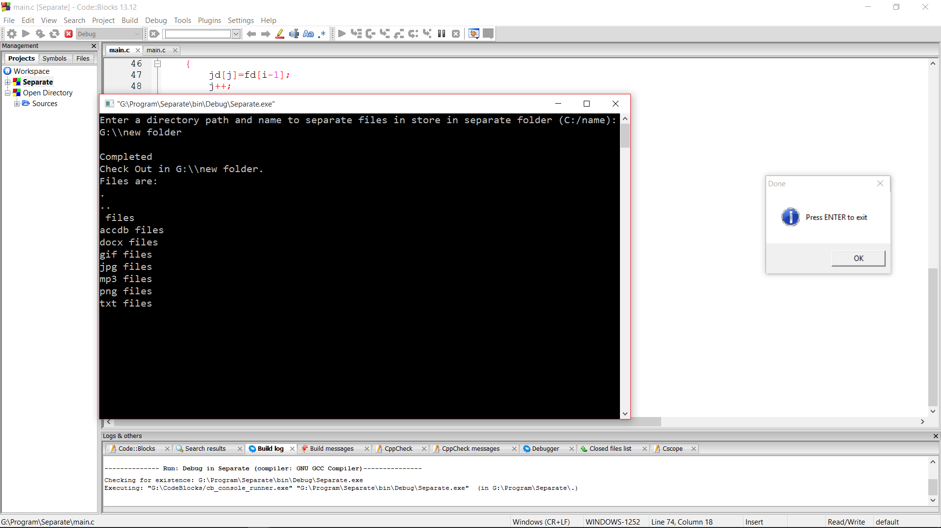

Fig:1 Console Screen

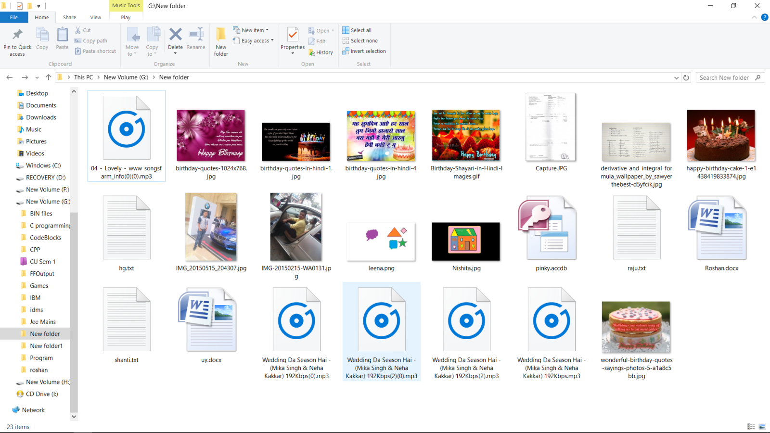

Fig:2 Before Execution of Program

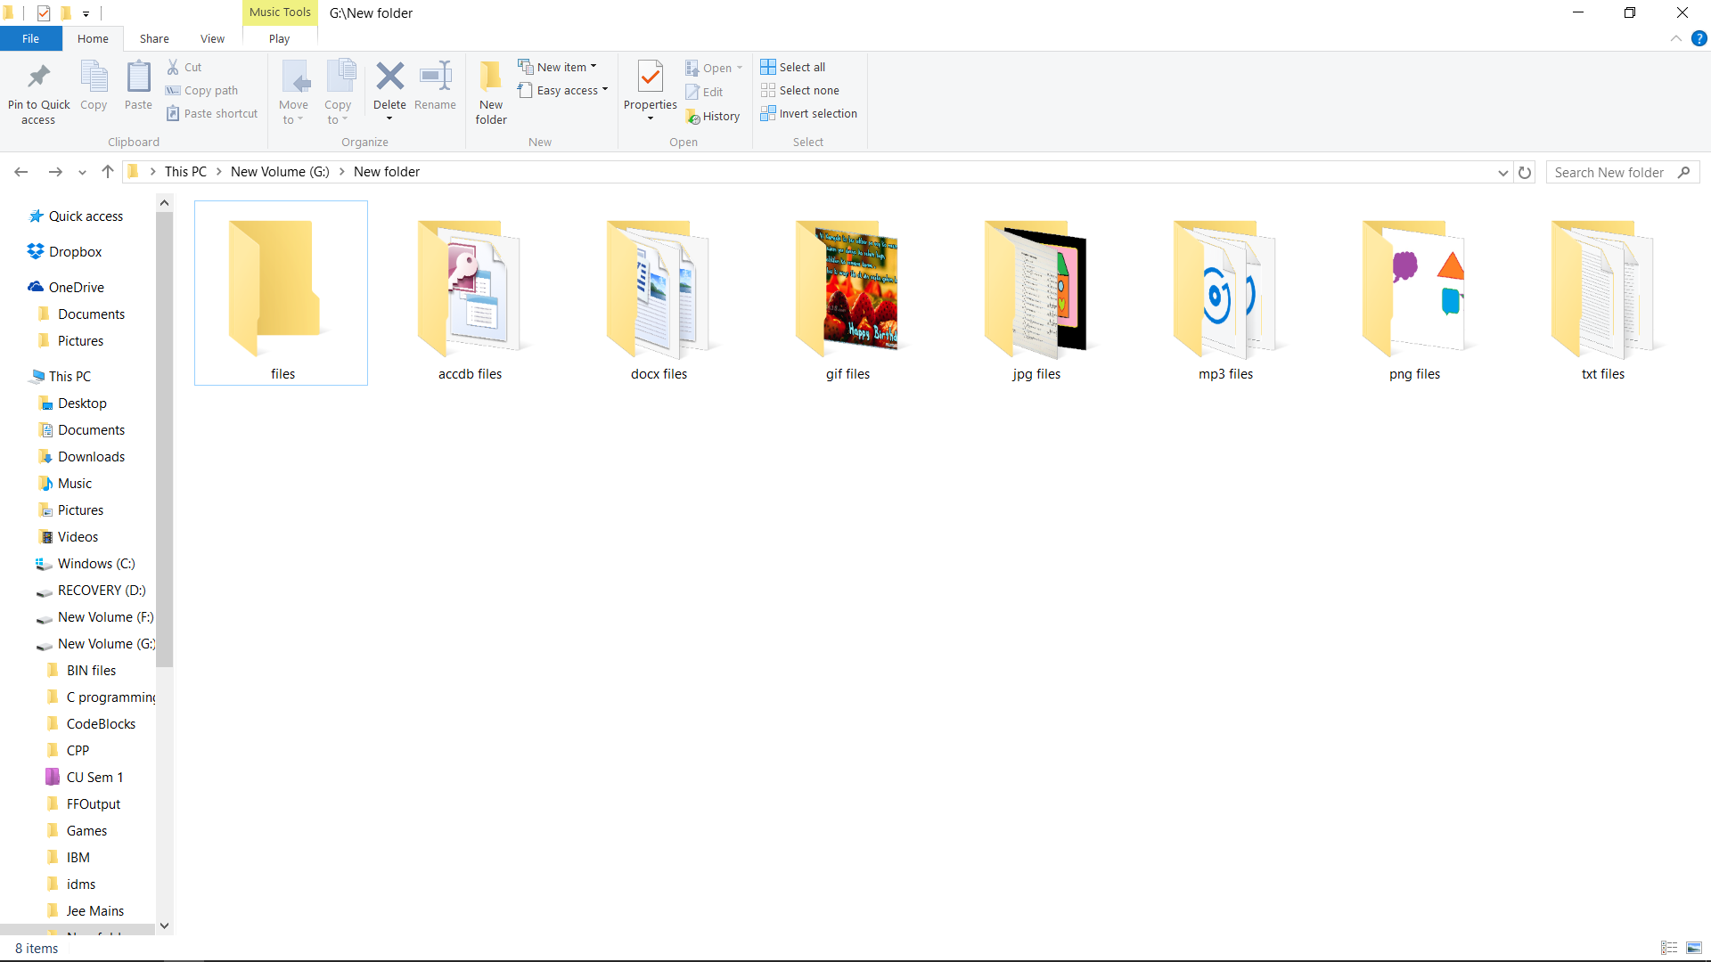

Fig:3 After Execution of Program

The source code and snapshots are less but program is very powerful and useful in separating files and it can be useful for different big companies.

CONCLUSION

We are very much thankful to our teachers for all the support they has given to us. We learn many new functions while doing this project. This is only their support that we are able to Complete the project with in time. We are very grateful for their cooperation in completion of this project. He acted as the guiding spirit behind the completion of this project.

Special Thanks to our IBM Experts that they given us their time to clear our doubts and give us an exert lecture. They also helped in completion of Project.