**ACTIVITY 2: Creating a custom matcher table.**

1. Open “Tables” >> New.
2. Give the label name as “ testing lookup ”.
3. Add “ Matcher Field Definition ” in the Extends table field.
4. Click on Submit.

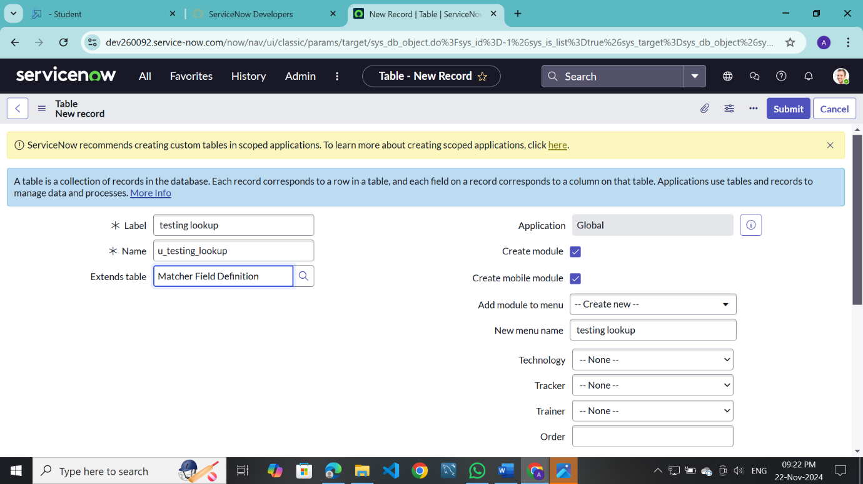

Now right click on “ technology ” field click on Configure Choices.

Enter the item as “ Salesforce ” and click on Add.

Add two more items

* 1. ServiceNow
  2. Testing

Click on save.

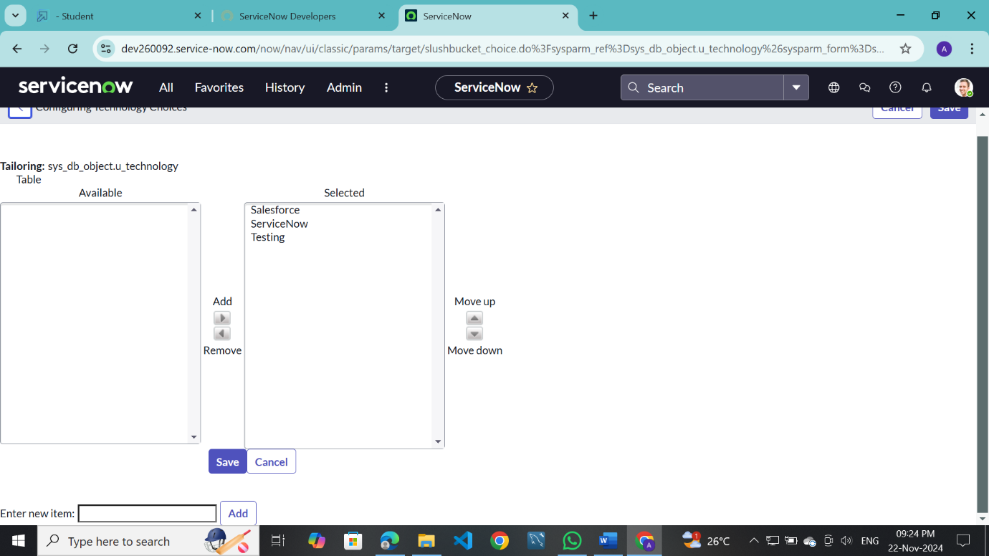

Tracker values are:

* 1. Admin
  2. Developer

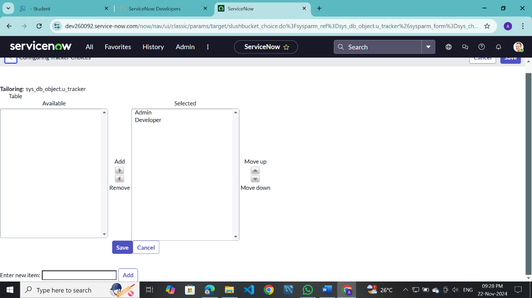

Trainer values are:

* 1. Rakesh
  2. Tarakesh
  3. Ajay
  4. Phani
  5. Shivam

Click on save.

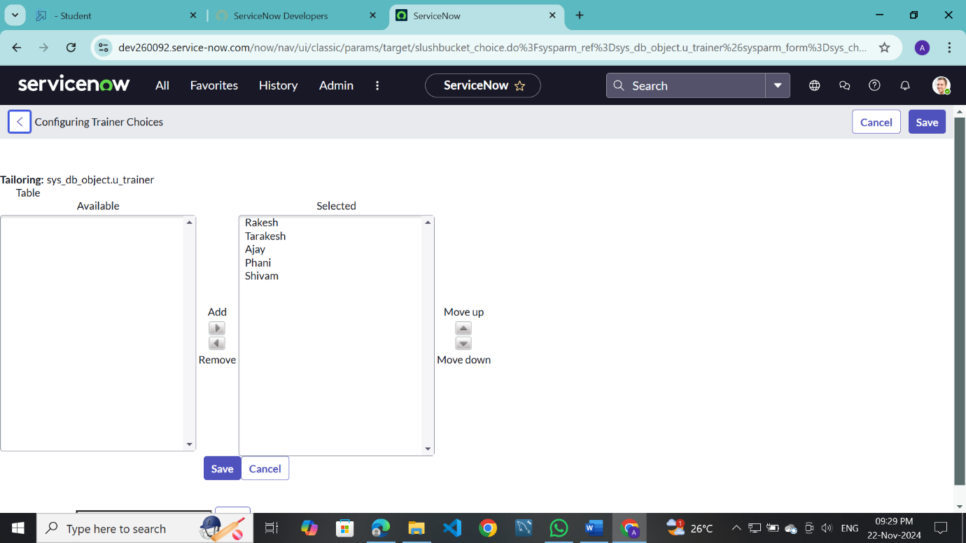

And add another field from the Form Layout that is “ order ”.

Click on save.

