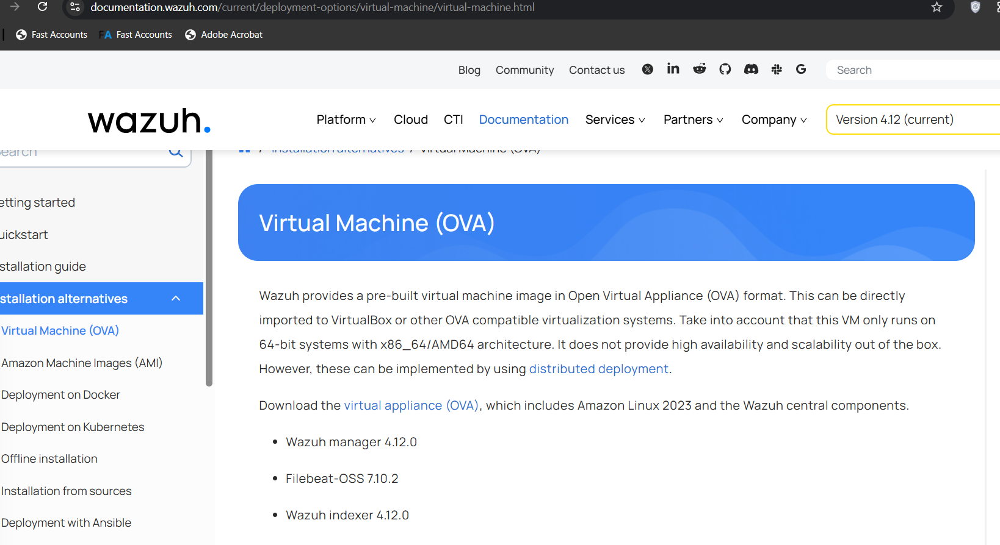

* Downloading Wazuh from their official website
* Its an Ova File so don’t need to create any virtual machiene just import and use.
* Wazuh is an open source SIEM like **SPLUNK ( cisco ) , MICROSOFT SENTINAL ,**