Student Name : Santosh Acharya

Sudent Id : c0930325

Program Code : CSD 2206

Assignment 3

Create the following table using a SQL Script;

1. Table Name **Students_{YourStudentID}** e.g Students_C0697697

|  |  |
| --- | --- |
| Student_ID | Varchar(10) |
| FirstName | Varchar(50) |
| LastName | Varchar(100) |
| Telephone_Number | Varchar(10) |
| Age | int |
| City | Varchar(50) |

1. Add a **Primary Key** Constraint to Student_ID
2. Add a **NOT NULL** Constraint to LastName
3. Add a **UNIQUE** Constraint to Telephone_Number
4. Add a **CHECK** Constraint to Age (> 18)
5. Add a **DEFAULT** Constraint to City (Default city ‘Toronto’)

**Solution**

* SQL is a standard language for accessing and manipulating database.
* Constraints are used to limit the type of data that can go into a table.
* There are two type of Constraints

1. **Column Level Constraint** : - Column level constraints apply to a column.
2. **Table Level Constraint** :- Table level constraints apply to the whole table

* ALTER is used to make the modification in the table after table is created.

1. **Create the table**
   * + Create Table is used to create a new table in a database.
     + The table name is Student_C0930325.
     + The Student_C0930325 contain following attributes.

|  |  |
| --- | --- |
| Attributes | Datatype |
| Student_Id | Varchar(10) |
| FirstName | Varchar(50) |
| LastName | Varchar(100) |
| Telephone_Number | Varchar(10) |
| Age | int |
| City | Varchar(50) |

* SQL Query to create the table is
* CREATE TABLE Student_C0930325 (
  + Student_Id varchar(10),
  + FirstName varchar(50),
  + LastName varchar(100),
  + Telephone_Number varchar(10),
  + Age int,
  + City varchar(50)

);

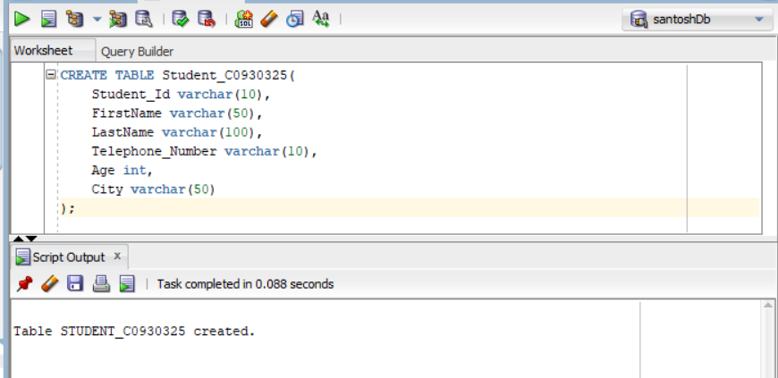

Output to show that table has created.

SQL Query to create table

1. **Add the primary Key Constraint to the Student_Id**

* Primary Key is the constraint used define the primary key in the table
* At the start table created was drop using Sql query

**Drop table Student_C0930325;**

* To make the **Student_Id** Primary Key we use Column Level Constraint in the table.
* SQL Query to create the Student_Id as primary key is
* **Syntax**

CREATE TABLE Student_C0930325 (

Student_Id varchar(10) Primary Key,

FirstName varchar(50),

LastName varchar(100),

Telephone_Number varchar(10),

Age int,

City varchar(50)

);

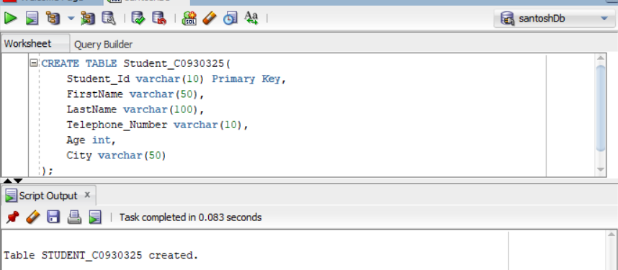

Output to Show that table has been create

SQL Query to create the table with Student_Id as Primary Key

**Inserting Data into Table**

* To insert the data in the Student_C0930325 using SQL query.

Insert into Student_C0930325

Values(1,’Santosh’,’Acharya’,’4379551559’,25,’Mississauga’);

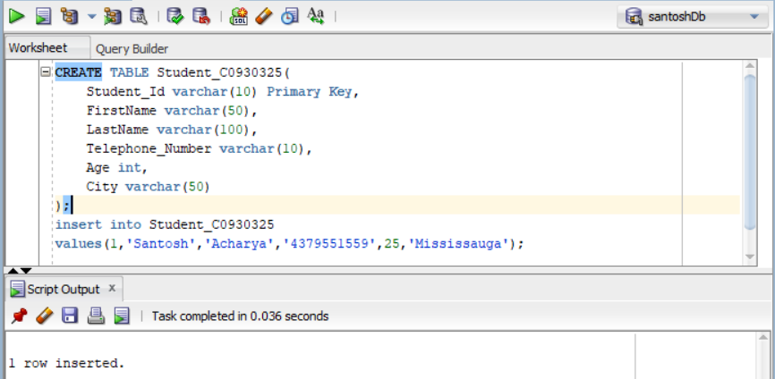

Insert data into table

**Displaying Error entry**

* To insert the data in the Student_C0930325 using SQL query when enter the Null in primary key.
* It display the error message since primary key cannot null or repeated.

Insert into Student_C0930325

Values(1,’Santosh’,’Acharya’,’4379551559’,25,’Mississauga’);

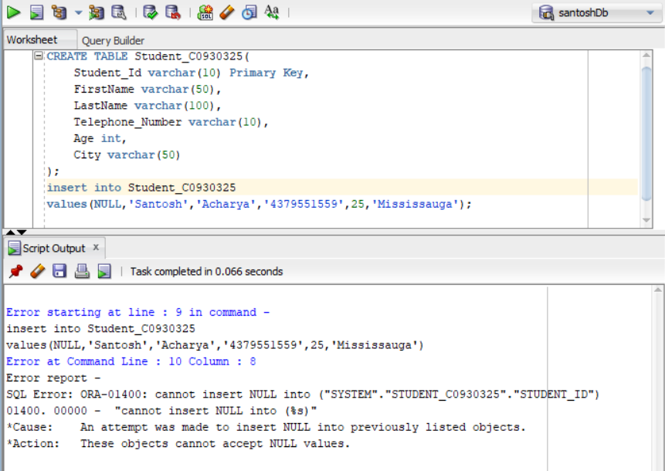

Insert null in primary key

Error message

**View the data in the table**

* To display the data from the Student_C0930325 we use SQL Query.

Select * from Student_C0930325;

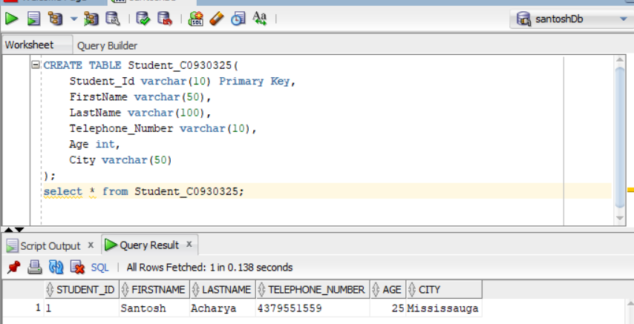

Display the table data

1. **Add a NOT NULL Constraint in LastName**

* NOT NULL is constraint used to define the column or attributes to be not null.
* At the start table created was drop using SQL query

**Drop table Student_C0930325;**

* To make the LastName NOT NULL Constraint we use Column Level Constraint in the table.
* **Syntax**

CREATE TABLE Student_C0930325 (

Student_Id varchar(10) ,

FirstName varchar(50),

LastName varchar(100) NOT NULL,

Telephone_Number varchar(10),

Age int,

City varchar(50)

);

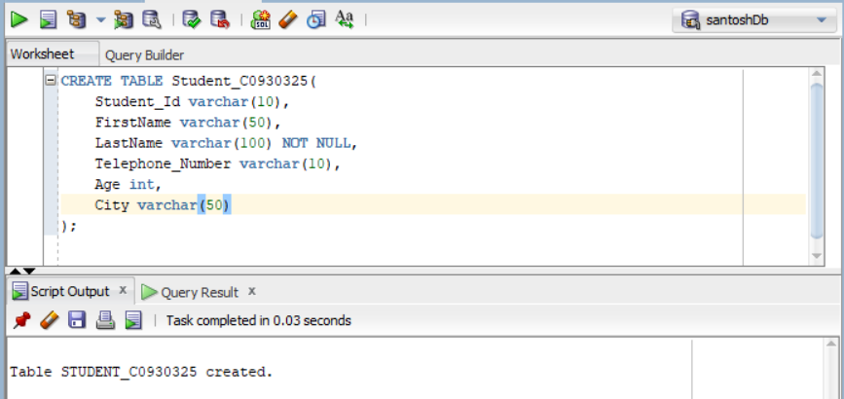

SQL Query to create the table with LastName as NOT NULL

**Inserting Data into Table**

* To insert the data in the Student_C0930325 using SQL query.

Insert into Student_C0930325

Values(1,’Santosh’,’Acharya’,’4379551559’,25,’Canada’);

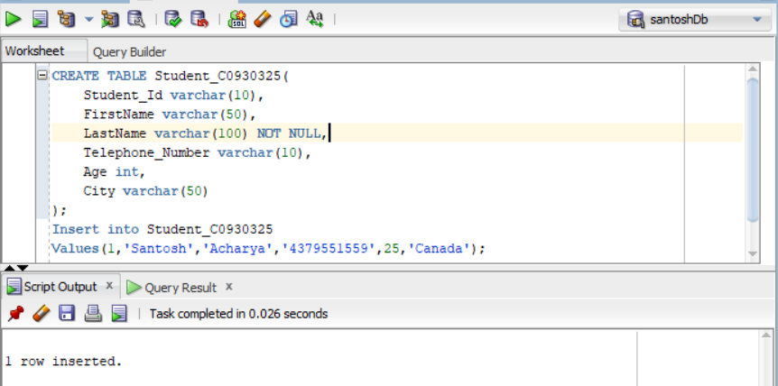

Insert the value in the table

**Displaying Error entry**

* To insert the data in the Student_C0930325 using SQL query when enter the Null in NOT NULL value.
* It display the error message since NOT NULL cannot be null

Insert into Student_C0930325

Values(1,’Santosh’,NULL,’4379551559’,25,’Mississauga’);

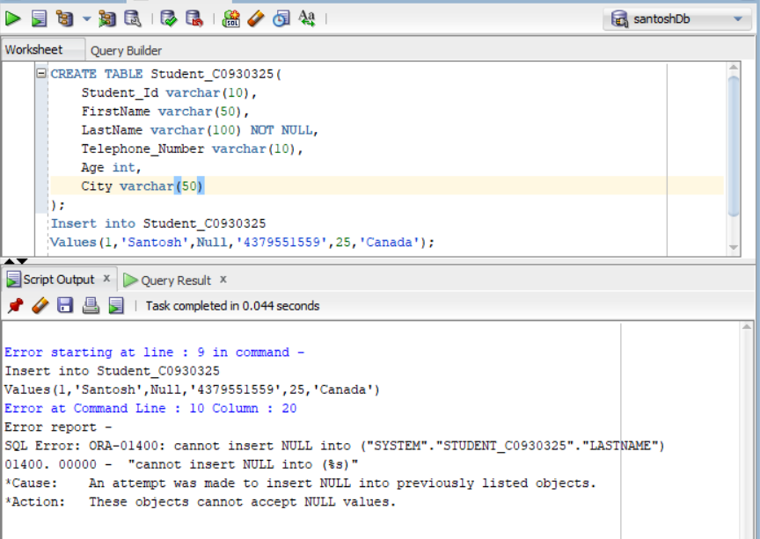

Insert Null in the LastName which show the error

**View the data in the table**

* To display the data from the Student_C0930325 we use SQL Query.

Select * from Student_C0930325;

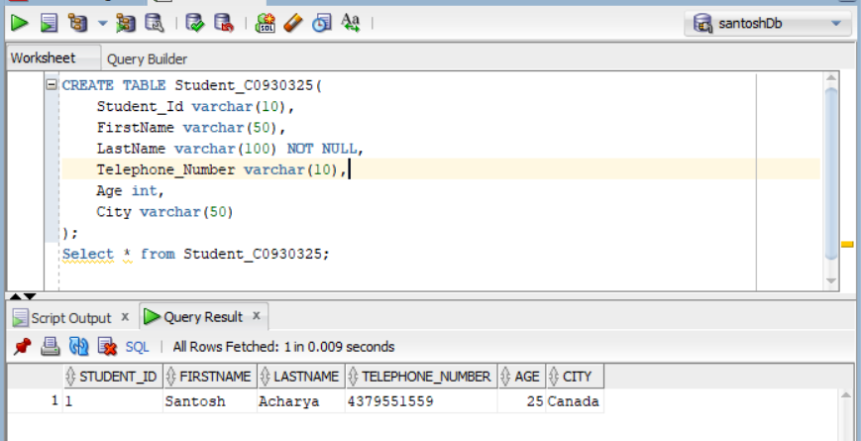

Show the table

1. **Add a UNIQUE Constraint in Telephone_number**

* UNIQUE Key is the constraint that will allow only enter a value for one and don’t allow to repeat the same value in the table.
* At the start table created was drop using Sql query

**Drop table Student_C0930325;**

* To make the Telephone_Number Constraint we use Table Level Constraint in the table.
* SQL Query to create the Telephone_Number as unique is

CREATE TABLE Student_C0930325 (

Student_Id varchar(10),

FirstName varchar(50),

LastName varchar(100),

Telephone_Number varchar(10),

Age int,

City varchar(50)

);

ALTER table Student_C0930325

ADD CONSTRAINTS student_uk

UNIQUE (Telephone_Number);

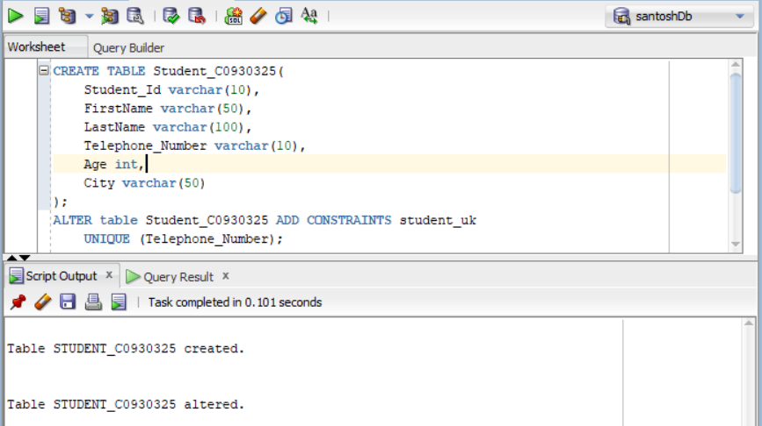

SQL Query to create the table with Telephone_Number as Unique Key

**Inserting Data into Table**

* To insert the data in the Student_C0930325 using SQL query.

Insert into Student_C0930325

Values(101,’Santosh’,’Acharya’,’4379551559’,25,’Toronto’);

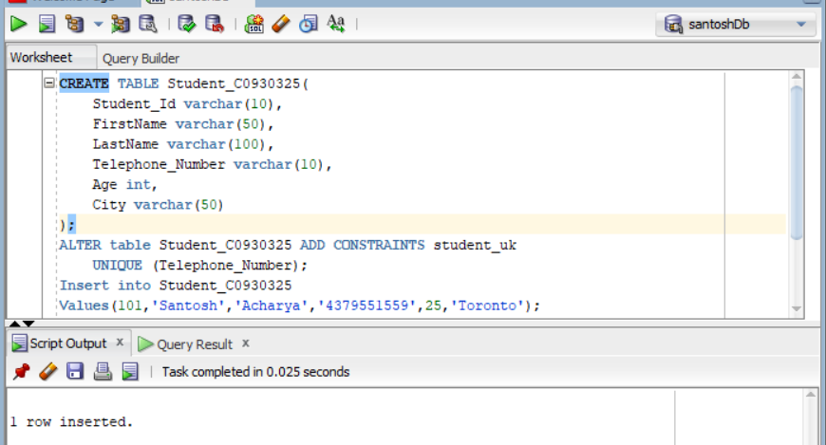

Insert the value in the table

**Displaying Error entry**

* To insert the data in the Student_C0930325 using SQL query when enter the same number twice in the database which as UNIQUE Key constraint can’t be same.

Insert into Student_C0930325

Values(104,’Shayam’,’Sunder’,’**4379551559**’,25,’Canada’);

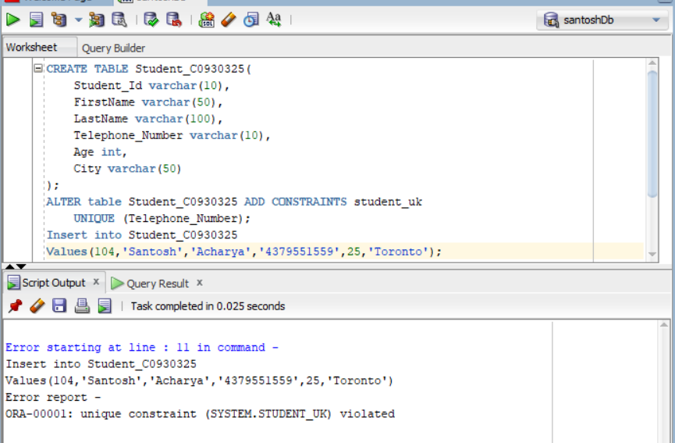

Insert the same number which show error since Telephone is unique

**View the data in the table**

* To display the data from the Student_C0930325 we use SQL Query.

Select * from Student_C0930325;

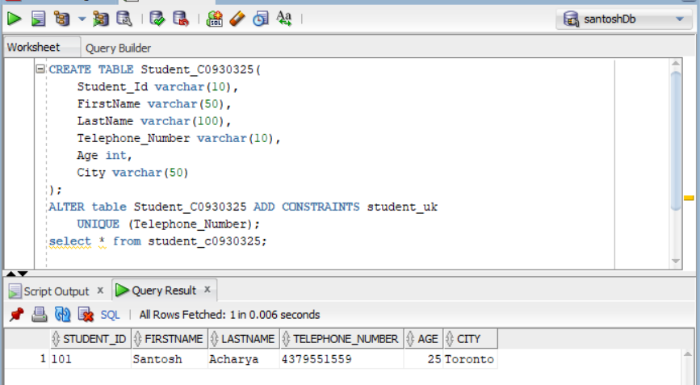

1. **Add a CHECK Constraint in Age**

At the start table created was drop using Sql query.

**Drop table Student_C0930325;**

To make the Age Constraint we use Table Level Constraint in the table.

SQL Query to create the Telephone_Number as unique is

CREATE TABLE Student_C0930325 (

Student_Id varchar(10),

FirstName varchar(50),

LastName varchar(100),

Telephone_Number varchar(10),

Age int,

City varchar(50)

);

ALTER table Student_C0930325

ADD CONSTRAINTS student_ck

CHECK(Age > 18);

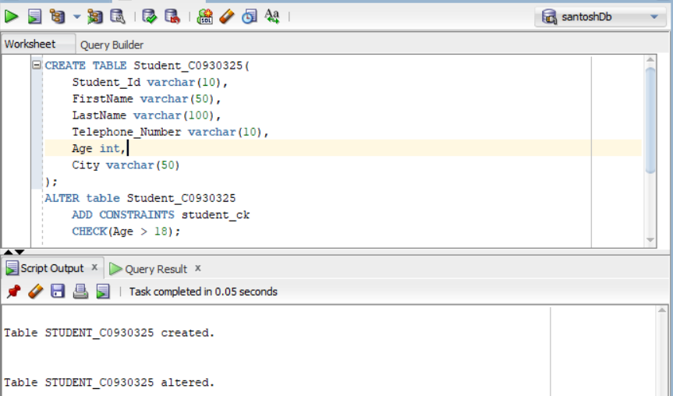

SQL Query to create the table to Check the Age enter in the table

**Inserting Data into Table**

* To insert the data in the Student_C0930325 using SQL query.

Insert into Student_C0930325

Values(16,’Santosh’,’Acharya’,’4379551559’,25,’Mississauga’);

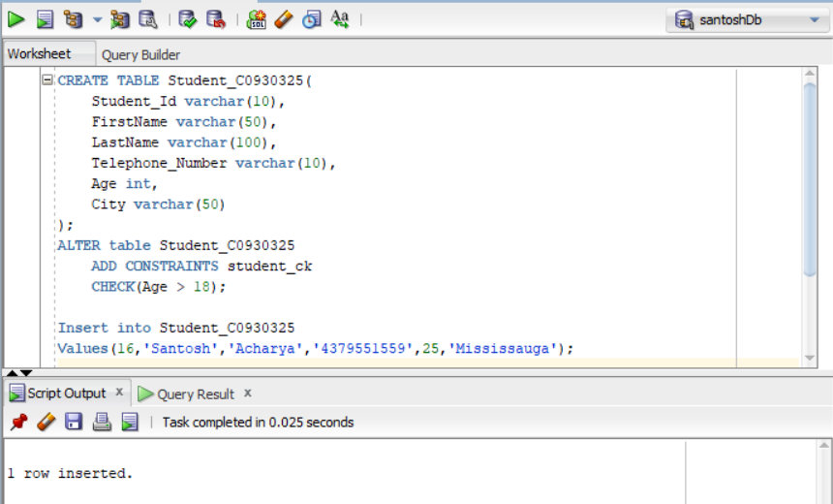

Insert the value

**Displaying Error entry**

* To insert the data in the Student_C0930325 using SQL query when CHECK is used to validate the data entry.
* Since 17 is less than 18 error is displayed.

Insert into Student_C0930325

Values(16,’Santosh’,’Acharya’,’4379551559’,17,’Mississauga’);

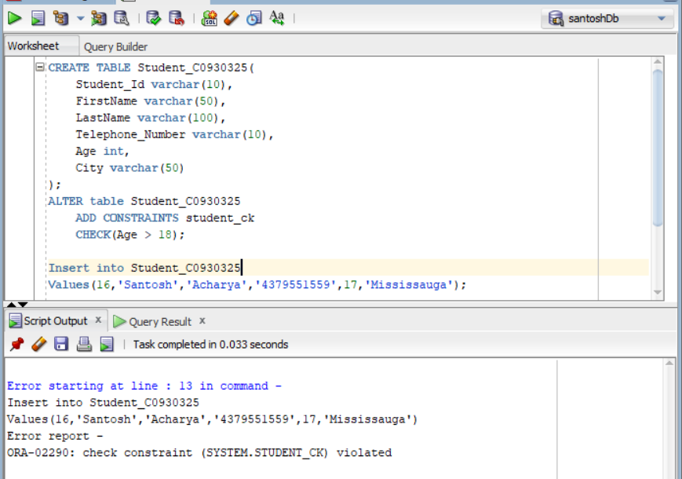

Insert the value less than 17

**View the data in the table**

* To display the data from the Student_C0930325 we use SQL Query.

Select * from Student_C0930325;

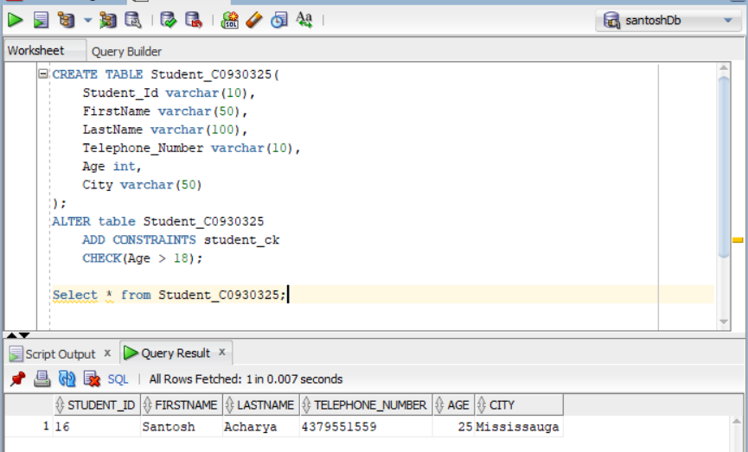

1. **Add DEFAULT Constraint in City**

* DEFAULT is use to make the value assigned at the starting, if value is not enter then it will be assigned automatically.
* At the start table created was drop using Sql query

**Drop table Student_C0930325;**

* To make the City as Constraint we use Column Level Constraint in the table.
* SQL Query to create the Telephone_Number as unique is

CREATE TABLE Student_C0930325 (

Student_Id varchar(10),

FirstName varchar(50),

LastName varchar(100),

Telephone_Number varchar(10),

Age int,

City varchar(50) DEFAULT ‘Toronto’

);

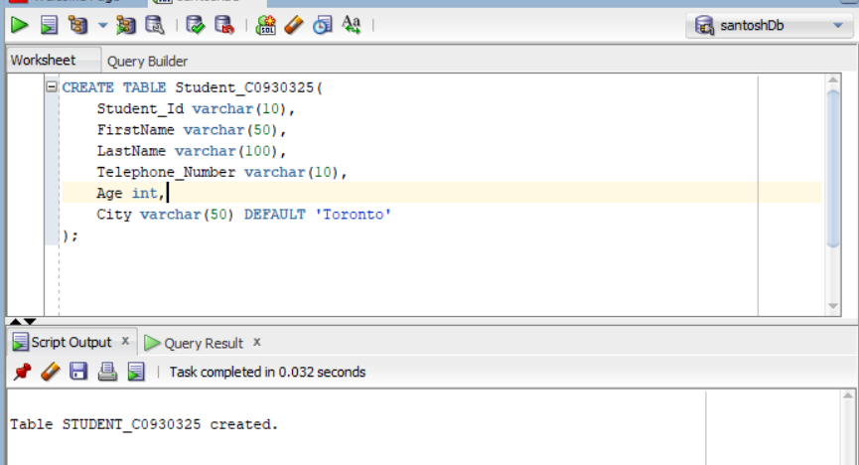

SQL Query to create the table with City as Default

**Inserting Data into Table**

* To insert the data in the Student_C0930325 using SQL query.

Insert into Student_C0930325(Student_Id, FirstName, LastName, Telephone_Number, Age)

Values(29,’Santosh’,’Acharya’,’4379551559’,25);

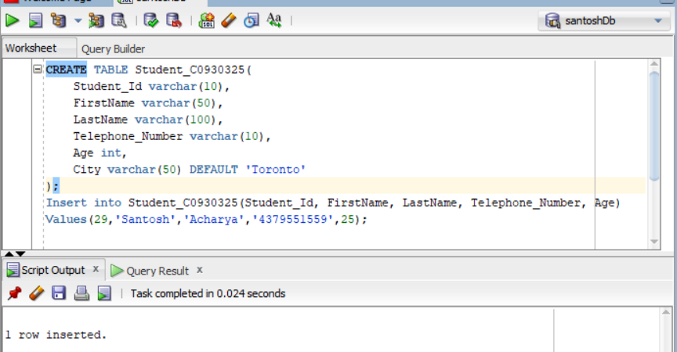

Insert the value in table

**Change the value of default constraint**

* To insert the data in the Student_C0930325 using SQL query when City has default value Toronto but we have enter value as Mississauga in City which will repleace Toronto.

Insert into Student_C0930325

Values(‘29’,’Santosh’,’Acharya’,’4379551559’,25,’Mississauga’);

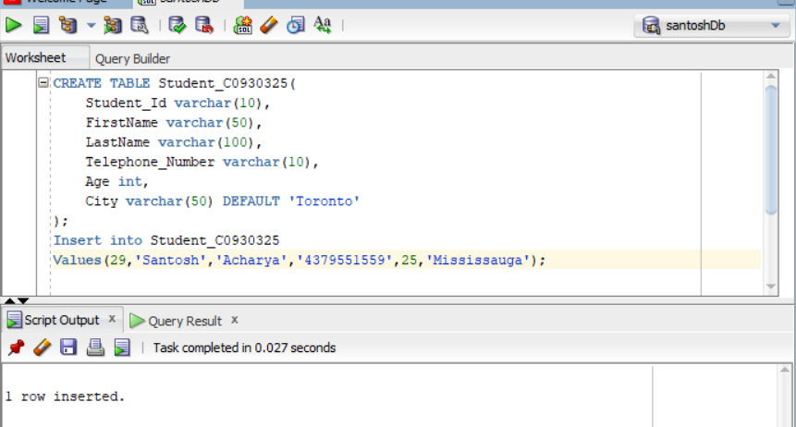

Insert the value in default column

**View the data in the table**

* To display the data from the Student_C0930325 we use SQL Query.

Select * from Student_C0930325;

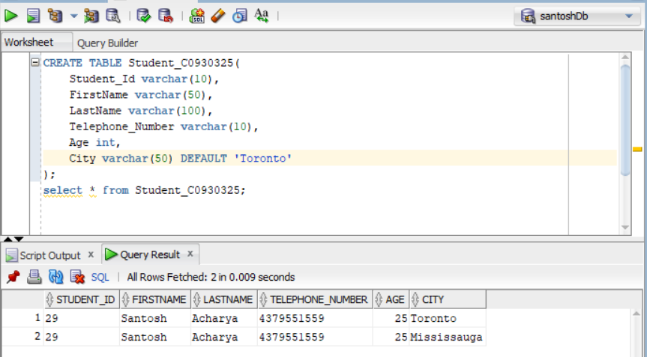

Table data