**CONSTRAINT**

**Primary Key, Not Null and Check**

* Primary key is used to define the unique key in the table it is one of the important constraint of the database.
* Not Null is used in the table when the attributes can’t be null in the table.
* Check Constraint is used when the certain condition should be fulfill for the data to be inserted into the table
* The Room used Column level constraint for Not Null and Table level Constraints for Primary Key and Check.
* SQL Query

|  |
| --- |
| create table Room(  Room_Number int,  Room_type varchar(50),  Maximum_occupancy int,  Room_rate float Not Null,  Bed_type varchar(50)  );  Alter table Room  Add Constraint roomrate_pk  Primary Key(Room_Number)  Alter table Room  Add Constraint roomrate_ck  Check(Room_rate > 0); |

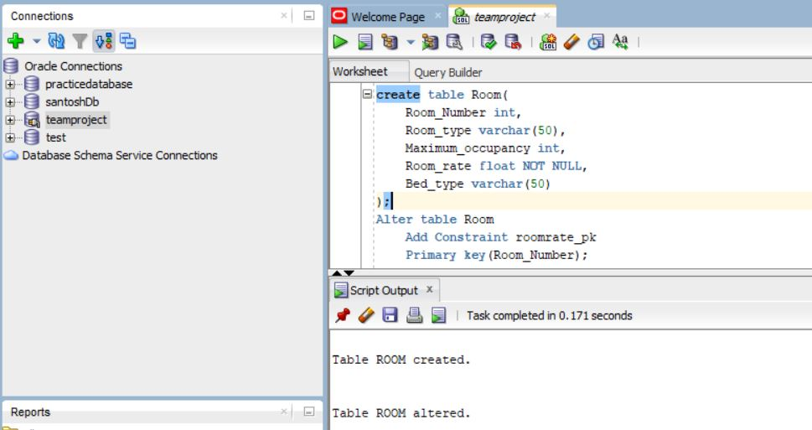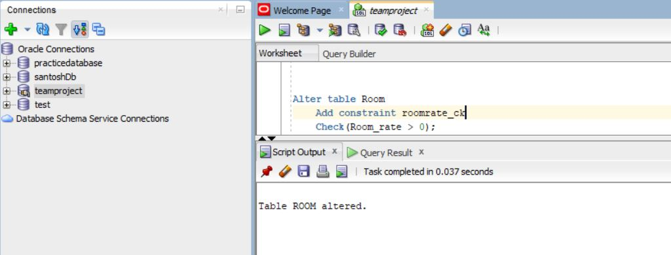

**Insert into table**

|  |
| --- |
| Insert into Room  Values(101, ‘Single Room’,3,255,’Single Bed’); |

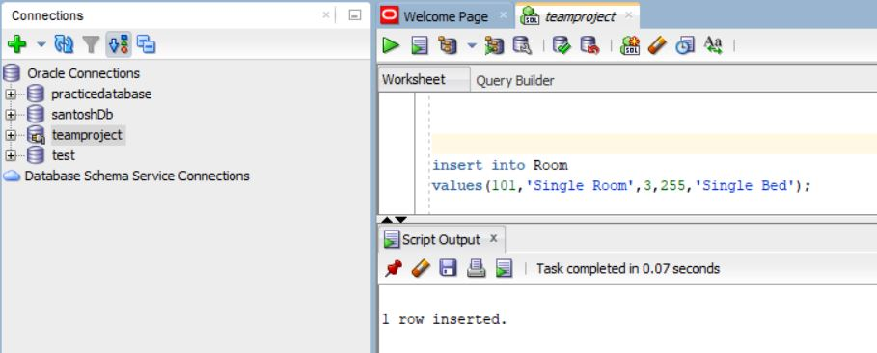

**Error in primary key and Not Null**

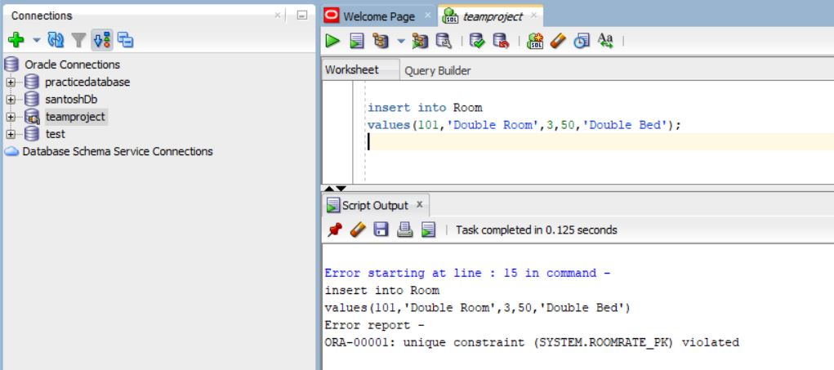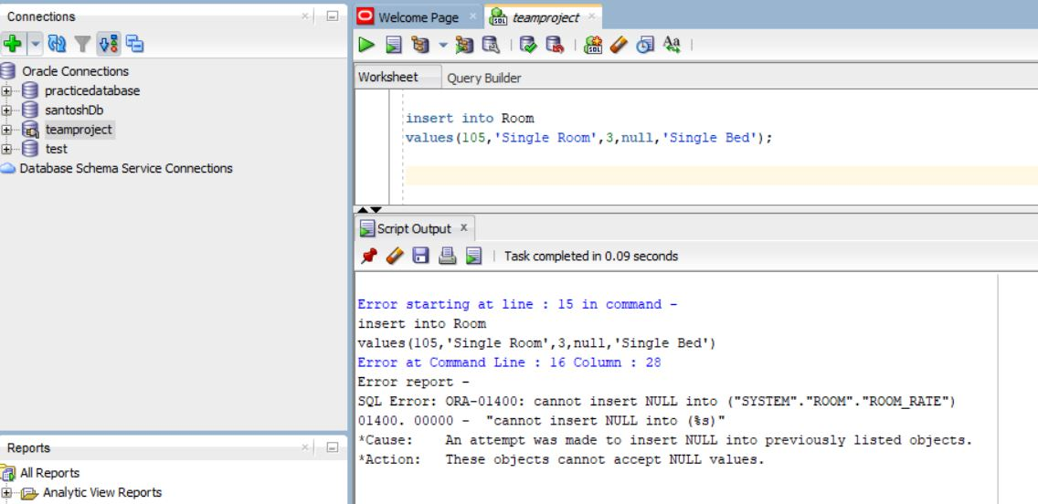

**Check Condition error**

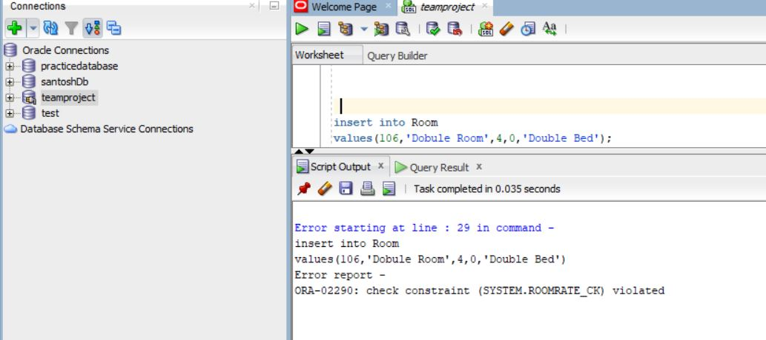

**View of the Room table**

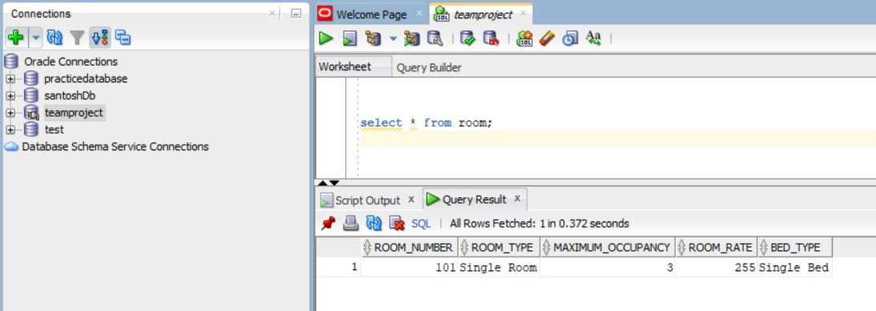

**UNIQUE KEY and DEFAULT**

* Unique key is used to make the value in the attributes to be unique from each other. It is used when the same value can’t be repeated into attributes.
* Default is used to assigned the value to the attributes. If the value is not given to the attributes then it will take the default value.
* SQL Query

|  |
| --- |
| create table Customer(  Customer_id int,  Customer_Name varchar(150),  Customer_Number int,  email_address varchar(100),  booking_history varchar(100),  address varchar(100)  Membership_status varchar(20) DEFAULT 'NO',  Nationality varchar(25),  Payment_id int,  Primary Key(Customer_id)  );  Alter table Customer  ADD Constraint customernumber_uk  UNIQUE(Customer_Number); |

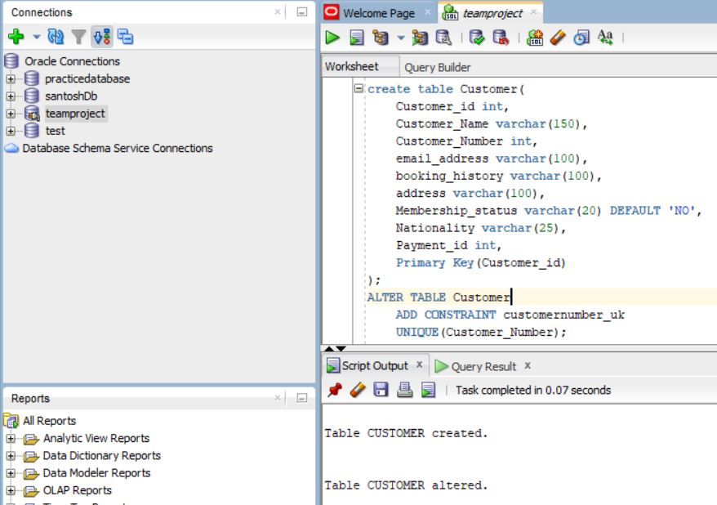

**Insert value in Customer table**

|  |
| --- |
| insert into Customer  values(500,'Santosh Acharya',4379551559,'acharyaanish16@gmail.com','No any','Mississauga','','Nepali',102); |

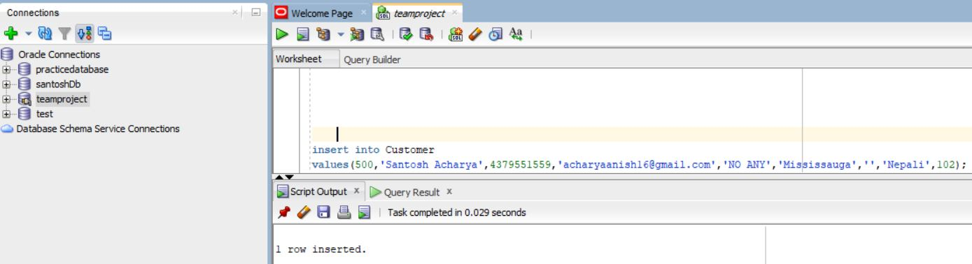

**Error in unique default**

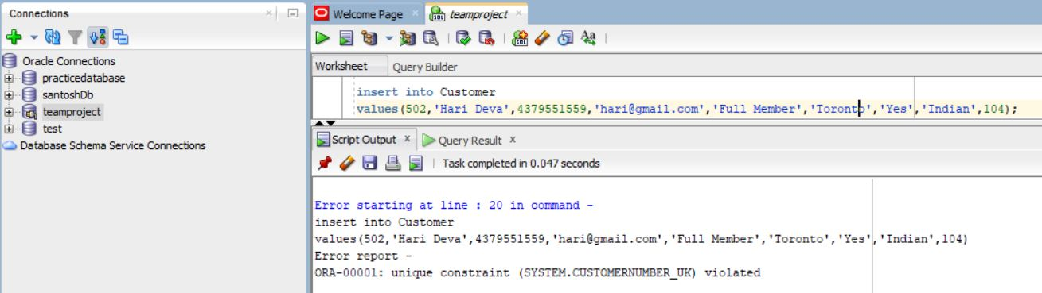

**View of the table**

