**Database Project Management**

**Hotel Reservation System**

**Project Content : ERD , Normalization, Constraints**

**Project Submission Date : 7 April 2024**

**Project Team Member**

**Santosh Acharya**

**Roshan Bhandari**

**Balu Rana Magar**

**Sumit Dulal**

Contents

DATABASE TERMINOLOGY……………………………………………………………………………………………………………………3-4

ENTITY TABLE……………………………………………………………………………………………………………………………………….5-7

ERD BEFORE NORMALIZATION…………………………………………………………………………………………………………….7-8

ERD AFTER NORMALIZATION………………………………………………………………………………………………………………9-10

NORMALIZATION……………………………………………………………………………………………………………………………11-14

RELATIONAL MATRIX……………………………………………………………………………………………………………………………15

CONSTRAINT……………………………………………………………………………………………………………………………………16-22

# DATABASE TERMINOLOGY

* **Database**

**Database** is an organized collection of structured data or the information**. Database** help to store and retrieve data in more efficient manner.

* **Entity**

**Entity** is an object in the database that exists.

* **Attribute**

**Attribute** refers to a database component, such as a table.

* **Mandatory Attributes**

**Mandatory Attributes** are the attributes that are required for the table to function and must be contained in the table.

* **Optional Attributes**

**Optional Attributes** are the attributes that are not essential in the table to function but add some meaning to the table. ➢ **Cardinality**

**Cardinality** can be defined as the set of elements arranged in tables and rows.

* **Datatypes**

A data type is an attribute associated with a piece of data that tells a computer system how to interpret its value. Data types mainly classified into three categories for every database.

o **String Data types** o

**Numeric Data types** o **Date and time Data types**

* **Constraint**

In SQL, a constraint is any rule applied to a column or table that limits what data can be entered into it. Some of Important Constraint are:

* **Primary Key**

A primary key is a unique identifier for each record in a database table.

* **Foreign Key**

A foreign key is a column or a set of columns in one table that references the primary key columns in another table.

* **NOT NULL**

NOT NULL is use to specify that a column in a database table must contain a value.

* **Unique Key**

A unique key is a constraint that ensures the values within a column or group of columns are unique across all rows in a table

* **Candidate Key**

A candidate key is a set of one or more columns in a database table that can uniquely identify each record (row) within that table.

* **ERD / Entity Relationship Digram**

A is a visual representation of the entities, their attributes, and the relationships among them within a database or information system.

* **Column Level Constraint**

The Constraint that is implement in the column is known as column level constraint. It is done while creating the table.

* **Table Level Constraint**

The constraint that is implement in the whole table level is known as Table level

Constraint. It can be implement into the table. Atler is use for table level constraint.

**Entity Table**

|  |  |  |  |  |
| --- | --- | --- | --- | --- |
| **Entities** | **Required Attributes** | **Datatype** | **Optional Attribute** | **Data Type** |
| **Room** | **Room_Number (PK)**  Room_Type  Room_availabilty  Maximum_occupancy  Room_rate  Bed_Type | Int  Varchar(50)  Varchar(50)  Varchar(50)  Varchar(50)  Varchar(50) |  |  |
| **Booking** | **Booking_id (PK)**  **Room_Number (FK)**  **Customer_id (FK)**  Number_of_Guest  Date_of_arrival  Date_of_Depature | Int  Varchar(50)  Int  Varchar(50)  Date  Date |  |  |
| **Customer** | **Customer_id (PK)**  Customer_Name  Customer_Number  Email_address Address  Nationality  **Payment_id (FK)** | Int  Varchar(50)  Varchar(50)  Varchar(50)  Varchar(50)  Int | Booking_history  Membership_status | Varchar(10)  Varchar(10) |
| **Reservation** | **Reservation_id (PK)**  **Customer_Id (FK)**  Reservation_Time  Reservation_date  **Payment_id(FK)** | Int  Int  Varchar(50)  Date  Int |  |  |
| **Payment**  **Method** | **Payment_id (PK)**  Payment_type  Payment_status | Int  Varchar(50)  Varchar(50)  Date |  |  |

|  |  |  |  |  |
| --- | --- | --- | --- | --- |
|  | Payment_date  Card_details | Varchar(50) |  |  |
| **Room**  **Inventory** | **RoomInventory_id (PK)**  Room_Number  Inventory_id  Room_Quantity | Int  Varchar(50)  Int  Varchar(50) |  |  |
| **Supplier** | Supplier_id  Supplier_Name  Supplier_Address  Supplier_Contact  Product_type | Int  Varchar(50)  Varchar(50)  Varchar(50)  Varchar(50) |  |  |
| **Inventory** | **Inventory_id**  Inventory_Name  Inventory_rate  Inventory_Quantity  Inventory_description  Purchased_date | Int  Varchar(50)  Varchar(50)  Varchar(50)  Varchar(50)  Date |  |  |
| **Department** | Department_id  Department_Name | Int  Varchar(50) |  |  |
| **Staff_Memb**  **er** | Staff_id  Staff_Name  Staff_address  Staff_contact  Staff_hours  Department_id | Int  Varchar(50)  Varchar(50)  Varchar(50)  Varchar(50)  Int |  |  |
| **Feedback** | Feedback_id  Customer_ID  Room_Number  Rating  Comment | Int  Int  Int  Varchar(50)  Varchar(50) |  |  |

Each Room may have one or many booking

Each Room may have one or many room inventory

**Each Room may have one or many Reservation**

**Each Booking have one and only one room**

**Each Booking have one and only one Customer**

**Each Customer may have one or many Booking**

**Each Customer may have one or many payment**

**Each Customer may have one or many Reservation**

**Each Customer may have zero, one or many feedback**

**Each Reservation have one and only one Room**

**Each Reservation have one and only one payment method**

**Each Supplier may have one or many Inventory**

**Each Inventory may have one or many Inventory**

**Each Staff Member may have one or many room**

**Each Staff member have one and only one department**

**Each Department may have one or many staff member**

**Each feedback have one and only one Customer**

# ERD BEFORE NORMALIZATION

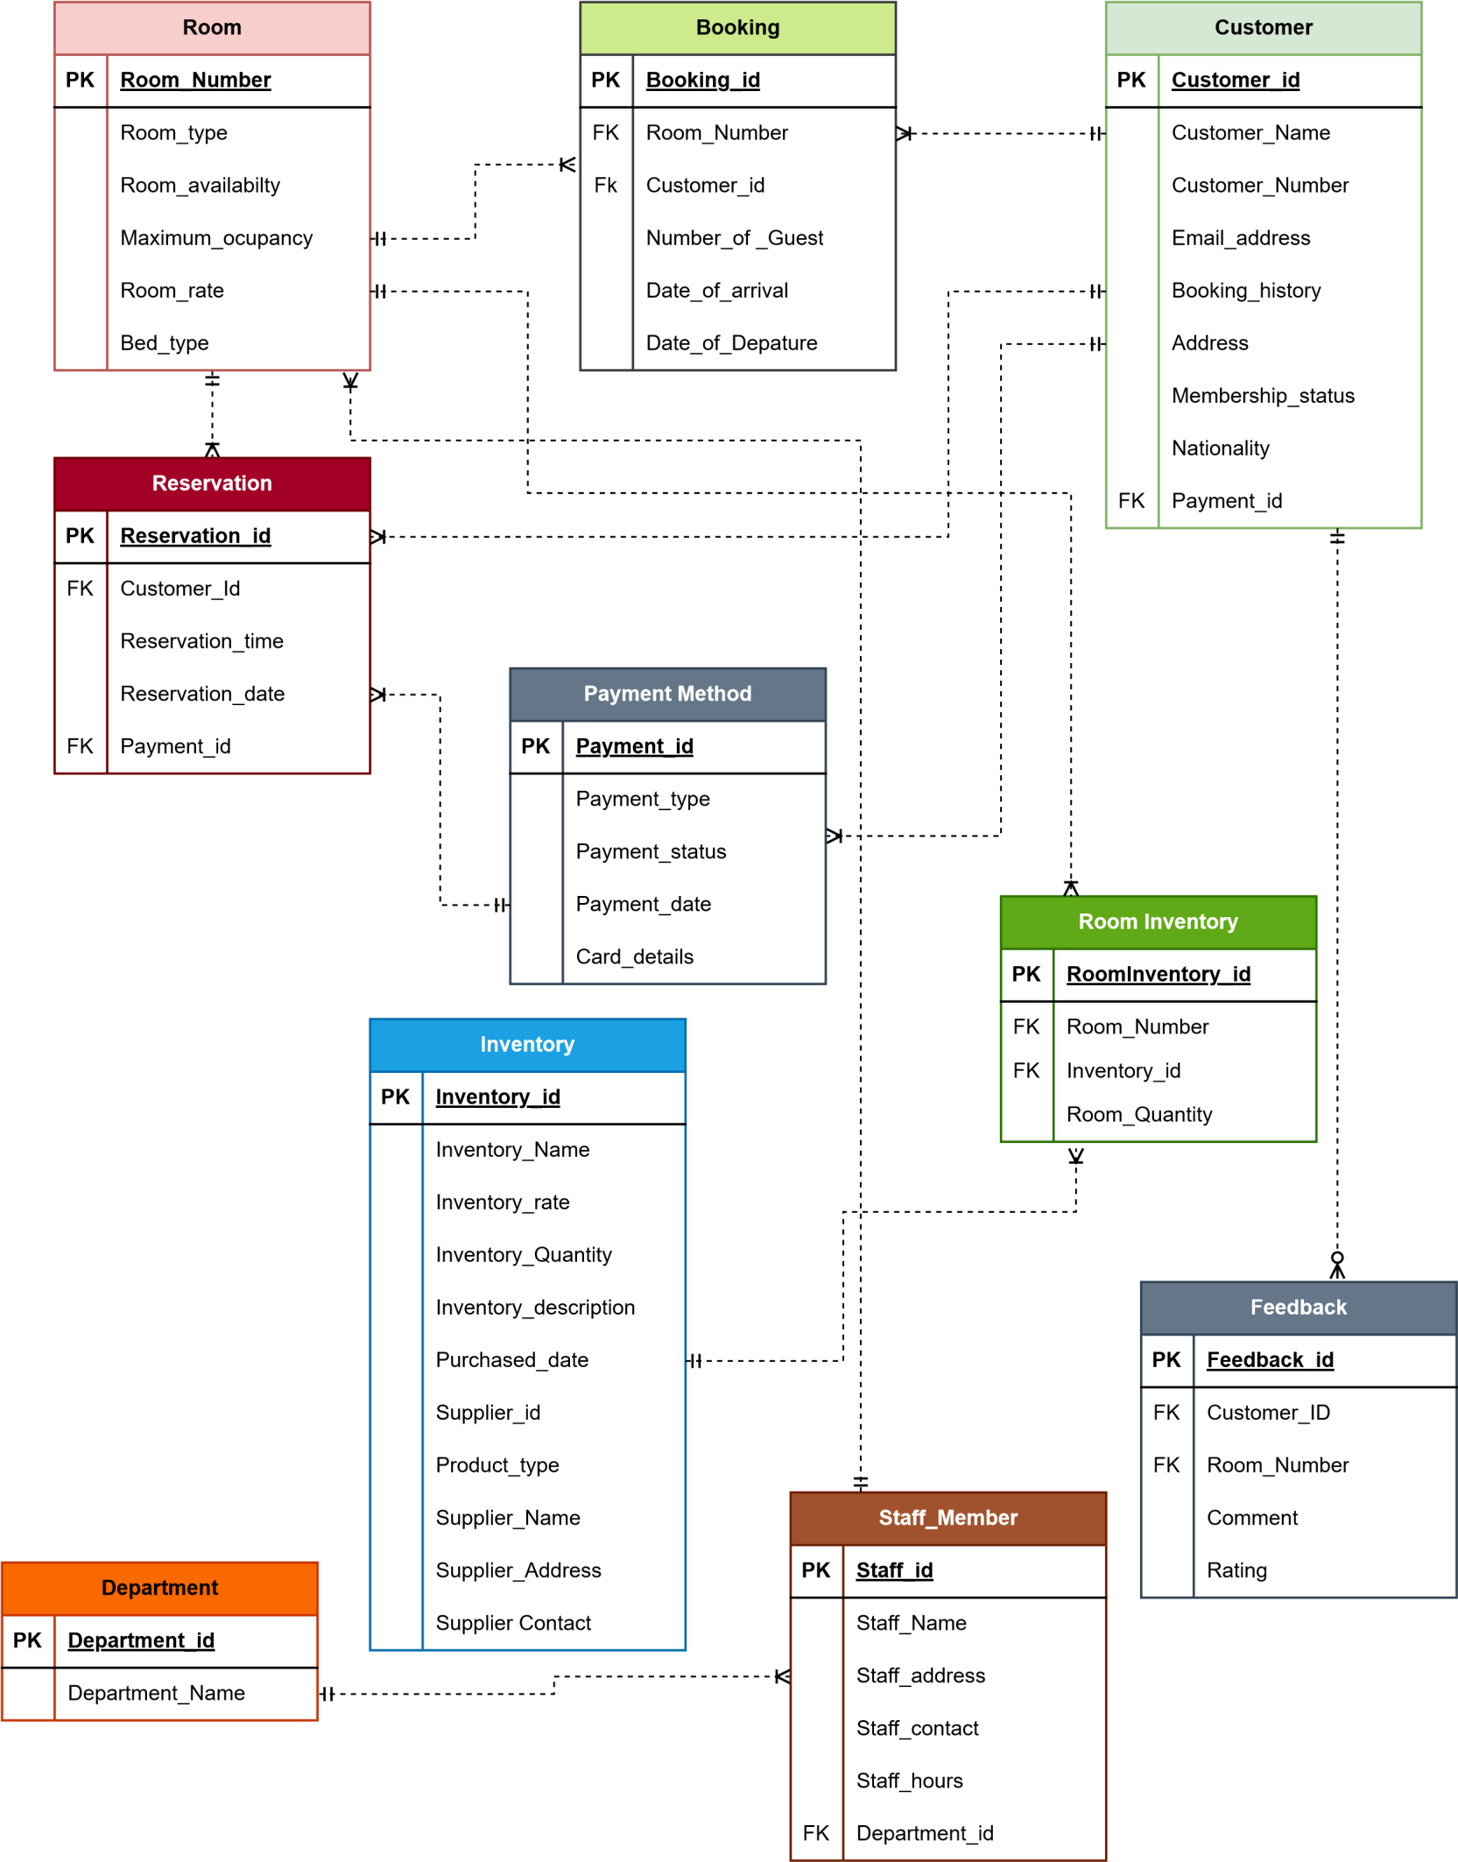

# ERD AFTER NORMALIZATION

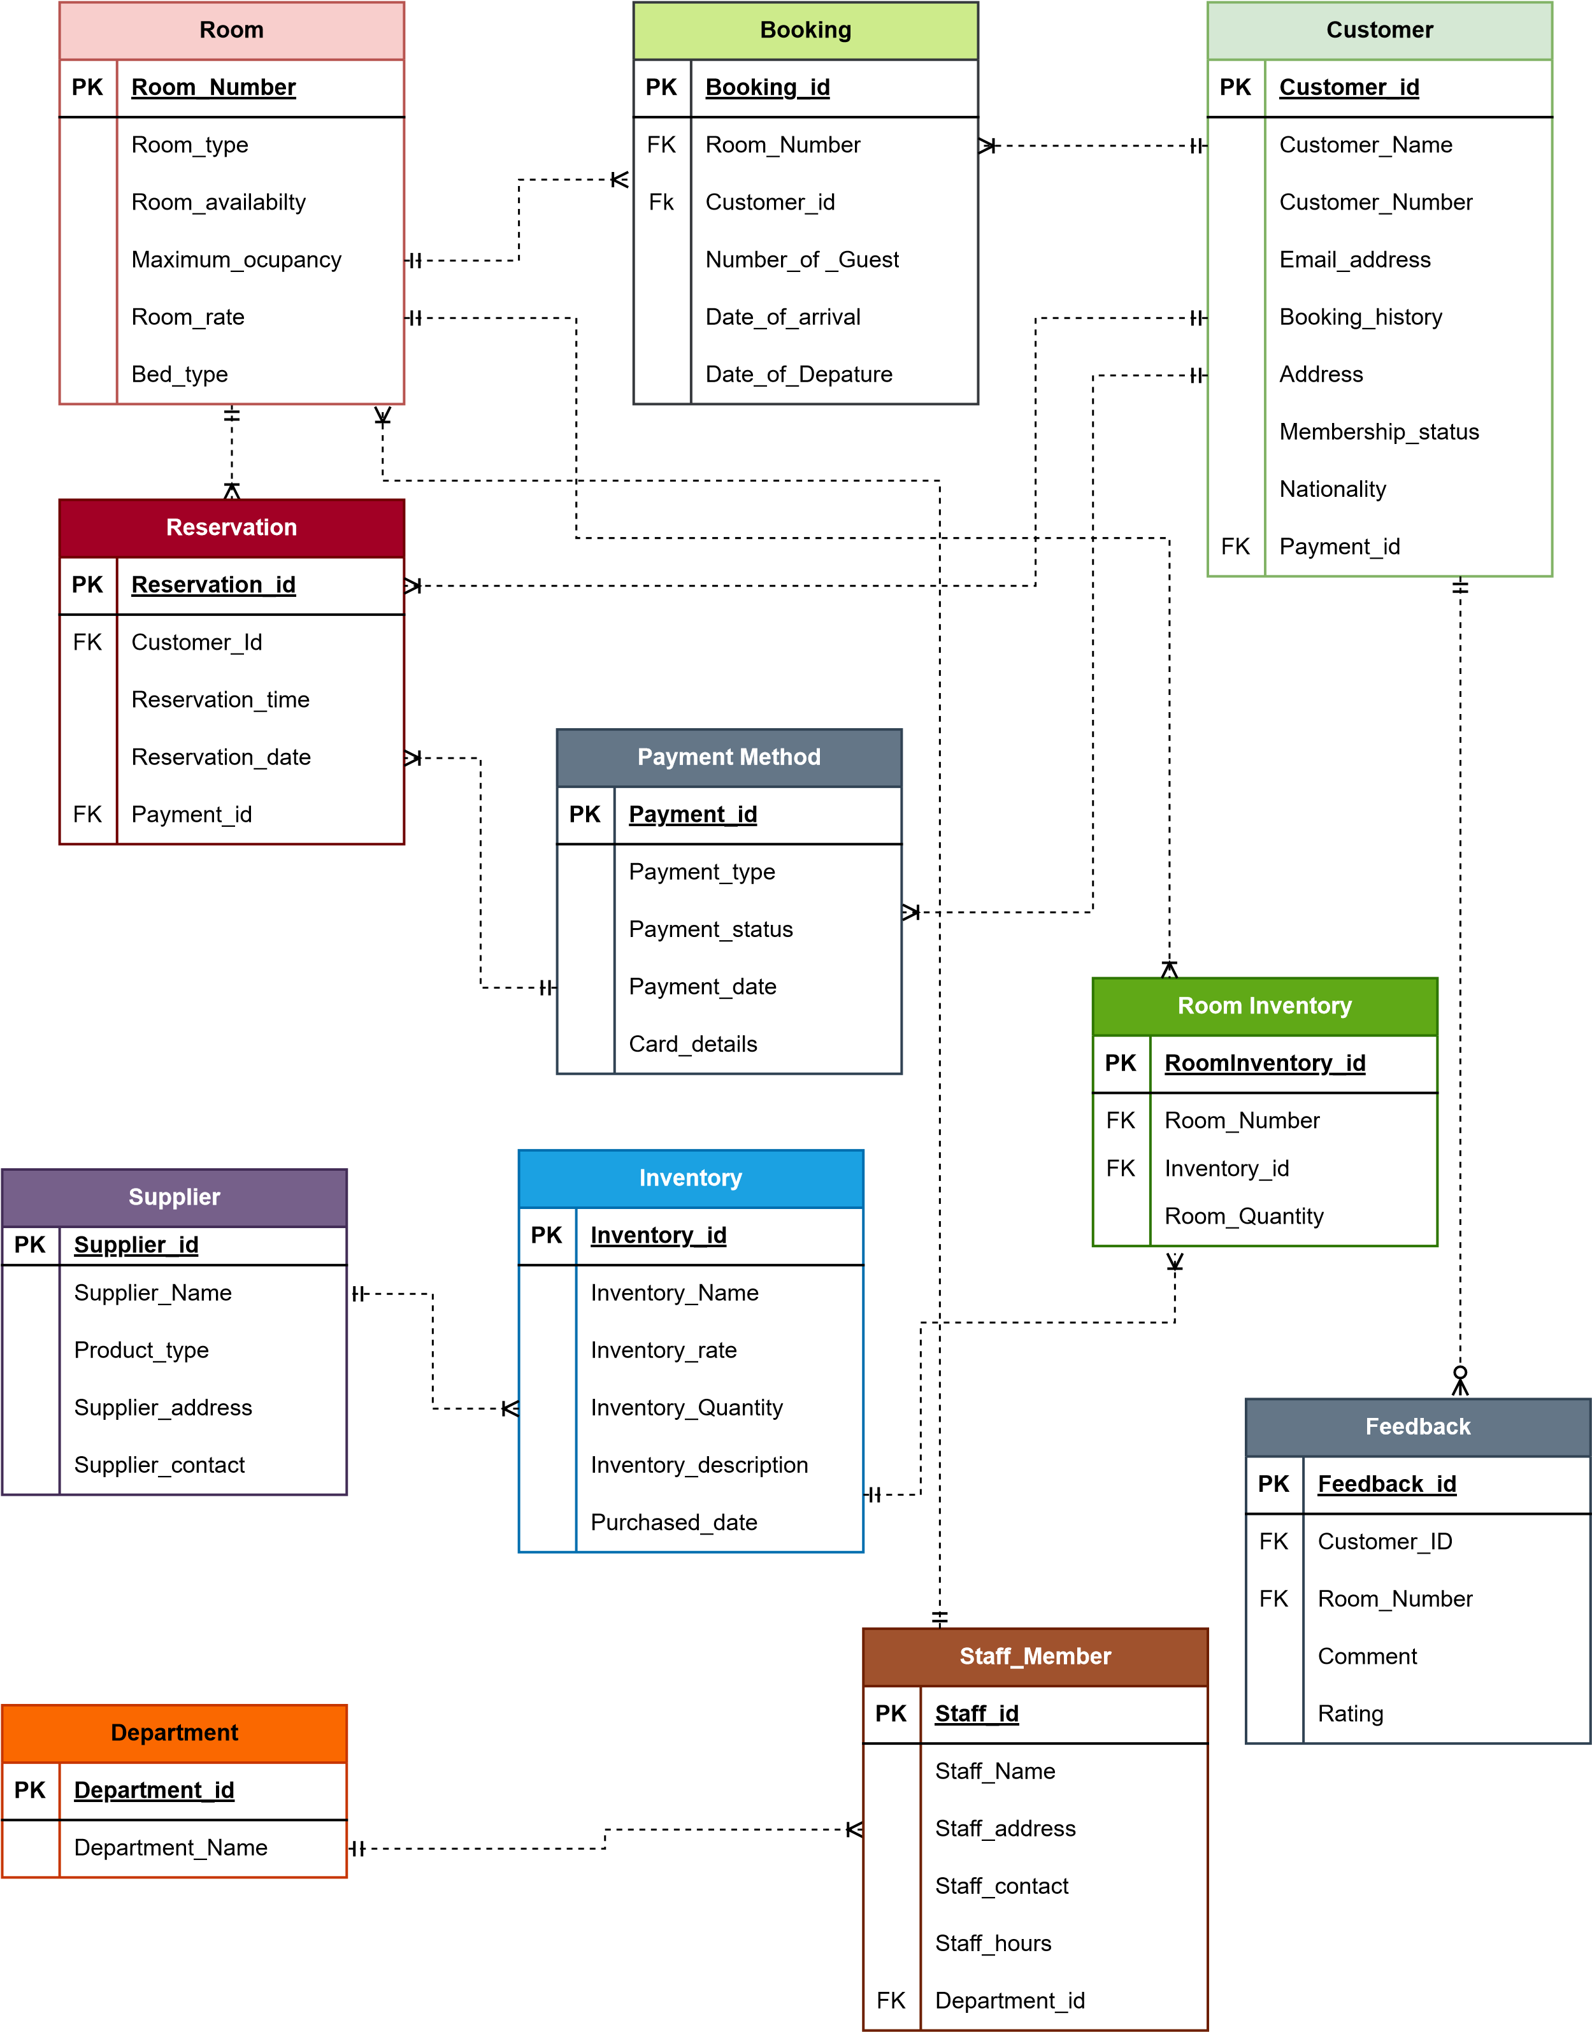

**Normalization**

**Table With the data**

**Room**

|  |  |  |  |  |  |
| --- | --- | --- | --- | --- | --- |
| **Room_Number** | Room_Type | Room_availability | Room_rate | Maximum_occupancy | Bed_type |
| 501 | Single Room | Open | 155 | 2 | Double bed |
| 502 | Double Room | Closed | 165 | 4 | King Size |
| 503 | Attach room | Closed | 250 | 6 | King Size |

**Booking**

|  |  |  |  |  |  |
| --- | --- | --- | --- | --- | --- |
| **Booking_id** | **Room_Number** | Customer_Id | Number_of_Guest | Date_of_  arrival | Date_of_Depature |
| 101 | 502 | 201 | 2 | 2023-12-31 | 2024-01-02 |
| 102 | 503 | 205 | 4 | 2024-01-23 | 2024-02-03 |
| 103 | 505 | 202 | 5 | 2024-02-22 | 2024-02-24 |

**Customer**

|  |  |  |  |  |  |  |  |  |
| --- | --- | --- | --- | --- | --- | --- | --- | --- |
| **Custo mer_id** | Custome r_Name | Customer _Number | Email_address | Booking  _history | Addre ss | membersh ip_status | Natio  nality | Payme nt_id |
| 201 | Davidson  jr | 56995135 78 | david@gmail.c om | 1 | Missis sauga | No | US | Card |
| 202 | Sam  Patel | 98765432 11 | Sampatel2@g mail.com | 0 | New  York | Yes | UK | Cash |
| 205 | Hari Krishna | 56498725 89 | Harikrishna02 @gmail.com | 5 | Toron to | Yes | Cana dian | Card |

**Reservation**

|  |  |  |  |  |
| --- | --- | --- | --- | --- |
| **Reservation_id** | **Customer_Id** | Reservation_time | Reservation_date | **Payment_id** |
| 100 | 252 | 12:30 | 2023-12-01 | 20 |
| 101 | 265 | 02:00 | 2024-01-02 | 25 |
| 105 | 545 | 13:25 | 2024-02-25 | 35 |

**Payment Method**

|  |  |  |  |  |
| --- | --- | --- | --- | --- |
| **Payment_id** | Payment_type | Payment_status | Payment_date | Card_details |
| 25 | Card | Full | 2024-01-02 | RBC |
| 40 | Card | Partial | 2023-11-25 | CIBC |
| 41 | None | None | 2023-12-24 | TD |

**Room Inventory**

|  |  |  |  |
| --- | --- | --- | --- |
| **RoomInventory_id** | **Room_Number** | **Inventory_id** | Room_Quantity |
| 1 | 201 | 101 | 20 |
| 2 | 205 | 103 | 50 |
| 3 | 203 | 102 | 25 |

**Feedback**

|  |  |  |  |  |
| --- | --- | --- | --- | --- |
| **Feedback_id** | **Customer_id** | **Room_number** | Comment | Rating |
| 6622 | 101 | 252 | This is good | 5 |
| 6988 | 103 | 202 | Not good service | 3 |
| 7024 | 105 | 208 | Very Good Service | 5 |

**Department**

|  |  |
| --- | --- |
| **Department_id** | Department_Name |
| 01 | Cleaning |
| 02 | Kitchen |
| 03 | Room Staff |

**Staff Member**

|  |  |  |  |  |  |
| --- | --- | --- | --- | --- | --- |
| **Staff_id** | Staff_Name | Staff_address | Staff_contact | Staff_hours | **Department_id** |
| 20 | Ram KC | Mississauga | 6578903245 | 25 | 03 |
| 21 | Harry Bonj | Texas | 56789032 | 50 | 01 |
| 23 | Roshan Bhandari | Nepal | 5896321254 | 23 | 02 |

**Inventory**

|  |  |  |  |  |  |  |  |  |  |  |
| --- | --- | --- | --- | --- | --- | --- | --- | --- | --- | --- |
| Inventory _id | Inventor y_Name | Inventory _rate | Inventory_ Quantity | Inventory  _descripti on | Purchas ed_date | Suppli er_id | Produc t_type | Supplier _Name | Supplier_a ddress | Supplier_co ntact |
| 101 | Towel | 10 | 100 | For toilet use | 2023-  12-21 | 501 | Cleanin g | Ram Sharma | Mississau ga | 4379551559 |
| 102 | Shampo | 25 | 250 | For  human body | 2023-  11-20 | 503 | Liquid | David Becham | Toronto | 3576545925 |
| 103 | Chair | 35 | 600 | For room | 2022-  01-12 | 524 | Furnitu re | William  Jr | Brampton | 5658973654 |

**First Normal Form / 1NF**

 1NF is also known as First Normal Form. It is used to reduce the multivalued and multi-column in the table.

**Requirement / Criteria of the 1NF**.

* It doesn’t contain repeating group and there is no multi-column in the table.

 **Room, Booking, Customer, Reservation, Payment Method, Room Inventory, Feedback,**

**Department and Staff member** are in 1NF. Because, it full fill the 1NF requirement  Inventory was not in 1NF but it also fulfill the criteria to be 1NF

**Table Complete the below criteria to be 1NF**

* **Inventory_id** and **Supplier_id** are composite key for the table.
* Doesn’t contain any multi-valued column or repeating group

**Inventory**

|  |  |  |  |  |  |  |  |  |  |  |
| --- | --- | --- | --- | --- | --- | --- | --- | --- | --- | --- |
| **Inventor y_id** | **Supplier _id** | Inventor y_Name | Inventory _rate | Inventory_ Quantity | Inventory  _descripti on | Purchas ed_date | Produc t_type | Supplier _Name | Supplier_a ddress | Supplier_co ntact |
| 101 | 501 | Towel | 10 | 100 | For toilet use | 2023-  12-21 | Cleanin g | Ram Sharma | Mississau ga | 4379551559 |
| 102 | 503 | Shampo | 25 | 250 | For  human body | 2023-  11-20 | Liquid | David Becham | Toronto | 3576545925 |
| 103 | 524 | Chair | 35 | 600 | For room | 2022-  01-12 | Furnitu re | William  Jr | Brampton | 5658973654 |

**Second Normal Form / 2NF**

The table is said to be in 2NF if it is in 1NF and there is composite key in the 1NF and partial dependency which can be reduce in the 2NF.

**Requirement / Criteria to be 2NF**

* The table must be in 1NF
* The 2nd Normal Form is performed when there is composite primary key and partial dependencies.

 **Room, Booking, Customer, Reservation, Payment Method, Room Inventory, Feedback,**

**Department and Staff member** are in 1NF. Because, it full fill the 2NF requirement  **Supplier_id** is foreign key in inventory

**Table Complete the below Criteria to be 2NF**

* Table is already in 1NF
* There is partial dependency between Inventory_id and Supplier_id which has been eliminated in

2NF

**Inventory**

|  |  |  |  |  |  |  |
| --- | --- | --- | --- | --- | --- | --- |
| **Inventory _id** | Inventory_n ame | Inventory_ rate | Inventory_qua  ntity | Inventory_Descri ption | Purchase_ date | **Supplier _id** |
| 101 | Towel | 10 | 100 | For toilet Use | 2023-12-21 | 501 |
| 102 | Shampo | 25 | 250 | For human body | 2023-11-20 | 503 |
| 103 | Chair | 35 | 600 | For room | 2022-01-12 | 524 |

**Supplier**

|  |  |  |  |  |
| --- | --- | --- | --- | --- |
| **Supplier_id** | Supplier_name | Supplier_address | Supplier_contact | Product_type |
| 501 | Cleaning | Ram Sharma | Mississauga | 4379551559 |
| 503 | Liquid | David Becham | Toronto | 3576545925 |
| 524 | Furniture | William Jr | Brampton | 5658973654 |

**Third Normal Form / 3NF**

The table should be in 2NF to be in 3NF. There should not be transitive dependency for the table to be in 3NF.

**Requirement / Criteria to be 3NF**

* The table must be in 2nd Normal Form to be converted into 3NF  The table should not contain non-key dependencies.

 **Room, Booking, Customer, Reservation, Payment Method, Room Inventory, Feedback,**

**Department and Staff member** are in 2NF. Because, it full fill the 3NF requirement

**Table Complete the criteria to be 3NF**

* The table is in 2NF.
* The table doesn’t contain any non-key dependenices.

**Inventory**

|  |  |  |  |  |  |  |
| --- | --- | --- | --- | --- | --- | --- |
| **Inventory _id** | Inventory_n ame | Inventory_ rate | Inventory_qua  ntity | Inventory_Descri ption | Purchase_ date | **Supplier _id** |
| 101 | Towel | 10 | 100 | For toilet Use | 2023-12-21 | 501 |
| 102 | Shampo | 25 | 250 | For human body | 2023-11-20 | 503 |
| 103 | Chair | 35 | 600 | For room | 2022-01-12 | 524 |

**Supplier**

|  |  |  |  |  |
| --- | --- | --- | --- | --- |
| **Supplier_id** | Supplier_name | Supplier_address | Supplier_contact | Product_type |
| 501 | Cleaning | Ram Sharma | Mississauga | 4379551559 |
| 503 | Liquid | David Becham | Toronto | 3576545925 |
| 524 | Furniture | William Jr | Brampton | 5658973654 |