ER Diagrams
Product: Hardware Inventory System
Source of truth: prisma/schema.prisma
Version: 1.0
Date: 2026-07-24
Related docs: DATA_DICTIONARY.md (fields & enums), FSD.md §8
Visual entity-relationship views of the PostgreSQL schema. Field-level definitions live in the data dictionary — diagrams here show structure and key attributes only.
Mermaid note: Unique keys are labeled UK (Mermaid’s unique-key marker). Types in diagrams are simplified (string, float, bool, date) for renderer compatibility; see the data dictionary for exact Prisma/Decimal types.

1. High-level relationships
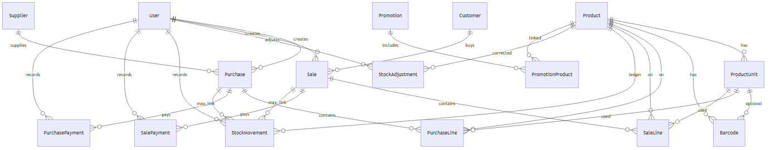
Diagram 1

2. Catalog domain
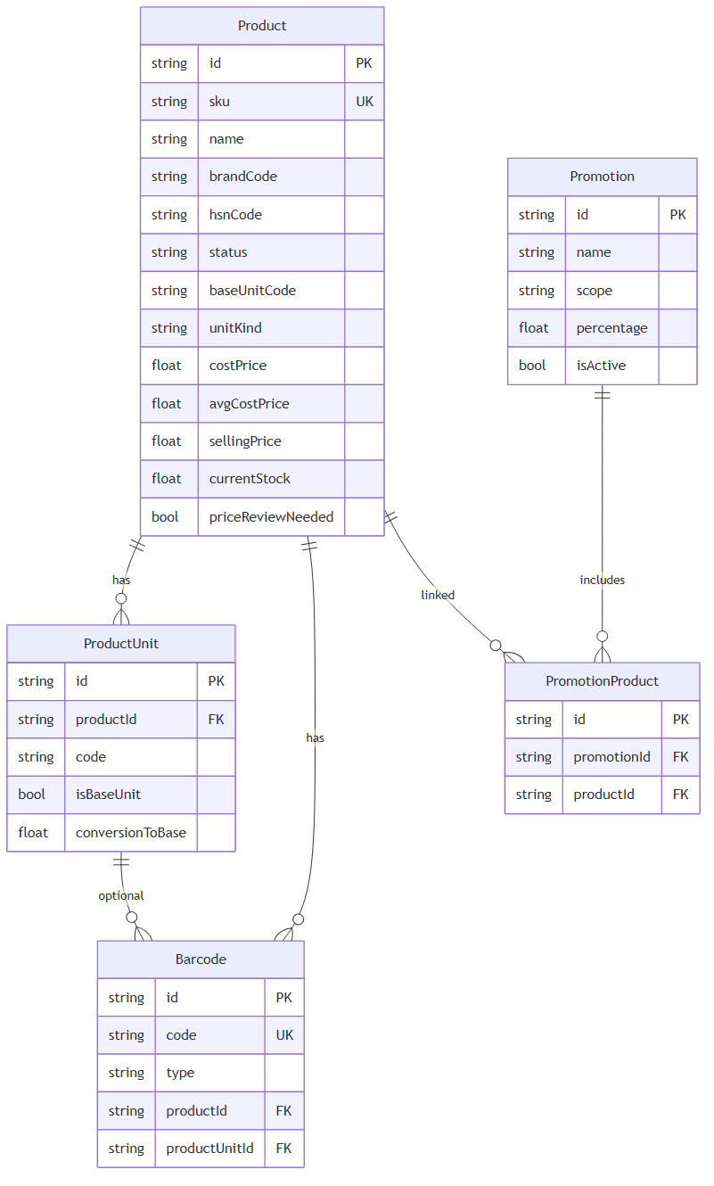
Diagram 2

3. Purchasing domain
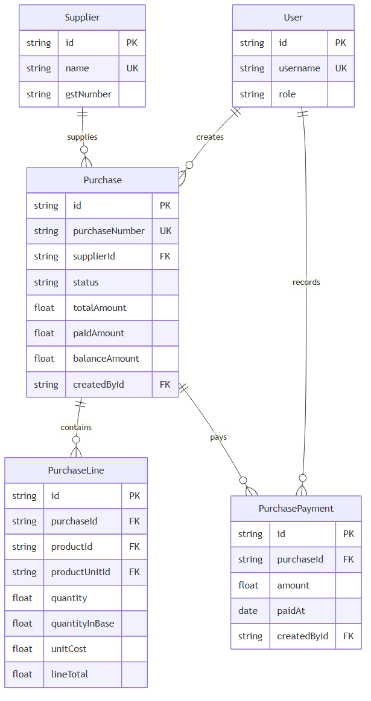
Diagram 3

4. Sales domain
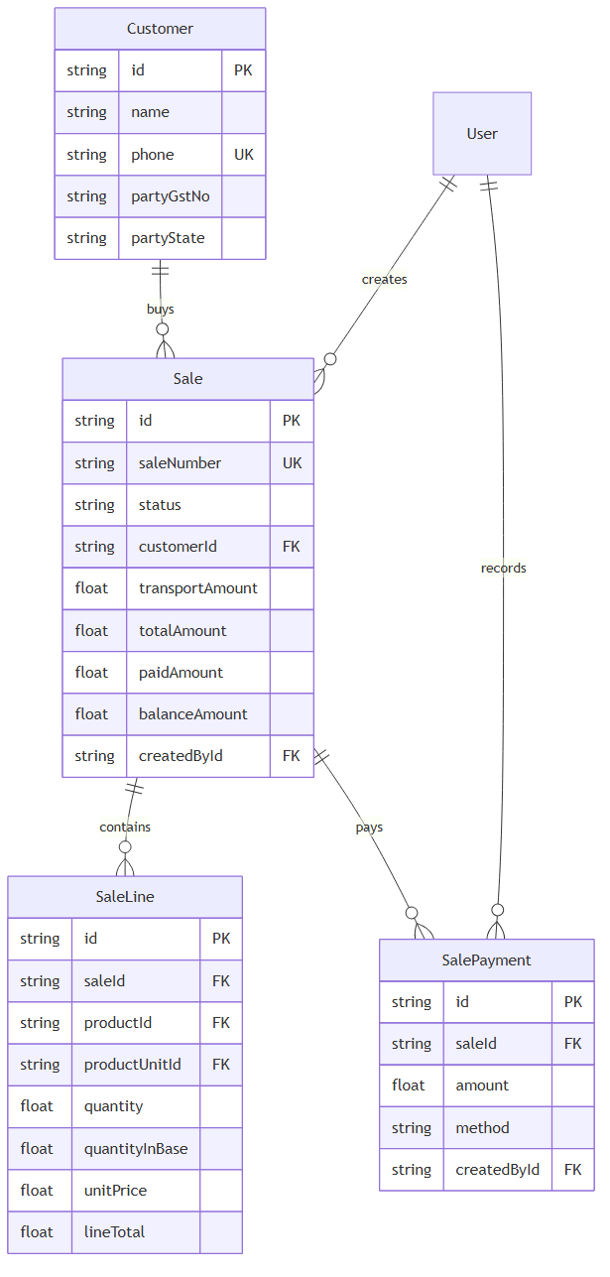
Diagram 4

5. Stock domain
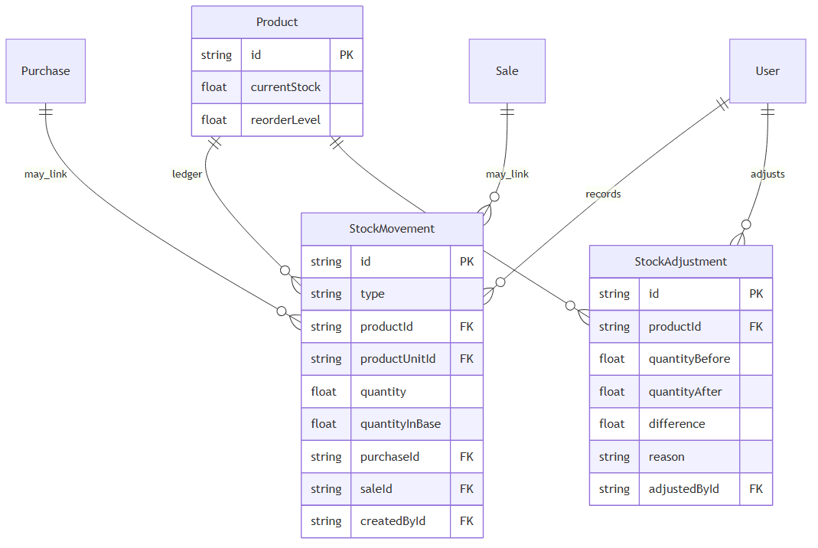
Diagram 5

6. Scheduled reports domain
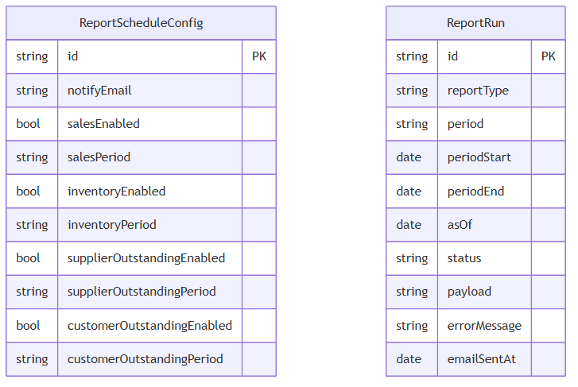
Diagram 6
ReportScheduleConfig is a singleton row with id = "default". ReportRun rows are independent history (no FK between them); uniqueness is (reportType, period, periodStart).

Maintenance
- Update diagrams when relationships or key identifying fields change in prisma/schema.prisma.
- Keep field lists in sync via DATA_DICTIONARY.md.
- Regenerate Word/PDF:
powershell -NoProfile -ExecutionPolicy Bypass -File scripts/export-doc.ps1 -DocName ER_DIAGRAMS -Title "Hardware Inventory - ER Diagrams"

End of ER Diagrams.

