Functional Specification Document (FSD)
Product: Hardware Inventory System
Document type: Functional Specification (design of behavior)
Audience: Developers (primary); owners/managers for flows and business rules
Version: 1.0
Date: 2026-07-24
Related docs: FRD.md (requirements), USER_GUIDE.md, packaging/GO-LIVE-NOTES.md, packaging/README.md
This FSD describes how the as-built system fulfills the FRD: architecture, flows, business rules, UI surfaces, and API surface. It is not a pixel-level UI kit or full OpenAPI spec.

1. Document control
Item | Value
Requirements source | docs/FRD.md
Implementation truth | prisma/schema.prisma, src/, frontend/src/
Auth note | Live model is JWT + RBAC. Ignore any older “no JWT” notes in AI context docs.

2. System context
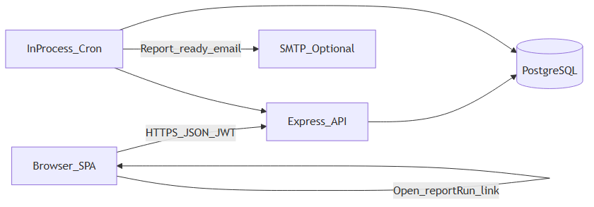
Diagram 1
Layer | Technology
Frontend | React 19, TypeScript, Vite 6; inline styles; no UI kit
Backend | Node ≥20, Express 5, Zod validation, tsx
Database | PostgreSQL via Prisma 7 (@prisma/adapter-pg)
Auth | Username/password → JWT Bearer; bcrypt password hashes
Jobs | node-cron in API process (Asia/Kolkata)
Email | Optional Nodemailer SMTP for scheduled reports

3. Architecture overview
- buildApp() (src/app.ts) mounts /api/login, /api/health, then JWT actingUserMiddleware on /api/*, then domain routers.
- Production may set SERVE_FRONTEND=1 so Express serves frontend/dist and SPA fallback for non-API GETs.
- Validation schemas live in src/validation/schemas.ts.
- Inventory/pricing/report logic lives under src/services/ and src/lib/.
- Frontend API client: frontend/src/api/client.ts (Authorization + optional X-Acting-User-Id).

4. Auth and RBAC
FR: FR-AUTH-*, role matrix §7 in FRD.

4.1 Login flow
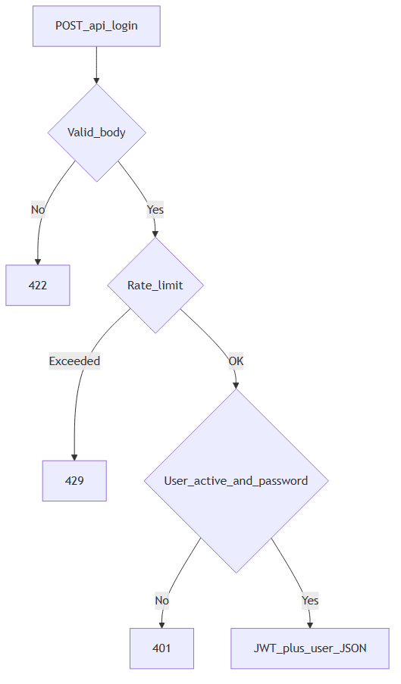
Diagram 2
- Route: POST /api/login (no Bearer required).
- Success: access token + user profile; client stores token (localStorage; ~7-day JWT lifetime per env/docs).
- Rate limit: LOGIN_RATE_LIMIT_MAX / LOGIN_RATE_LIMIT_WINDOW_MS (default 10 / 15 min).

4.2 Acting user
- Middleware: src/middleware/actingUser.ts.
- Requires Authorization: Bearer <token>.
- Optional header X-Acting-User-Id: only if JWT user has admin access (ADMIN or MANAGER); switches req.actingUser.
- hasAdminAccess(role) treats MANAGER as admin for compatibility.
- requireAdmin middleware gates back-office routes.

4.3 Session API
- GET /api/session — current JWT user, acting user, and (for admin) list of users available for acting-as switcher.

5. Information architecture
Source: frontend/src/Sidebar.tsx, frontend/src/App.tsx, frontend/src/featureFlags.ts.
Tab id | Label | Component | Visibility
home | Home | HomeView | All
pos | Sell (POS) | POSView (in App) | All
outstanding | Outstanding | OutstandingView | All
invoices | Invoices | ReprintInvoicePage | All
reporting | Reporting | ReportingPage (+ SavedReportViewer) | Admin + FEATURE_FLAGS.reporting
products | Products | ProductsPage | All (mutations admin only)
promotion | Promotions | PromotionsPage | Admin + catalogPromotions (default off)
inventory | Overview | InventoryView | All
purchase | Purchases | PurchaseView | Admin
adjustment | Adjustments | AdjustmentView | Admin
settings | Settings | SettingsPage | All
Unauthenticated → LoginPage. Soft redirect to Home if a cashier hits admin-only tabs. Deep link ?reportRun=<id> opens Reporting for admin when reporting is enabled.
Current feature flags: reporting: true; catalogPromotions: false; other catalog/inventory sub-flags false.

6. Module functional design

6.1 Home
FR: FR-HOME-*
Aspect | Design
Goals | Orient staff; jump to POS/inventory; show alerts and (admin) revenue
UI | Shortcuts, recent activity, stock alert counts, admin charts via report timeseries APIs
APIs used | Sales recent-activity; report dashboard/revenue series (admin); products for alert counts
Edges | Cashier UI emphasizes sell path; charts may be empty on fresh installs

6.2 Catalog (products)
FR: FR-CAT-*

Business rules
- Product has base unit + optional additional ProductUnit rows with conversionToBase.
- Barcode.code unique; types PRODUCT / PACK / INTERNAL / SUPPLIER.
- brandCode unique case-insensitively when non-blank; blank may auto-generate BC-#####.
- Stock on hand: Product.currentStock (base units); ledger via StockMovement.
- Price review: cheaper purchase → keep sellingPrice, set priceReviewNeeded, suggestedSellingPrice, priceReviewNote. Cost increase → selling may rise via markup (src/lib/productPricing.ts / purchase receive path). Admin apply/dismiss per product or all.
- GST fields: hsnCode, cgstPercent / sgstPercent / igstPercent.
- Status ACTIVE / INACTIVE.

UI surfaces
- Products grid: paginated (50), server search; some columns hidden in grid but present in forms/import.
- Add/edit, batch entry, CSV/Excel import (≤ ~1500), download template.
- Price review banner: Apply / Keep current (per item and bulk).

API (/api/products)
Method | Path | Auth
GET | / | Authenticated (list/search/paging)
GET | /:id/stock | Authenticated
POST | /batch | Admin
PATCH | /:id | Admin
DELETE | /:id | Admin
POST | /price-review/apply-all | Admin
POST | /price-review/dismiss-all | Admin
POST | /:id/price-review/apply | Admin
POST | /:id/price-review/dismiss | Admin

Edges
- Delete may fail if product is referenced by historical lines (constraint/error handling as implemented).
- Bulk create uses chunked transactions (~100/chunk).

6.3 Parties (suppliers and customers)
FR: FR-PARTY-*
Entity | API | Notes
Supplier | GET/POST /api/suppliers — admin router | Unique name; used by purchases
Customer | GET /, GET /:id, POST / under /api/customers — authenticated | Optional partyGstNo, partyState; phone unique when set
UI: supplier management primarily on Purchases screen; customers used from POS / outstanding / reports.

6.4 Purchases
FR: FR-PUR-*
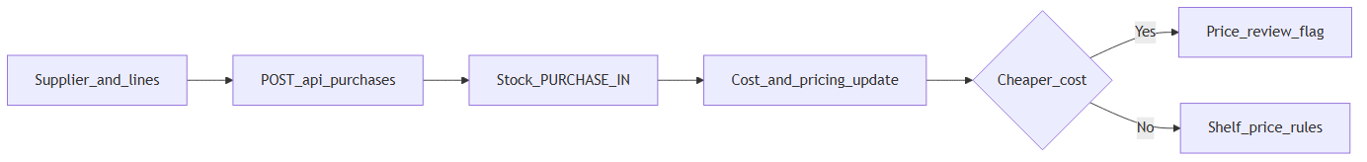
Diagram 3

Business rules
- Status enum: DRAFT / RECEIVED / CANCELLED (create path records received stock as implemented in purchase service).
- Unique purchaseNumber; rare collisions retried.
- Lines: quantity in selected unit → quantityInBase; unit cost drives catalog cost / avg cost / selling rules.
- Payments: POST /api/purchases/:id/payments updates paidAmount / balanceAmount.
- Import: match by brand code and/or product name; optional single supplier column; >40 lines → summary UI before Record Purchase.

API (/api/purchases) — all admin
Method | Path
GET | /
POST | /
GET | /:id
POST | /:id/payments

Edges
- Cashier: 403 / nav hidden.
- Large imports need JSON_BODY_LIMIT (default 15mb).

6.5 Point of sale (POS)
FR: FR-POS-*
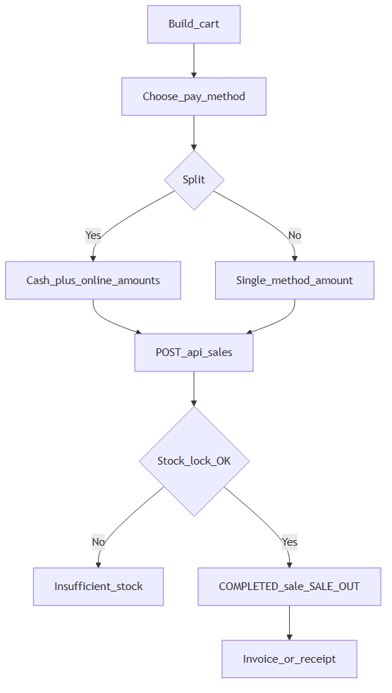
Diagram 4

Business rules
- Sale statuses: DRAFT / COMPLETED / CANCELLED / RETURNED (POS complete path produces completed sales with movements).
- Payments: SalePaymentMethod CASH | ONLINE_BANKING; multiple payments allowed over time.
- Split: cash + online entered separately; remainder = balance due (not auto-assigned).
- Totals: subtotal, discount, tax, transportAmount, total, paid, balance.
- Customer: walk-in fields and/or customerId; snapshots for name/GST/state on the sale.
- Document numbers: BIL-{n} vs INV-{n} from src/lib/documentNumbers.ts; starts via SALE_NUMBER_BILL_START / SALE_NUMBER_TAX_START.
- Concurrent completion uses stock locking so oversell is rejected.

UI
- Product search/cart, discounts, payment panel, processing indicator on long confirms, invoice print integration (frontend/src/invoice/).

API (/api/sales) — authenticated (no admin gate)
Method | Path
POST | / (create/complete sale as validated)
GET | /recent-activity
GET | /outstanding
GET | /search
GET | /by-number/:saleNumber
GET | /:id
POST | /:id/payments

Edges
- Insufficient stock → error to client; cart may be retried with reduced qty.
- Body createdById must match acting user where enforced.

6.6 Outstanding
FR: FR-OUT-*
Aspect | Design
UI | OutstandingView — list sales with balanceAmount > 0; record payment
API | GET /api/sales/outstanding; POST /api/sales/:id/payments
Rules | Payments append SalePayment rows; update paid/balance

6.7 Invoices (reprint)
FR: FR-INV-*
Aspect | Design
UI | ReprintInvoicePage — search/lookup by sale number; print layout from invoice module
API | GET /api/sales/search, GET /api/sales/by-number/:saleNumber, GET /api/sales/:id
Branding | UI strings: frontend/src/lib/branding.ts (VITE_COMPANY_NAME); invoice letterhead fields in frontend/src/invoice/invoiceBranding.ts

6.8 Stock overview and adjustments
FR: FR-STK-*
Aspect | Design
Overview UI | InventoryView — levels, search/sort, in/low/out status vs reorder
Adjustment UI | AdjustmentView — product, target/delta as implemented, reason, note
API | Adjust: POST /api/stock-adjustments (admin). Stock read also via products.
Rules | StockAdjustment stores before/after/difference; movements ADJUSTMENT_IN/OUT, DAMAGE_OUT, etc. as typed
Edges | Cashiers see overview only

6.9 On-demand reporting
FR: FR-RPT-*
All under /api/reports, admin only.
Method | Path | Query
GET | /sales-summary | from, to (YYYY-MM-DD)
GET | /tax-invoice-sales | from, to
GET | /sales-by-product | from, to
GET | /sales-by-customer | from, to
GET | /supplier-payments | from, to
GET | /purchases | from, to
GET | /gross-margin | from, to
GET | /dashboard-timeseries | days (default 14)
GET | /sales-revenue-series | granularity day|week|month; buckets
UI: ReportingPage — pick report and date range; charts for series endpoints. Indexes on sale/purchase createdAt support range queries.

6.10 Scheduled owner reports
FR: FR-SCH-*
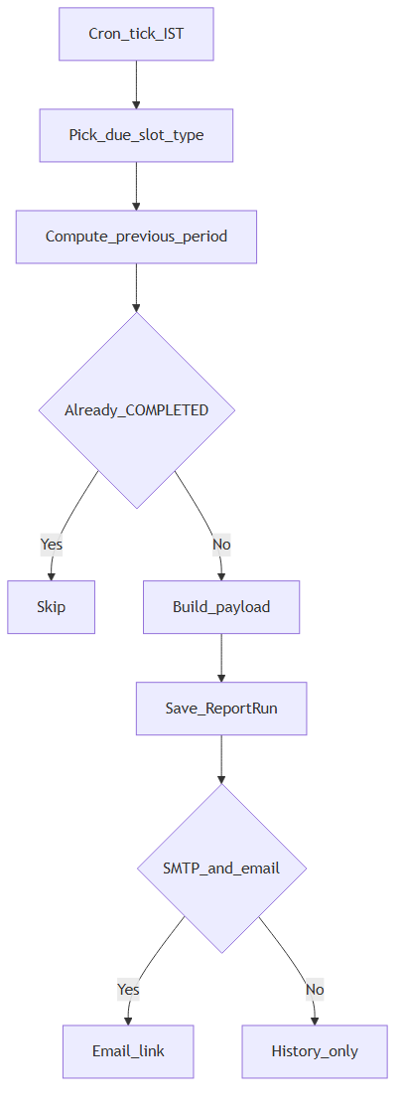
Diagram 5

Configuration
Singleton ReportScheduleConfig id=default:
- notifyEmail (required if any type enabled)
- Per type: enabled + period (DAILY | MONTHLY | QUARTERLY | YEARLY)
- Types: Sales, Inventory, Supplier outstanding, Customer outstanding

Payload content
Type | Content
SALES | Sales summary + gross margin for period
INVENTORY | Active product stock snapshot (value, OOS, below reorder)
SUPPLIER_OUTSTANDING | RECEIVED purchases with balance > 0, by supplier
CUSTOMER_OUTSTANDING | COMPLETED sales with balance > 0
Periods generate the previous completed window. Quarterly uses Indian FY (Q1 Apr–Jun … Q4 Jan–Mar).

Scheduler
- Files: src/jobs/reportScheduler.ts, src/services/scheduledReports.ts, src/lib/reportScheduleSlots.ts
- Enable: REPORT_SCHEDULER_ENABLED=1|true, or default on when NODE_ENV=production
- Cron: REPORT_CRON_IST default 0,30 6-8 * * * Asia/Kolkata
- Stagger ~30 min: Sales → Inventory → Supplier → Customer; one type per tick
- Unique (reportType, period, periodStart); retries failed/incomplete; skips completed

Email
- Requires notifyEmail + SMTP_HOST (and related SMTP_* vars)
- Link: {APP_PUBLIC_URL}/?reportRun={id}
- Without SMTP: run still COMPLETED in DB

API (/api/scheduled-reports) — admin
Method | Path
GET/PUT | /config
GET | /runs?limit=
GET | /runs/:id
UI: Reporting → Scheduled owner reports; history; SavedReportViewer for a run.

6.11 Promotions (optional)
FR: FR-PROMO-01
- Schema: Promotion + PromotionProduct; scope CART / PRODUCT / CATEGORY; percentage discount; optional date window.
- API: GET /api/promotions (auth); POST/PUT/DELETE admin.
- UI: hidden unless FEATURE_FLAGS.catalogPromotions === true (default false).

6.12 Settings
FR: FR-SET-*
- SettingsPage: Light / Dark / System via useTheme — browser local only; no settings API.

7. Cross-cutting concerns
Concern | Design
Validation | Zod schemas in src/validation/schemas.ts; 422 with field details on failure
Errors | Central errorHandler; domain errors return JSON { error } (+ details)
CORS | buildCorsOptions(); production uses CORS_ORIGIN list
Body size | JSON_BODY_LIMIT default 15mb for bulk imports
Feature flags | frontend/src/featureFlags.ts — compile-time constants
Document numbers | Env start values; separate bill/tax series
Branding | VITE_COMPANY_NAME / short name; invoice static letterhead module
Acting user audit | Sale/purchase/adjustment creator IDs must align with acting user checks

8. Data model summary
Primary entities (see prisma/schema.prisma for full fields):
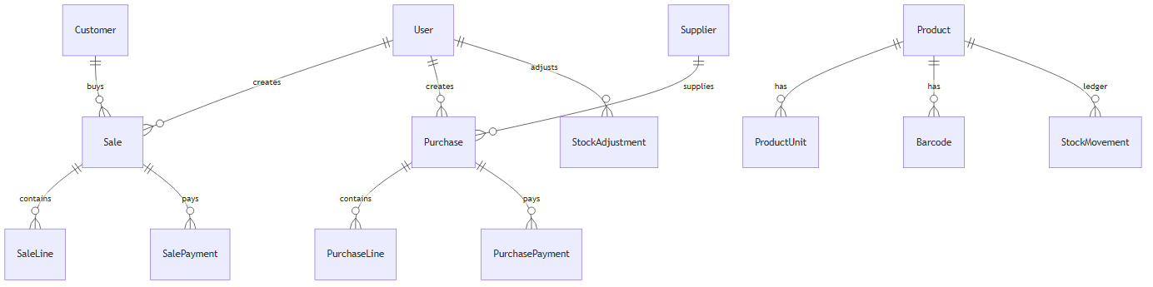
Diagram 6
Entity | Role
User | Staff; role ADMIN/MANAGER/CASHIER; passwordHash
Product | Catalog + currentStock, costs, MRP, selling, GST, price review
ProductUnit / Barcode | Sell/buy units and scan codes
Supplier / Customer | Parties
Purchase / PurchaseLine / PurchasePayment | Stock in + payables
Sale / SaleLine / SalePayment | Stock out + receivables
StockMovement | Immutable-style ledger of qty changes
StockAdjustment | Explicit correction audit
Promotion* | Optional discounts
ReportScheduleConfig / ReportRun | Owner schedule + saved payloads

9. Deployment modes (functional view)
Mode | Behavior
Dev API + Vite | API (e.g. :4000) + frontend (:5173); CORS allows local Vite origins
npm run start:prod | Built SPA served from Express when SERVE_FRONTEND=1 / production dist present
Railway / hosted | See packaging/RAILWAY.md; same API + DB + env
Backups | npm run db:backup / restore — scripts/BACKUP.md
Health | GET /api/health unauthenticated
Install steps are not duplicated here; see packaging docs.

10. FR → FSD index
FR ID prefix | FSD
FR-AUTH | §4
FR-HOME | §6.1
FR-CAT | §6.2
FR-PARTY | §6.3
FR-PUR | §6.4
FR-POS | §6.5
FR-OUT | §6.6
FR-INV | §6.7
FR-STK | §6.8
FR-RPT | §6.9
FR-SCH | §6.10
FR-PROMO | §6.11
FR-SET | §6.12
NFR-SEC / CON / PERF / OPS / OBS / I18N | §4, §7, §9

11. Known optional / disabled surfaces
Documented so requirements are not mistaken for missing defects:
Item | Status
Promotions nav/UI | Flag off by default
Catalog brands / product types / price books nav | Flags off
Inventory order / receive / supplier returns / counts nav | Flags off
Invoice company address/GST/bank | Code constants, not admin UI
Server-side user admin CRUD UI | Not a first-class module (seed/DB for users)

End of FSD. Requirements and acceptance criteria are in docs/FRD.md.

