CYBERSECURITY PROJECT REPORT

Phishing URL Detection System

A Hybrid Rule-Based and Machine-Learning Approach

Submitted by | [Student Name(s)]
Guide / Trainer | [Guide / Trainer Name]
Institute | [Institute Name]
Submission Date | [Submission Date]

Abstract
Phishing is one of the most common cyber attacks, in which attackers use deceptive web addresses to trick users into revealing credentials or financial data. This project presents a Phishing URL Detection System that analyses a URL and classifies it as Legitimate, Suspicious or Phishing, and explains the reasons behind the decision. The system extracts 20 lexical and host-based features from the URL, such as length, number of subdomains, use of an IP address, the '@' symbol, HTTPS usage, suspicious keywords, abused top-level domains, URL shorteners and brand names embedded in lookalike domains. Two detection approaches are implemented and compared: a weighted rule-based engine that produces human-readable reasons, and a Random Forest machine-learning classifier. A hybrid score combines both (70% ML probability, 30% rule score). The system was implemented in Python using pandas and scikit-learn and evaluated on a labelled dataset of 5,216 unique URLs with an 80/20 stratified split. On the held-out test set, the rule-based approach reached 87.3% accuracy, the Random Forest 96.5% and the hybrid 96.5% (F1-score 0.97). All 15 manual test cases produced the expected result. The dataset used is synthetic, generated from real-world phishing patterns, which is a limitation discussed in this report.

Table of Contents
Abstract 2
Table of Contents 3
- Introduction 4
- Problem Statement 4
- Objectives 4
- Scope 4
- Literature / Existing Systems 4
- Proposed System 5
- System Requirements 5
- Methodology / Implementation 5
- Testing 6
- Results & Analysis 7
- Limitations 8
- Future Scope 9
- Conclusion 9
References 9

Introduction
Phishing is a social-engineering attack where an attacker impersonates a trusted organisation, such as a bank, payment service or email provider, to steal sensitive information. The attack usually starts with a link in an email, SMS or message that leads to a fake website. Since the URL is the first and often the only visible artefact of the attack, analysing it is an effective and lightweight first line of defence.
Attackers use many URL tricks: raw IP addresses instead of domain names, the '@' symbol to hide the real destination, long and confusing paths, many subdomains, brand names placed in subdomains (for example paypal.secure-login.xyz), hyphenated lookalike domains, URL shorteners and cheap top-level domains. Manual inspection by users is unreliable, so automated detection is needed.

Problem Statement
Given a URL as input, determine automatically whether it is legitimate or potentially phishing, using only features that can be computed from the URL itself, and present the contributing reasons so that the decision is explainable to the user.

Objectives
- Accept a URL as input through a command-line tool (single URL, file of URLs or interactive mode).
- Extract at least 15 meaningful URL features (implemented: 20 features).
- Implement a rule-based detector and a machine-learning classifier, and combine them into a hybrid detector.
- Return a clear classification (Legitimate / Suspicious / Phishing) along with the reasons for the decision.
- Evaluate using accuracy, precision, recall, F1-score and confusion matrix on a labelled dataset.
- Validate with at least 15 test URLs showing expected versus actual results.

Scope
In scope: lexical and host-string analysis of URLs, rule-based and ML classification, explainable output, evaluation on a labelled dataset and a command-line application.
Out of scope: analysing web-page content or screenshots, WHOIS/domain-age and SSL-certificate lookups, live blacklist/reputation services, email analysis, a browser extension or web interface, and any testing against real systems without authorisation.

Literature / Existing Systems
Existing approaches to phishing detection include:
- Blacklists (e.g. Google Safe Browsing, PhishTank): accurate for known URLs but cannot detect new (zero-day) phishing sites and need constant updates.
- Heuristic / rule-based filters: fast and explainable, but rules are static and attackers adapt quickly.

- Machine-learning classifiers (Random Forest, SVM, neural networks) trained on URL and content features: better generalisation, but often act as a black box and depend on dataset quality.
- Content-based and visual-similarity methods: analyse page HTML or screenshots; accurate but slower and require fetching the page, which is risky and resource-intensive.
This project combines rules (explainability) with an ML model (generalisation) in a lightweight URL-only solution that needs no network access.

Proposed System
The proposed system is a pipeline of four modules:
- Feature Extractor (features.py): parses the URL and computes 20 features.
- Rule Engine (rules.py): applies weighted rules to produce a rule score (0 to 1) and a list of reasons.
- ML Model (train.py): Random Forest classifier trained on the labelled dataset, giving a phishing probability.
- Hybrid Decision (detect.py): score = 0.7 x ML probability + 0.3 x rule score; score >= 0.65 = PHISHING, 0.40 to 0.65 = SUSPICIOUS, below 0.40 = LEGITIMATE.
URL input -> Feature extraction (20 features) -+-> Rule engine -> rule score + reasons -+
| +-> Hybrid score -> Verdict + rea
+-> Random Forest -> phishing probability +

System Requirements

Item | Requirement
Hardware | Any PC/laptop, 4 GB RAM, ~200 MB free disk
Operating system | Windows 10/11, Linux or macOS
Language | Python 3.9 or later
Libraries | pandas, scikit-learn, matplotlib, joblib
Tools | Terminal / Command Prompt, text editor or IDE (VS Code)

Methodology / Implementation

Dataset and preprocessing
The dataset (data/urls_dataset.csv) has two columns: url and label (1 = phishing, 0 = legitimate). A synthetic dataset of 6,000 URLs (3,000 per class) was generated by generate_dataset.py. Legitimate URLs combine popular domains with realistic paths, subdomains and tracking parameters. Phishing URLs follow nine common patterns: IP-address hosts, brand-as-subdomain, hyphenated lookalikes, long keyword paths, '@' tricks, excessive subdomains, URL shorteners, non-standard ports and subtle keyword lookalikes. A 3% label noise was added to avoid an unrealistically perfect result. After removing duplicate URLs, 5,216 unique URLs remained (2,962 phishing and 2,254 legitimate). Note: the dataset is synthetic; the pipeline can be retrained on any real dataset (e.g. PhishTank or Kaggle) with the same two columns.

Feature extraction

Feature | Description
url_length, host_length, path_length | Lengths of the full URL, host and path; long URLs can hide the real domain
num_dots, num_hyphens | Count of dots in URL and hyphens in host
num_digits, digit_ratio | Count and proportion of digits
num_special_chars | Count of @ ? = & % _ ~ #
has_at_symbol, has_ip_address | '@' present; host is a raw IP
uses_https, has_port | HTTPS used; non-standard port used
num_subdomains | Number of subdomain labels
num_suspicious_keywords | Count of words like login, verify, secure, account, update
suspicious_tld, is_shortener | Abused TLD (.xyz, .top, .tk ...); known URL shortener
brand_in_subdomain_or_path | Brand name in subdomain/path or lookalike domain
double_slash_in_path, num_query_params | '//' inside the path; number of query parameters
host_entropy | Shannon entropy of host name (random-looking domains score higher)

Rule-based detection
Each rule adds weighted points (for example IP host = 3, '@' symbol = 2, brand lookalike = 2, abused TLD = 1.5, multiple keywords = 1.5, long URL = 1, no HTTPS = 0.5). The total is normalised to a 0-1 rule score and every triggered rule is stored as a text reason, which is displayed to the user.

Machine-learning model
A Random Forest classifier (200 trees, maximum depth 12) was trained using scikit-learn on 80% of the data (4,172 URLs); 20% (1,044 URLs) was kept for testing using a stratified split with random_state = 42. Random Forest was chosen because it handles mixed numeric features well, needs little tuning, resists over-fitting and provides feature importance.

Hybrid decision and application
The final risk score is 0.7 x ML probability + 0.3 x rule score. The command-line tool (detect.py) prints the verdict, the score, the ML probability, the rule score and the list of reasons. Commands: python src/detect.py "URL", python src/detect.py --file urls.txt, or interactive mode.

Testing
Fifteen URLs (7 legitimate, 8 phishing-style) were tested using tests/test_urls.py. A URL flagged as Phishing or Suspicious counts as correctly detected for phishing cases.

# | URL | Expected | Actual | Score | Result
1 | https://www.google.com | LEGIT | LEGITIMATE | 0.01 | PASS
2 | https://en.wikipedia.org/wiki/Phishing | LEGIT | LEGITIMATE | 0.017 | PASS
3 | https://github.com/python/cpython | LEGIT | LEGITIMATE | 0.006 | PASS
4 | https://www.amazon.in/ | LEGIT | LEGITIMATE | 0.012 | PASS
5 | https://www.hdfcbank.com/personal/pay | LEGIT | LEGITIMATE | 0.08 | PASS

# | URL | Expected | Actual | Score | Result
6 | https://nptel.ac.in/courses | LEGIT | LEGITIMATE | 0.012 | PASS
7 | https://www.linkedin.com/in/someone | LEGIT | LEGITIMATE | 0.024 | PASS
8 | http://paypal.secure-login-verify.xyz/account?id=88231 | PHISH | PHISHING | 0.908 | PASS
9 | http://192.168.45.12/login/paypal/update.php | PHISH | PHISHING | 0.833 | PASS
10 | http://www.google.com@malicious-site.top/signin | PHISH | PHISHING | 0.779 | PASS
11 | http://login.microsoft.verify.x7k2.abcd123.tk/confirm | PHISH | PHISHING | 0.912 | PASS
12 | https://bit.ly/3xYzAbC | PHISH | PHISHING | 0.755 | PASS
13 | http://sbi-netbanking-verify-account.top/ | PHISH | PHISHING | 0.923 | PASS
14 | http://amazon-support-billing.xyz:8080/update.html | PHISH | PHISHING | 0.893 | PASS
15 | http://paytm-wallet-login.info/password | PHISH | PHISHING | 0.875 | PASS
Outcome: 15 / 15 test cases passed. Note that these hand-written test URLs follow common phishing patterns and are therefore easier than real-world traffic; the larger test-set evaluation in Section 10 is the better indicator of performance.

Results & Analysis
Evaluation was done on the held-out test set of 1044 URLs.

Approach | Accuracy | Precision | Recall | F1-score
Rule-based | 0.8726 | 0.9457 | 0.8229 | 0.8801
Random Forest (ML) | 0.9646 | 0.9572 | 0.9815 | 0.9692
Hybrid (Rules + ML) | 0.9655 | 0.9588 | 0.9815 | 0.9700
Confusion matrix (Random Forest): TN = 425, FP = 26, FN = 11, TP = 582. Hybrid: TN = 426, FP = 25, FN = 11, TP = 582.
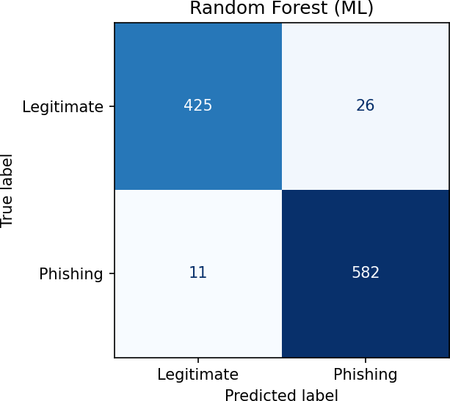
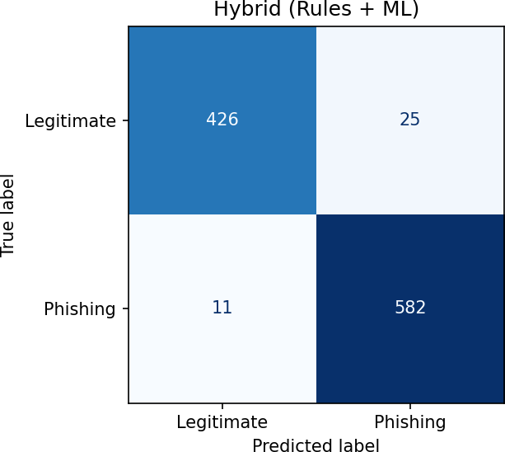

Figure 1: Confusion matrices of the Random Forest (left) and hybrid (right) detectors

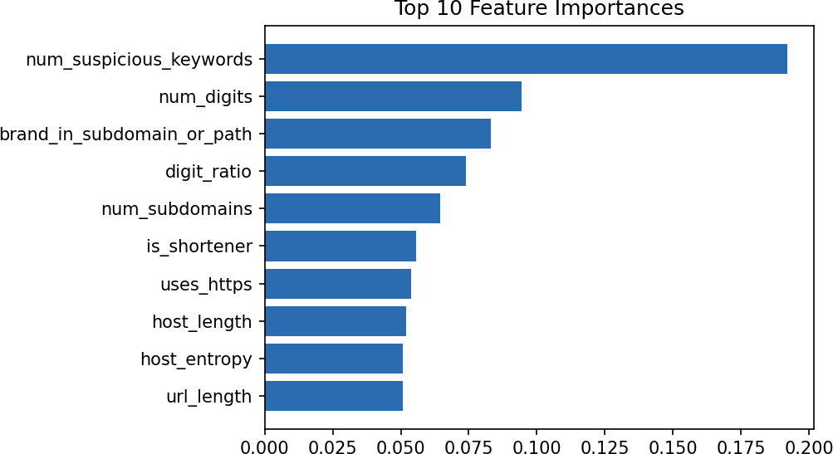

Figure 2: Top 10 feature importances

Observations
- The ML model improves accuracy by about 9 percentage points over rules alone, mainly through recall (0.82 to 0.98): rules miss subtle phishing URLs.
- The rule-based approach has high precision (0.95) but lower recall; it rarely raises false alarms but misses phishing URLs that match few rules.
- The hybrid gives the best overall result and, uniquely, an explanation for every decision.
- The most important features are the number of suspicious keywords, digit counts, brand-in-subdomain, number of subdomains and URL shortener use, which agrees with common phishing characteristics.

Sample outputs
Detailed screenshots of the program execution (training output, single-URL detection and the 15-case test run) are provided in the Screenshots folder of the submission. The test-run output is reproduced above in Section 9.

Limitations
- Synthetic dataset: the results show the method works on phishing patterns, but real-world accuracy will be lower. Retraining on a real dataset such as PhishTank is required before practical use.
- False positives (26 for ML): examples flagged as phishing but labelled legitimate: http://20azgj375.gq:8080/login.html, https://support.hdfcbank.com/login,
http://apple.confirm-pm38b.tk/suspend?id=dy8ta0rjo9. Many of these actually look phishing-like and arise from the 3% label noise deliberately added to the dataset; genuine legitimate login pages with long or keyword-heavy URLs can also be flagged.
- False negatives (11 for ML): clean-looking URLs labelled as phishing, for example https://www.linkedin.com/products, https://www.python.org/news/world, https://blog.github.com/about. A URL-only approach cannot detect phishing hosted on a compromised legitimate domain.
- Only URL text is analysed: no page content, domain age, SSL-certificate or reputation data.
- Brand and keyword lists are limited and English-centric; new attack styles may be missed.

Future Scope
- Train on large real-world datasets (PhishTank, OpenPhish, Kaggle) and compare other models (XGBoost, neural networks).
- Add host-based features: WHOIS domain age, DNS records and SSL certificate details.
- Add page-content and visual-similarity analysis.
- Build a browser extension or web/REST API for real-time protection and integrate live blacklist look-ups.
- Add detection of homograph (Unicode lookalike) domains and automatic retraining.

Conclusion
A working Phishing URL Detection System was designed, implemented and tested. It extracts 20 explainable features, applies a rule engine and a Random Forest model, and combines them into a hybrid detector that achieved 96.5% accuracy and an F1-score of 0.97 on the test set, passing all 15 manual test cases and giving clear reasons for every verdict. The project demonstrated the full workflow of a security-ML task: dataset preparation, feature engineering, model training, evaluation and error analysis. The main learning outcome is that combining rules with machine learning gives both accuracy and explainability, and that dataset quality is critical for real-world performance.

References
- PhishTank - community phishing URL database: https://phishtank.org
- Kaggle - Phishing Site URLs / Web Page Phishing datasets: https://www.kaggle.com
- Pedregosa et al., 'Scikit-learn: Machine Learning in Python', JMLR 12, 2011. https://scikit-learn.org
- Python documentation - urllib.parse: https://docs.python.org/3/library/urllib.parse.html
- APWG Phishing Activity Trends Reports: https://apwg.org
- OWASP - Phishing: https://owasp.org
- Source code and synthetic dataset generator: developed by the student(s) (this project, src/ folder).

