MACHINE LEARNING ENGINEER INTERNSHIP
Week 2 Task
Data Preprocessing and Feature Engineering Strategy
A tested, leakage-free pipeline demonstrated on the public IBM Telco Customer Churn dataset (7,043 customers, 21 columns)
Prepared by: Roshanpreet Singh
Programme: B.E. Computer Science Engineering, Chitkara University
Dataset: IBM Telco Customer Churn (public)
Tools: Python, pandas, NumPy, scikit-learn, SciPy, matplotlib, seaborn
Date: October 2026
Code & notebook: GitHub repository linked in the submission

Table of Contents
1. Introduction and Objectives 3
1.1 Why the Telco Customer Churn dataset 3
1.2 Objectives 3
2. Data Understanding 3
2.1 Dataset overview 3
2.2 Target distribution 4
2.3 Descriptive statistics 4
3. Data Quality Analysis 5
3.1 The hidden missing-value problem 6
4. Data Cleaning Strategy 6
4.1 Handling missing values 6
4.2 Duplicates 7
4.3 Outliers 7
4.4 Data type and consistency fixes 7
5. Feature Engineering 7
5.1 Transforming a skewed variable 7
5.2 New features created 8
6. Encoding and Scaling 9
6.1 Encoding choices 9
6.2 Scaling: StandardScaler versus MinMaxScaler 9
6.3 Leakage-free pipeline 9
7. Feature Selection 10
7.1 Filter method: correlation 10
7.2 Filter method: mutual information 10
7.3 Wrapper method: Recursive Feature Elimination 11
7.4 Embedded method: random-forest importance 11
7.5 Consolidated decision 11
8. Dimensionality Reduction with PCA 11
9. Step-by-Step Execution Plan 13
10. Validation: Does the Preprocessing Help? 13
10.1 Honest interpretation 13
11. Python Library Reference 14
12. Risks and Specific Mitigations 14
13. Conclusion 15
14. References 15

1. Introduction and Objectives
Raw data is almost never ready for a machine learning model. Columns arrive with the wrong data type, missing values hide behind blank strings, categories need numeric encodings, and features live on very different scales. Preprocessing and feature engineering decide how much of the signal in the data a model can actually use, and mistakes made here (especially data leakage) are silent: the model still trains, but its reported performance cannot be trusted.
This report designs a complete preprocessing and feature engineering strategy and, unlike a purely theoretical plan, tests every step on a real public dataset. All numbers, tables and figures in this document are produced by the accompanying Python notebook (Data_Preprocessing_Feature_Engineering.ipynb), so each claim can be reproduced.

1.1 Why the Telco Customer Churn dataset
The IBM Telco Customer Churn dataset describes 7,043 telecom customers with 21 columns: demographics, the services each customer subscribes to, contract and billing details, and a binary target, Churn, which says whether the customer left. It was chosen because it contains exactly the problems a preprocessing strategy must solve:
- a hidden missing-value problem (blank strings inside a numeric column, invisible to isna()),
- a mix of binary, ordinal and nominal categorical features,
- numeric features on different scales and one skewed feature (TotalCharges),
- a realistic class imbalance (about 26.5% churners), and
- a real business meaning, which lets us justify cleaning decisions with domain logic rather than only statistics.

1.2 Objectives
- Assess data quality without any proprietary data, using only descriptive statistics and visualisation.
- Clean the data: missing values, duplicates, outliers and data types, with a justification for each choice.
- Engineer new features and measure whether they carry signal.
- Encode and scale features inside a pipeline that is fitted on the training split only.
- Select features and reduce dimensionality using filter, wrapper and embedded methods plus PCA.
- Validate the pipeline against a baseline and report the result honestly, including where the gain is small.

2. Data Understanding

2.1 Dataset overview
The dataset has 7,043 rows and 21 columns (3 numeric, 17 categorical or text, 1 identifier). Each row is one customer and customerID is unique, so no customer appears twice.
Group | Columns | Type
Identifier | customerID | text (dropped later, no predictive value)
Demographics | gender, SeniorCitizen, Partner, Dependents | binary
Account | tenure (months), Contract, PaperlessBilling, PaymentMethod | numeric / ordinal / binary / nominal
Services | PhoneService, MultipleLines, InternetService, OnlineSecurity, OnlineBackup, DeviceProtection, TechSupport, StreamingTV, StreamingMovies | categorical (Yes / No / No service)
Charges | MonthlyCharges, TotalCharges | numeric (TotalCharges stored as text)
Target | Churn | binary (Yes / No)

2.2 Target distribution
Of the 7,043 customers, 5,174 stayed (73.46%) and 1,869 churned (26.54%). The classes are imbalanced but not extreme, so we use stratified splitting everywhere to keep the 26.5% churn rate identical in the training and test sets (measured: 0.265 in both).
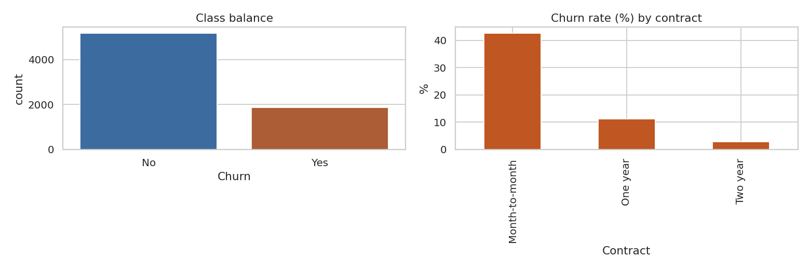
Figure 1. Class balance (left) and churn rate by contract type (right). Month-to-month customers churn at 42.7%, one-year at 11.3% and two-year at 2.8%.

2.3 Descriptive statistics
Statistic | tenure | MonthlyCharges | TotalCharges
count | 7,043 | 7,043 | 7,032 (after type conversion)
mean | 32.37 | 64.76 | 2,283.30
std | 24.56 | 30.09 | 2,266.77
min | 0 | 18.25 | 18.80
25% | 9 | 35.50 | 401.45
median | 29 | 70.35 | 1,397.48
75% | 55 | 89.85 | 3,794.74
max | 72 | 118.75 | 8,684.80
skewness | 0.240 | -0.221 | 0.962

Two observations drive later decisions. First, TotalCharges has only 7,032 valid values although there are 7,043 rows, which exposes the hidden missing-value problem (Section 3). Second, TotalCharges is clearly right-skewed (skewness 0.96, mean far above median), which motivates a log transform (Section 5).
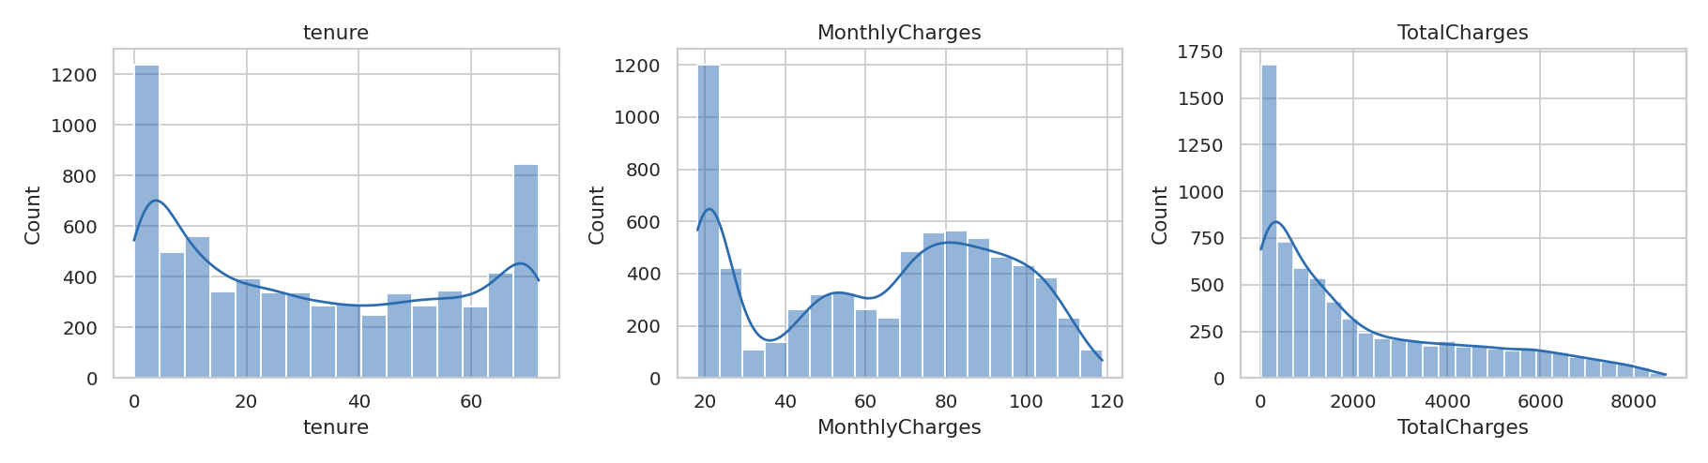
Figure 2. Distributions of the three numeric features. TotalCharges is strongly right-skewed.
The correlation heatmap shows the expected structure: TotalCharges is strongly correlated with tenure (longer customers have accumulated more charges) and with MonthlyCharges. This overlap is a first warning of multicollinearity, which we revisit during feature selection.
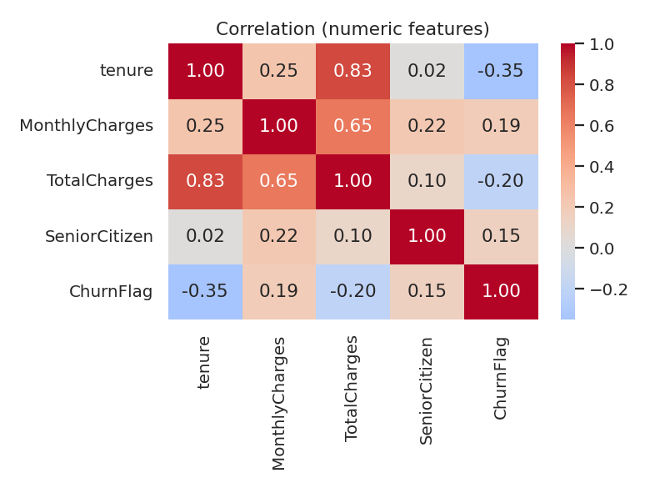
Figure 3. Correlation matrix of numeric features and the churn flag.

3. Data Quality Analysis
Data quality is analysed before any modification, using pandas only. The checks below are ordered from most to least common source of silent errors.
Check | Method | Result | Action
Real missing values | df.isna().sum() | 0 in all 21 columns | None needed, but not sufficient (see next row)
Hidden missing values | df.TotalCharges.str.strip() == "" | 11 blank strings in TotalCharges | Convert to numeric, then impute (Section 4.1)
Wrong data type | df.info() | TotalCharges is text, not float | pd.to_numeric(errors="coerce")
Duplicate rows | df.duplicated().sum() | 0 | None
Duplicate IDs | df.customerID.duplicated() | 0 (all unique) | Drop the column (no signal)
Outliers | IQR rule and z-score | 0 in all numeric columns | Keep values (Section 4.3)
Class balance | value_counts(normalize=True) | 73.5% / 26.5% | Stratified split
Redundant categories | correlation of dummies | Six "No internet service" dummies are perfectly correlated (r = 1.0) with InternetService_No | Flag for removal (Section 7)

3.1 The hidden missing-value problem
df.isna().sum() reports zero missing values, yet TotalCharges is stored as text. Converting it with pd.to_numeric(errors="coerce") exposes 11 blank strings. This is the classic failure of a pipeline that only trusts isna().
blank = df["TotalCharges"].str.strip() == ""
print("Real NaNs per column:", int(df.isna().sum().sum()))
print("Blank TotalCharges :", int(blank.sum()))
print("tenure==0 rows:", int((df.tenure==0).sum()),
"| blanks that have tenure==0:", int((blank & (df.tenure==0)).sum()))

Output:
Real NaNs per column: 0
Blank TotalCharges : 11
tenure==0 rows: 11 | blanks that have tenure==0: 11

Key insight: all 11 blanks belong to customers with tenure = 0, meaning they signed up but have not been billed yet. The data is not randomly missing; the missingness has an explanation, which tells us the correct imputation value.

4. Data Cleaning Strategy

4.1 Handling missing values
Three imputation strategies were compared on the 11 affected rows:
Strategy | Value filled | Verdict
Mean imputation | 2,283.30 | Wrong: implies a brand-new customer already paid over 2,000
Median imputation | 1,397.47 | Better than mean for skewed data, but still wrong for a customer with zero months of billing
Domain rule: 0 when tenure = 0 | 0.00 | Chosen. Logically correct, needs no model, and cannot leak information

df["TotalCharges"] = pd.to_numeric(df["TotalCharges"], errors="coerce")
df["TotalCharges"] = df["TotalCharges"].fillna(0) # tenure==0 -> not billed yet
print("Remaining NaNs:", int(df.isna().sum().sum()))

Output:
Remaining NaNs: 0

General rule used in the strategy: if the cause of missingness is understood, use domain logic; if values are missing at random, use median (numeric, skewed) or most-frequent (categorical) imputation inside a SimpleImputer placed in the pipeline so its statistics are learned from training data only; use KNNImputer when features are strongly related and the extra cost is acceptable. Because missingness here is only 0.16% of rows, deleting the rows would also be defensible, but it would discard 11 valid customers for no benefit.

4.2 Duplicates
There are 0 duplicate rows and 0 duplicate customer IDs. The strategy still keeps the check as a permanent step (df.duplicated().sum()) because duplicates inflate evaluation scores when one copy lands in training and the other in testing. customerID is dropped afterwards since a unique identifier cannot generalise.

4.3 Outliers
Both the IQR rule (values beyond Q1 - 1.5 x IQR or Q3 + 1.5 x IQR) and the z-score rule (|z| > 3) were applied:
Feature | IQR lower bound | IQR upper bound | IQR outliers | |z| > 3 outliers
tenure | -60.0 | 124.0 | 0 | 0
MonthlyCharges | -46.0 | 171.4 | 0 | 0
TotalCharges | -4,683.5 | 8,868.7 | 0 | 0

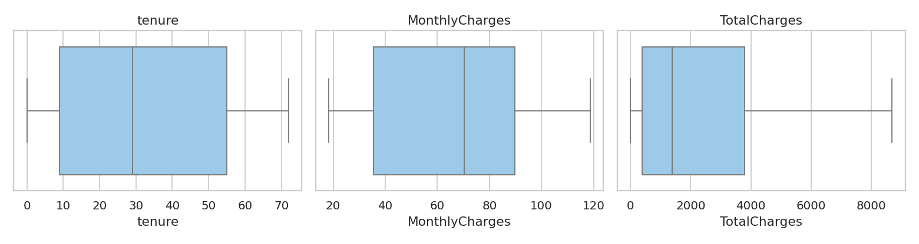
Figure 4. Box plots of the numeric features. No points fall outside the whiskers.
Decision: no rows are removed. Every observed value is plausible (tenure is bounded at 72 months, monthly bills are within a realistic tariff range). The strategy for a dataset that does contain outliers is: (1) investigate whether they are errors; (2) if genuine, keep them and use a robust transform (log) or RobustScaler; (3) cap (winsorise) only when a business limit exists; (4) remove only confirmed data-entry errors.

4.4 Data type and consistency fixes
- TotalCharges: text to float (Section 3.1).
- SeniorCitizen is already 0/1 while other binary columns use Yes/No; it is passed through unchanged to avoid double encoding.
- Target Churn is mapped to 1 (Yes) and 0 (No) in a separate variable y so the target never enters the feature matrix.

5. Feature Engineering
Feature engineering creates inputs that make patterns easier for a model to see. Every feature below uses only information that exists for a customer at prediction time (no target leakage).

5.1 Transforming a skewed variable
TotalCharges has skewness 0.963. Applying np.log1p (log of 1 + x, safe for zero values) changes the skewness to -0.824, reducing its absolute value, and compresses the long right tail so that a few high-spending customers no longer dominate distance- and gradient-based models.
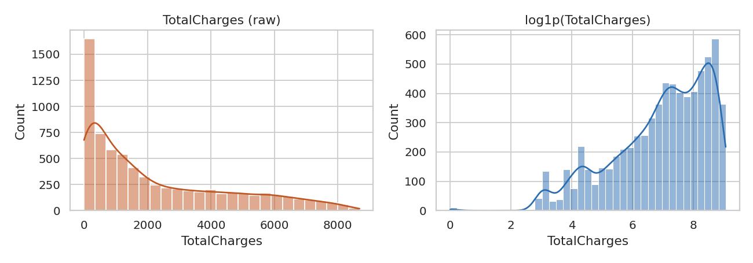
Figure 5. TotalCharges before (left) and after (right) the log1p transform.
Note that log1p does not make the distribution perfectly symmetric (it overcorrects slightly into a mild left skew), which is why both the raw and the log version are retained and left to feature selection to judge.

5.2 New features created
New feature | How it is built | Rationale | Observed churn rate
tenure_group | pd.cut(tenure, [-1,12,24,48,72]) | Churn risk is non-linear in tenure; bins let linear models capture it | 0-12: 47.4%, 13-24: 28.7%, 25-48: 20.4%, 49-72: 9.5%
num_services | Count of subscribed services (phone, internet, add-ons) | Customers tied to many services find it harder to leave | used by models
avg_monthly_paid | TotalCharges / tenure (MonthlyCharges when tenure = 0) | Actual historical spend versus current price | used by models
charge_gap | MonthlyCharges - avg_monthly_paid | Detects recent price increases or upgrades | used by models
has_streaming | TV or movies streaming = Yes | Combines two sparse binary columns into one meaningful flag | used by models
has_protection | OnlineSecurity, TechSupport or DeviceProtection = Yes | Customers with support services are more engaged | No: 31.5%, Yes: 22.3%
auto_pay | PaymentMethod contains "automatic" | Automatic payment reduces friction to stay | No: 34.7%, Yes: 16.0%
log_total | np.log1p(TotalCharges) | Reduces skew (Section 5.1) | used by models

The three engineered binary flags and the tenure bins show clear separation in churn rate (for example 16.0% versus 34.7% for automatic versus manual payment), which is evidence that these features carry signal and are not just noise.
fe["tenure_group"] = pd.cut(fe.tenure, [-1,12,24,48,72], labels=["0-12","13-24","25-48","49-72"])
fe["num_services"] = sum((fe[c]=="Yes").astype(int) for c in svc) + (fe.InternetService!="No").astype(int)
fe["avg_monthly_paid"] = np.where(fe.tenure>0, fe.TotalCharges/fe.tenure.replace(0,1), fe.MonthlyCharges)
fe["charge_gap"] = fe.MonthlyCharges - fe["avg_monthly_paid"]
fe["auto_pay"] = fe.PaymentMethod.str.contains("automatic").astype(int)
fe["log_total"] = np.log1p(fe.TotalCharges)

Output:
tenure_group num_services avg_monthly_paid charge_gap log_total
0-12 2 29.85 0.00 3.429
25-48 4 55.57 1.38 7.545
0-12 4 54.08 -0.23 4.693

6. Encoding and Scaling

6.1 Encoding choices
Different categorical columns need different encoders. Using one-hot for everything wastes columns, and using label encoding for nominal data invents a false order.
Feature type | Columns | Encoder | Why
Binary | gender, Partner, Dependents, PhoneService, PaperlessBilling | OrdinalEncoder (0/1) | Two categories need only one column
Ordinal | Contract (Month-to-month < One year < Two year) | OrdinalEncoder with explicit order | Order is meaningful and matches churn risk
Nominal | MultipleLines, InternetService, OnlineSecurity, OnlineBackup, DeviceProtection, TechSupport, StreamingTV, StreamingMovies, PaymentMethod, tenure_group | OneHotEncoder(handle_unknown="ignore") | No natural order; unseen categories at inference must not crash the model
Already numeric flags | SeniorCitizen, has_streaming, has_protection, auto_pay | passthrough | Already 0/1

6.2 Scaling: StandardScaler versus MinMaxScaler
Scaling matters for logistic regression, SVMs, KNN, neural networks and PCA, all of which are sensitive to feature magnitude (tenure is 0-72 while TotalCharges reaches 8,685). Tree-based models do not need it. Both scalers were fitted on the training split only and compared on TotalCharges:
 | raw | StandardScaler | MinMaxScaler
mean | 2,299.335 | 0.000 | 0.265
std | 2,279.204 | 1.000 | 0.262
min | 0.000 | -1.009 | 0.000
max | 8,684.800 | 2.802 | 1.000

Choice: StandardScaler is used for the numeric block. MinMaxScaler would squeeze most customers into a narrow range because of the long right tail (the max maps to 1 while the mean is only 0.265), and it is more sensitive to future extreme values. RobustScaler is the recommended alternative if later data contains outliers.

6.3 Leakage-free pipeline
The most important rule of this whole strategy: split first, then fit. Imputers, encoders and scalers learn statistics (means, categories, ranges). If they are fitted on the full dataset, information from the test set leaks into training. All steps are therefore wrapped in a ColumnTransformer that is fitted on the training split and only applied to the test split.
Xtr, Xte, ytr, yte = train_test_split(X, y, test_size=0.2, stratify=y, random_state=42)

pre = ColumnTransformer([
("bin", OrdinalEncoder(), binary),
("ord", OrdinalEncoder(categories=[["Month-to-month","One year","Two year"]]), ordinal),
("ohe", OneHotEncoder(handle_unknown="ignore", sparse_output=False), nominal),
("num", StandardScaler(), numeric),
("pas", "passthrough", passthrough)])
Xtr_t = pre.fit_transform(Xtr) # learn on train only
Xte_t = pre.transform(Xte) # apply to test

Output:
train (5634, 27) test (1409, 27) | churn rate train/test: 0.265 0.265
Features before: 27 -> after encoding/scaling: 49
NaNs in output: 0

7. Feature Selection
After encoding there are 49 features. Four complementary methods were used, because no single method is reliable on its own (Guyon and Elisseeff, 2003).

7.1 Filter method: correlation
Pairs with absolute correlation above 0.9 were listed. The result is striking: every "No internet service" dummy (for OnlineSecurity, OnlineBackup, DeviceProtection, TechSupport, StreamingTV, StreamingMovies) has correlation 1.0 with InternetService_No, because they all describe the same customers (those without internet). Keeping all seven columns adds no information and causes perfect multicollinearity for linear models.
Recommendation: keep InternetService_No and drop the six duplicated "No internet service" dummies (or encode with drop="first"). This removes 6 of 49 columns with zero information loss.

7.2 Filter method: mutual information
Mutual information measures any dependency (not only linear) between a feature and the target. The strongest features were:
Rank | Feature | Mutual information
1 | Contract (ordinal) | 0.0944
2 | tenure | 0.0674
3 | OnlineSecurity = No | 0.0637
4 | TechSupport = No | 0.0619
5 | MonthlyCharges | 0.0511
6 | InternetService = Fiber optic | 0.0496
7 | tenure_group = 0-12 (engineered) | 0.0457
8 | charge_gap (engineered) | 0.0429
9 | PaymentMethod = Electronic check | 0.0413

Contract type is the strongest single predictor, in line with the 42.7% / 11.3% / 2.8% churn rates seen in Section 2. Two engineered features (tenure_group, charge_gap) appear in the top ten, which supports the feature engineering step.

7.3 Wrapper method: Recursive Feature Elimination
RFE with logistic regression repeatedly removes the weakest feature until 15 remain. Selected features include Contract, PaperlessBilling, the InternetService categories, StreamingMovies = Yes, PaymentMethod = Mailed check, log_total and the engineered auto_pay.

7.4 Embedded method: random-forest importance
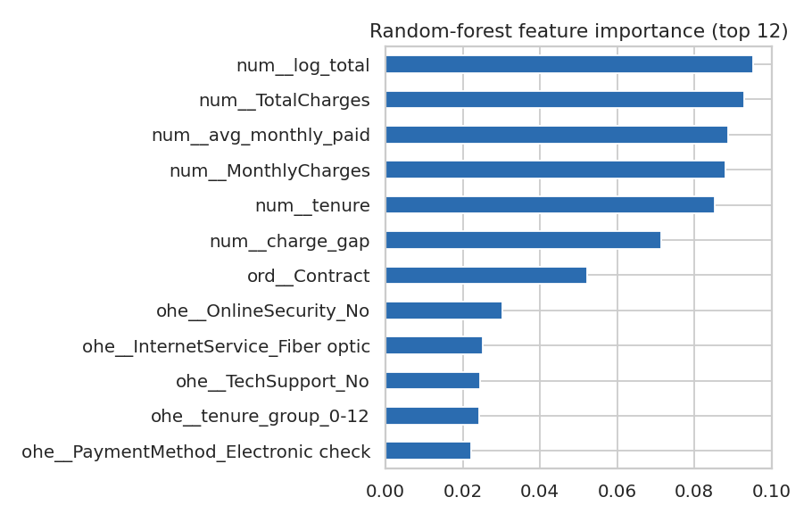
Figure 6. Random-forest feature importance (top 12). Numeric billing features and Contract dominate.
The forest ranks log_total (0.0953), TotalCharges (0.0928), the engineered avg_monthly_paid (0.0887), MonthlyCharges (0.0881) and tenure (0.0853) highest, with charge_gap (0.0714) and Contract (0.0523) next. Note that tree importances favour continuous features, so they are interpreted together with the mutual-information ranking rather than alone.

7.5 Consolidated decision
Decision | Features | Evidence
Keep (strong) | Contract, tenure, MonthlyCharges, TotalCharges / log_total, InternetService, OnlineSecurity, TechSupport, PaymentMethod | High in mutual information and forest importance
Keep (engineered) | tenure_group, charge_gap, avg_monthly_paid, auto_pay, has_protection | Top-ten in at least one method; clear churn-rate separation
Drop (redundant) | Six "No internet service" dummies | Correlation = 1.0 with InternetService_No
Review | gender, Partner, PhoneService | Low mutual information (ranks 31, 34 and 33 of 49, values about 0.011 to 0.012), none selected by RFE; PhoneService is 46th of 49 in forest importance. Candidates to drop for a simpler model

8. Dimensionality Reduction with PCA
Principal Component Analysis (PCA) was applied to the 49 scaled and encoded features to see how much the dimensionality can be compressed.
p = PCA().fit(Xtr_df); cum = np.cumsum(p.explained_variance_ratio_)
for t in (0.90, 0.95):
print(f"{int(t*100)}% variance needs {int(np.argmax(cum>=t))+1} of {len(cum)} components")

Output:
90% variance needs 15 of 49 components
95% variance needs 19 of 49 components

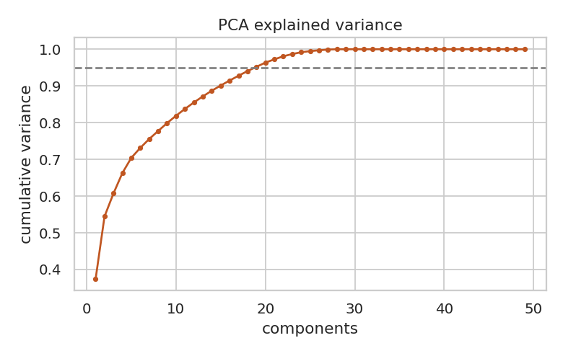
Figure 7. Cumulative explained variance. 19 of 49 components retain 95% of the variance.
PCA can shrink the feature space from 49 to 19 dimensions while keeping 95% of the variance. However, PCA is not applied in the final pipeline. The components are linear mixtures of features and are not interpretable, which matters for a churn model whose results business teams must act on. PCA is recommended instead when (a) the number of features becomes much larger than the number of samples, (b) a distance-based model is slow, or (c) strong multicollinearity cannot be removed by feature selection.

9. Step-by-Step Execution Plan
The table summarises the order in which the pipeline is executed and how each step is tested. The order is deliberate: inspection first, anything that learns from data after the split.
# | Step | Library calls | Test / expected result
1 | Load and inspect | pd.read_csv, df.info(), df.describe() | Shape (7043, 21); dtypes reviewed
2 | Quality audit | isna, duplicated, str.strip()=="" | 11 hidden blanks found; 0 duplicates
3 | Fix types | pd.to_numeric(errors="coerce") | TotalCharges becomes float64
4 | Impute | fillna(0) (domain rule) | df.isna().sum().sum() == 0
5 | Outlier check | quantile, scipy.stats.zscore | 0 outliers; data kept
6 | Feature engineering | pd.cut, np.log1p, arithmetic | 8 new columns; churn rates differ across groups
7 | Stratified split | train_test_split(stratify=y) | Churn 0.265 in both splits
8 | Encode and scale | ColumnTransformer, OneHotEncoder, StandardScaler | 49 features, 0 NaN, scaler mean 0 / std 1 on train
9 | Select features | mutual_info_classif, RFE, RandomForestClassifier | Ranked features; redundant dummies flagged
10 | Validate | cross_val_score, roc_auc_score, f1_score | Compare with baseline (Section 10)

Testing each step in practice. Every step is followed by a small assertion-style check so errors surface immediately:
assert df.isna().sum().sum() == 0, "NaNs remain after imputation"
assert df.TotalCharges.dtype == "float64", "TotalCharges not numeric"
assert abs(ytr.mean() - yte.mean()) < 0.01, "Split is not stratified"
assert not np.isnan(Xtr_t).any(), "NaN after encoding/scaling"
assert Xtr_t.shape[1] == Xte_t.shape[1], "Train/test columns differ"

10. Validation: Does the Preprocessing Help?
A strategy should be judged by evidence. A logistic regression was trained twice with identical splits and 5-fold stratified cross-validation: a baseline (cleaned data, one-hot encoding, no scaling, no engineered features) and the full pipeline of this report.
Model | CV ROC-AUC | CV F1 | Test ROC-AUC | Test F1
Baseline (no scaling, no new features) | 0.8463 | 0.5932 | 0.8423 | 0.6081
Full pipeline (this report) | 0.8488 | 0.5996 | 0.8460 | 0.5956

Using only the 15 RFE-selected features gave Test ROC-AUC 0.8458 and Test F1 0.5931, compared with 0.8460 and 0.5956 for all 49 features, so the model is almost as good with 70% fewer features.

10.1 Honest interpretation
- The full pipeline improves ROC-AUC consistently (cross-validation +0.0025, test +0.0037), but the gain is small. Logistic regression with one-hot encoding already captures most of the signal, and the engineered features are partly linear combinations of existing columns.
- Test F1 is slightly lower than the baseline (0.5956 versus 0.6081) while cross-validated F1 is slightly higher. Differences of this size are within normal split-to-split variation and should not be read as a real gain or loss.
- F1 around 0.60 is low mainly because the default decision threshold of 0.5 is not suited to a 26.5% minority class. Class weights or threshold tuning are the correct next step, not more preprocessing.
- Feature engineering and scaling are expected to matter more for distance-based or neural models and for compact models. The 15-feature result shows the real benefit here: a simpler, equally accurate model.

11. Python Library Reference
Library | Used for | Key functions in this project
pandas | Loading, inspection, cleaning, feature construction | read_csv, info, describe, to_numeric, fillna, duplicated, cut, groupby, cut, groupby
NumPy | Vectorised arithmetic, transforms | log1p, where, cumsum, isnan
SciPy | Statistics | stats.zscore for outlier detection
scikit-learn | Pipeline, encoding, scaling, selection, PCA, evaluation | ColumnTransformer, OneHotEncoder, OrdinalEncoder, StandardScaler, MinMaxScaler, SimpleImputer, KNNImputer, mutual_info_classif, RFE, PCA, cross_val_score
matplotlib / seaborn | Visual analysis | histplot, boxplot, heatmap, countplot

12. Risks and Specific Mitigations
Risk | What goes wrong | Concrete mitigation
Data leakage | Scaler or encoder fitted on all data inflates test scores | Split first; fit everything inside ColumnTransformer on train only; assert train/test column match
Hidden missing values | Blanks or placeholders ("?", "N/A", " ") bypass isna() | Check dtypes; coerce numeric columns; inspect value_counts of every text column
Wrong imputation | Mean fill creates unrealistic records (2,283 for a new customer) | Prefer domain rules; otherwise impute inside the pipeline; compare strategies as in Section 4.1
Unseen categories at inference | A new payment method crashes the model | OneHotEncoder(handle_unknown="ignore")
Multicollinearity | Perfectly correlated dummies destabilise linear coefficients | Correlation filter; drop redundant "No internet service" columns
Over-engineering | Many weak features add noise and slow training | Keep features only if they appear in selection methods; the 15-feature model matches the 49-feature model
Class imbalance | Accuracy looks high while churners are missed | Stratified split; report ROC-AUC and F1; add class weights or threshold tuning
Train/serve skew | Production data is preprocessed differently | Persist the fitted pipeline (joblib.dump) and use it unchanged in production
Distribution drift | Prices or customer mix change over time | Monitor feature distributions; retrain on a schedule

13. Conclusion
This report presented a complete, executable preprocessing and feature engineering strategy and tested it on 7,043 real customer records. The main findings are:
- A hidden data-quality defect (11 blank TotalCharges values) was found only because column types were inspected, and it was fixed with a domain rule (0 for customers with tenure 0) rather than a statistical guess.
- No duplicates or outliers were present, so no rows were deleted; skew was handled with log1p instead.
- Engineered features such as tenure groups and automatic payment showed clear churn-rate separation (for example 47.4% for the first year versus 9.5% after four years) and several ranked in the top ten of the selection methods.
- All encoders and scalers are fitted on the training split only, which keeps evaluation honest.
- The full pipeline gave a small but consistent ROC-AUC gain (0.8423 to 0.8460 on test), and a 15-feature subset performed almost identically, which shows that preprocessing here mainly produces a simpler and safer model.
The next phase (model training) can start from this pipeline with confidence, and should focus on class imbalance handling, threshold tuning and comparing tree-based models, where the engineered features are likely to matter more.

14. References
- Guyon, I. and Elisseeff, A. (2003). An introduction to variable and feature selection. Journal of Machine Learning Research, 3, 1157-1182.
- Harris, C. R. et al. (2020). Array programming with NumPy. Nature, 585, 357-362.
- IBM. Telco Customer Churn sample dataset. https://github.com/IBM/telco-customer-churn-on-icp4d
- Jolliffe, I. T. and Cadima, J. (2016). Principal component analysis: a review and recent developments. Philosophical Transactions of the Royal Society A, 374(2065), 20150202.
- Kuhn, M. and Johnson, K. (2019). Feature Engineering and Selection: A Practical Approach for Predictive Models. CRC Press.
- Little, R. J. A. and Rubin, D. B. (2019). Statistical Analysis with Missing Data (3rd ed.). Wiley.
- McKinney, W. (2010). Data structures for statistical computing in Python. Proceedings of the 9th Python in Science Conference, 56-61.
- Pedregosa, F. et al. (2011). Scikit-learn: Machine learning in Python. Journal of Machine Learning Research, 12, 2825-2830.
- scikit-learn documentation. Preprocessing data; Feature selection. https://scikit-learn.org/stable/modules/preprocessing.html

