# Assignment_2.3-SQL

1.Useing train.csv from <https://www.kaggle.com/c/titanic/data>

2. Write SQL queries to answer the following questions

a. Retrieve the names of passengers who survived the Titanic disaster.

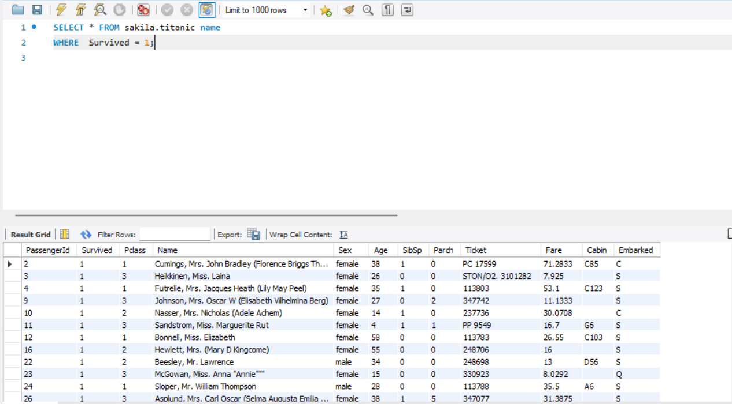

b. Find the names and ages of the five oldest survivors.

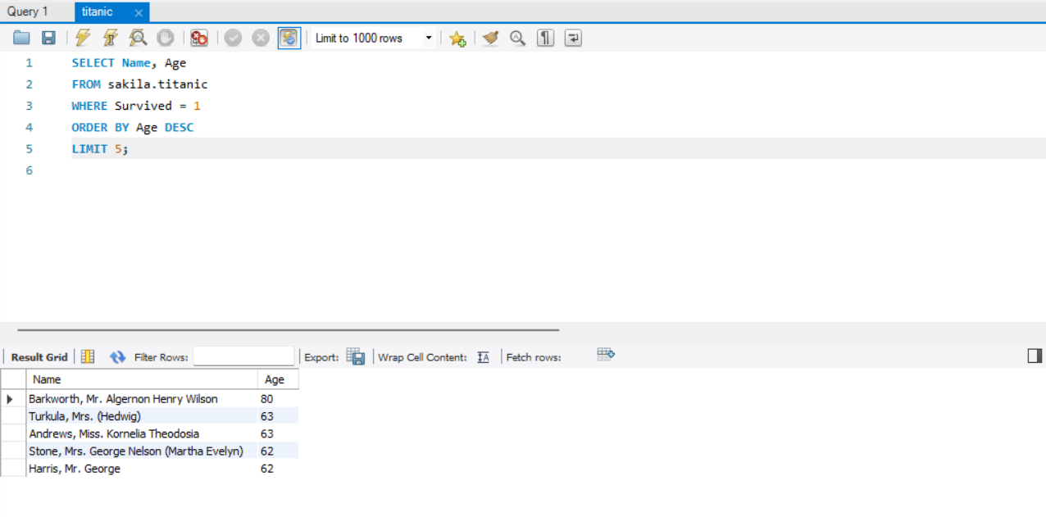

c. Calculate the average age of passengers who did not survive, and also the

average age of passengers who survived, grouped by sex.

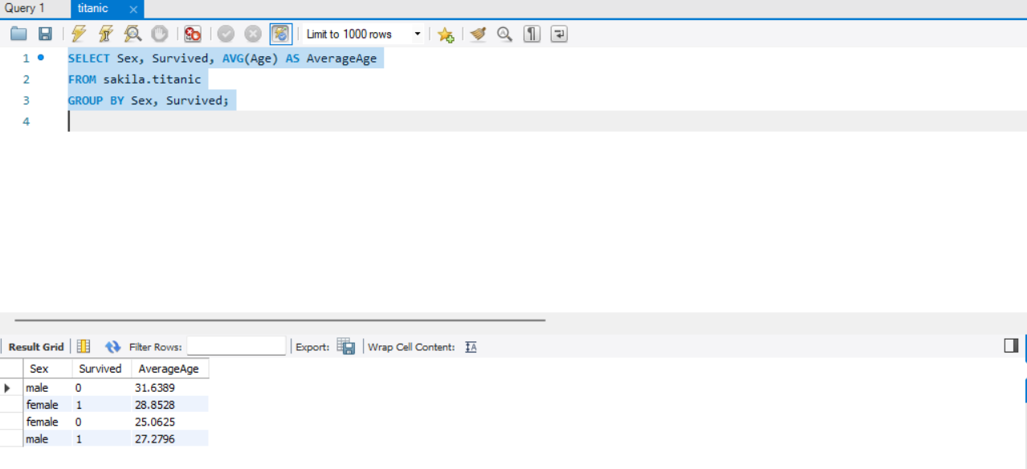

d. Count the number of males and females

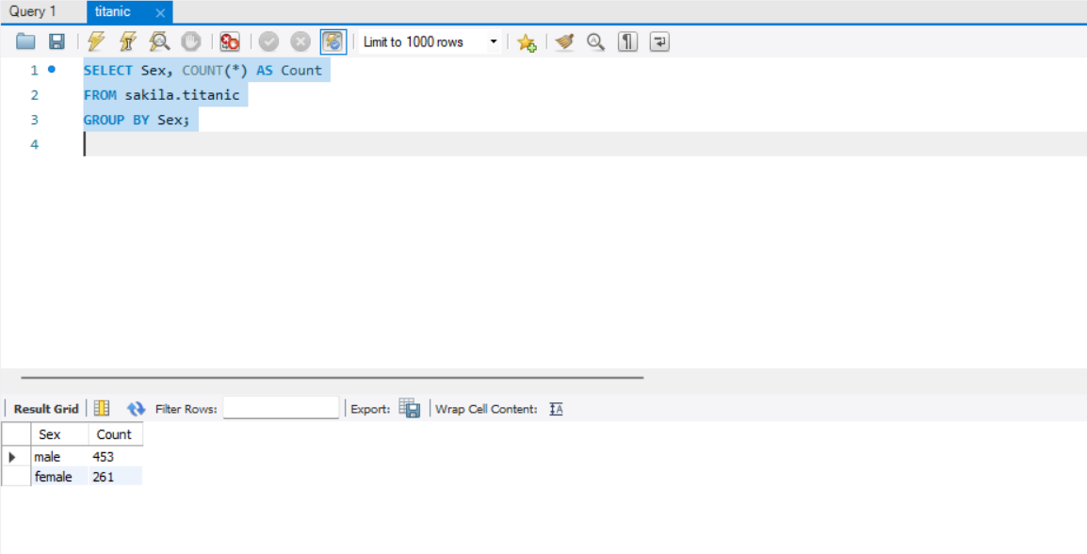

e. Update the cabin class of a Futrelle, Mrs. Jacques Heath (Lily May Peel) to

3rd class.

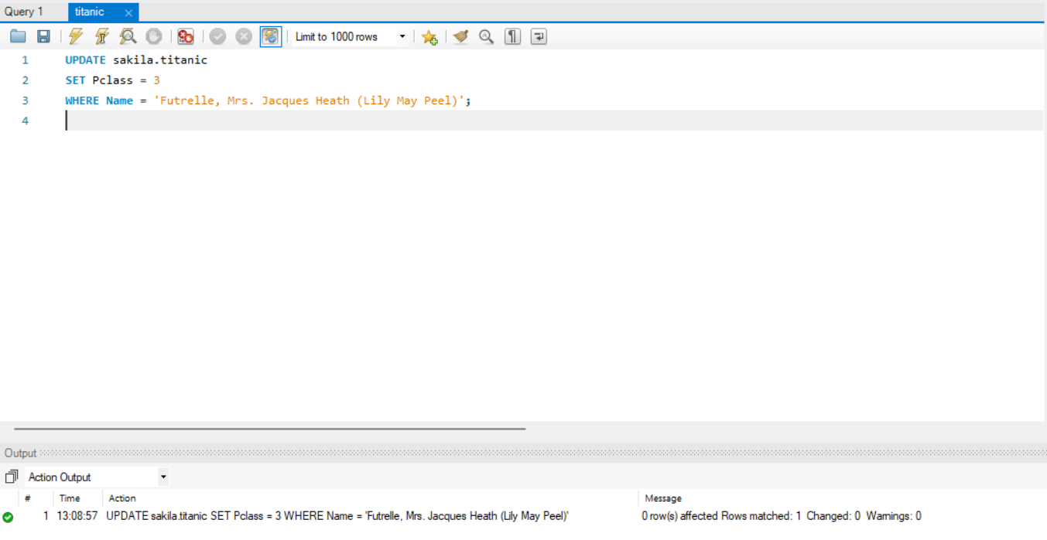

f. Delete all passengers who did not have a recorded age

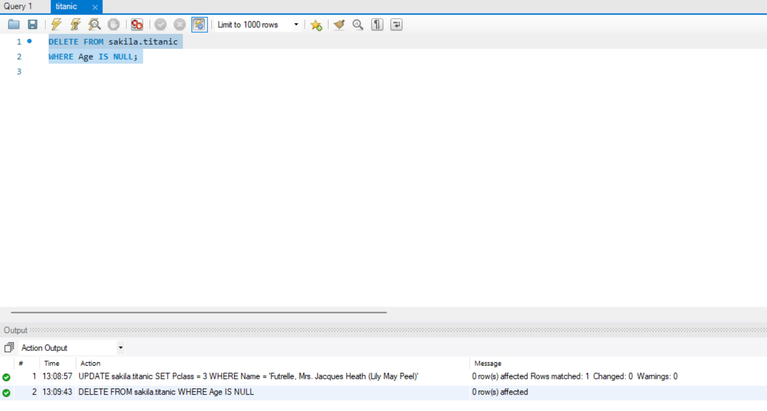

g. Retrieve the names of passengers who survived and have siblings or

spouses on board, along with the count of their siblings or spouses.

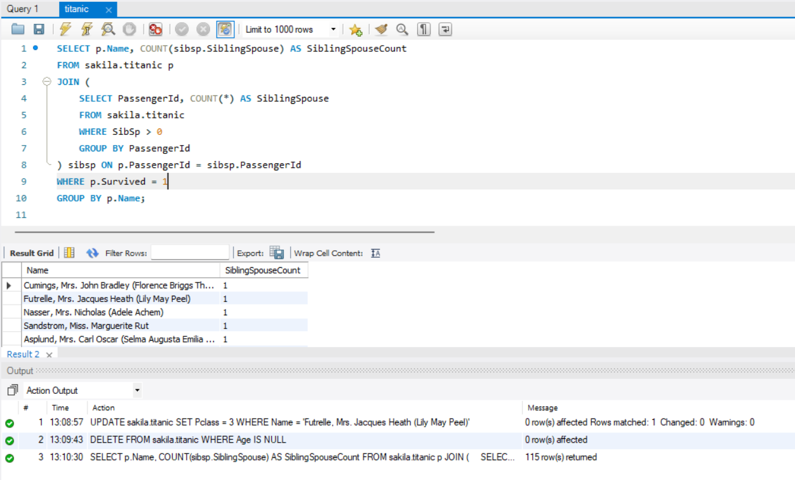

h. Find the top 10 oldest passengers who did not survive, along with their ages

and ticket numbers.

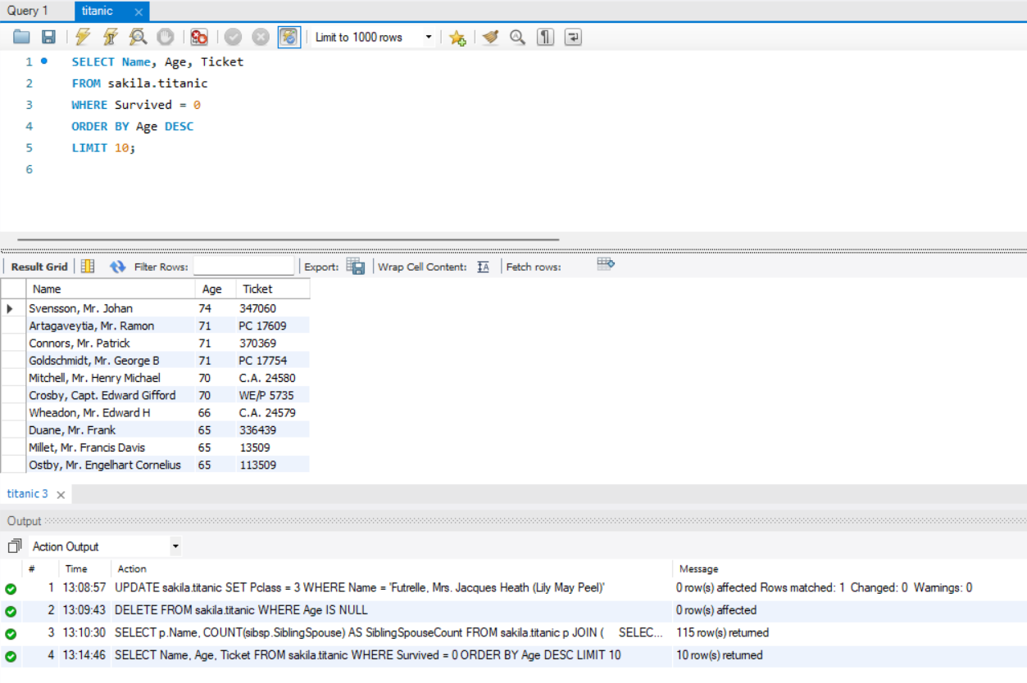

i. Calculate the survival counts for passengers in each cabin class (1st, 2nd,

3rd), and display the results in descending order

