**x=DataAnalyzer(r'Titanic-Dataset.csv')**

**x.load_data()**

**x.generate_bar_graph("Sex")**

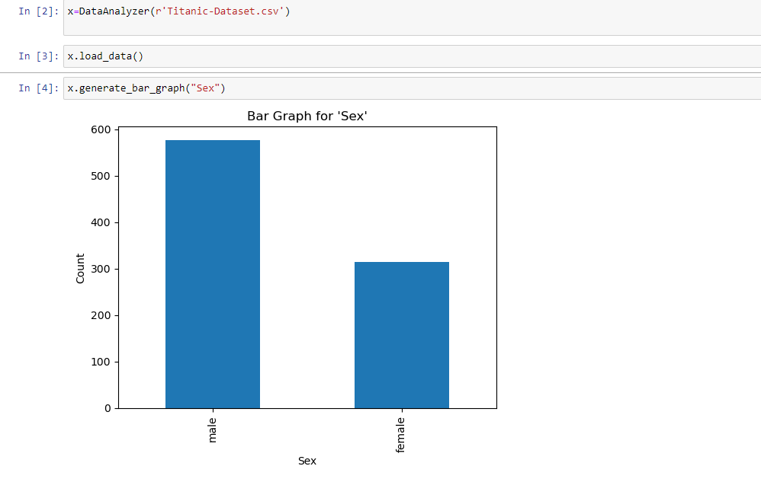

**x.plot_scatter_plot('Age','Survived')**

