NAME-ROSHANI GUPTA

SAP ID-86062300035

ROLL NO-A018

**Cloud Computing Architecture**

Cloud computing architecture is the blueprint of a cloud environment, comprising various components and services that work together to deliver cloud services. It typically includes:

1. **Front-End Platform**: This is what the end user interacts with, such as a web browser or mobile application. It serves as the interface to access cloud services.
2. **Back-End Platform**: The infrastructure and services that power the cloud, including servers, storage, and networking. This is where data processing and storage take place.
3. **Cloud-Based Delivery**: The mechanisms through which cloud services are delivered, which could include APIs, web services, and middleware.
4. **Network**: The internet or private networks that connect the front-end and back-end components, enabling communication and data exchange between them.

Cloud computing architecture can be broken down into different service models, the most common of which are IaaS (Infrastructure as a Service), PaaS (Platform as a Service), and SaaS (Software as a Service).

**IaaS (Infrastructure as a Service)**

IaaS is one of the fundamental service models of cloud computing, where a cloud provider offers virtualized computing resources over the internet. IaaS provides businesses with the core infrastructure, including virtual machines (VMs), storage, networks, and operating systems, on a flexible, pay-as-you-go basis.

* **Key Features**:
  + **Scalability**: IaaS allows businesses to quickly scale resources up or down based on demand. This means you can add more virtual machines or storage when needed and scale back when demand decreases.
  + **Cost-Efficiency**: Rather than investing in physical hardware, businesses can rent resources from the cloud provider. This reduces capital expenditures and lowers the total cost of ownership.
  + **Control and Flexibility**: With IaaS, users have control over the infrastructure, including the ability to install and configure software, operating systems, and applications. This flexibility allows businesses to tailor their cloud environment to specific needs.
  + **Automation and Management**: Many IaaS providers offer tools for automating the management of resources, including provisioning, load balancing, and scaling.
* **Common Use Cases**:
  + **Hosting Websites and Applications**: IaaS can be used to host websites, web applications, and APIs, providing the necessary compute and storage resources.
  + **Storage, Backup, and Recovery**: Businesses can use IaaS to store large amounts of data, create backups, and implement disaster recovery solutions.
  + **High-Performance Computing**: IaaS is ideal for running compute-intensive tasks, such as simulations, scientific calculations, and large-scale data processing.

**AWS (Amazon Web Services)**

AWS is one of the largest and most popular cloud service providers, offering a wide range of cloud computing services that cater to various needs. AWS provides everything from basic infrastructure services like compute, storage, and networking to more advanced services like machine learning, analytics, and artificial intelligence.

* **Key Offerings**:
  + **Compute Services**: AWS offers a variety of compute services, including:
    - **EC2 (Elastic Compute Cloud)**: Provides scalable virtual servers.
    - **Lambda**: Enables serverless computing, allowing you to run code without provisioning servers.
    - **Elastic Beanstalk**: A platform-as-a-service that makes it easy to deploy and manage applications.
  + **Storage Services**: AWS provides several storage options, such as:
    - **S3 (Simple Storage Service)**: Object storage for storing and retrieving any amount of data.
    - **EBS (Elastic Block Store)**: Persistent block storage for use with EC2 instances.
    - **Glacier**: Low-cost archival storage for long-term backups and data retention.
  + **Database Services**: AWS offers managed database services, including:
    - **RDS (Relational Database Service)**: Supports several database engines like MySQL, PostgreSQL, and Oracle.
    - **DynamoDB**: A fully managed NoSQL database service.
    - **Aurora**: A high-performance, MySQL- and PostgreSQL-compatible relational database.
  + **Networking Services**: AWS includes networking services such as:
    - **VPC (Virtual Private Cloud)**: Allows you to create isolated networks within the AWS cloud.
    - **Route 53**: A scalable DNS web service.
    - **CloudFront**: A content delivery network (CDN) for delivering content globally with low latency.
* **Global Reach**: AWS operates data centers across multiple regions and availability zones worldwide, ensuring high availability, fault tolerance, and disaster recovery capabilities. This global infrastructure enables customers to deploy applications closer to their users for improved performance and compliance with data residency requirements.

**Amazon EC2 (Elastic Compute Cloud)**

Amazon EC2 is a core service in AWS that provides resizable compute capacity in the cloud. It allows businesses to run virtual servers, known as instances, that can be tailored to their specific needs, offering flexibility, scalability, and control.

* **Key Features**:
  + **Wide Range of Instance Types**: EC2 offers a broad selection of instance types optimized for various use cases, including:
    - **General-Purpose Instances**: Balanced compute, memory, and networking resources for a wide range of applications.
    - **Compute-Optimized Instances**: Ideal for compute-bound applications that benefit from high-performance processors.
    - **Memory-Optimized Instances**: Suitable for memory-intensive applications, such as in-memory databases and high-performance computing.
    - **GPU Instances**: Designed for graphics-intensive applications, machine learning, and scientific simulations.
  + **Auto Scaling**: EC2 can automatically scale the number of instances up or down based on demand, ensuring that your application remains responsive and cost-effective.
  + **Elastic IP Addresses**: EC2 provides static IP addresses that can be associated with instances, ensuring consistent communication even if the instance's underlying infrastructure changes.
  + **Security**: EC2 integrates with AWS Identity and Access Management (IAM) to control access to instances, and it uses security groups and network ACLs to manage inbound and outbound traffic at the instance level.
  + **Flexibility**: EC2 supports a variety of operating systems, including Linux, Windows, and custom AMIs (Amazon Machine Images). Users can configure their instances with specific software and settings to meet their unique requirements.
* **Common Use Cases**:
  + **Hosting Web Applications and Services**: EC2 is commonly used to host websites, web applications, and microservices. It provides the compute power needed to run front-end and back-end components of applications.
  + **Running Large-Scale Data Processing Tasks**: EC2 is ideal for big data processing tasks, such as those involving Hadoop, Apache Spark, and other data processing frameworks. You can scale up the number of instances to handle large volumes of data efficiently.
  + **Building and Testing Applications**: Developers can use EC2 instances to build, test, and deploy applications in isolated environments that mimic production settings.
  + **High-Performance Computing (HPC) and Machine Learning**: EC2 offers specialized instance types, such as GPU instances, that are optimized for HPC tasks and machine learning model training.

Step 1: Launch Instance

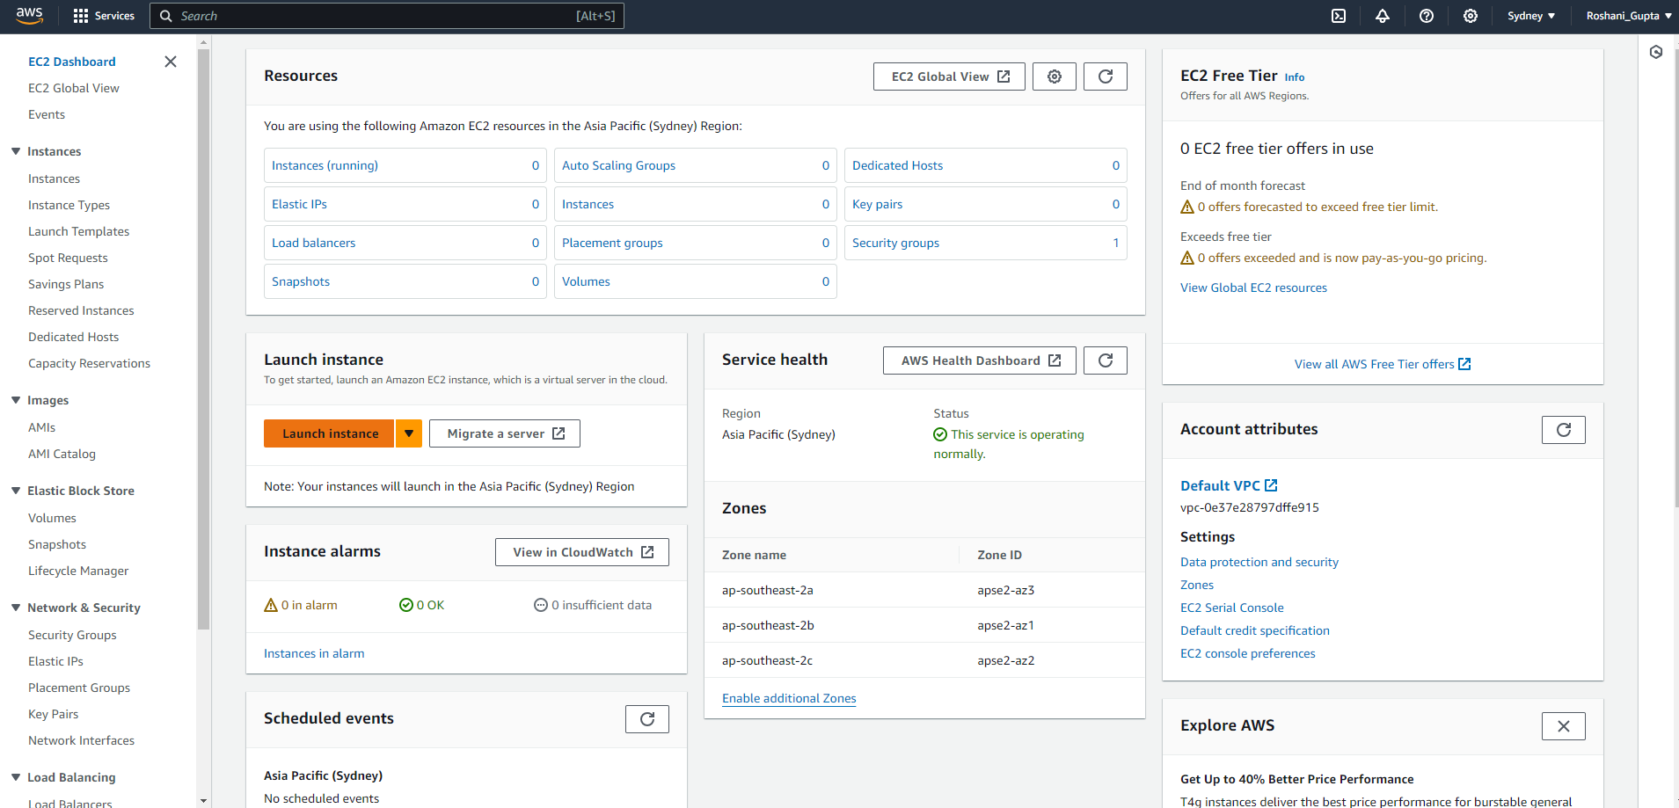

Step 2: Add the name choose ubuntu

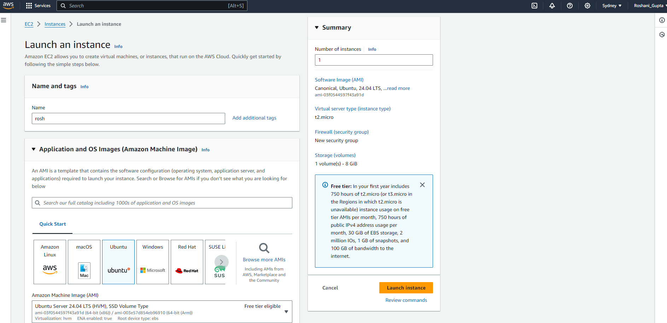

Step 3 : Choose the default key pair value

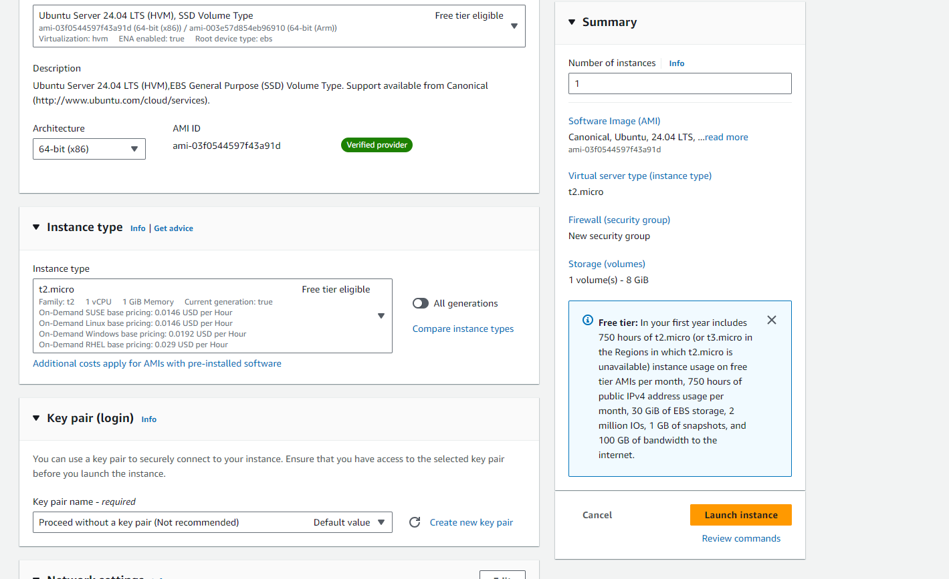

Step 4: Allow HTTPS traffic from internet

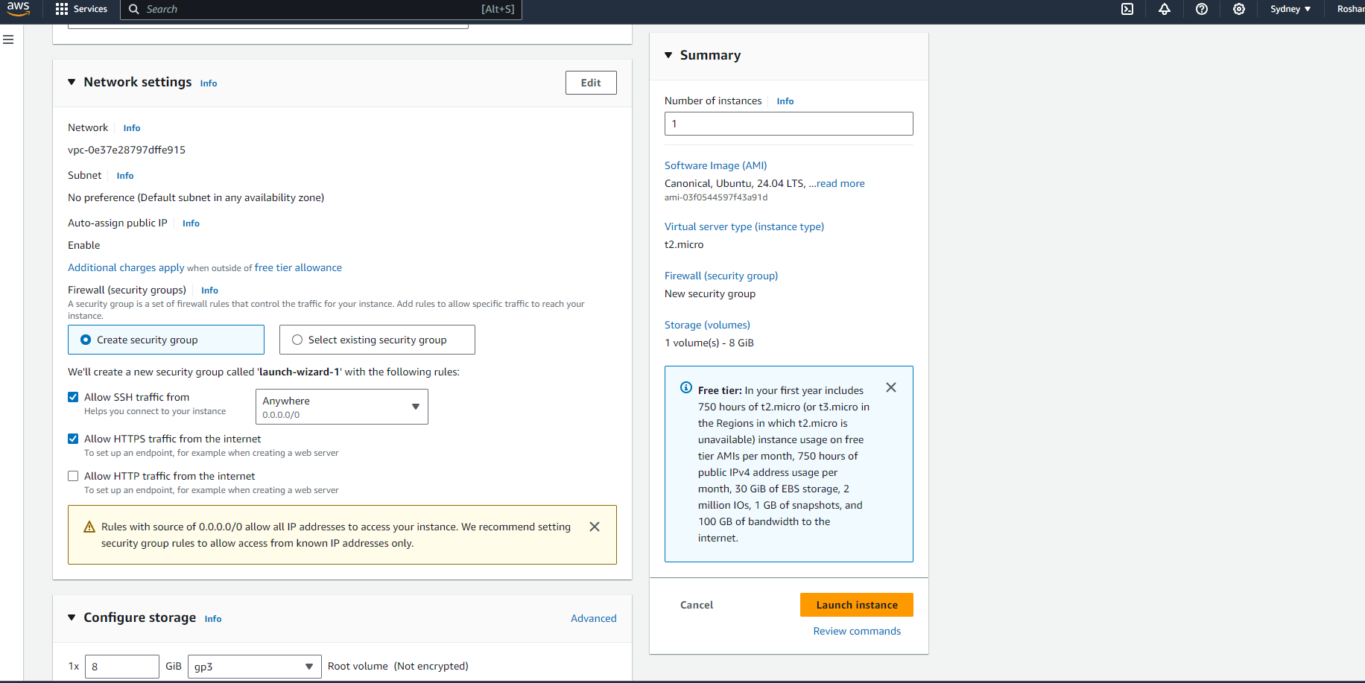

Step 5 : Launch instance and navigate to instances tab

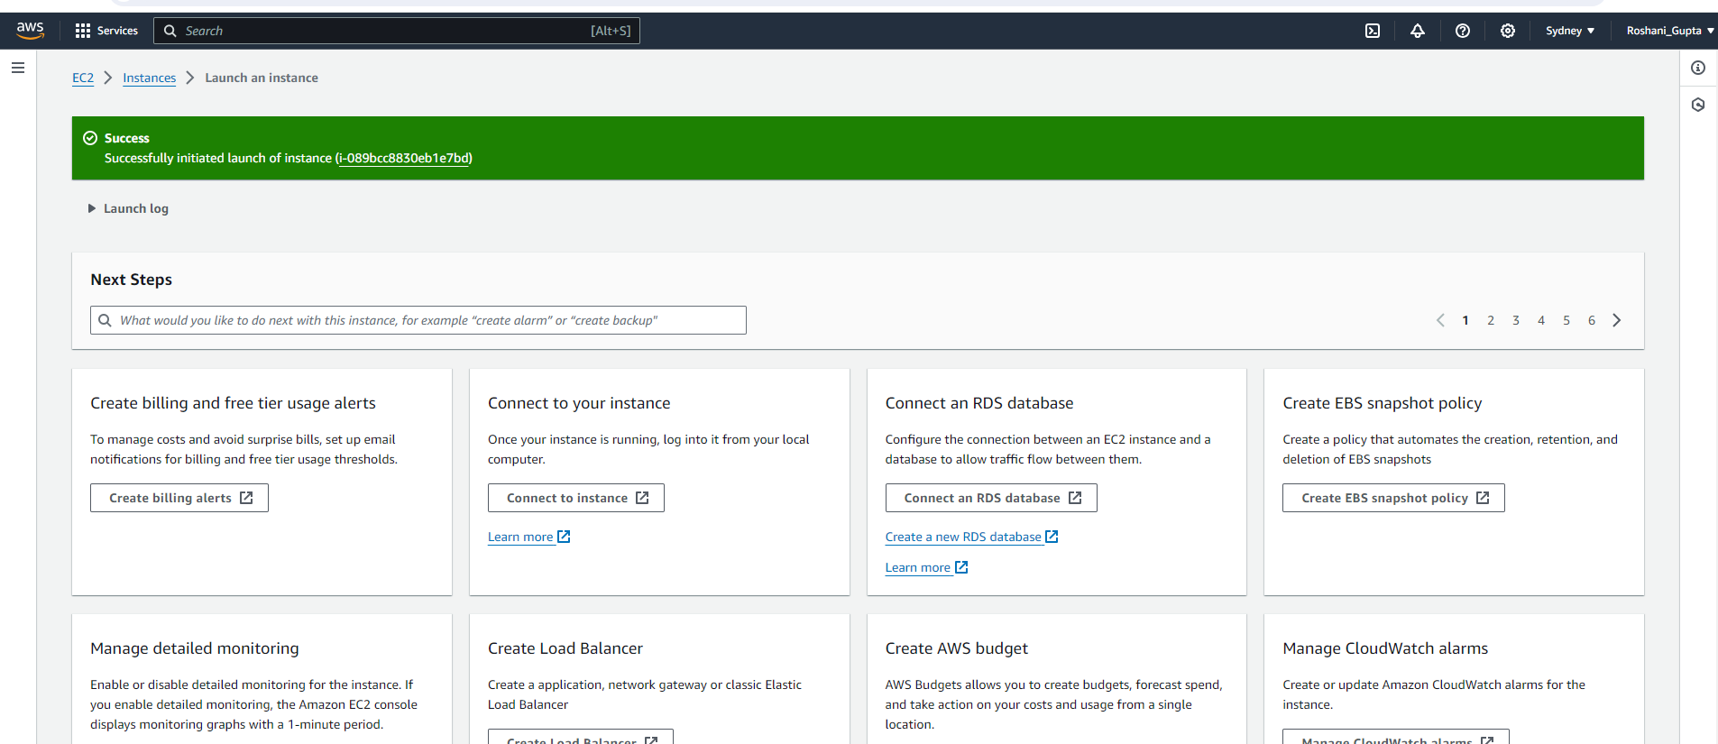

Step 6: Choose the instance and connect

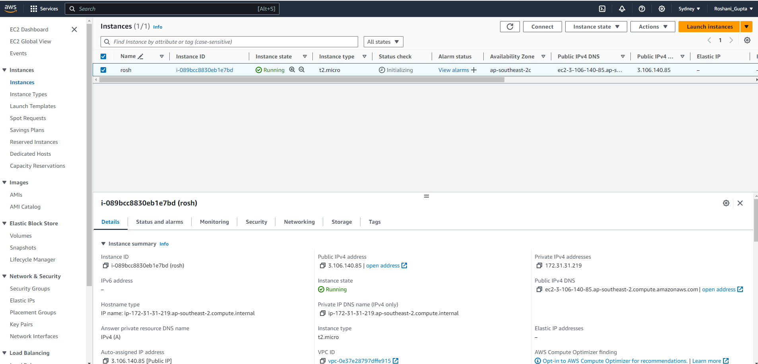

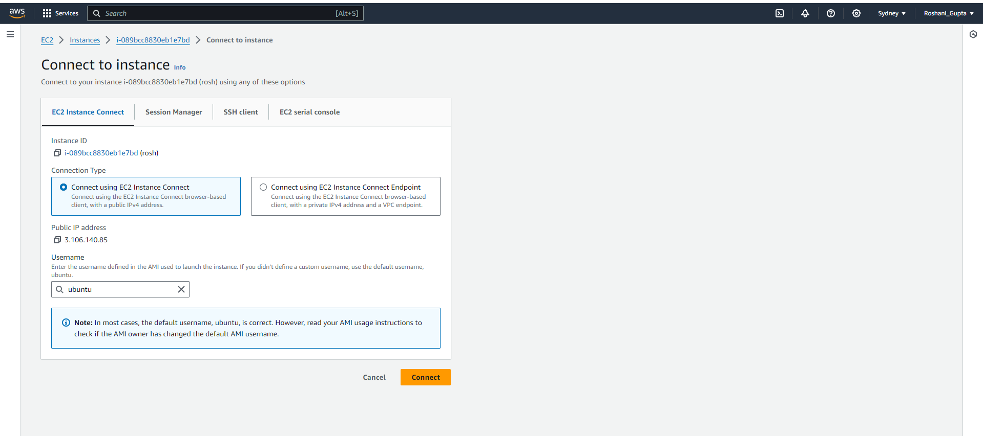

Step 7: Start the terminal and run simple command

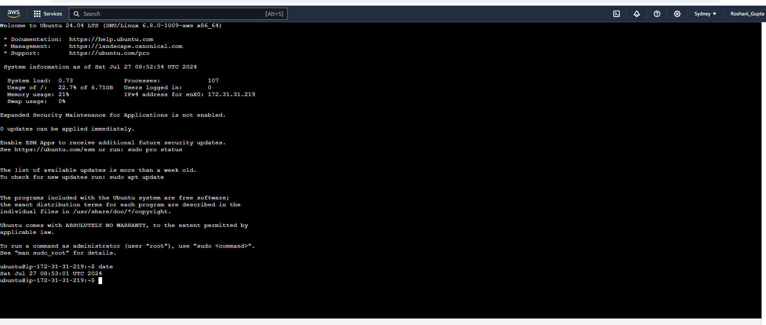

Step 8: After using the instance stop the instance from the instance state tab

